Chapter 1. Introduction to Kubernetes and OpenShift 7
Containers and Kubernetes 7
Objectives 7
Introduction to Containers and Kubernetes 7
Containers Overview 7
Kubernetes Overview 8
Kubernetes Features 8
NOTE 9
Kubernetes Architectural Concepts 9
The Kubernetes API and Configuration Model 10
Red Hat OpenShift Components and Editions 11
Objectives 11
Introduction to Red Hat OpenShift 11
Red Hat OpenShift Editions 12
Navigate the OpenShift Web Console 14
Objectives 14
Overview of the Red Hat OpenShift Web Console 14
Accessing the OpenShift Web Console 14
Web Console Perspectives 16
Note 16
OpenShift Web Console Layout 16
Note 16
Red Hat OpenShift Key Concepts 19
Guided Exercise: Navigate the OpenShift Web Console 20
Monitor an OpenShift Cluster 36
Objectives 36
Overview of Nodes, Machines, and Machine Configurations 36
Note 36
Identifying Errors from Nodes 36
Accessing Pod Logs 38
Red Hat OpenShift Container Platform Metrics and Alerts 39
Kubernetes Events 40
Red Hat OpenShift Container Platform API Explorer 41
Lab: Introduction to Kubernetes and OpenShift 42
Summary 51
Chapter 2. Kubernetes and OpenShift Command-line Interfaces and APIs 52
The Kubernetes and OpenShift Command-line Interfaces 52
Objectives 52
The Kubernetes Command-line Interface 52
Kubernetes Command-line Tool 53
Note 53
The OpenShift Command-line Interface 54
Authentication Methods 55
Note 56
Important 57
Managing Resources at the Command Line 57
Guided Exercise: The Kubernetes and OpenShift Command-line Interfaces 61
Inspect Kubernetes Resources 68
Objectives 68
Kubernetes and OpenShift Resources 68
Note 68
Structure of Resources 70
Command Outputs 73
YAML Output 74
Note 75
Note 75
JSON Output 75
Custom Output 75
Guided Exercise: Inspect Kubernetes Resources 77
Assess the Health of an OpenShift Cluster 86
Objectives 86
Query Operator Conditions 86
Examining Cluster Metrics 88
Viewing Cluster Metrics 88
Viewing Project Metrics 89
Viewing Resource Metrics 90
Performing Prometheus Queries in the Web Console 91
Note 92
Query Cluster Events and Alerts 92
Note 92
Kubernetes Alerts 93
Check Node Status 93
Note 96
Check Pod Status 96
Collect Information for Support Requests 97
Guided Exercise: Assess the Health of an OpenShift Cluster 99
Summary 107
Chapter 3. Run Applications as Containers and Pods 108
Guided Exercise: Create Linux Containers and Kubernetes Pods 119
Find and Inspect Container Images 132
Objectives 132
Container Image Overview 132
Container Image Registries 132
Red Hat Registry 132
Note 135
Quay.io 135
Private Registries 136
Public Registries 136
Container Image Identifiers 137
Container Image Components 138
Container Image Instructions and Metadata 138
Base Images 140
Inspecting and Managing Container Images 142
Skopeo 142
Note 143
Registry Credentials 145
Note 147
The oc image Command 147
Running Containers as Root 148
Guided Exercise: Find and Inspect Container Images 150
Troubleshoot Containers and Pods 168
Objectives 168
Container Troubleshooting Overview 168
CLI Troubleshooting Tools 168
Note 168
Editing Resources 169
Copy Files to and from Containers 170
Note 170
Note 171
Note 171
Remote Container Access 172
Connect to Running Containers 172
Execute Commands in a Container 173
Note 174
Container Events and Logs 174
Available Linux Commands in Containers 175
Troubleshooting from Inside the Cluster 176
Guided Exercise: Troubleshoot Containers and Pods 177
Lab: Run Applications as Containers and Pods 186
Chapter 4. Deploy Managed and Networked Applications on Kubernetes 194
Deploy Applications from an Image and from a Template 195
Objectives 195
Deploying Applications 195
Resources and Resource Definitions 195
Managing Resources 195
Note 196
Common Resource Types and Their Uses 196
Templates 196
Note 198
Pod 201
Deployments 202
Projects 204
Services 204
Persistent Volume Claims 206
Secrets 207
Managing Resources from the Command Line 208
Imperative Resource Management 208
Declarative Resource Management 210
Retrieving Resource Information 212
Guided Exercise: Deploy Applications from an Image and from a Template 213
Manage Long-lived and Short-lived Applications by Using the Kubernetes Workload API 221
Objectives 221
Kubernetes Workload Resources 221
Jobs 221
Cron Jobs 222
Deployments 223
Note 223
Daemonsets 226
Stateful Sets 226
Guided Exercise: Manage Long-lived and Short-lived Applications by Using the Kubernetes Workload API 227
Kubernetes Pod and Service Networks 233
Objectives 233
The Software-defined Network 233
Kubernetes Networking 234
Using Services 236
Kubernetes DNS for Service Discovery 239
Kubernetes Networking Drivers 241
The OpenShift Cluster Network Operator 241
Guided Exercise: Kubernetes Pod and Service Networks 243
Note 243
Scale and Expose Applications to External Access 252
Objectives 252
Outcomes 252
IP Addresses for Pods and Services 252
Note 252
Service Types 253
Warning 253
Warning 254
Using Routes for External Connectivity 254
Important 255
Note 256
Using Ingress Objects for External Connectivity 257
Note 257
Sticky Sessions 259
Note 259
Load Balance and Scale Applications 260
Load Balance Pods 260
Guided Exercise: Scale and Expose Applications to External Access 261
Summary 271
Chapter 5. Manage Storage for Application Configuration and Data 272
Externalize the Configuration of Applications 272
Objectives 272
Configuring Kubernetes Applications 273
Note 277
Creating Secrets 277
Creating Configuration Maps 279
Note 281
Using Configuration Maps and Secrets to Initialize Environment Variables 281
Using Secrets and Configuration Maps as Volumes 285
Note 288
Updating Secrets and Configuration Maps 288
Deleting Secrets and Configuration Maps 289
Guided Exercise: Externalize the Configuration of Applications 290
Provision Persistent Data Volumes 299
Objectives 299
Kubernetes Persistent Storage 299
Persistent Volumes 299
Volume Access Mode 301
Volume Modes 302
Manually Creating a PV 303
Persistent Volume Claims 304
Creating a PVC 305
Kubernetes Dynamic Provisioning 310
Note 311
PV and PVC Lifecycles 312
Deleting a Persistent Volume Claim 313
Guided Exercise: Provision Persistent Data Volumes 314
Selecting a Storage Class for an Application 324
Objectives 324
Storage Class Selection 324
Reclaim Policy 324
Kubernetes and Application Responsibilities 325
Use Cases for Storage Classes 326
Create a Storage Class 327
Cluster Storage Classes 330
Storage Class Usage 331
Guided Exercise: Selecting a Storage Class for an Application 333
Manage Non-shared Storage with Stateful Sets 344
Objectives 344
Application Clustering 344
File Storage 344
Block Storage 345
Stateful Sets 346
Headless Services for Stateful Sets 347
Working with Stateful Sets 348
Note 350
Note 353
Guided Exercise: Manage Non-shared Storage with Stateful Sets 355
Lab: Manage Storage for Application Configuration and Data 365
Summary 380
Chapter 6. Configure Applications for Reliability 381
Application High Availability with Kubernetes 381
Objectives 381
Concepts of Deploying Highly Available Applications 381
Writing Reliable Applications 382
Kubernetes Application Reliability 382
Restarting Pods 383
Guided Exercise: Application High Availability with Kubernetes 384
Application Health Probes 390
Objectives 390
Kubernetes Probes 390
Authoring Probe Endpoints 390
Probe Types 390
Startup Probes 390
Readiness Probes 390
Liveness Probes 391
Types of Tests 391
Timings and Thresholds 391
Adding Probes by Using a YAML File 392
Adding Probes via the CLI 393
Note 393
Adding Probes via the Web Console 393
Guided Exercise: Application Health Probes 397
Reserving Compute Capacity for Applications 403
Objectives 403
Kubernetes Pod Scheduling 403
Note 403
Configuring Compute Resource Requests 403
Inspecting Cluster Compute Resources 404
Guided Exercise: Reserving Compute Capacity for Applications 407
Limit Compute Capacity for Applications 412
Objectives 412
Setting Memory Limits 412
Setting CPU Limits 415
Note 415
Viewing Requests, Limits, and Actual Usage 417
Guided Exercise: Limit Compute Capacity for Applications 420
Application Autoscaling 424
Objectives 424
Horizontal Pod Autoscaling 424
The Autoscaling Process in Kubernetes 424
Prerequisites for Autoscaling 425
Important 425
Creating a Horizontal Pod Autoscaler 425
Using the oc autoscale Command 425
Using a YAML Manifest 425
Note 427
Using the Web Console 427
Verifying Horizontal Pod Autoscaler Status 429
Viewing HPA Objects 429
Inspecting HPA Details and Events 430
Guided Exercise: Application Autoscaling 430
Lab: Configure an Application for Reliability 438
Summary 445
Chapter 7. Manage Application Updates 446
Container Image Identity and Tags 446
Objectives 446
Kubernetes Image Tags 446
Floating Tag Issues 447
Using an SHA Image ID 448
Note 449
Selecting a Pull Policy 450
Pruning Images from Cluster Nodes 451
Note 452
Guided Exercise: Container Image Identity and Tags 454
Update Application Image and Settings 464
Objectives 464
Application Code, Configuration, and Data 464
Deployment Strategies 464
Rolling Update Strategy 465
Note 466
Recreate Strategy 467
Rolling out Applications 467
Monitoring Replica Sets 468
Managing Rollout 470
Guided Exercise: Update Application Image and Settings 472
Reproducible Deployments with OpenShift Image Streams 480
Objectives 480
Image Streams 480
Image Stream Tags 480
Image Names, Tags, and IDs 482
Image Stream Use Cases 484
Creating Image Streams and Tags 485
Inspecting an Image Stream Definition 486
Importing Image Stream Tags Periodically 487
Configuring Image Pull-through 488
Using Image Streams in Deployments 488
Enabling the Local Lookup Policy 489
Configuring Image Streams in Deployments 489
Guided Exercise: Reproducible Deployments with OpenShift Image Streams 491
Automatic Image Updates with OpenShift Image Change Triggers 495
Objectives 495
Using Triggers to Manage Images 495
Configuring Image Triggers for Deployments 495
Rolling out Deployments 497
Rolling Back Deployments 497
Managing Image Stream Tags 497
Guided Exercise: Automatic Image Updates with OpenShift Image Change Triggers 500
Lab: Manage Application Updates 505
Update two live applications to their latest releases as identified by non-floating tags. 505
Outcomes 505
You should be able to configure Deployment objects with images and triggers, and configure image stream tags and aliases. 505
As the student user on the workstation machine, use the lab command to prepare your system for this exercise. 505
This command ensures that all resources are available for this exercise. It also creates the updates-review project and deploys two applications, app1 and app2, in that project. 505
The command creates the /home/student/DO180/labs/updates-review/resources.txt file. The resources.txt file contains the name of the images that you use during the exercise. You can use the file to copy and paste these image names. 505
[student@workstation ~]$ lab start updates-review 505
Instructions 505
The API URL of your OpenShift cluster is https://api.ocp4.example.com:6443, and the oc command is already installed on your workstation machine. 505
Log in to the OpenShift cluster as the developer user with the developer password. Use the updates-review project for your work. 505
1. Your team created the app1 deployment in the updates-review project from the registry.ocp4.example.com:8443/redhattraining/php-ssl:latest container image. Recently, a developer in your organization pushed a new version of the image and then reassigned the latest tag to that version.
Reconfigure the app1 deployment to use the 1-222 static tag instead of the latest floating tag, to prevent accidental redeployment of your application with untested image versions that your developers can publish at any time. 505
Log in to the OpenShift cluster. 505
[student@workstation ~]$ oc login -u developer -p developer \ 505
https://api.ocp4.example.com:6443 505
Login successful. 505
...output omitted... 505
Set the updates-review project as the active project. 505
[student@workstation ~]$ oc project updates-review 506
...output omitted... 506
Verify that the app1 deployment uses the latest tag. Retrieve the container name. 506
[student@workstation ~]$ oc get deployment/app1 -o wide 506
NAME READY ... CONTAINERS IMAGES ... 506
app1 1/1 ... php-ssl registry...:8443/redhattraining/php-ssl:latest ... 506
In the Deployment object, change the image to registry.ocp4.example.com:8443/redhattraining/php-ssl:1-222. 506
[student@workstation ~]$ oc set image deployment/app1 \ 506
php-ssl=registry.ocp4.example.com:8443/redhattraining/php-ssl:1-222 506
deployment.apps/app1 image updated 506
Verify your work. 506
[student@workstation ~]$ oc get deployment/app1 -o wide 506
NAME READY ... CONTAINERS IMAGES ... 506
app1 1/1 ... php-ssl registry...:8443/redhattraining/php-ssl:1-222 ... 506
2. The app2 deployment is using the php-ssl:1 image stream tag, which is an alias for the php-ssl:1-222 image stream tag.
Enable image triggering for the app2 deployment, so that whenever the php-ssl:1 image stream tag changes, OpenShift rolls out the application. You test your configuration in a later step, when you reassign the php-ssl:1 alias to a new image stream tag. 506
Retrieve the container name from the Deployment object. 506
[student@workstation ~]$ oc get deployment/app2 -o wide 506
NAME READY UP-TO-DATE AVAILABLE AGE CONTAINERS ... 506
app2 1/1 1 1 21m php-ssl ... 506
Add the image trigger to the Deployment object. 506
[student@workstation ~]$ oc set triggers deployment/app2 \ 506
--from-image php-ssl:1 --containers php-ssl 506
deployment.apps/app2 triggers updated 506
Verify your work. 506
[student@workstation ~]$ oc set triggers deployment/app2 506
NAME TYPE VALUE AUTO 507
deployments/app2 config true 507
deployments/app2 image php-ssl:1 (php-ssl) true 507
3. A new image version, registry.ocp4.example.com:8443/redhattraining/php-ssl:1-234, is available in the container registry. Your QA team tested and approved that version. It is ready for production.
Create the php-ssl:1-234 image stream tag that points to the new image. Move the php-ssl:1 image stream tag alias to the new php-ssl:1-234 image stream tag. Verify that the app2 application redeploys. 507
Create the php-ssl:1-234 image stream tag. 507
[student@workstation ~]$ oc create istag php-ssl:1-234 \ 507
--from-image registry.ocp4.example.com:8443/redhattraining/php-ssl:1-234 507
imagestreamtag.image.openshift.io/php-ssl:1-234 created 507
Move the php-ssl:1 alias to the new php-ssl:1-234 image stream tag. 507
[student@workstation ~]$ oc tag --alias php-ssl:1-234 php-ssl:1 507
Tag php-ssl:1 set up to track php-ssl:1-234. 507
Verify that the app2 application rolls out. The names of the replica sets on your system probably differ. 507
[student@workstation ~]$ oc describe deployment/app2 507
Name: app2 507
Namespace: updates-review 507
...output omitted... 507
Events: 507
Type ... Age Message 507
---- ---- ------- 507
Normal ... 33m ... Scaled up replica set app2-7dd589f6d5 to 1 507
Normal ... 3m30s ... Scaled up replica set app2-7bf5b7787 to 1 507
Normal ... 3m28s ... Scaled down replica set app2-7dd589f6d5 to 0 from 1 507
Evaluation 507
As the student user on the workstation machine, use the lab command to grade your work. Correct any reported failures and rerun the command until successful. 507
[student@workstation ~]$ lab grade updates-review 507
Finish 507
As the student user on the workstation machine, use the lab command to complete this exercise. This step is important to ensure that resources from previous exercises do not impact upcoming exercises. 508
[student@workstation ~]$ lab finish updates-review 508
Abbreviations and definitions 509
USEFUL COMMANDS 512
Quiz: Run Applications as Containers and Pods — Cheat Sheet 513
LOGIN FIRST (always do this before any skopeo command) 513
Q1: Which command is executed in a container image? 513
Q2: Deployment scenarios based on UID (php-74 = UID 1001) 513
Q3: What is the hash (Digest) for an image? 513
Q4: Which environment variables are in an image? 514
Q5: Which tags are available for an image? 514
Q6: Which images run as privileged when admin deploys? 514
Q7: Which port is exposed in an image? 515
SUMMARY OF KEY COMMANDS 515

Chapter 1. Introduction to Kubernetes and OpenShift
Containers and Kubernetes
Quiz: Containers and Kubernetes
Red Hat OpenShift Components and Editions
Quiz: Red Hat OpenShift Components and Editions
Navigate the OpenShift Web Console
Guided Exercise: Navigate the OpenShift Web Console
Monitor an OpenShift Cluster
Guided Exercise: Monitor an OpenShift Cluster
Lab: Introduction to Kubernetes and OpenShift
Quiz: Introduction to Kubernetes and OpenShift
Summary
Abstract
Goal | Identify the main Kubernetes cluster services and OpenShift platform services and monitor them by using the web console.
Sections | - Containers and Kubernetes (and Matching Quiz)  - Red Hat OpenShift Components and Editions (and Matching Quiz)  - Navigate the OpenShift Web Console (and Guided Exercise)  - Monitor an OpenShift Cluster (and Guided Exercise)
Lab | - Introduction to Kubernetes and OpenShift

Containers and Kubernetes

Objectives
- Describe the main characteristics of containers and Kubernetes.

Introduction to Containers and Kubernetes
Red Hat OpenShift Container Platform (RHOCP) is a complete platform to run applications in clusters of servers. OpenShift is based on existing technologies such as containers and Kubernetes. Containers provide a way to package applications and their dependencies that can be executed on any system with a container runtime.
Kubernetes provides many features to build clusters of servers that run containerized applications. However, Kubernetes does not intend to provide a complete solution, but rather provides extension points so system administrators can complete Kubernetes. OpenShift builds on the extension points of Kubernetes to provide a complete platform.

Containers Overview
A container is a process that runs an application independently from other containers on the host. Containers are created from a container image, which includes all the runtime dependencies of the application. Containers can then be executed on any host, without requiring the installation of any dependency on the host, and without conflicts between the dependencies of different containers.
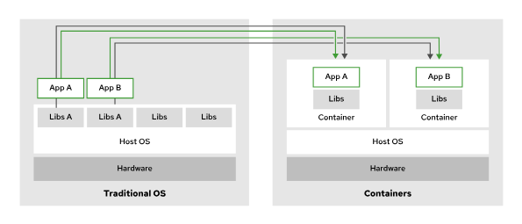
Figure 1.1: Applications in containers versus on the host operating system
Containers use Linux kernel features, such as namespaces and control groups (cgroups). For example, containers use cgroups for resource management, such as CPU time allocation and system memory. Namespaces isolate a container's processes and resources from other containers and the host system.
The Open Container Initiative (OCI) maintains standards about containers, container images, and container runtimes. Because most container engine implementations are designed to conform to the OCI specifications, applications that are packaged according to the specification can run on any conforming platform.

Kubernetes Overview
Kubernetes is a platform that simplifies the deployment, management, and scaling of containerized applications.
You can run containers on any Linux system by using tools such as Podman. Further work is required to create containerized services that, for example, can run across a cluster for redundancy.
Kubernetes creates a cluster that runs applications across multiple nodes. If a node fails, then Kubernetes can restart an application in a different node.
Kubernetes uses a declarative configuration model. Kubernetes administrators write a definition of the workloads to execute in the cluster, and Kubernetes ensures that the running workloads match the definition. For example, an administrator defines several workloads. Each workload defines the amount of required memory. Kubernetes then creates the necessary containers in different nodes, to meet the memory requirements.
Kubernetes defines workloads in terms of pods. A pod is one or multiple containers that run in the same cluster node. Pods with multiple containers are useful in certain situations, when two containers must run in the same cluster node to share some resource. For example, a job is a workload that runs a task in a pod until completion.

Kubernetes Features
Kubernetes offers the following features on top of a container infrastructure:
Service discovery and load balancing
Distributing applications over multiple nodes can complicate communication between applications.
Kubernetes automatically configures networking and provides a DNS service for pods. With these features, pods can communicate with services from other pods transparently across nodes by using only hostnames instead of IP addresses. Multiple pods can back a service for performance and reliability. For example, Kubernetes can evenly split incoming requests to an NGINX web server by considering the availability of the NGINX pods.
Horizontal scaling
Kubernetes can monitor the load on a service, and create or delete pods to adapt to the load. With some configurations, Kubernetes can also provision nodes dynamically to accommodate cluster load.
Self-healing
If applications declare health check procedures, then Kubernetes can monitor, restart, and reschedule failing or unavailable applications. Self-healing protects applications both from internal failure (the application stops unexpectedly) or external failure (the node that runs the application becomes unavailable).
Automated rollout
Kubernetes can gradually roll out updates to your application's containers. If something goes wrong during the rollout, then Kubernetes can roll back to the previous version of the deployment. Kubernetes routes requests to the rolled out version of the application, and deletes pods from the previous version when the rollout completes.
Secrets and configuration management
You can manage the configuration settings and secrets of your applications without requiring changes to containers. Application secrets can be usernames, passwords, and service endpoints, or any configuration setting that must be kept private.

NOTE
Kubernetes does not encrypt secrets.
Operators
Operators are packaged Kubernetes applications that can manage Kubernetes workloads in a declarative manner. For example, an operator can define a database server resource. If the user creates a database resource, then the operator creates the necessary workloads to deploy the database, configure replication, and back up automatically.

Kubernetes Architectural Concepts
Kubernetes uses several servers (also called nodes) to ensure the resilience and scalability of the applications that it manages. These nodes can be physical or virtual machines. The nodes come in two types, each of which provides a different aspect of the cluster operations.
Control plane nodes provide global cluster coordination for scheduling the deployed workloads. These nodes also manage the state of the cluster configuration in response to cluster events and requests.
Compute plane nodes run the user workloads.
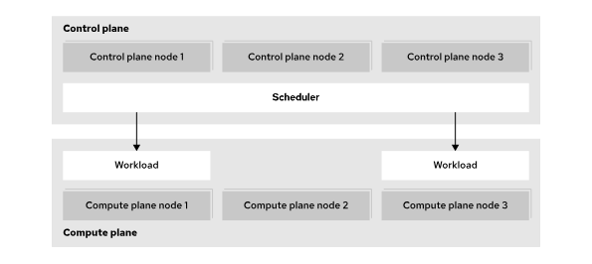
Figure 1.2: Kubernetes components
Although a server can act as both a control plane node and a compute node, the two roles are usually separated for increased stability, security, and manageability. Kubernetes clusters can range from small single-node clusters, to large clusters with up to 5,000 nodes.

The Kubernetes API and Configuration Model
Kubernetes provides a model to define the workloads to run on a cluster.
Administrators define workloads in terms of resources.
All resource types work in the same way, with a uniform API. Tools such as the kubectl command can manage resources of all types, even custom resource types.
Kubernetes can import and export resources as text files. By working with resource definitions in text formats, administrators can describe their workloads instead of performing the right sequence of operations to create them. This approach is called declarative resource management.
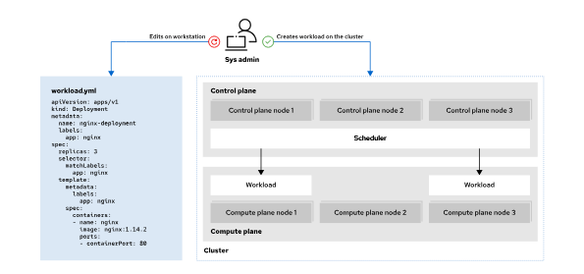
Figure 1.3: Declarative resource management
Declarative resource management can reduce the work to create workloads and improve maintainability. Additionally, when using text files to describe resources, administrators can use generic tools such as version control systems to gain further benefits such as change tracking.
To support declarative resource management, Kubernetes uses controllers that continuously track the state of the cluster and perform the necessary steps to keep the cluster in the intended state. This process means that changes to resources often require some time to be effective. However, Kubernetes can automatically apply complex changes. For example, if you increase the RAM requirements of an application that cannot be satisfied on the current node, then Kubernetes can move the application to a node with sufficient RAM. Kubernetes redirects traffic to the new instance only when the movement is complete.
Kubernetes also supports namespaces. Administrators can create namespaces, and most resources must be created inside a namespace. Besides helping organize large amounts of resources, namespaces provide the foundations for features such as resource access. Administrators can define permissions for namespaces, to allow specific users to view or modify resources.

Back to video

Red Hat OpenShift Components and Editions

Objectives
- Describe the relationship between OpenShift, Kubernetes, and other Open Source projects, and list key features of Red Hat OpenShift products and editions.

Introduction to Red Hat OpenShift
Kubernetes provides many features to run container workloads on clusters. However, for some features, Kubernetes provides only the building blocks to implement them, because different environments might need different solutions. Kubernetes administrators can select an existing solution or implement their own solution to fit their specific requirements.
OpenShift uses the extensibility of Kubernetes to build a complete solution by adding the following features to a Kubernetes cluster:
Integrated developer workflow
When running applications on Kubernetes, you need to build and store container images for the applications. OpenShift integrates a built-in container registry, CI/CD pipelines, and S2I, a tool to build artifacts from source repositories to container images.
Observability
To achieve the intended reliability, performance, and availability of applications, cluster administrators might need additional tools to prevent and solve issues. OpenShift includes monitoring and logging services for both your applications and the cluster.
Server management
Kubernetes requires an operating system to run on that must be installed, configured, and maintained.
OpenShift provides installation and update procedures for many scenarios.
Additionally, hosts in a cluster use Red Hat Enterprise Linux CoreOS (RHEL CoreOS) as the underlying operating system. RHEL CoreOS is an immutable operating system that is optimized for running containerized applications. RHEL CoreOS uses the same kernel and packages as Red Hat Enterprise Linux. OpenShift also provides features to manage RHEL CoreOS following the Kubernetes configuration model.
OpenShift also brings unified tools and a graphical web console to manage all the different capabilities, and additional enhancements such as improved security measures.
This diagram shows many of the projects that provide the various functions within each OpenShift cluster:
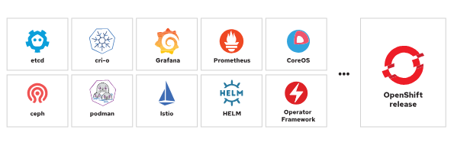
Figure 1.4: Open source projects in an OpenShift release
Because OpenShift features build on Kubernetes extensibility, administrators can often operate these features by using their existing Kubernetes knowledge. Besides Kubernetes knowledge, OpenShift administrators can use most existing products that are designed for Kubernetes.

Red Hat OpenShift Editions
When you initially explore OpenShift, using Red Hat OpenShift Local is a viable approach that deploys a cluster on a local computer for testing and exploration. Red Hat also provides a Developer Sandbox where you get 30 days of free access to a shared OpenShift cluster. These options provide access to a cluster and support testing and exploration as you consider adopting OpenShift, but are not suitable environments for production deployments.
When you are ready to adopt Red Hat OpenShift for production workloads, various editions are available to suit any business requirement for the cluster deployment.
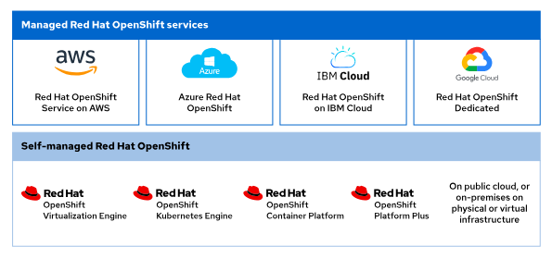
Figure 1.5: Product editions
Public cloud partners, such as Amazon Web Services, Microsoft Azure, IBM Cloud, and Google Cloud each provide quick access to an on-demand Red Hat OpenShift deployment. These managed deployments offer quick access to a cluster on infrastructure that you can rely on from a Red Hat trusted cloud provider.
You can also deploy a Red Hat OpenShift cluster by using the available installers on physical or virtual infrastructure, either on-premise or in a public cloud. These self-managed offerings are available in several forms.
The choice of deployment methods depends on many factors. When using the managed services, more responsibilities are delegated to Red Hat and the cloud provider. Because the installation process integrates with the cloud provider, the managed service creates and manages all necessary cloud resources.
When using the installers, you can still delegate hardware management to a cloud provider, or use your own. However, you manage the rest of the solution. With self-managed editions, you have greater control and flexibility, but you also take on greater responsibilities over the service.
For example, with managed services, the Red Hat Site Reliability Engineering teams update the clusters and remedy update issues (although you still participate in scheduling the updates). On self-managed editions, you update the clusters and remedy update issues. On the other hand, on self-managed editions you have complete control over aspects such as authentication, when managed editions might restrict some options.
Each managed edition documents the responsibilities for customers, Red Hat, and the cloud provider.
Additionally, to assist in managing clusters, the Red Hat Insights Advisor is available from the Red Hat Hybrid Cloud Console. The Insights Advisor helps administrators to identify and remediate cluster issues by analyzing data that the Insights Operator provides. The data from the operator is uploaded to the Red Hat Hybrid Cloud Console, where you further inspect the recommendations and their impact on the cluster.
The contents of this course apply to both managed services and self-managed editions.
Red Hat OpenShift Virtualization Engine provides the virtualization functionality found across all OpenShift editions to deploy, manage, and scale virtual machines (VMs) exclusively. This solution offers a focused approach to virtual machine management and includes key capabilities for VM support including a dedicated virtualization admin console, Red Hat OpenShift GitOps, user workload monitoring, and platform logging.
Red Hat OpenShift Kubernetes Engine includes the latest version of the Kubernetes platform with the additional security hardening and enterprise stability that Red Hat is famous for delivering. This deployment runs on the Red Hat Enterprise Linux CoreOS immutable container operating system, by using Red Hat OpenShift Virtualization for virtual machine management, and provides an administrator console to aid in operational support.
Red Hat OpenShift Container Platform builds on the features of the OpenShift Kubernetes Engine to include additional cluster manageability, security, stability, and ease of application development for businesses. Additional features of this tier include a developer console, as well as log management, cost management, and metering information. This offering adds Red Hat OpenShift Serverless (Knative), Red Hat OpenShift Service Mesh (Istio), Red Hat OpenShift Pipelines (Tekton), and Red Hat OpenShift GitOps (Argo CD) to the deployment.
Red Hat OpenShift Platform Plus expands further on the offering to deliver the most valuable and robust available features. This offering includes Red Hat Advanced Cluster Management for Kubernetes, Red Hat Advanced Cluster Security for Kubernetes, and the Red Hat Quay private registry platform. For the most complete and full-featured container experience, Red Hat OpenShift Platform Plus bundles all the necessary tools for a complete development and administrative approach to containerized application platform management.
All OpenShift editions use the same code. Most content in this course applies to all OpenShift editions.

Navigate the OpenShift Web Console

Objectives
- Navigate the OpenShift web console to identify running applications and cluster services.

Overview of the Red Hat OpenShift Web Console
The Red Hat OpenShift Web Console provides a graphical user interface to perform many administrative tasks for managing a cluster. The web console uses the Kubernetes APIs and OpenShift extension APIs to deliver a robust graphical experience. The menus, tasks, and features within the web console are always available by using the CLI. The web console provides ease of access and management for the complex tasks that cluster administration requires.
Kubernetes provides a web-based dashboard, which is not deployed by default within a cluster. The Kubernetes dashboard provides minimal security permissions, and accepts only token-based authentication. This dashboard also requires a proxy setup that limits access to the web console from only the system terminal that creates the proxy. By contrast with the stated limitations of the Kubernetes web console, OpenShift includes a fuller-featured web console.
The OpenShift web console is not related to the Kubernetes dashboard, but is a separate tool for managing OpenShift clusters. Additionally, operators can extend the web console features and functions to include more menus, views, and forms to aid in cluster administration.

Accessing the OpenShift Web Console
You access the web console by any modern web browser. The web console URL is generally configurable, and you can discover the address for your cluster web console by using the oc command-line interface (CLI). From a terminal, you must first authenticate to the cluster via the CLI by using the oc login -u <USERNAME> -p <PASSWORD> <API_ENDPOINT>:<PORT> command:
[user@host ~]$ oc login -u developer -p developer https://api.ocp4.example.com:6443
Login successful.

...output omitted...
Then, you execute the oc whoami --show-console command to retrieve the web console URL:
[user@host ~]$ oc whoami --show-console
https://console-openshift-console.apps.ocp4.example.com
Lastly, use a web browser to go to the URL, which displays the authentication page:
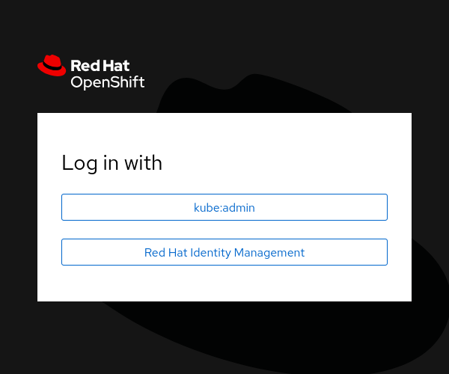
Figure 1.6: The OpenShift authentication page
Using the credentials for your cluster access brings you to the home page for the web console.
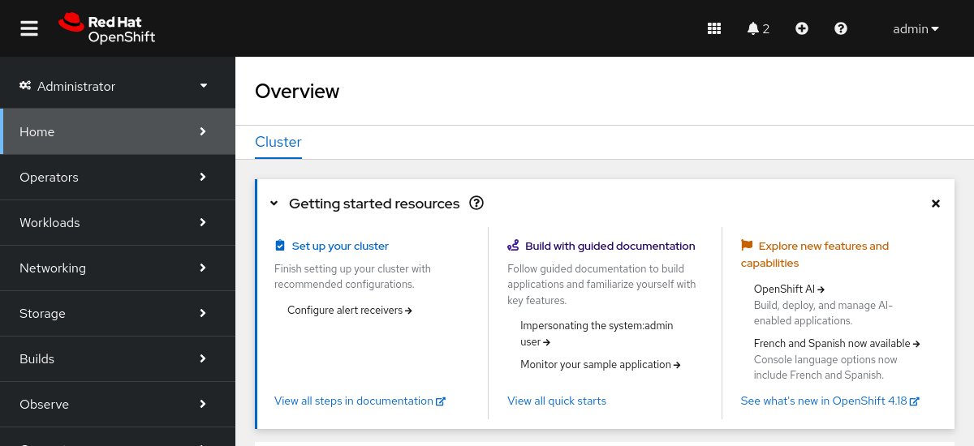
Figure 1.7: The OpenShift home page

Web Console Perspectives
The OpenShift web console provides the Administrator and Developer console perspectives. The sidebar menu layout and the features that it displays differ between using the two console perspectives. The first item on the console sidebar menu is the perspective switcher, to switch between the Administrator and the Developer perspectives.
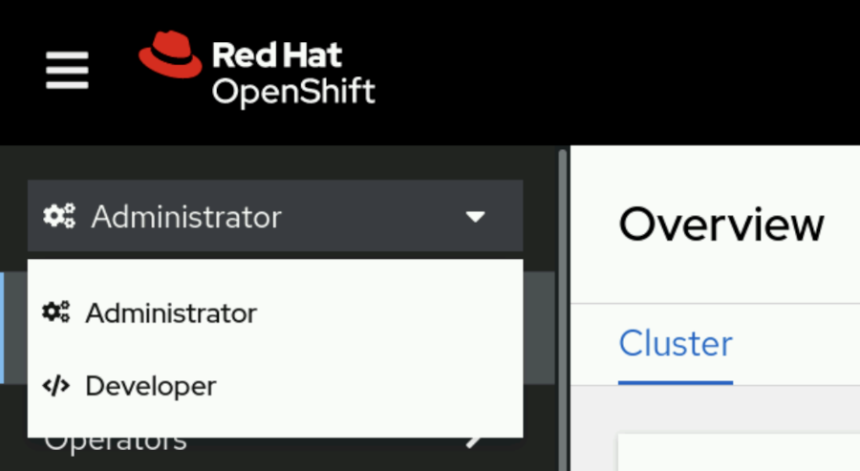
Figure 1.8: The OpenShift web console perspective switcher
Each perspective presents the user with different menu categories and pages that cater to the needs of the two separate personas. The Administrator perspective focuses on cluster configuration, deployments, and operations of the cluster and running workloads. The Developer perspective pages focus on creating and running applications.

Note
In clusters with the Red Hat OpenShift Virtualization operator deployed, a Virtualization perspective is available. The Virtualization perspective pages focus on creating and managing virtual machines.

OpenShift Web Console Layout
From the web console home page, the primary navigation method is through the sidebar. The sidebar organizes cluster functions and administration into several major categories. By selecting a category from the sidebar, the category expands to reveal the various areas that each provide specific cluster information, configuration, or functionality.

Note
An initial log in to the web console presents the option for a short informational tour. Click Skip Tour if you prefer to dismiss the tour option at this time.
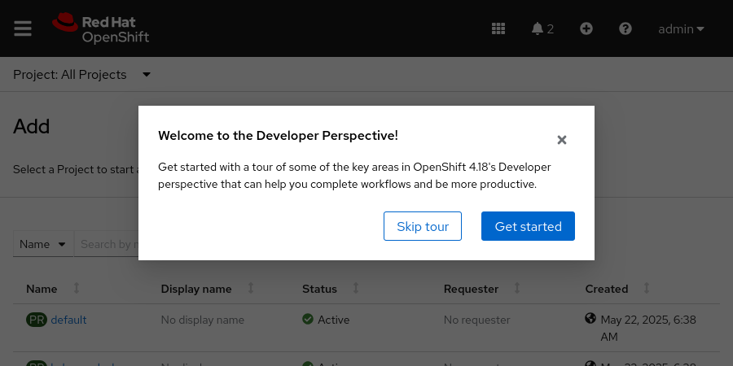
By default, the console displays the Home → Overview page, which provides a quick glimpse of initial cluster configurations, documentation, and general cluster status. Go to Home → Projects to list all projects in the cluster that are available to the credentials in use.
You might initially peruse the Operators → OperatorHub page, which provides access to the collection of operators that are available for your cluster.
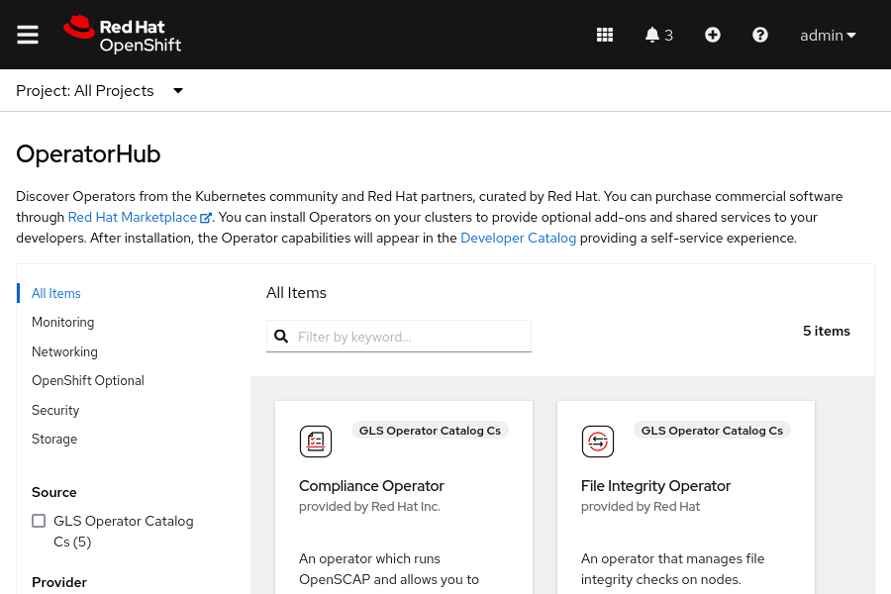
Figure 1.10: The OpenShift OperatorHub
By adding operators to the cluster, you can extend the features and functions that your OpenShift cluster provides. Use the search filter to find the available operators to enhance the cluster and to supply the OpenShift aspects that you require.
By clicking the link on the Operator Hub page, you can peruse the Developer Catalog.
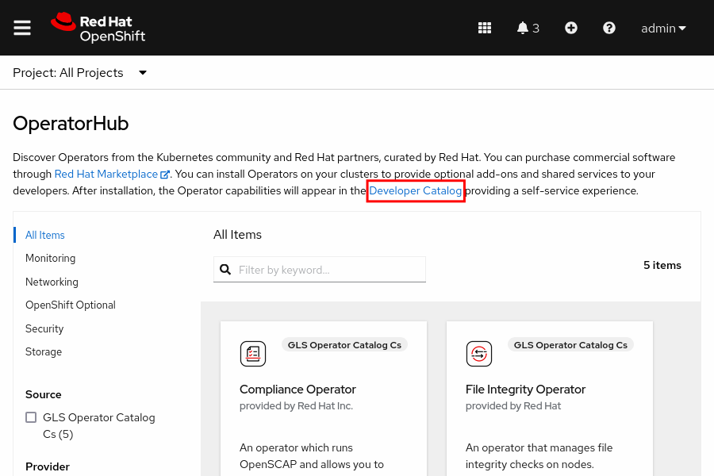
Select any project, or use the search filter to find a specific project, to visit the Developer Catalog for that project, where shared applications, services, event sources, or source-to-image builders are available.
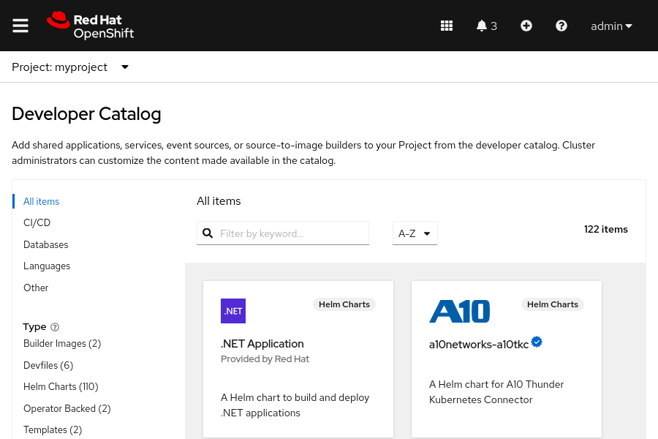
Figure 1.12: The Developer Catalog
After finding the preferred additions for a project, a cluster administrator can further customize the content that the catalog provides. By adding the necessary features to a project from this approach, developers can customize features to provide an ideal application deployment.

Red Hat OpenShift Key Concepts
When you navigate the OpenShift web console, it is useful to know some introductory OpenShift, Kubernetes, and container terminology. The following list includes some basic concepts that can help you to navigate the OpenShift web console.
- Pods: The smallest unit of a Kubernetes-managed containerized application. A pod consists of one or more containers.
- Deployments: The operational unit that provides granular management of a running application.
- Projects: A Kubernetes namespace with additional annotations that provide multitenancy scoping for applications.
- Routes: Networking configuration to expose your applications and services to resources outside the cluster.
- Operators: Packaged Kubernetes applications that extend cluster functions.
These concepts are covered in more detail throughout the course. You can find these concepts throughout the web console as you explore the features of an OpenShift cluster from the graphical environment.

Guided Exercise: Navigate the OpenShift Web Console
Access an OpenShift cluster by using its web console and review pages to identify key OpenShift cluster services.
Outcomes
- Explore the features and components of Red Hat OpenShift by using the web console.
- Create a sample application by using the Developer perspective in the web console.
- Switch to the Administrator perspective and examine the resources that are created for the sample application.
- Use the web console to describe the cluster nodes, networking, storage, and authentication.
- View the default cluster operators, pods, deployments, and services.
As the student user on the workstation machine, use the lab command to prepare your system for this exercise.
This command ensures that the cluster is validated for the exercise.
[student@workstation ~]$ lab start intro-navigate
Instructions
- As the developer user, locate and go to the Red Hat OpenShift web console.
  - Use the terminal to log in to the OpenShift cluster as the developer user with the developer password.
[student@workstation ~]$ oc login -u developer -p developer https://api.ocp4.example.com:6443

  - ...output omitted...
  - Identify the URL for the OpenShift web console.
[student@workstation ~]$ oc whoami --show-console
  - https://console-openshift-console.apps.ocp4.example.com
  - Open a web browser and go to https://console-openshift-console.apps.ocp4.example.com.
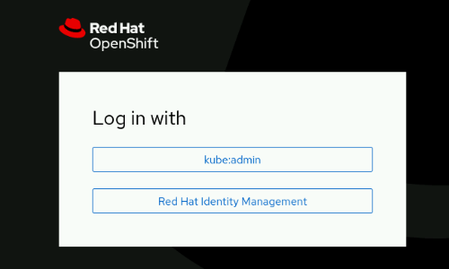
- Log in to the OpenShift web console as the developer user.
  - Click Red Hat Identity Management and log in as the developer user with the developer password.
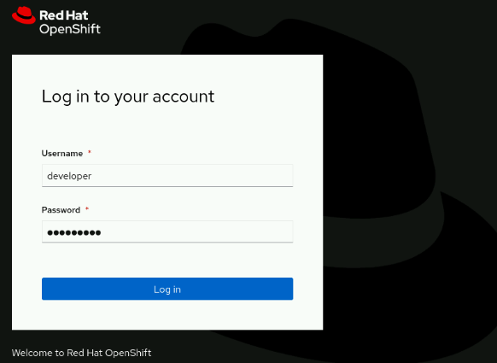
  - Note
Click Skip Tour to dismiss the option to view a short tour on the first visit.
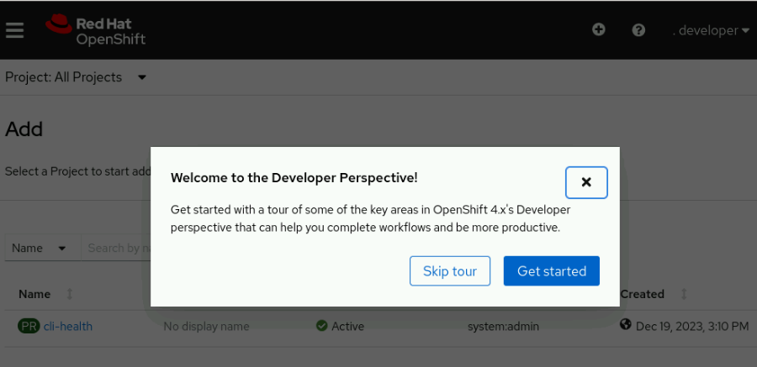
- Use the Developer perspective of the web console to create your first project.
  - From the Getting Started section in the +Add page, click Create a new project to open the Create Project wizard.
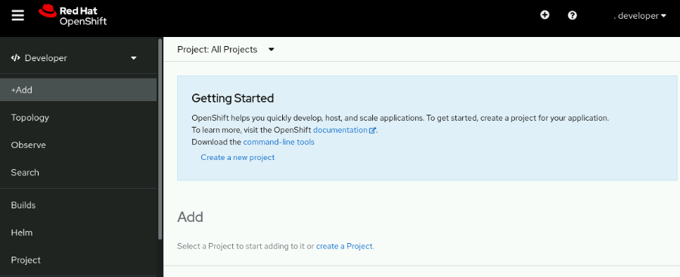
  - Create a project named intro-navigate by using the wizard. Use intro-navigate for the display name, and add a brief description of the project.
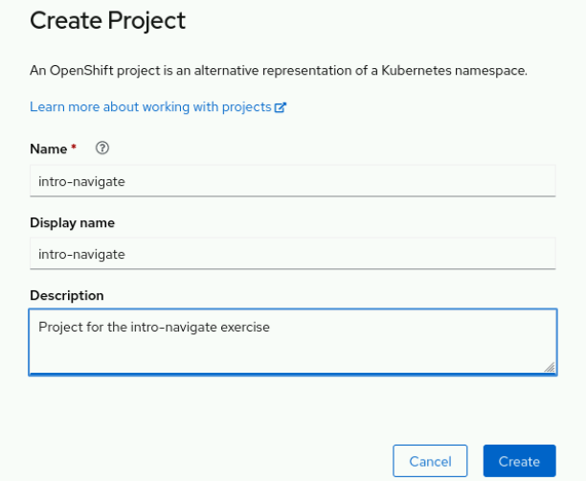
  - Click Create to create the project.
  - Click Topology to view the project.
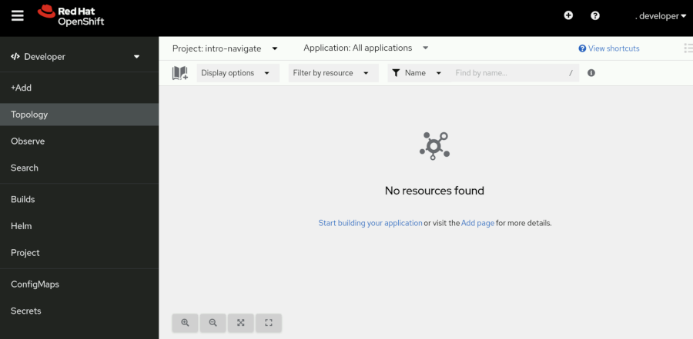
- Deploy a sample application in the project.
  - Select the +Add page. Select the Import from Git panel.
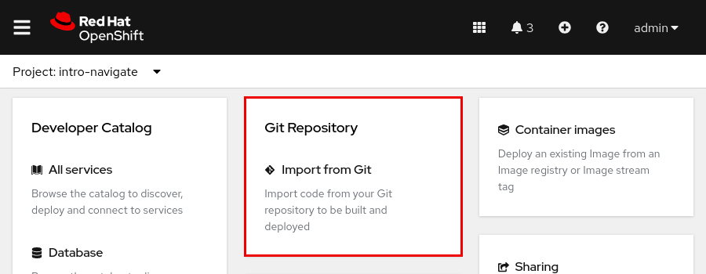
  - Enter https://git.ocp4.example.com/developer/intro-navigate.git into the Git Repo URL field and select GitLab for the Git Type field. Click Create to start the deployment.
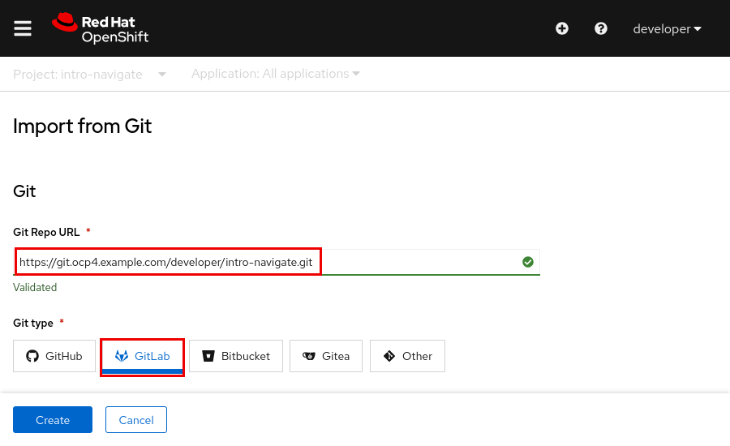
  - The Topology page opens and displays the intro-navigate-git-app application deployment.
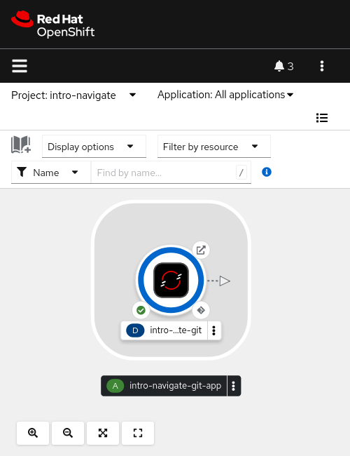
- View the deployment details for the intro-navigate-git-app application.
  - Click D to display the deployment in the right panel. Click Details in the panel. Wait, for several minutes if needed, for the Details page to show one pod deployed.
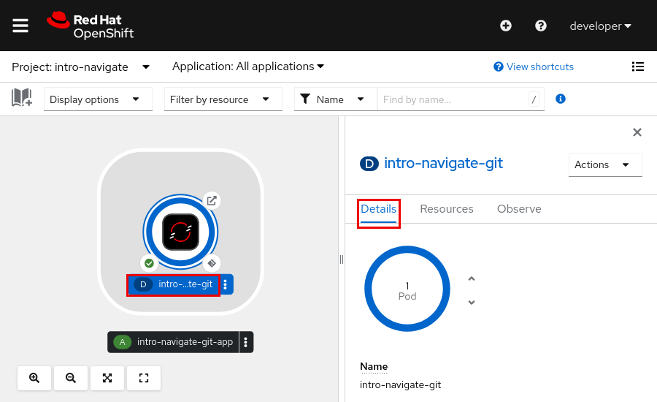
  - Select the Actions list to view the available controls for the deployment.
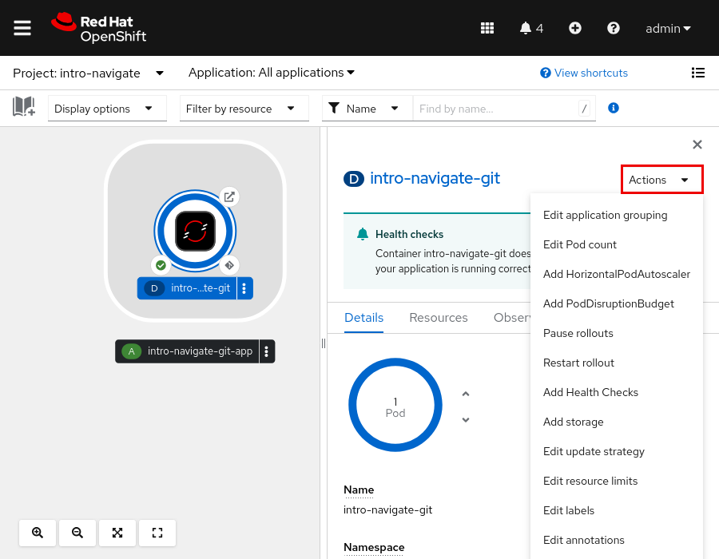
- Switch into the Administrator perspective and inspect the deployment.
  - From the OpenShift web console, locate the left panel. If you do not see the left panel, then click the main menu icon at the upper left of the web console. Click Developer and then click Administrator to change to the Administrator perspective. The web console changes to the new perspective and exposes additional information through the sidebar.
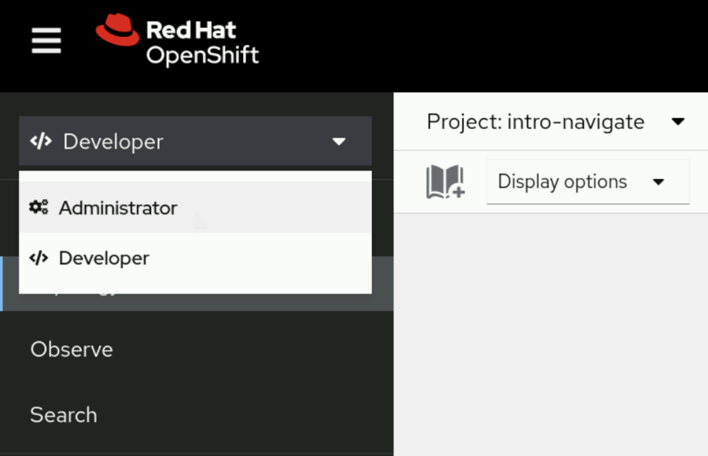
  - Select the Home → Projects page from the left panel. Select the intro-navigate project to open the Project Details page.
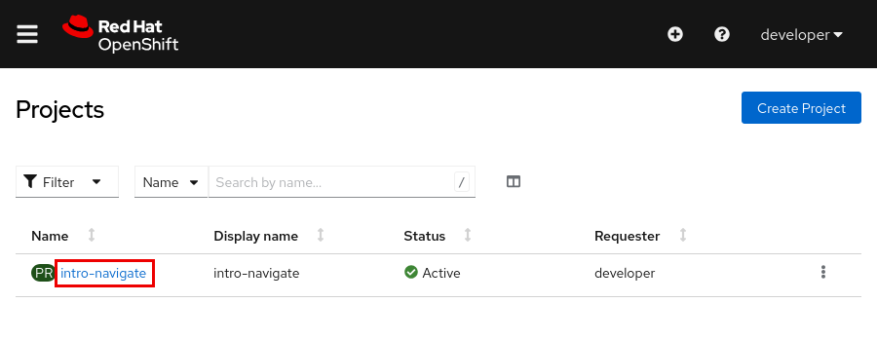
  - This page includes a general overview of the project, such as the project status and resource usage details.
Note
You can ignore image stream import warnings because the image streams are not available in the classroom cluster.
- View the intro-navigate pods and deployment.
  - From the OpenShift web console menu, go to Workloads → Pods to view the intro-navigate pods.
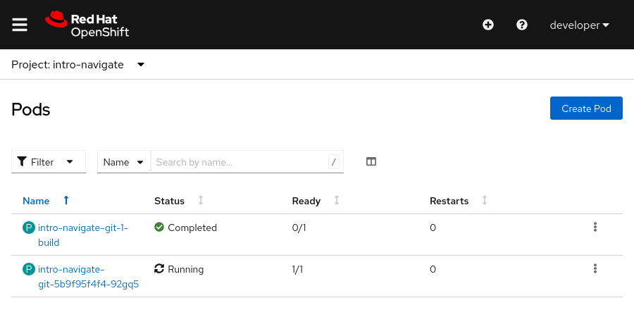
  - Go to Workloads → Deployments to view the list of deployments in the project.
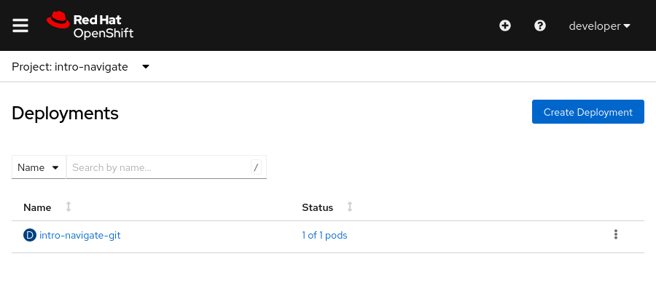
  - Click the intro-navigate-git link to view the deployment details.
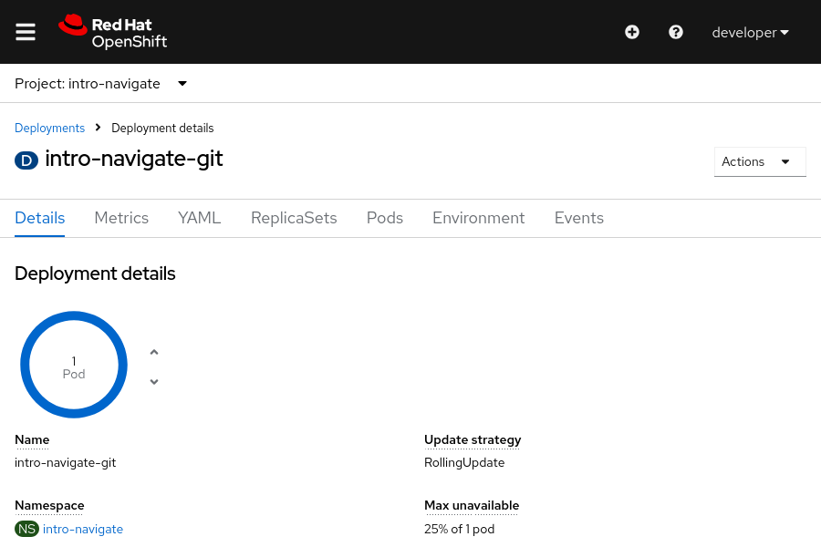
- View the intro-navigate service and route.
  - Go to Networking → Services and click intro-navigate-git to view the details of the intro-navigate service.
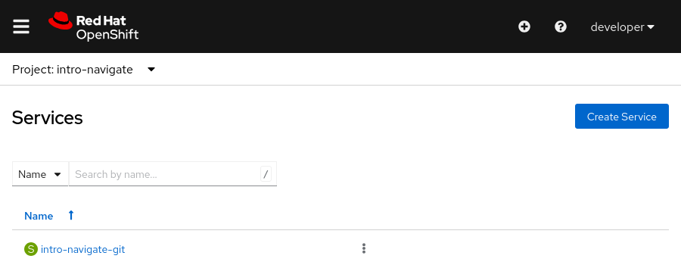
  - Go to Networking → Routes and click intro-navigate-git to view the details of the intro-navigate route.
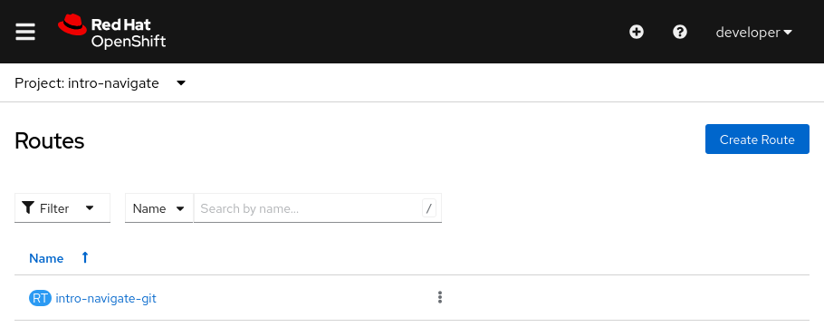
- Delete the project and log out of the web console.
  - From the OpenShift web console menu, go to Home → Projects. Select Delete Project from the context menu for the intro-navigate project.
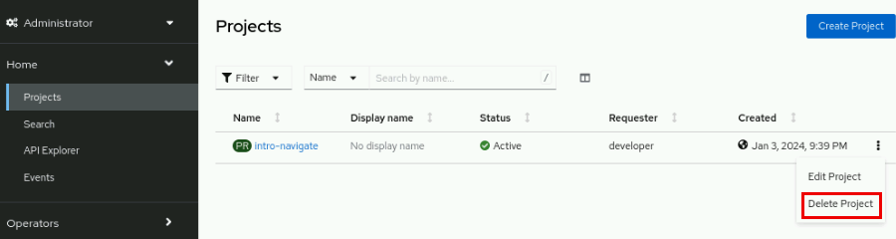
  - Enter the project name in the text field and then select Delete.
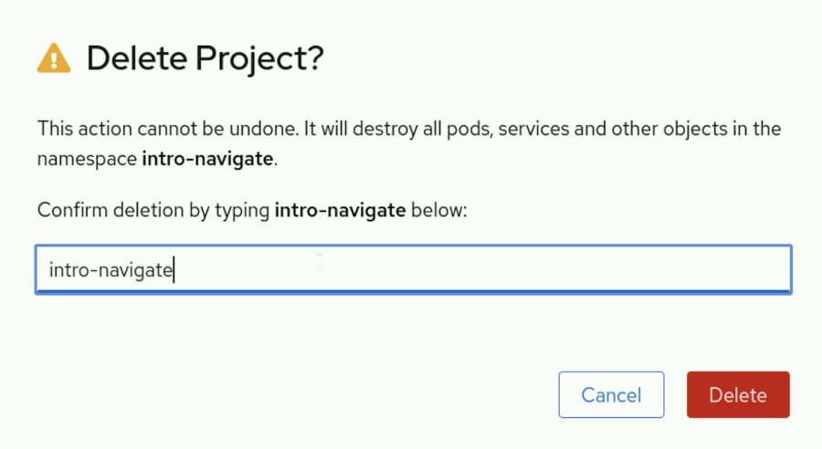
  - Log out of the web console. From the OpenShift web console right panel, click developer and then select Log out from the account menu.
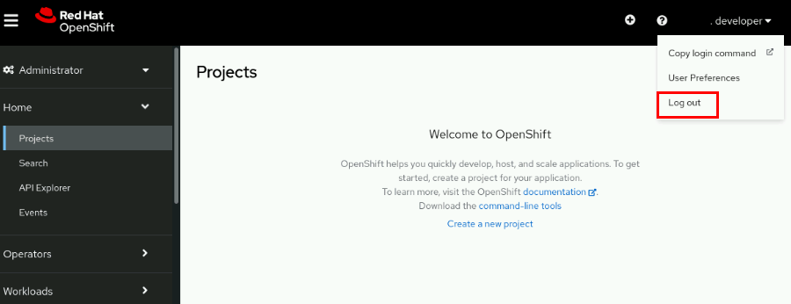
- Log in to the OpenShift web console as the admin user to inspect additional cluster details.
Note
When you use a cluster administrator account, you can browse the cluster components, but do not alter or remove any components.
  - Log in to the web console. Select Red Hat Identity Management and then enter the admin username and the redhatocp password.
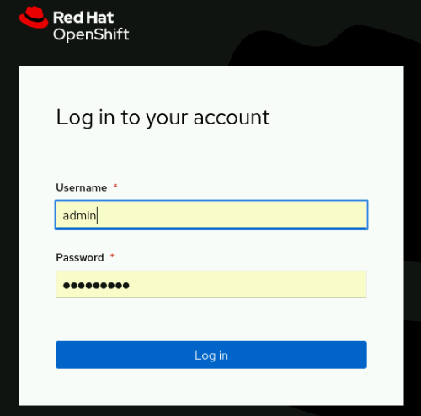
  - From the OpenShift web console menu, go to Operators → Installed Operators. Each operator provides a specific function for the cluster. Select an individual operator to display its details.
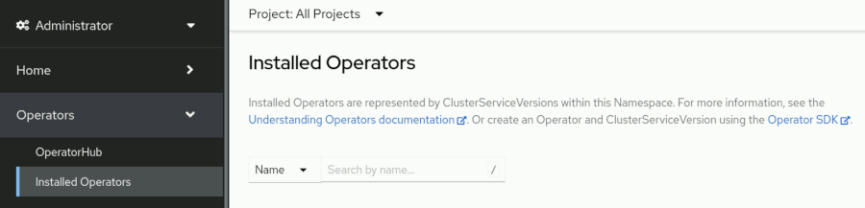
  - Go to Workloads → Pods to view the list of all pods in the cluster. The search bar at the top can narrow down the list of pods. Select an individual pod to display its details.
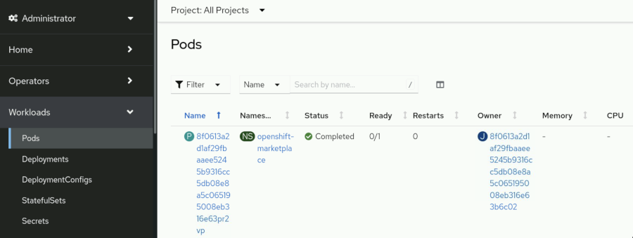
  - Go to Workloads → Deployments to view the list of all deployments in the cluster. Select an individual deployment to display its details.
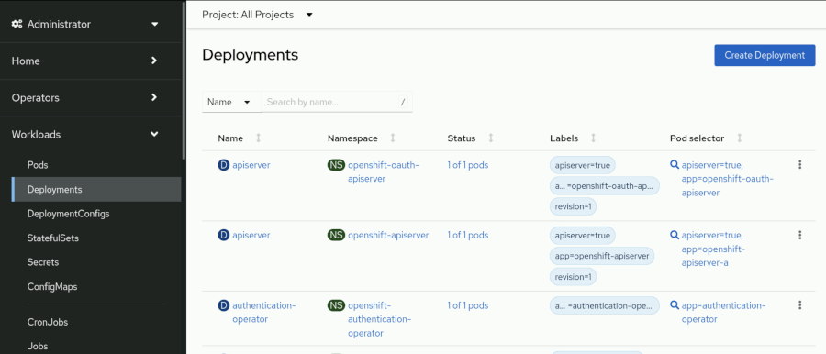
  - Go to Networking → Services to view the list of all services in the cluster. Select an individual service to display its details.
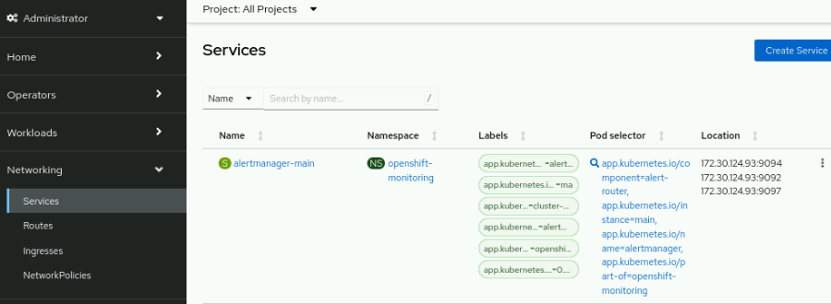
- Log out of the web console.
  - Log out of the web console. From the OpenShift web console right panel, click admin and select Log out from the account menu.
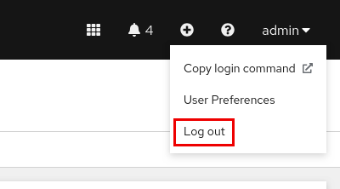
Finish
On the workstation machine, use the lab command to complete this exercise. This step is important to ensure that resources from previous exercises do not impact upcoming exercises.
[student@workstation ~]$ lab finish intro-navigate

Monitor an OpenShift Cluster

Objectives
- Navigate the Events, Compute, and Observe panels of the OpenShift web console to assess the overall state of a cluster.

Overview of Nodes, Machines, and Machine Configurations
In Kubernetes, a node is any single system in the cluster where pods can run. These systems are any of the bare metal, virtual, or cloud computers that are members of the cluster. Nodes run the necessary services to communicate within the cluster, and receive control plane operational requests. When you deploy a pod, an available node is tasked with satisfying the request.
Whereas the node and machine terms are often interchangeable, Red Hat OpenShift Container Platform (RHOCP) uses the machine term more specifically. In OpenShift, a machine is the resource that describes a cluster node. Using a machine resource is particularly valuable when using public cloud providers to provision infrastructure.
A MachineConfig resource defines the initial state and any changes to files, services, operating system updates, and critical OpenShift service versions for the kubelet and cri-o services. OpenShift relies on the Machine Config Operator (MCO) to maintain the operating systems and configuration of the cluster machines. The MCO is a cluster-level operator that ensures the correct configuration of each machine. This operator also performs routine administrative tasks, such as system updates. This operator uses the machine definitions in a MachineConfig resource to continually validate and remediate the state of cluster machines to the intended state. After a MachineConfig change, the MCO orchestrates the execution of the changes for all affected nodes.

Note
The orchestration of MachineConfig changes through the MCO is prioritized alphabetically by zone, by using the topology.kubernetes.io/zone node label.

Identifying Errors from Nodes
Administrators routinely view the logs and connect to the nodes in the cluster by using a terminal. This technique is necessary to manage a cluster and to remediate issues that arise. From the web console, go to Compute → Nodes to view the list of all nodes in the cluster.
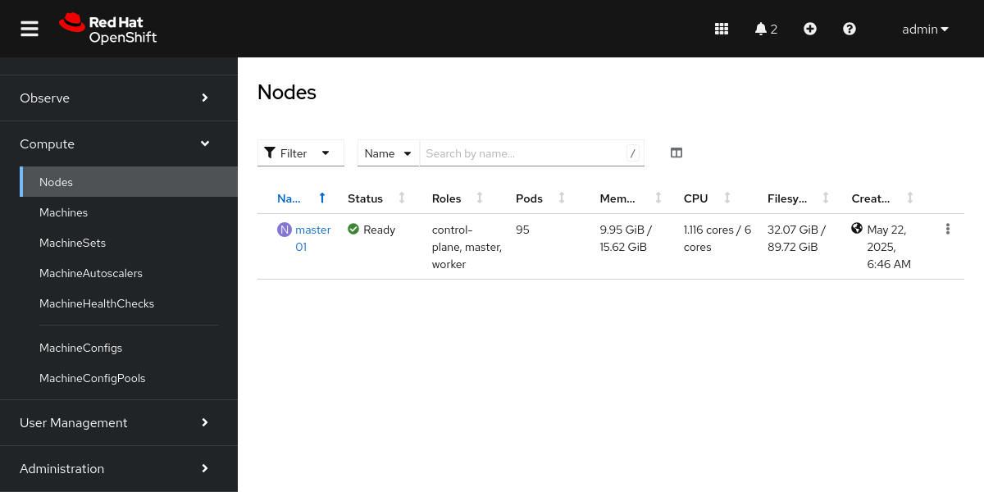
Figure 1.40: Node list in the web console
Click a node's name to go to the overview page for the node. On the node overview page, you can view the node logs or connect to the node by using the terminal.
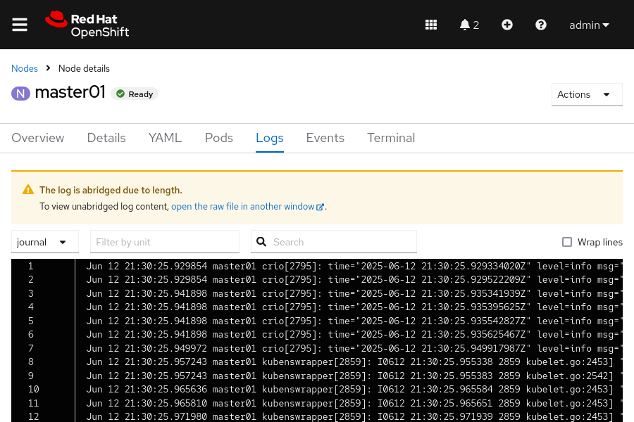
Figure 1.41: Logs page in the web console
From the previous page in the web console, view the node logs and investigate the system information to aid troubleshooting and remediation for node issues.
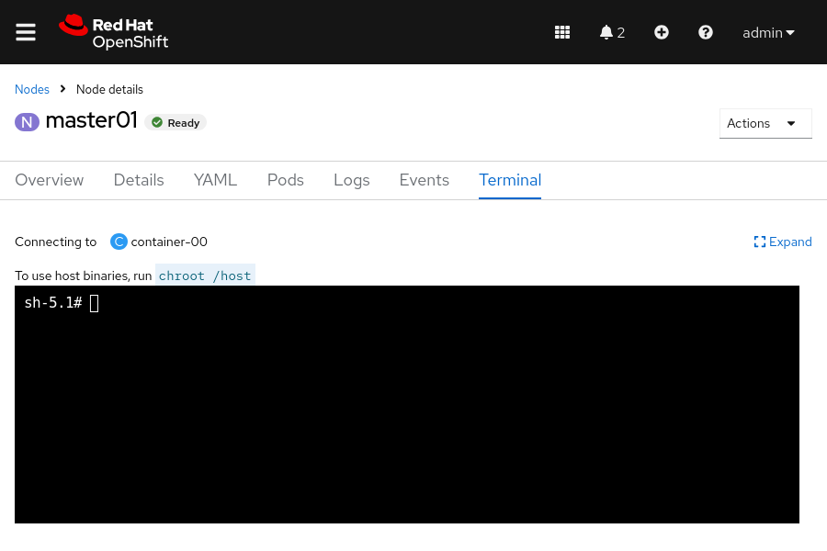
Figure 1.42: Terminal shell in the web console
The preceding page shows the web console terminal that is connected to the cluster node. From this tab, you can access the debug pod and use the commands from the host binaries to view the status of the node's services. An OpenShift node debug pod is an interface to a container that runs on the node.
Although making changes directly on the cluster node from the terminal is not recommended, it is common practice to connect to the cluster node for diagnostic investigation and remediation. From this terminal, you can use the same binaries that are available within the cluster node itself.
Additionally, the tabs on the node overview page show metrics, events, and the node's YAML definition file.

Accessing Pod Logs
Administrators often peruse pod logs to assess the health of a deployed pod or to troubleshoot pod deployment issues. Go to the Workloads → Pods page to view the list of all pods in the cluster.
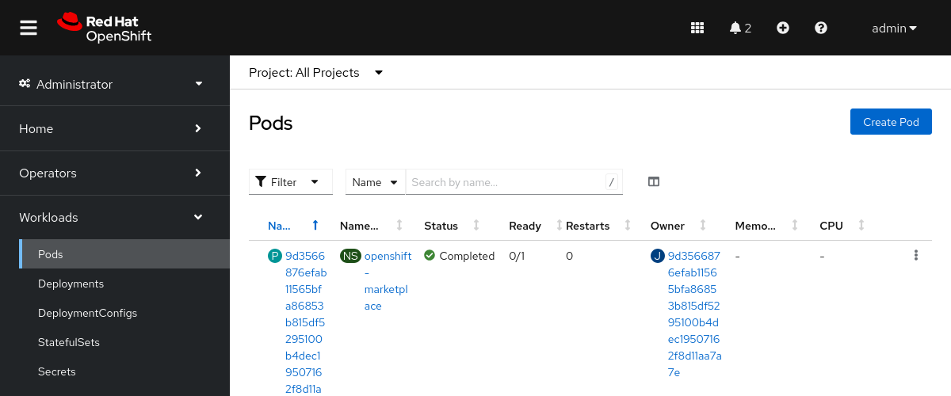
Figure 1.43: Pods page in the web console
You can filter and order pods by project and by other fields. To view the pod details page, click a pod name in the list.
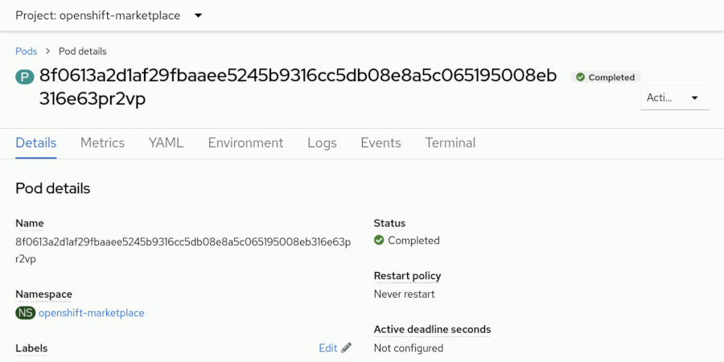
Figure 1.44: Pod details page
The pod details page contains links to pod metrics, environment variables, logs, events, a terminal, and the pod's YAML definition. The pod logs are available on the Pods → Logs page and provide information about the pod status. The Pods → Terminal page opens a shell connection to the pod for inspection and issue remediation. Although it is not recommended to alter a running pod, the terminal is useful for diagnosing and remediating pod issues. To fix a pod, update the pod configuration to reflect the necessary changes, and redeploy the pod.

Red Hat OpenShift Container Platform Metrics and Alerts
In an RHOCP cluster, HTTP service endpoints provide data metrics that are collected to provide information for monitoring cluster and application performance. These metrics are authored at the application level for each service by using the client libraries that are provided by Prometheus, an open source monitoring and alerting toolkit. Metrics data is available from the service /metrics endpoint. You can use the data for creating monitors to alert based on degradation of the service. Monitors are processes that continuously assess the value for a specific metric and provide alerts that are based on a predefined condition, to signal a degradation in the service or a performance issue. Authoring a ServiceMonitor resource defines how a specific service uses the metrics to define a monitor and the alerting values. The same approach is available for monitoring pods by defining a PodMonitor resource that uses the metrics that are gathered from the pod.
Depending on the monitor definitions, alerting is then available based on the metric that is polled and the defined success criteria. The monitor continuously compares the gathered metric, and creates an alert when the success criteria are no longer met. As an example, a web service monitor polls on the listening port, port 80, and alerts only if the response from that port becomes invalid.
From the web console, go to Observe → Metrics to visualize gathered metrics by using a Grafana-based data query utility. On this page, users can submit queries to build data graphs and dashboards, which administrators can view to gather valuable statistics for the cluster and applications.
For configured monitors, visit Observe → Alerting to view firing alerts, and filter on the alert severity to view those alerts that need remediation. Alerting data is a key component to help administrators to deliver cluster and application accessibility and functions.

Kubernetes Events
Administrators are typically familiar with the contents of log files for services, whereas logs tend to be highly detailed and granular. Events provide a high-level abstraction to log files and to provide information about more significant changes. Events are useful in understanding the performance and behavior of the cluster, nodes, projects, or pods, at a glance. Events provide details to understand general performance and to highlight meaningful issues. Logs provide a deeper level of detail for remediating specific issues.
The Home → Events page shows the events for all projects or for a specific project. You can further filter and search events.
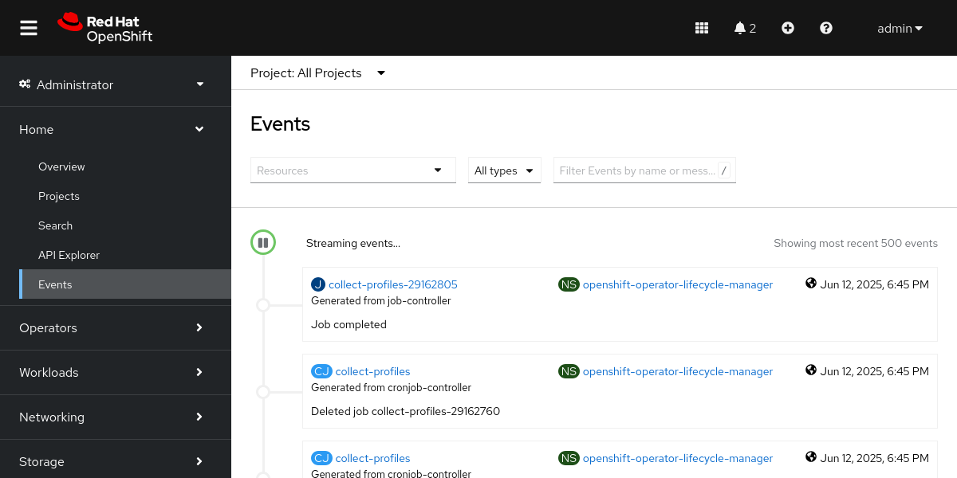
Figure 1.45: RHOCP Events console

Red Hat OpenShift Container Platform API Explorer
Starting from version 4, RHOCP includes the API Explorer feature, for users to view the catalog of Kubernetes resource types that are available within the cluster. By navigating to Home → API Explorer, you can view and explore the details for resources. Such details include the description, schema, and other metadata for the resource. This feature is helpful for all users, and especially for new administrators.
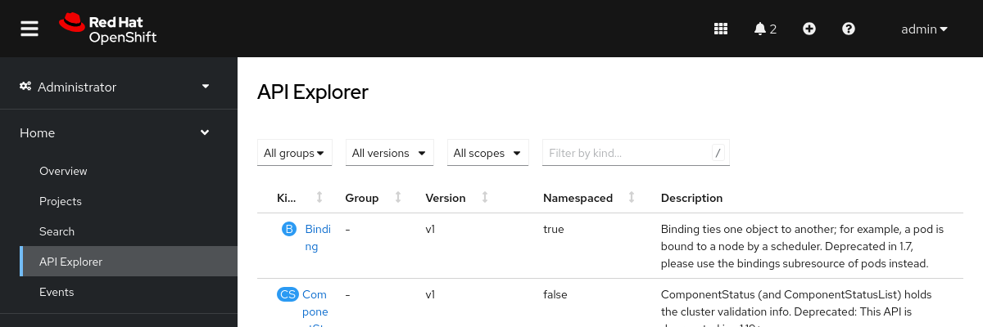
Figure 1.46: The RHOCP API Explorer

Lab: Introduction to Kubernetes and OpenShift
Find essential information about your OpenShift cluster by navigating its web console.
Outcomes
Navigate the Red Hat OpenShift Container Platform web console to find various information items and configuration details.
As the student user on the workstation machine, use the lab command to prepare your system for this exercise.
This command ensures that the Red Hat OpenShift Container Platform is deployed and ready for the lab.
[student@workstation ~]$ lab start intro-review
Instructions
- Log in to the Red Hat OpenShift Container Platform web console, with Red Hat Identity Management as the admin user with the redhatocp password, and review the answers for the quiz in the section that follows.
  - Use a browser to view the login page at the https://console-openshift-console.apps.ocp4.example.com address.
  - Click Red Hat Identity Management, and supply the admin username and the redhatocp password, and then click Log in to access the home page.
- View the cluster version on the Overview page for the cluster.
  - From the Home → Overview page, scroll down to view the cluster details.
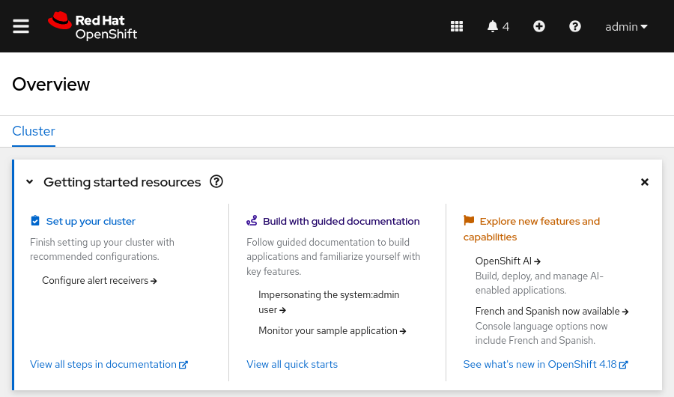
  - Locate the OpenShift version in the Details section.
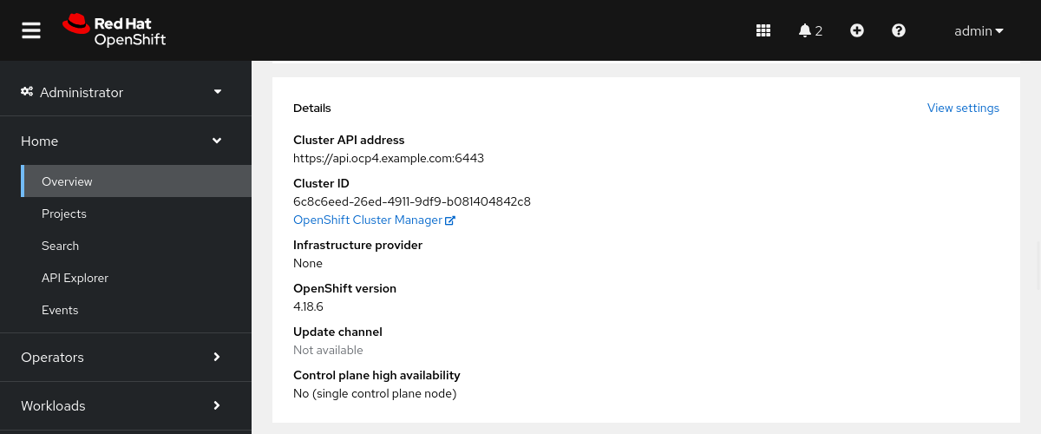
- View the available alert severity types within the filters on the Alerting page.
  - Go to the Observe → Alerting page.
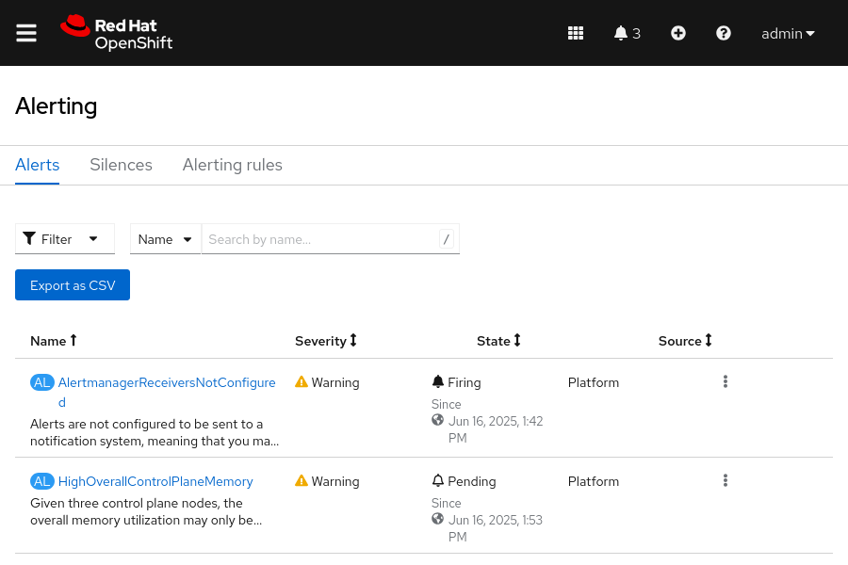
  - Click the Filter drop-down to view the available severity options.
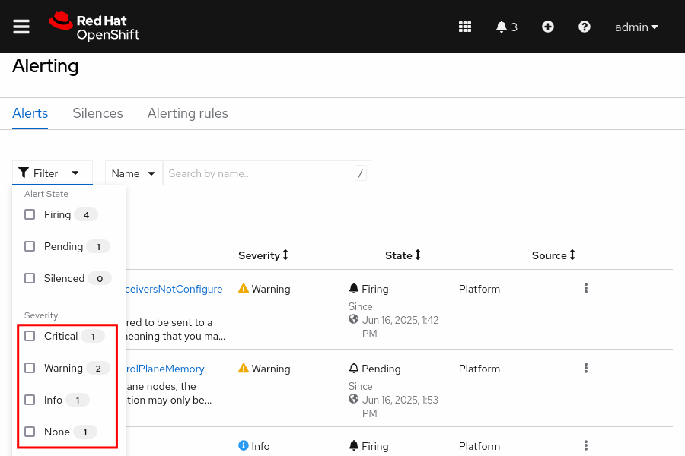
- View the labels for the thanos-querier route.
  - Go to the Networking → Routes page.
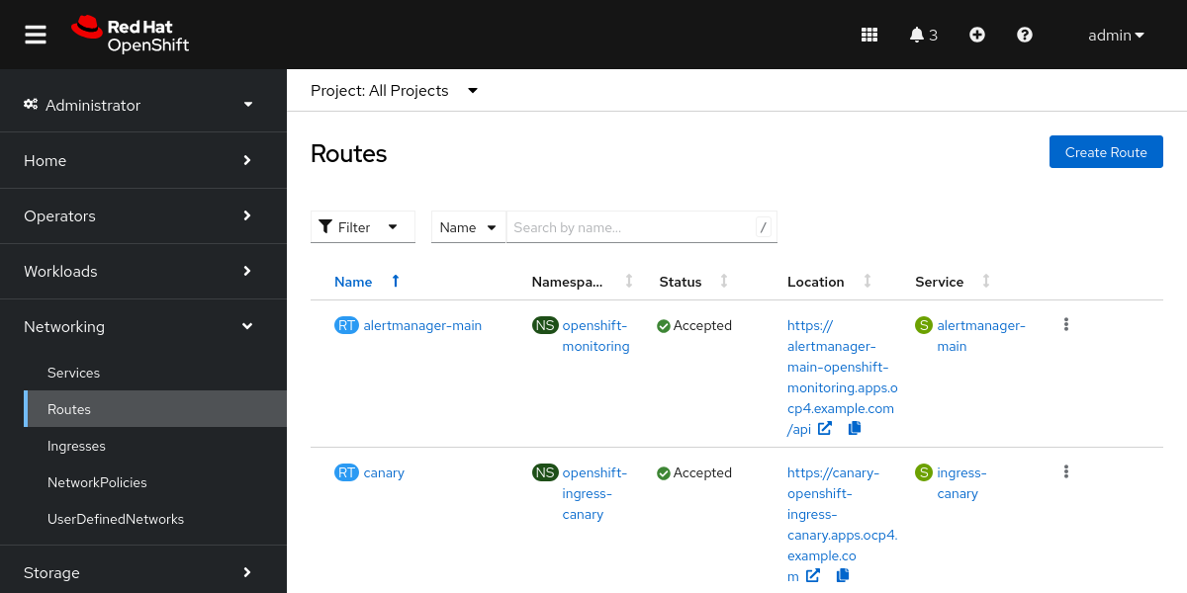
  - Type the thanos keyword in the text search field.
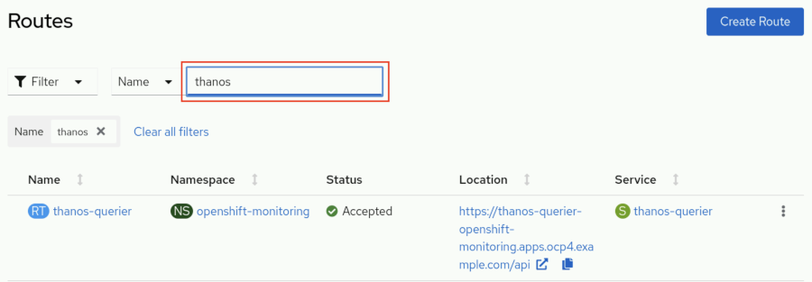
  - Select the thanos-querier route in the Name column.
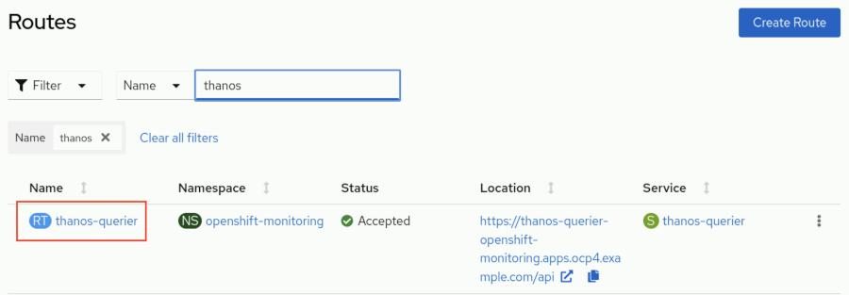
  - Scroll down on the thanos-querier route details page to view the labels.
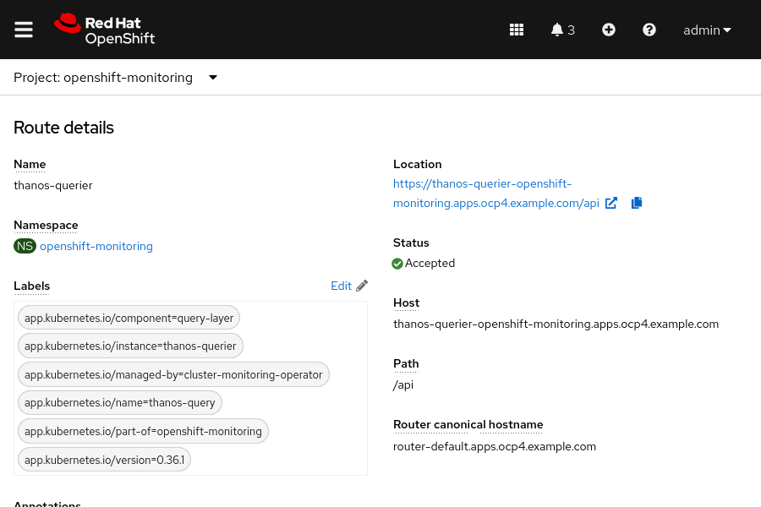
- View the available storage classes in the cluster.
  - Go to the Storage → StorageClasses page.
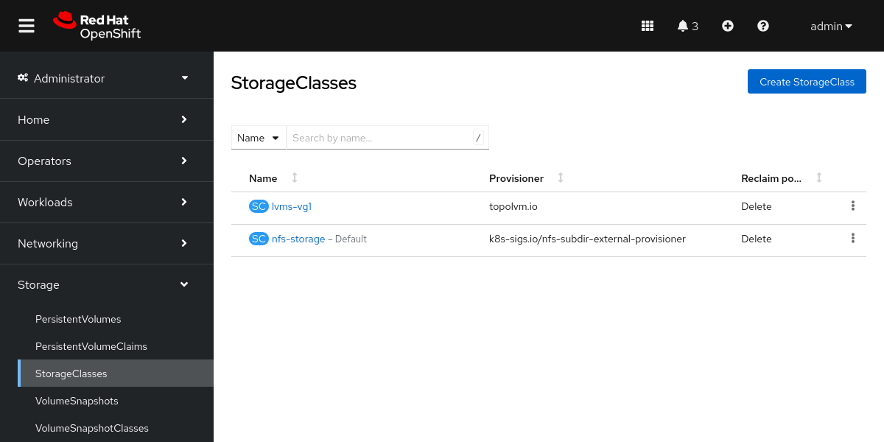
  - View the available storage classes in the cluster.
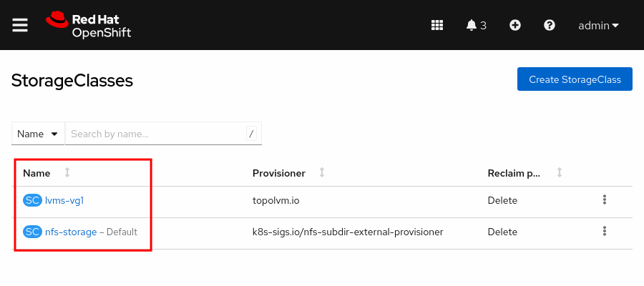
- View the installed operators for the cluster.
  - Go to the Operators → Installed Operators page.
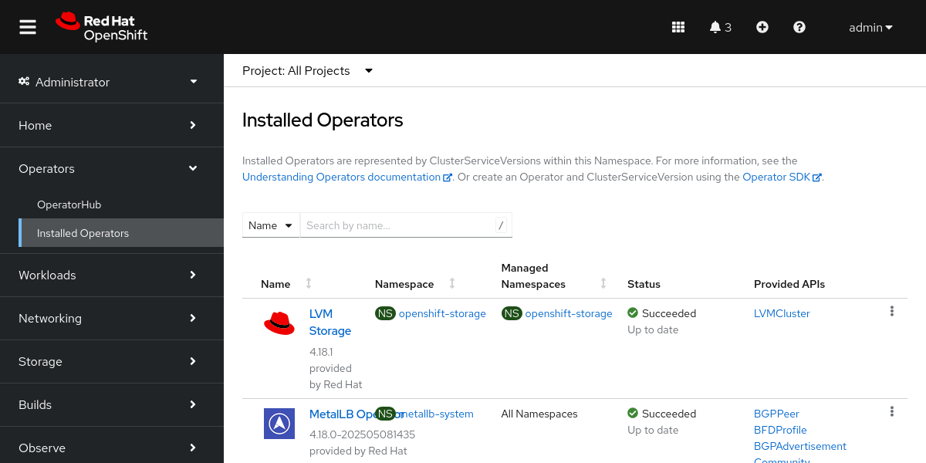
  - View the list of installed operators in the cluster.
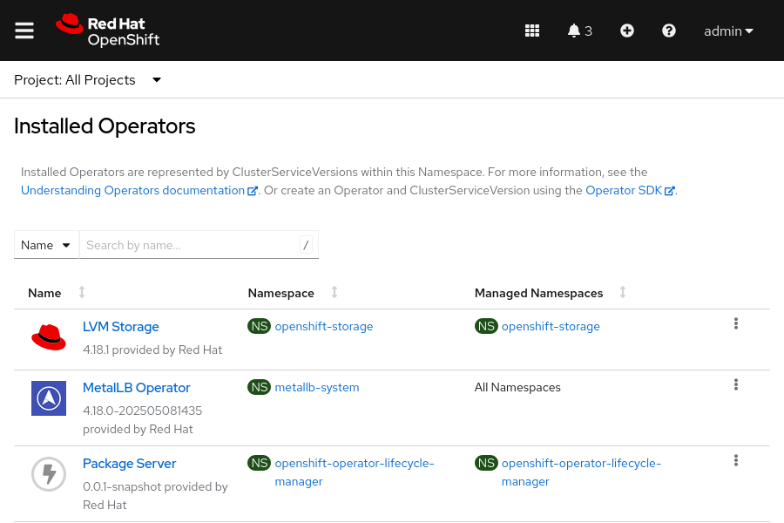
Finish
As the student user on the workstation machine, use the lab command to complete this exercise. This step is important to ensure that resources from previous exercises do not impact upcoming exercises.
[student@workstation ~]$ lab finish intro-review

Summary
- A container is an encapsulated process that includes the required runtime dependencies for an application to run.
- Containerization addresses the application development challenges around code portability, to aid in consistently running an application from diverse environments.
- Containerization also aims to modularize applications to improve development and maintenance on the various components of the application.
- When running containers at scale, it becomes challenging to configure and deliver high availability applications and to set up networking without a container platform, such as Kubernetes.
- Pods are the smallest organizational unit for a containerized application in a Kubernetes cluster.
- Red Hat OpenShift Container Platform (RHOCP) adds enterprise-class functions to the Kubernetes container platform to deliver the wider business needs.
- Most administrative tasks that cluster administrators and developers perform are available through the RHOCP web console.
- Logs, metrics, alerts, terminal connections to the nodes and pods in the cluster, and many other features are available through the RHOCP web console.

Chapter 2. Kubernetes and OpenShift Command-line Interfaces and APIs
The Kubernetes and OpenShift Command-line Interfaces
Guided Exercise: The Kubernetes and OpenShift Command-line Interfaces
Inspect Kubernetes Resources
Guided Exercise: Inspect Kubernetes Resources
Assess the Health of an OpenShift Cluster
Guided Exercise: Assess the Health of an OpenShift Cluster
Lab: Kubernetes and OpenShift Command-line Interfaces and APIs
Quiz: Kubernetes and OpenShift Command-line Interfaces and APIs
Summary
Abstract
Goal | Access an OpenShift cluster by using the command line and query its Kubernetes API resources to assess the health of a cluster.
Sections | - The Kubernetes and OpenShift Command-line Interfaces (and Guided Exercise)  - Inspect Kubernetes Resources (and Guided Exercise)  - Assess the Health of an OpenShift Cluster (and Guided Exercise)
Lab | - Kubernetes and OpenShift Command-line Interfaces and APIs

The Kubernetes and OpenShift Command-line Interfaces

Objectives
- Access an OpenShift cluster by using the Kubernetes and OpenShift command-line interfaces.

The Kubernetes Command-line Interface
You can manage an OpenShift cluster from the web console or by using the kubectl or oc command-line interfaces (CLI). The kubectl commands are native to Kubernetes, and are a thin wrapper over the Kubernetes API. The OpenShift oc commands are a superset of the kubectl commands, and add commands for the OpenShift-specific features. In this course, examples of both the kubectl and the oc commands are shown, to highlight the differences between the commands.
With the oc command, you can create applications and manage Red Hat OpenShift Container Platform (RHOCP) projects from a terminal. The OpenShift CLI is ideal in the following situations:
- Working directly with project source code
- Scripting OpenShift Container Platform operations
- Managing projects that are restricted by bandwidth
- When the web console is unavailable
- Working with OpenShift resources, such as routes and projects

Kubernetes Command-line Tool
The oc CLI installation also includes an installation of the kubectl CLI, which is the recommended method for installing the kubectl CLI for OpenShift users.
You can also install the kubectl CLI independently of the oc CLI. You must use a kubectl CLI version that is within one minor version difference of your cluster. For example, a v1.30 client can communicate with v1.29, v1.30, and v1.31 control planes. Using the latest compatible version of the kubectl CLI helps to avoid unforeseen issues.
To perform a manual installation of the kubectl binary for a Linux installation, you must first download the latest release by using the curl command.
[user@host ~]$ curl -LO "https://dl.k8s.io/release/$(curl -L \
-s https://dl.k8s.io/release/stable.txt)/bin/linux/amd64/kubectl"
Then, you must download the kubectl checksum file and validate the kubectl binary against the checksum file.
[user@host ~]$ curl -LO "https://dl.k8s.io/$(curl -L \
-s https://dl.k8s.io/release/stable.txt)/bin/linux/amd64/kubectl.sha256"
[user@host ~]$ echo "$(cat kubectl.sha256) kubectl" | sha256sum --check
kubectl: OK
If the check fails, then the sha256sum command exits with nonzero status, and prints a kubectl: FAILED message.
You can then install the kubectl CLI.
[user@host ~]$ sudo install -o root -g root -m 0755 kubectl \
/usr/local/bin/kubectl

Note
If you do not have root access on the target system, then you can still install the kubectl CLI to the ~/.local/bin directory. For more information, refer to https://kubernetes.io/docs/tasks/tools/install-kubectl-linux/.
Finally, use the kubectl version command to verify the installed version. This command prints the client and server versions. Use the --client option to view the client version only.
[user@host ~]$ kubectl version --client
Client Version: v1.31.1
Kustomize Version: v5.4.2
Alternatively, a distribution that is based on Red Hat Enterprise Linux (RHEL) can install the kubectl CLI with the following command:
[user@host ~]$ cat <<EOF | sudo tee /etc/yum.repos.d/kubernetes.repo
[kubernetes]
name=Kubernetes
baseurl=https://pkgs.k8s.io/core:/stable:/v1.31/rpm/
enabled=1
gpgcheck=1
gpgkey=https://pkgs.k8s.io/core:/stable:/v1.31/rpm/repodata/repomd.xml.key
EOF
[user@host ~]$ sudo yum install -y kubectl
To view a list of the available kubectl commands, use the kubectl --help command.
[user@host ~]$ kubectl --help
kubectl controls the Kubernetes cluster manager.

Find more information at:
https://kubernetes.io/docs/reference/kubectl/

Basic Commands (Beginner):
create Create a resource from a file or from stdin
expose Take a replication controller, service, deployment or pod and
expose it as a new Kubernetes Service
run Run a particular image on the cluster
set Set specific features on objects

Basic Commands (Intermediate):
...output omitted...
You can also use the --help option with any command to view detailed information about the command, including its purpose, examples, available subcommands, and options.
For example, the following command provides information about the kubectl create command and its usage.
[user@host ~]$ kubectl create --help
Create a resource from a file or from stdin.

JSON and YAML formats are accepted.

Examples:
# Create a pod using the data in pod.json
kubectl create -f ./pod.json

# Create a pod based on the JSON passed into stdin
cat pod.json | kubectl create -f -

# Edit the data in registry.yaml in JSON then create the resource using the edited data
kubectl create -f registry.yaml --edit -o json

Available Commands:
clusterrole Create a cluster role
clusterrolebinfing Create a cluster role binding for a particular cluster role
...output omitted...
Kubernetes uses many resource components to support applications. The kubectl explain command provides detailed information about the attributes of a given resource. For example, use the following command to learn more about the attributes of a pod resource.
[user@host ~]$ kubectl explain pod
KIND: Pod
VERSION: v1

DESCRIPTION:
Pod is a collection of containers that can run on a host. This resource is
created by clients and scheduled onto hosts.
FIELDS:
apiVersion <string>
APIVersion defines the versioned schema of this representation of an
object.
...output omitted...
Refer to the Kubernetes documentation at https://kubernetes.io/docs/reference/generated/kubectl/kubectl-commands/ for further information about the kubectl commands.

The OpenShift Command-line Interface
The main method of interacting with an RHOCP cluster is by using the oc command.
You can download the oc CLI from the OpenShift web console to ensure that the CLI tools are compatible with the RHOCP cluster. From the OpenShift web console, go to Help → Command Line tools. The Help menu is represented by a ? icon. The web console provides several installation options for the oc client, such as downloads for the following operating systems:
- x86_64 Windows, Mac, and Linux systems
- ARM 64 Linux and Mac systems
- Linux for IBM Z, IBM Power, and little endian
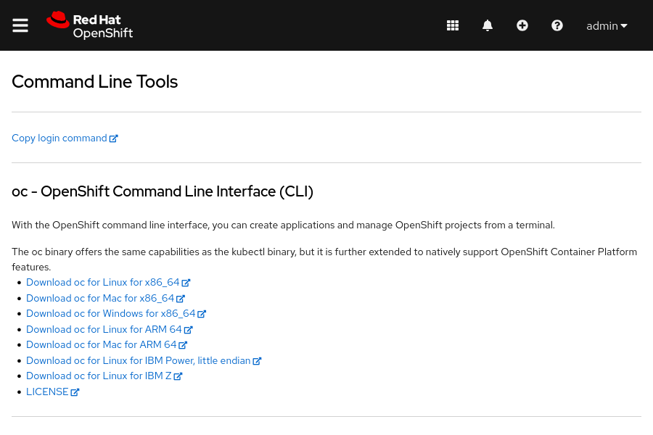
The basic usage of the oc command is through its subcommands in the following syntax:
[user@host ~]$ oc command
Because the oc CLI is a superset of the kubectl CLI, the version, --help, and explain commands work the same for both CLIs. However, the oc CLI includes additional commands that are not included in the kubectl CLI, such as the oc login and oc new-project commands.
Developers who are familiar with Kubernetes can use the kubectl utility to manage a RHOCP cluster. This course uses the oc command-line utility, to take advantage of additional RHOCP features. The oc commands manage resources that are exclusive to RHOCP, such as projects, routes, and image streams.

Authentication Methods
Before you can interact with your RHOCP cluster, you must authenticate your requests. The authentication layer identifies the user that is associated with requests to the RHOCP API. After authentication, the authorization layer uses information about the requesting user to determine whether the request is allowed.
A user in OpenShift is an entity that can send requests to the RHOCP API. An RHOCP User object represents an actor that can be granted permissions in the system by adding roles to the user or to the user's groups. Typically, this entity represents the account of a developer or an administrator.
Several types of users can exist.
Regular users
Most interactive RHOCP users are represented by this user type. An RHOCP User object represents a regular user.
System users
Infrastructure uses system users to interact with the API securely. Some system users are automatically created, including the cluster administrator, with access to everything. By default, unauthenticated requests use an anonymous system user.
Service accounts
ServiceAccount objects represent accounts that allow applications to access the API without sharing regular user credentials. RHOCP creates service accounts automatically when a project is created. Project administrators can create additional service accounts to define access to the contents of each project.
Each user must authenticate to access a cluster. After authentication, the policy determines what the user is authorized to do.

Note
Authentication and authorization are covered in greater detail in the Red Hat OpenShift Administration II: Operating a Production Kubernetes Cluster (DO280) course.
Use the oc login command to authenticate your requests. The oc login command provides role-based authentication and authorization that protects the RHOCP cluster from unauthorized access.
The oc login command supports several authentication methods.
Username and Password Authentication
The syntax for username and password authentication is as follows:
[user@host ~]$ oc login -u username api-url
Then, the oc login command prompts for the password.
For example, in this course, you can use the following command:
[user@host ~]$ oc login -u admin https://api.ocp4.example.com:6443
Console URL: https://api.ocp4.example.com:6443/console
Authentication required for https://api.ocp4.example.com:6443 (openshift)
Username: admin
Password: redhatocp
Login successful.
...output omitted...
Token-based Authentication
The RHOCP control plane includes a built-in OAuth server. To authenticate to the API, users obtain OAuth access tokens. Token authentication is the recommended method for production environments, automation, and CI/CD pipelines to improve security and to eliminate storing passwords in scripts. You can use token-based authentication to log in to the cluster, as follows:
[user@host ~]$ oc login --token=your-token --server=cluster-url
To retrieve a token, open a web browser and go to https://oauth-openshift.apps.cluster-url/oauth/token/request Then, click Display token to display the login command.
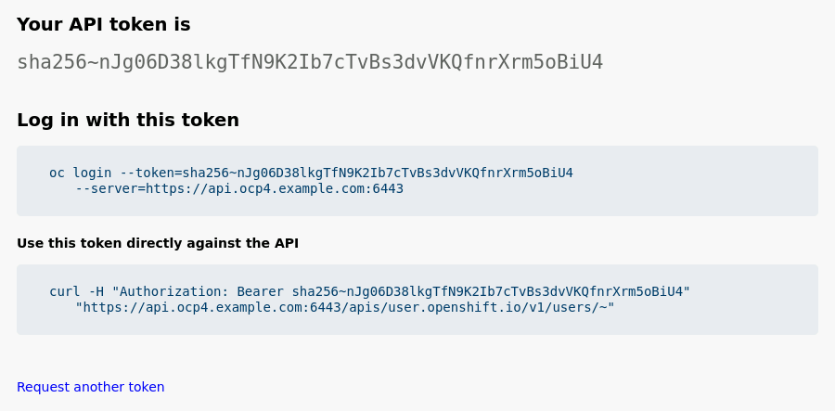
Web Authentication
You can also use the --web option to log in to the cluster by using a web browser, as follows:
[user@host ~]$ oc login --web api-url
This command opens a browser window to the OpenShift authentication page, to log in with your username and password, or other authentication method. Then, the command automatically returns the authentication token to the command line, to complete the login process.

Important
For simplicity, this course uses the username and password authentication method by providing the password as plain text, as follows:
[user@host ~]$ oc login -u admin -p redhatocp \
https://api.ocp4.example.com:6443
However, this method is not secure, and Red Hat does not recommended it for production environments. Thus, in production environments use a more secure method, such as token-based authentication.

Managing Resources at the Command Line
After authenticating to the RHOCP cluster, you can create a project with the oc new-project command. Projects provide isolation between your application resources. Projects are Kubernetes namespaces with additional annotations that provide multitenancy scoping for applications.
[user@host ~]$ oc new-project myapp
Several essential commands can manage RHOCP and Kubernetes resources, as described here. Unless otherwise specified, the following commands are compatible with both the oc and kubectl CLIs.
Some commands require a user with cluster administrator access. The following list includes several useful oc commands for cluster administrators.
oc cluster-info
The cluster-info command prints the address of the control plane and other cluster services. The oc cluster-info dump command expands the output to include helpful details for debugging cluster problems.
[user@host ~]$ oc cluster-info
Kubernetes control plane is running at https://api.ocp4.example.com:6443
...output omitted...
oc api-versions
The structure of cluster resources has a corresponding API version, which the oc api-versions command displays. The command prints the supported API versions on the server, in the form of "group/version".
In the following example, the group is admissionregistration.k8s.io and the version is v1:
[user@host ~]$ oc api-versions
admissionregistration.k8s.io/v1
...output omitted...
oc get clusteroperator
The cluster operators that Red Hat ships serve as the architectural foundation for RHOCP. RHOCP installs cluster operators by default. Use the oc get clusteroperator command to see a list of the cluster operators:
[user@host ~]$ oc get clusteroperator
NAME VERSION AVAILABLE PROGRESSING DEGRADED SINCE ...
authentication 4.18.6 True False False 18d
baremetal 4.18.6 True False False 18d
...output omitted...
Other useful commands are available to both regular and administrator users:
oc get
Use the get command to retrieve information about resources in the selected project. Generally, this command shows only the most important characteristics of the resources, and omits detailed information.
The oc get RESOURCE_TYPE command displays a summary of all resources of the specified type.
For example, the following command returns the list of the pod resources in the current project:
[user@host ~]$ oc get pod
NAME READY STATUS RESTARTS AGE
quotes-api-6c9f758574-nk8kd 1/1 Running 0 39m
quotes-ui-d7d457674-rbkl7 1/1 Running 0 67s
You can use the oc get RESOURCE_TYPE RESOURCE_NAME command to export a resource definition. Typical use cases include creating a backup or modifying a definition. The -o yaml option prints the object representation in YAML format. You can change to JSON format by providing a -o json option.
oc get all
Use the oc get all command to retrieve a summary of the most important resources in a project. This command iterates through the major resource types for the current project, and prints a summary of their information:
[user@host ~]$ oc get all
...output omitted...
NAME READY STATUS RESTARTS AGE
pod/mysql-6bb757c595-qj5ng 1/1 Running 0 16s

NAME TYPE CLUSTER-IP EXTERNAL-IP PORT(S) AGE
service/mysql ClusterIP 172.30.173.61 <none> 3306/TCP,33060/TCP 2m21s

NAME READY UP-TO-DATE AVAILABLE AGE
deployment.apps/mysql 1/1 1 1 2m21s

NAME DESIRED CURRENT READY AGE
replicaset.apps/mysql-55dc44b4c9 0 0 0 2m21s
replicaset.apps/mysql-6bb757c595 1 1 1 16s
replicaset.apps/mysql-7d9b6b5996 0 0 0 2m21s

NAME IMAGE REPOSITORY TAGS UPDATED
imagestream.image.openshift.io/mysql image-registry.../mysql-openshift/mysql latest 2 minutes ago
oc describe
If the summaries from the get command are insufficient, then you can use the oc describe RESOURCE_TYPE RESOURCE_NAME command to retrieve additional information. Unlike the get command, you can use the describe command to iterate through all the different resources by type. Although most major resources can be described, this function is not available across all resources. The following example demonstrates describing a pod resource:
[user@host ~]$ oc describe pod mysql-6bb757c595-qj5ng
Name: mysql-6bb757c595-qj5ng
Namespace: mysql-openshift
Priority: 0
Service Account: default
Node: master01/192.168.50.10
Start Time: Mon, 16 Jun 2025 16:07:00 -0400
Labels: db=mysql
deployment=mysql
...output omitted...
Status: Running
SeccompProfile: RuntimeDefault
IP: 10.129.0.85
...output omitted...
oc explain
To learn about the fields of an API resource object, use the oc explain command. This command describes the purpose and the fields that are associated with each supported API resource. You can also use this command to print the documentation of a specific field of a resource. Fields are identified via a JSONPath identifier. The following example prints the documentation for the .spec.containers.resources field of the pod resource type:
[user@host ~]$ oc explain pods.spec.containers.resources
KIND: Pod
VERSION: v1

FIELD: resources <ResourceRequiremnts>

DESCRIPTION:
Compute Resources required by this container. Cannot be updated. More info:
https://kubernetes.io/docs/concepts/configuration/manage-resources-containers/

ResourceRequirements describes the compute resource requirements.

FIELDS:
claims <[]ResourceClaim>
Claims lists the names of resources, defined in spec.resourceClaims, that
are used by this container.

This is an alpha field nd requires enabling the DynamicResourceAllocation
feature gate.

This field is immutable. It can only be set for containers.

limits <map[string]Quantity>
Limits describes the maximum amount of compute resources allowed. More
info:
https://kubernetes.io/docs/concepts/configuration/manage-resources-containers/

requests <map[string]Quantity>
Requests describes the minimum amount of compute resources required. If
Requests is omitted for a container, it defaults to Limits if that is
explicitly specified, otherwise to an implementation-defined value. Requests
cannot exceed Limits. More info:
https://kubernetes.io/docs/concepts/configuration/manage-resources-containers/
Add the --recursive flag to display all fields of a resource without descriptions. Information about each field is retrieved from the server in OpenAPI format.
oc create
Use the create command to create a RHOCP resource in the current project. This command creates resources from a resource definition. Typically, this command is paired with the oc get RESOURCE_TYPE RESOURCE_NAME -o yaml command for editing definitions. Developers commonly use the -f flag to indicate the file that contains the JSON or YAML representation of an RHOCP resource.
For example, to create resources from the pod.yaml file, use the following command:
[user@host ~]$ oc create -f pod.yaml
pod/quotes-pod created
RHOCP resources in the YAML format are discussed later.
oc status
The oc status command provides a high-level overview of the current project. The command shows services, deployments, build configurations, and active deployments. Information about any misconfigured components is also shown. The --suggest option shows additional details for any identified issues.
oc delete
Use the delete command to delete an existing RHOCP resource from the current project. You must specify the resource type and the resource name.
For example, to delete the quotes-ui pod, use the following command:
[user@host ~]$ oc delete pod quotes-ui
pod/quotes-ui deleted
A fundamental understanding of the RHOCP architecture is needed here, because deleting managed resources, such as pods, results in the automatic creation of new instances of those resources. When a project is deleted, it deletes all the resources and applications within it.
Each of these commands is executed in the current selected project. To execute commands in a different project, you must include the --namespace or -n options.
[user@host ~]$ oc get pods -n openshift-apiserver
NAME READY STATUS RESTARTS AGE
apiserver-68c9485699-ndqlc 2/2 Running 2 18d
Refer to the references for a complete list of oc commands.

Guided Exercise: The Kubernetes and OpenShift Command-line Interfaces
Access an OpenShift cluster by using the command-line to get information about cluster services and nodes.
Outcomes
- Use the OpenShift web console to locate the installation file for the oc OpenShift command-line interface.
- Get and use a token from the web console to access the cluster from the command line.
- Identify key differences between the kubectl and oc command-line tools.
- Identify the main components of OpenShift and Kubernetes.
As the student user on the workstation machine, use the lab command to prepare your system for this exercise.
This command ensures that all resources are available for this exercise.
[student@workstation ~]$ lab start cli-interfaces
Instructions
- Log in to the OpenShift web console as the developer user. Locate the installation file for the oc OpenShift command-line interface (CLI).
  - Open a web browser and go to https://console-openshift-console.apps.ocp4.example.com.
  - Click Red Hat Identity Management and log in as the developer user with the developer password.
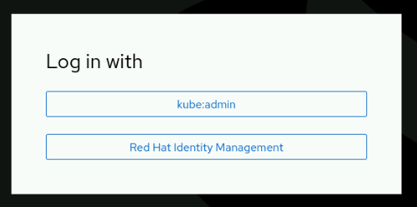
  - Locate the installation file for the oc CLI. From the OpenShift web console, select Help → Command line tools. The Help menu is represented by a ? icon.
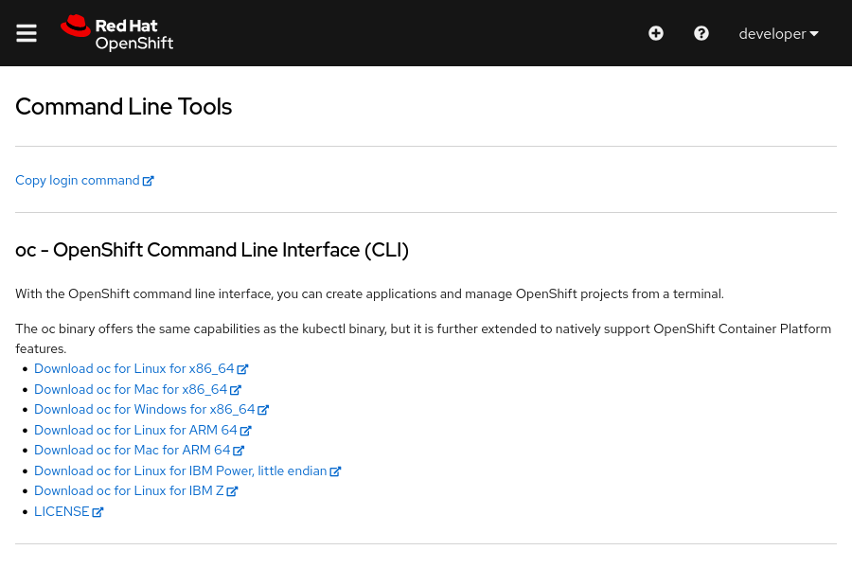
The oc binary is available for multiple operating systems and architectures. For each operating system and architecture, the oc binary also includes the kubectl binary.
Note
You do not need to download or install the oc and kubectl binaries, which are already installed on the workstation machine.
- Download an authorization token from the web console. Then, use the token and the oc command to log in to the OpenShift cluster.
  - From the Command Line Tools page, click the Copy login command link.
  - The link opens a login page. Click Red Hat Identity Management and log in as the developer user with the developer password.
  - A web page is displayed. Click the Display token link to show your API token and the login command.
  - Copy the oc login command to your clipboard. Open a terminal window and then use the copied command to log in to the cluster with your token.
[student@workstation ~]$ oc login --token=sha256-fypX...Ot6A \
--server=https://api.ocp4.example.com:6443
Logged into "https://api.ocp4.example.com:6443" as "developer" using the token provided.
  - ...output omitted...
- Compare the available commands for the kubectl and oc commands.
  - Use the help command to list and review the available commands for the kubectl command.
[student@workstation ~]$ kubectl help
kubectl controls the Kubernetes cluster manager.

Find more information at: https://kubernetes.io/docs/reference/kubectl/

Basic Commands (Beginner):
create Create a resource from a file or from stdin
expose Take a replication controller, service, deployment or pod and expose it as a new Kubernetes service
run Run a particular image on the cluster
set Set specific features on objects

Basic Commands (Intermediate):
explain Get documentation for a resource
get Display one or many resources
edit Edit a resource on the server
delete Delete resources by file names, stdin, resources and names, or by resources and label selector
  - ...output omitted....
  - Notice that the kubectl command does not provide a login command.
  - Examine the available subcommands and options for the kubectl create command by using the --help option.
[student@workstation ~]$ kubectl create --help
Create a resource from a file or from stdin.

JSON and YAML formats are accepted.

Examples:
# Create a pod using the data in pod.json
kubectl create -f ./pod.json
...output omitted....
Available Commands:
clusterrole Create a cluster role
clusterrolebinding Create a cluster role binding for a particular cluster role
configmap Create a config map from a local file, directory or literal value
cronjob Create a cron job with the specified name
deployment Create a deployment with the specified name
...output omitted...
Options:
--allow-missing-template-keys=true:
If true, ignore any errors in templates when a field or map key is missing in the template. Only applies to
golang and jsonpath output formats.

--dry-run='none':
Must be "none", "server", or "client". If client strategy, only print the object that would be sent, without
sending it. If server strategy, submit server-side request without persisting the resource.
...output omitted....
Usage:
kubectl create -f FILENAME [options]

Use "kubectl create <command> --help" for more information about a given command.
  - Use "kubectl options" for a list of global command-line options (applies to all commands).
  - You can use the --help option with any kubectl command. The --help option provides information about a command, including the available subcommands and options, and the command syntax.
  - List and review the available commands for the oc binary by using the help command.
[student@workstation ~]$ oc help
OpenShift Client

This client helps you develop, build, deploy, and run your applications on any
OpenShift or Kubernetes cluster. It also includes the administrative
commands for managing a cluster under the 'adm' subcommand.

Basic Commands:
login Log in to a server
new-project Request a new project
new-app Create a new application
status Show an overview of the current project
project Switch to another project
projects Display existing projects
explain Get documentation for a resource
  - ...output omitted....
  - The oc command supports the same capabilities as the kubectl command. The oc command provides additional commands to natively support an OpenShift cluster. For example, the new-project command creates a project, which is a Kubernetes namespace, in the OpenShift cluster. The new-app command is unique to the oc command. It creates applications by using existing source code or prebuilt images.
  - Use the --help option with the oc create command to view the available subcommands and options.
[student@workstation ~]$ oc create --help
Create a resource from a file or from stdin.

JSON and YAML formats are accepted.

Examples:
# Create a pod using the data in pod.json
oc create -f ./pod.json
...output omitted...

Available Commands:
build Create a new build
clusterresourcequota Create a cluster resource quota
clusterrole Create a cluster role
clusterrolebinding Create a cluster role binding for a particular cluster role
configmap Create a config map from a local file, directory or literal value
cronjob Create a cron job with the specified name
deployment Create a deployment with the specified name
...output omitted....
Options:
--allow-missing-template-keys=true:
If true, ignore any errors in templates when a field or map key is missing in the template. Only applies to
golang and jsonpath output formats.

--dry-run='none':
Must be "none", "server", or "client". If client strategy, only print the object that would be sent, without
sending it. If server strategy, submit server-side request without persisting the resource.
...output omitted...
Usage:
oc create -f FILENAME [options]
  - ....output omitted....
  - The oc create command includes the same subcommands and options as the kubectl create command, and provides additional subcommands for OpenShift resources. For example, you can use the oc create command to create OpenShift resources such as a deployment, a route, and an image stream.
- Use the oc login command with the --web option to log in as the admin user with redhatocp as the password. Identify the components and Kubernetes resources of an OpenShift cluster by using the terminal. Regular cluster users, such as the developer user, cannot list resources at a cluster scope. Unless otherwise noted, all commands are available for the oc and kubectl commands.
  - In a terminal, use the oc login --web command.
  - [student@workstation ~]$ oc login --web
  - In the browser tab that opens, click Red Hat Identity Management and log in as the admin user with redhatocp as the password. You get the access token received successfully; please return to your terminal message. Close the browser tab.
  - Return to the terminal window. Identify the cluster version with the version command.
[student@workstation ~]$ oc version
Client Version: 4.18.6
Kustomize Version: v5.4.2
Server Version: 4.18.6
  - Kubernetes Version: v1.31.6
  - Use the cluster-info command to identify the URL for the Kubernetes control plane.
[student@workstation ~]$ oc cluster-info
Kubernetes control plane is running at https://api.ocp4.example.com:6443

  - To further debug and diagnose cluster problems, use 'kubectl cluster-info dump'.
  - Identify the supported API versions by using the api-versions command.
[student@workstation ~]$ oc api-versions
admissionregistration.k8s.io/v1
admissionregistration.k8s.io/v1beta1
apiextensions.k8s.io/v1
apiregistration.k8s.io/v1
apiserver.openshift.io/v1
apps.openshift.io/v1
apps/v1
  - ...output omitted....
  - List cluster operators with the get clusteroperator command.
[student@workstation ~]$ oc get clusteroperator
NAME VERSION AVAILABLE PROGRESSING DEGRADED SINCE ...
authentication 4.18.6 True False False 5d5h
baremetal 4.18.6 True False False 41d
cloud-controller-manager 4.18.6 True False False 41d
cloud-credential 4.18.6 True False False 41d
cluster-autoscaler 4.18.6 True False False 41d
config-operator 4.18.6 True False False 41d
console 4.18.6 True False False 29d
control-plane-machine-set 4.18.6 True False False 41d
csi-snapshot-controller 4.18.6 True False False 41d
dns 4.18.6 True False False 32m
etcd 4.18.6 True False False 41d
image-registry 4.18.6 True False False 41d
ingress 4.18.6 True False False 41d
  - ...output omitted...
  - Use the get command to list pods in the openshift-api project. Specify the project with the -n option.
[student@workstation ~]$ oc get pods -n openshift-apiserver
NAME READY STATUS RESTARTS AGE
  - apiserver-68c9485699-ndqlc 2/2 Running 6 18d
  - Use the oc status command to retrieve the status of resources in the openshift-authentication project.
[student@workstation ~]$ oc status -n openshift-authentication
Warning: apps.openshift.io/v1 DeploymentConfig is deprecated in v4.14+, unavailable in v4.10000+
In project openshift-authentication on server https://api.ocp4.example.com:6443

https://oauth-openshift.apps.ocp4.example.com (passthrough) to pod port 6443 (svc/oauth-openshift)
deployment/oauth-openshift deploys quay.io/openshift-release-dev/ocp-v4.0-art-dev@sha256:64e6...de42
deployment #7 running for 2 weeks - 1 pod
deployment #6 deployed 2 weeks ago
deployment #4 deployed 2 weeks ago
deployment #5 deployed 2 weeks ago
deployment #3 deployed 2 weeks ago
deployment #2 deployed 2 weeks ago
deployment #1 deployed 2 weeks ago
  - ...output omitted...
  - Use the explain command to list the description and available fields for services resources.
[student@workstation ~]$ oc explain services
KIND: Service
VERSION: v1

DESCRIPTION:
Service is a named abstraction of software service (for example, mysql)
consisting of local port (for example 3306) that the proxy listens on, and
the selector that determines which pods will answer requests sent through
the proxy.

FIELDS:
apiVersion <string>
APIVersion defines the versioned schema of this representation of an
object. Servers should convert recognized schemas to the latest internal
value, and may reject unrecognized values.
  - ...output omitted...
  - Use the get command to list cluster nodes.
[student@workstation ~]$ oc get nodes
NAME STATUS ROLES AGE VERSION
  - master01 Ready control-plane,master,worker 18d v1.31.6
  - A single node exists in the cluster.
Finish
On the workstation machine, use the lab command to complete this exercise. This step is important to ensure that resources from previous exercises do not impact upcoming exercises.
[student@workstation ~]$ lab finish cli-interfaces

Inspect Kubernetes Resources

Objectives
- Query, format, and filter attributes of Kubernetes resources.

Kubernetes and OpenShift Resources
Kubernetes uses API resource objects to represent the intended state of everything in the cluster. All administrative tasks require creating, viewing, and changing the API resources. Use the oc api-resources command to view the Kubernetes resources.

Note
The oc commands in the examples are identical to the equivalent kubectl commands.
[user@host ~]$ oc api-resources
NAME SHORTNAMES APIVERSION NAMESPACED KIND
bindings v1 true Binding
componentstatuses cs v1 false ComponentStatus
configmaps cm v1 true ConfigMap
endpoints ep v1 true Endpoints
...output omitted...
daemonsets ds apps/v1 true DaemonSet
deployments deploy apps/v1 true Deployment
replicasets rs apps/v1 true ReplicaSet
statefulsets sts apps/v1 true StatefulSet
...output omitted...
The SHORTNAME for a component helps to minimize typing long CLI commands. For example, you can use oc get cm instead of oc get configmaps.
The APIVERSION column divides the objects into API groups. The column uses the <API-Group>/<API-Version> format. The API-Group object is blank for Kubernetes core resource objects.
Many Kubernetes resources exist within the context of a Kubernetes namespace. Kubernetes namespaces and OpenShift projects are broadly similar. A one-to-one relationship always exists between a namespace and an OpenShift project.
The KIND is the formal Kubernetes resource schema type.
The oc api-resources command can further filter the output with options that operate on the data.
Table 2.1. The api-resources Command Options
Option Example | Description
--namespaced=true | If false, return non-namespaced resources, otherwise return namespaced resources
--api-group apps | Limit to resources in the specified API group. Use --api-group='' to show core resources.
--sort-by name | If non-empty, sort the list of resources by using the specified field. The field can be either 'name' or 'kind'.

For example, use the following oc api-resources command to see all the namespaced resources in the apps API group, sorted by name.
[user@host ~]$ oc api-resources --namespaced=true --api-group apps --sort-by name
NAME SHORTNAMES APIVERSION NAMESPACED KIND
controllerrevisions apps/v1 true ControllerRevision
daemonsets ds apps/v1 true DaemonSet
deployments deploy apps/v1 true Deployment
replicasets rs apps/v1 true ReplicaSet
statefulsets sts apps/v1 true StatefulSet
Each resource contains fields that identify the resource or that describe the intended configuration of the resource. Use the oc explain command to get information about valid fields for an object. For example, execute the oc explain pod command to get information about possible pod object fields.
[user@host ~]$ oc explain pod
KIND: Pod
VERSION: v1

DESCRIPTION:
Pod is a collection of containers that can run on a host. This resource is
created by clients and scheduled onto hosts.

FIELDS:
apiVersion <string>
APIVersion defines the versioned schema of this representation of an
...

kind <string>
Kind is a string value representing the REST resource this object
...

metadata <ObjectMeta>
Standard object's metadata. More info:
...

spec <PodSpec>
Specification of the desired behavior of the pod. More info:
...output omitted...
Every Kubernetes resource contains the kind, apiVersion, spec, and status fields. However, when you create an object definition, you do not need to provide the status field. Instead, Kubernetes generates the status field, and it lists information such as runtime status and readiness. The status field is useful for troubleshooting an error or for verifying the current state of a resource.
You can use the YAML path to a field and dot-notation to get information about a particular field. For example, the following oc explain command shows details for the pod.spec fields.
[user@host ~]$ oc explain pod.spec
KIND: Pod
VERSION: v1

FIELD: spec <PodSpec>

DESCRIPTION:
Specification of the desired behavior of the pod. More info:
https://git.k8s.io/community/contributors/devel/sig-architecture/api-conventions.md#spec-and-status

PodSpec is a description of a pod.

FIELDS:
activeDeadlineSeconds <integer>
Optional duration in seconds the pod may be active on the node relative to
...output omitted...
The following Kubernetes main resource types can be created and configured by using a YAML or a JSON manifest file, or by using OpenShift management tools:
Pods (pod)
Represent a collection of containers that share resources, such as IP addresses and persistent storage volumes. It is the primary unit of work for Kubernetes.
Services (svc)
Define a single IP/port combination that provides access to a pool of pods. By default, services connect clients to pods in a round-robin fashion.
ReplicaSet (rs)
Ensure that a specified number of pod replicas are running at any given time.
Persistent Volumes (pv)
Define storage areas for Kubernetes pods to use.
Persistent Volume Claims (pvc)
Represent a request for storage by a pod. PVCs link a PV to a pod so that its containers can use the provisioned storage, usually by mounting the storage into the container's file system.
ConfigMaps (cm) and Secrets
Contain a set of keys and values that other resources can use. Configuration maps and secrets centralize configuration values for several resources. Secrets differ from configuration maps in that the values of Secrets are always encoded (not encrypted), and their access is restricted to authorized users.
Deployment (deploy)
A deployment represents a set of containers that are included in a pod, and the deployment strategies to use. A deployment object contains the configuration to apply to all containers of each pod replica, such as the base image, tags, storage definitions, and the commands to execute when the containers start. Although Kubernetes replicas can be created stand-alone in OpenShift, they are usually created by higher-level resources such as deployment controllers.
Red Hat OpenShift Container Platform (RHOCP) adds the following main resource types to Kubernetes:
Build (build)
A build is the generic process of taking an input source, such as the source code of an application, and producing a usable resource as the output, such as a runnable image.
BuildConfig (bc)
A BuildConfig object defines a build process. A BuildConfig object requires at least the source input of the build, the strategy that defines how to build the input, and where to store the output of the process.
Routes
Represent a DNS hostname that the OpenShift router recognizes as an ingress point for applications and microservices.

Structure of Resources
Almost every Kubernetes object includes two nested object fields that govern the object's configuration: the object spec and the object status. The spec object describes the intended state of the resource, and the status object describes the current state. You specify the spec section of the resource when you create the object. Kubernetes controllers continuously update the status of the object throughout the existence of the object. The Kubernetes control plane continuously and actively manages every object's actual state to match the desired state you supplied.
The status field uses a collection of condition resource objects with the following fields.
Table 2.2. Condition Resource Fields
Field | Example | Description
Type | ContainersReady | The type of the condition
Status | False | The state of the condition
Reason | RequirementsNotMet | An optional field to provide extra information
Message | 2/3 containers are running | An optional textual description for the condition
LastTransitionTime | 2023-03-07T18:05:28Z | The last time that conditions were changed

For example, in Kubernetes, a Deployment object can represent an application that is running on your cluster. When you create a Deployment object, you might configure the deployment spec object to specify that you want three replicas of the application to be running. Kubernetes reads the deployment spec object and starts three instances of your chosen application, and updates the status field to match your spec object. If any of those instances fails, then Kubernetes responds to the difference between the spec and status objects by making a correction, in this case to start a replacement instance.
Other common fields provide base information in addition to the spec and status fields of a Kubernetes object.
Table 2.3. API Resource Fields
Field | Description
apiVersion | Identifier of the object schema version.
kind | Schema identifier.
metadata.name | Creates a label with a name key that other resources in Kubernetes can use to find it.
metadata.namespace | The namespace, or the RHOCP project where the resource is.
metadata.labels | Key-value pairs that can connect identifying metadata with Kubernetes objects.

Resources in Kubernetes consist of multiple objects. These objects define the intended state of a resource. When you create or modify an object, you make a persistent record of the intended state. Kubernetes reads the object and modifies the current state accordingly.
All RHOCP and Kubernetes objects can be represented as a JSON or YAML structure. Consider the following pod object in the YAML format:
apiVersion: v1
kind: Pod
metadata:
name: wildfly
namespace: my_app
labels:
name: wildfly
spec:
containers:
- resources:
limits:
cpu: 0.5
image: quay.io/example/todojee:v1
name: wildfly
ports:
- containerPort: 8080
name: wildfly
env:
- name: MYSQL_DATABASE
value: items
- name: MYSQL_USER
value: user1
- name: MYSQL_PASSWORD
value: mypa55
...object omitted...
status:
conditions:
- lastProbeTime: null
lastTransitionTime: "2023-08-19T12:59:22Z"
status: "True"
type: PodScheduled
Identifier of the object schema version.
Schema identifier. In this example, the object conforms to the pod schema.
Metadata for a given resource, such as annotations, labels, name, and namespace.
A unique name for a pod in Kubernetes that enables administrators to run commands on it.
The namespace, or the RHOCP project that the resource resides in.
Creates a label with a name key that other resources in Kubernetes, usually a service, can use to find it.
Defines the pod object configuration, or the intended state of the resource.
Defines the container image name.
Name of the container inside a pod. Container names are important for oc commands when a pod contains multiple containers.
A container-dependent attribute to identify the port that the container uses.
Defines a collection of environment variables.
Current state of the object. Kubernetes provides this field, which lists information such as runtime status, readiness, and container images.
Labels are key-value pairs that you define in the .metadata.labels object path, for example:
kind: Pod
apiVersion: v1
metadata:
name: example-pod
labels:
app: example-pod
group: developers
...object omitted...
The preceding example contains the app=example-pod and group=developers labels. Developers often use labels to target a set of objects by using the -l or the --selector option. For example, the following oc get command lists pods that contain the group=developers label:
[user@host ~]$ oc get pod --selector group=developers
NAME READY STATUS RESTARTS AGE
example-pod-6c9f758574-7fhg 1/1 Running 5 11d

Command Outputs
The kubectl and oc CLI commands provide many output formatting options. By default, many commands display a small subset of the most useful fields for the given resource type in a tabular output. Many commands support a -o wide option that shows additional fields.
Table 2.4. Tabular Fields
oc get pods | oc get pods -o wide | Example value
NAME | NAME | example-pod
READY | READY | 1/1
STATUS | STATUS | Running
RESTARTS | RESTARTS | 5
AGE | AGE | 11d
 | IP | 10.8.0.60
 | NODE | master01
 | NOMINATED NODE | <none>
 | READINESS GATES | <none>

To view all the fields that are associated with a resource, the describe subcommand shows a detailed description of the selected resource and related resources. You can select a single object by name, or all objects of that type, or provide a name prefix, or a label selector.
For example, the following command first looks for an exact match on the TYPE object and the NAME-PREFIX object. If no such resource exists, then the command outputs details for every resource of that type with a name with a NAME_PREFIX prefix.
[user@host ~]$ oc describe TYPE NAME-PREFIX
The describe subcommand provides detailed human-readable output. However, the format of the describe output might change between versions, and thus is not recommended for script development. Any scripts that rely on the output of the describe subcommand might break after a version update.
Kubernetes provides YAML and JSON-formatted output options that are suitable for parsing or scripting.

YAML Output
The -o yaml option provides a YAML-formatted output that is parsable and still human-readable.
[user@host ~]$ oc get pods -o yaml
apiVersion: v1
items:
- apiVersion: v1
kind: Pod
metadata:
annotations:
...object omitted...

Note
The reference documentation provides a more detailed introduction to YAML.
You can use any tool that can process YAML documents to filter the YAML output for your chosen field. For example, you can use the yq tool at https://mikefarah.gitbook.io/yq/ to process YAML and JSON files.
The yq processor uses a dot notation to separate field names in a query. The following example pipes the YAML output to the yq command to parse the podIP field.
[user@host ~]$ oc get pods -o yaml | yq '.items[0].status.podIP'
10.8.0.60
The [0] in the example specifies the first index in the items array.

Note
Another tool named yq is at https://kislyuk.github.io/yq/. The two yq tools are not compatible; commands that are designed for one of them do not work with the other.

JSON Output
Kubernetes uses the JSON format internally to process resource objects. Use the -o json option to view a resource in the JSON format.
[user@host ~]$ oc get pods -o json
{
"apiVersion": "v1",
"items": [
{
"apiVersion": "v1",
"kind": "Pod",
"metadata": {
"annotations": {
You can use other tools to process JSON documents, such as the jq tool at https://jqlang.github.io/jq/. Similar to the yq processor, use the jq processor and dot notation on the fields to query specific information from the JSON-formatted output.
[user@host ~]$ oc get pods -o json | jq '.items[0].status.podIP'
"10.8.0.60"
Alternatively, the example might have used .items[].status.podIP for the query string. The empty brackets instruct the jq tool to query all items.

Custom Output
Kubernetes provides a custom output format that combines the convenience of extracting data via jq styled queries with a tabular output format. Use the -o custom-columns option with comma-separated <column name> : <jq query string> pairs.
[user@host ~]$ oc get pods \
-o custom-columns=PodName:".metadata.name",\
ContainerName:"spec.containers[].name",\
Phase:"status.phase",\
IP:"status.podIP",\
Ports:"spec.containers[].ports[].containerPort"
PodName ContainerName Phase IP Ports
myapp-77fb5cd997-xplhz myapp Running 10.8.0.60 <none>
Kubernetes also supports the use of JSONPath expressions. JSONPath is a query language for JSON. JSONPath expressions refer to a JSON data structure; they filter and extract formatted fields from JSON objects.
In the following example, the JSONPath expression uses the range operator to iterate over the list of pods to extract the name of the pod, its IP address, and the assigned ports.
[user@host ~]$ oc get pods \
-o jsonpath='{range .items[]}{"Pod Name: "}{.metadata.name}
{"IP: "}{.status.podIP}
{"Ports: "}{.spec.containers[].ports[].containerPort}{"\n"}{end}'
Pod Name: myapp-77fb5cd997-xplhz
IP: 10.8.0.60
Ports:
You can customize the format of the output with Go templates, which the Go programming language uses. Use the -o go-template option followed by a Go template, where Go expressions are inside double braces, {{ }}.
[user@host ~]$ oc get pods \
-o go-template='{{range .items}}{{.metadata.name}}{{"\n"}}{{end}}'
myapp-77fb5cd997-xplhz

Guided Exercise: Inspect Kubernetes Resources
Verify the state of an OpenShift cluster by querying its recognized resource types, their schemas, and extracting information from Kubernetes resources that are related to to OpenShift cluster services.
Outcomes
- List and explain the supported API resources for a cluster.
- Identify resources from specific API groups.
- Format command outputs in the YAML and JSON formats.
- Use filters to parse command outputs.
- Use JSONPath and custom columns to extract information from resources.
As the student user on the workstation machine, use the lab command to prepare your system for this exercise. This command ensures that the cluster is accessible and that all resources are available for this exercise. It also creates a myapp application in the cli-resources project.
[student@workstation ~]$ lab start cli-resources
Instructions
- Log in to the OpenShift cluster as the developer user with the developer password. Select the cli-resources project.
  - Log in to the OpenShift cluster.
[student@workstation ~]$ oc login -u developer -p developer \
https://api.ocp4.example.com:6443
Login successful.
  - ...output omitted...
  - Set the cli-resources project as the active project. (change to the cli-resources project.)
[student@workstation ~]$ oc project cli-resources
  - ...output omitted...
- List the available cluster resource types with the api-resources command. Then, use filters to list namespaced and non-namespaced resources.
  - List the available resource types with the api-resources command.
[student@workstation ~]$ oc api-resources
NAME SHORTNAMES APIVERSION NAMESPACED KIND
bindings v1 true Binding
componentstatuses cs v1 false ComponentStatus
configmaps cm v1 true ConfigMap
endpoints ep v1 true Endpoints
events ev v1 true Event
limitranges limits v1 true LimitRange
namespaces ns v1 false Namespace
nodes no v1 false Node
persistentvolumeclaims pvc v1 true PersistentVolumeClaim
persistentvolumes pv v1 false PersistentVolume
pods po v1 true Pod
...output omitted...
controllerrevisions apps/v1 true ControllerRevision
daemonsets ds apps/v1 true DaemonSet
...output omitted...
cronjobs cj batch/v1 true CronJob
jobs batch/v1 true Job
  - ...output omitted...
  - The api-resources command prints the supported API resources, including resource names, available shortnames, and the API versions.
You can use the APIVERSIONS field to determine which API group provides the resource. The field lists the group followed by the API version of the resource. For example, the jobs resource type is provided by the batch API group, and v1 is the API version of the resource.
  - Use the --namespaced option to limit the output of the api-resources command to namespaced resources.
Then, determine the number of available namespaced resources. Use the -o name option to list the resource names, and then pipe the output to the wc -l command.
[student@workstation ~]$ oc api-resources --namespaced
NAME SHORTNAMES APIVERSION NAMESPACED KIND
bindings v1 true Binding
configmaps cm v1 true ConfigMap
endpoints ep v1 true Endpoints
events ev v1 true Event
limitranges limits v1 true LimitRange
persistentvolumeclaims pvc v1 true PersistentVolumeClaim
pods po v1 true Pod
podtemplates v1 true PodTemplate
replicationcontrollers rc v1 true ReplicationController
resourcequotas quota v1 true ResourceQuota
secrets v1 true Secret
...output omitted...
[student@workstation ~]$ oc api-resources --namespaced -o name | wc -l
  - 122
  - The cluster has 122 namespaced cluster resource types, such as the pods, deployments, and services resources.
  - Limit the output of the api-resources command to non-namespaced resources.
Then, determine the number of available non-namespaced resources. To list the resource names, use the -o name option and then pipe the output to the wc -l command.
[student@workstation ~]$ oc api-resources --namespaced=false
NAME SHORTNAMES APIVERSION ...
componentstatuses cs v1 ...
namespaces ns v1 ...
nodes no v1 ...
persistentvolumes pv v1 ...
mutatingwebhookconfigurations admissionregistration.k8s.io/v1 ...
validatingwebhookconfigurations admissionregistration.k8s.io/v1 ...
customresourcedefinitions crd,crds apiextensions.k8s.io/v1 ...
...output omitted...
[student@workstation ~]$ oc api-resources --namespaced=false -o name | wc -l
  - 129
  - The cluster has 129 non-namespaced cluster resource types, such as the nodes, images, and project resources.
- Identify and explain the available cluster resource types that the core API group provides. Then, describe a resource from the core API group in the cli-resources project.
  - Filter the output of the api-resources command to show only resources from the core API group. Use the --api-group option and set '' as the value.
[student@workstation ~]$ oc api-resources --api-group ''
NAME SHORTNAMES APIVERSION NAMESPACED KIND
bindings v1 true Binding
componentstatuses cs v1 false ComponentStatus
configmaps cm v1 true ConfigMap
endpoints ep v1 true Endpoints
events ev v1 true Event
limitranges limits v1 true LimitRange
namespaces ns v1 false Namespace
nodes no v1 false Node
persistentvolumeclaims pvc v1 true PersistentVolumeClaim
persistentvolumes pv v1 false PersistentVolume
pods po v1 true Pod
podtemplates v1 true PodTemplate
replicationcontrollers rc v1 true ReplicationController
resourcequotas quota v1 true ResourceQuota
secrets v1 true Secret
serviceaccounts sa v1 true ServiceAccount
  - services svc v1 true Service
  - The core API group provides several resource types, such as nodes, events, and pods.
  - Use the explain command to list a description and the available fields for the pods resource type.
[student@workstation ~]$ oc explain pods
KIND: Pod
VERSION: v1

DESCRIPTION:
Pod is a collection of containers that can run on a host. This resource is
created by clients and scheduled onto hosts.

FIELDS:
apiVersion <string>
APIVersion defines the versioned schema of this representation of an
object. Servers should convert recognized schemas to the latest internal
value, and may reject unrecognized values. More info:
  - ...output omitted...
  - List all pods in the cli-resources project.
[student@workstation ~]$ oc get pods
NAME READY STATUS RESTARTS AGE
  - myapp-54fcdcd9d7-2h5vx 1/1 Running 0 4m25s
  - A single pod exists in the cli-resources project. The pod name might differ in your output.
  - Use the describe command to view the configuration and events for the pod. Specify the pod name from the previous step.
[student@workstation ~]$ oc describe pod myapp-54fcdcd9d7-2h5vx
Name: myapp-54fcdcd9d7-2h5vx
Namespace: cli-resources
...output omitted...
Status: Running
IP: 10.8.0.127
IPs:
IP: 10.8.0.127
Controlled By: ReplicaSet/myapp-54fcdcd9d7
Containers:
myapp:
Container ID: cri-o://e0da...669d
Image: registry.ocp4.example.com:8443/ubi8/httpd-24:1-215
Image ID: registry.ocp4.example.com:8443/ubi8/httpd-24@sha256:91ad...fd83
...output omitted...
Events:
Type Reason Age From Message
---- ------ ---- ---- -------
Normal Scheduled 10m default-scheduler Successfully assigned cli-resources/myapp-54fcdcd9d7-2h5vx to master01
  - ...output omitted...
  - Retrieve the details of the pod in a structured format. Use the get command and specify the output as the YAML format. Compare the results of the describe command versus the get command.
[student@workstation ~]$ oc get pod myapp-54fcdcd9d7-2h5vx -o yaml
apiVersion: v1
kind: Pod
metadata:
annotations:
...output omitted...
labels:
app: myapp
pod-template-hash: 54fcdcd9d7
name: myapp-54fcdcd9d7-2h5vx
namespace: cli-resources
...output omitted...
spec:
containers:
- image: registry.ocp4.example.com:8443/ubi8/httpd-24:1-215
imagePullPolicy: Always
name: myapp
resources: {}
securityContext:
  - ...output omitted...
  - Using a structured format with the get command provides more details about a resource than the describe command.
- Identify and explain the available cluster resource types that the Kubernetes apps API group provides. Then, describe a resource from the apps API group in the cli-resources project.
  - List the resource types that the apps API group provides.
[student@workstation ~]$ oc api-resources --api-group apps
NAME SHORTNAMES APIVERSION NAMESPACED KIND
controllerrevisions apps/v1 true ControllerRevision
daemonsets ds apps/v1 true DaemonSet
deployments deploy apps/v1 true Deployment
replicasets rs apps/v1 true ReplicaSet
  - statefulsets sts apps/v1 true StatefulSet
  - Use the explain command to list a description and fields for the deployments resource type.
[student@workstation ~]$ oc explain deployments
GROUP: apps
KIND: Deployment
VERSION: apps/v1

DESCRIPTION:
Deployment enables declarative updates for Pods and ReplicaSets.

FIELDS:
apiVersion <string>
APIVersion defines the versioned schema of this representation of an
object. Servers should convert recognized schemas to the latest internal
value, and may reject unrecognized values. More info:
  - ...output omitted...
  - Use the get command to identify any deployment resources in the cli-resources project.
[student@workstation ~]$ oc get deploy
NAME READY UP-TO-DATE AVAILABLE AGE
  - myapp 1/1 1 1 25m
  - The myapp deployment exists in the cli-resources project. Use the get command and the -o wide option to identify the container name and the container image in the deployment.
[student@workstation ~]$ oc get deploy myapp -o wide
NAME ... CONTAINERS IMAGES SELECTOR
  - myapp ... myapp registry.ocp4.example.com:8443/ubi8/httpd-24:1-215 app=myapp
  - The myapp deployment uses the registry.ocp4.example.com:8443/ubi8/httpd-24:1-215 container image for the myapp container.
  - Describe the myapp deployment to view more details about the resource.
[student@workstation ~]$ oc describe deployment myapp
Name: myapp
Namespace: cli-resources
CreationTimestamp: Tue, 23 Sep 2025 18:41:39 -0500
Labels: my-app
Annotations: deployment.kubernetes.io/revision: 1
Selector: app=myapp
Replicas: 1 desired | 1 updated | 1 total | 1 available | 0 unavailable
StrategyType: RollingUpdate
MinReadySeconds: 0
RollingUpdateStrategy: 25% max unavailable, 25% max surge
Pod Template:
Labels: app=myapp
Containers:
myapp:
Image: registry.ocp4.example.com:8443/ubi8/httpd-24:1-215
Port: <none>
Host Port: <none>
Environment: <none>
Mounts: <none>
Volumes: <none>
Node-Selectors: <none>
Tolerations: <none>
Conditions:
Type Status Reason
---- ------ ------
Available True MinimumReplicasAvailable
Progressing True NewReplicaSetAvailable
OldReplicaSets: <none>
NewReplicaSet: myapp-54fcdcd9d7 (1/1 replicas created)
Events:
Type Reason Age From Message
---- ------ ---- ---- -------
  - Normal ScalingReplicaSet 30m deployment-controller Scaled up replica set myapp-54fcdcd9d7 to 1
- Identify and explain the available cluster resource types that the OpenShift configuration API group provides. Then, describe a resource from the OpenShift configuration API group.
  - List the resource types that the OpenShift configuration API group provides.
[student@workstation ~]$ oc api-resources --api-group config.openshift.io
oc api-resources --api-group oauth.openshift.io
NAME SHORTNAMES APIVERSION NAMESPACED KIND
apiservers config.openshift.io/v1 false APIServer
authentications config.openshift.io/v1 false Authentication
builds config.openshift.io/v1 false Build
clusteroperators co config.openshift.io/v1 false ClusterOperator
clusterversions config.openshift.io/v1 false ClusterVersion
consoles config.openshift.io/v1 false Console
dnses config.openshift.io/v1 false DNS
featuregates config.openshift.io/v1 false FeatureGate
imagecontentpolicies config.openshift.io/v1 false ImageContentPolicy
imagedigestmirrorsets idms config.openshift.io/v1 false ImageDigestMirrorSet
images config.openshift.io/v1 false Image
imagetagmirrorsets itms config.openshift.io/v1 false ImageTagMirrorSet
infrastructures config.openshift.io/v1 false Infrastructure
ingresses config.openshift.io/v1 false Ingress
networks config.openshift.io/v1 false Network
nodes config.openshift.io/v1 false Node
oauths config.openshift.io/v1 false OAuth
operatorhubs config.openshift.io/v1 false OperatorHub
projects config.openshift.io/v1 false Project
proxies config.openshift.io/v1 false Proxy
  - schedulers config.openshift.io/v1 false Scheduler
  - The config.openshift.io API group provides multiple, non-namespaced resource types.
  - Use the explain command to list a description and fields for the projects resource type.
[student@workstation ~]$ oc explain projects
GROUP: project.openshift.io
KIND: Project
VERSION: v1

DESCRIPTION:
Projects are the unit of isolation and collaboration in OpenShift. A
project has one or more members, a quota on the resources that the project
may consume, and the security controls on the resources in the project.
Within a project, members may have different roles - project administrators
can set membership, editors can create and manage the resources, and
viewers can see but not access running containers. In a normal cluster
project administrators are not able to alter their quotas - that is
restricted to cluster administrators.

Listing or watching projects will return only projects the user has the
reader role on.
  - ...output omitted...
  - Describe the cli-resources project.
[student@workstation ~]$ oc describe project cli-resources
Name: cli-resources
Created: 10 minutes ago
Labels: kubernetes.io/metadata.name=cli-resources
pod-security.kubernetes.io/audit=restricted
pod-security.kubernetes.io/audit-version=latest
pod-security.kubernetes.io/warn=restricted
pod-security.kubernetes.io/warn-version=latest
Annotations: openshift.io/description=
openshift.io/display-name=
openshift.io/requester=system:admin
openshift.io/sa.scc.mcs=s0:c26,c25
openshift.io/sa.scc.supplemental-groups=1000710000/10000
openshift.io/sa.scc.uid-range=1000710000/10000
Display Name: <none>
Description: <none>
Status: Active
Node Selector: <none>
Quota: <none>
  - Resource limits: <none>
  - Retrieve more details of the cli-resources project. Use the get command, and format the output to use JSON.
[student@workstation ~]$ oc get project cli-resources -o json
{
"apiVersion": "project.openshift.io/v1",
"kind": "Project",
"metadata": {
...output omitted....
"labels": {
"kubernetes.io/metadata.name": "cli-resources",
"pod-security.kubernetes.io/audit": "restricted",
"pod-security.kubernetes.io/audit-version": "latest",
"pod-security.kubernetes.io/warn": "restricted",
"pod-security.kubernetes.io/warn-version": "latest"
},
"name": "cli-resources",
"resourceVersion": "705313",
"uid": "53cbbe45-31ea-4b41-93a9-4ba5c2c4c1f3"
},
...output omitted...
"status": {
"phase": "Active"
}
  - }
  - The get command provides additional details, such as the kind and apiVersion attributes, of the project resource.
- Verify the cluster status by inspecting cluster services. Format command outputs by using filters.
  - Retrieve the list of pods for the Etcd operator. The Etcd operator is available in the openshift-etcd namespace. Specify the namespace with the --namespace or -n option.
[student@workstation ~]$ oc get pods -n openshift-etcd
  - Error from server (Forbidden): pods is forbidden: User "developer" cannot list resource "pods" in API group "" in the namespace "openshift-etcd"
  - The developer user cannot access resources in the openshift-etcd namespace. Regular cluster users, such as the developer user, cannot query resources in the openshift- namespaces.
Log in as the admin user with the redhatocp password. Then, retrieve the list of pods in the openshift-etcd namespace.
[student@workstation ~]$ oc login -u admin -p redhatocp
Login successful
...output omitted...
[student@workstation ~]$ oc get pods -n openshift-etcd
NAME READY STATUS RESTARTS AGE
etcd-master01 5/5 Running 60 124d
installer-1-master01 0/1 Completed 0 124d
  - installer-2-master01 0/1 Completed 0 124d
  - Retrieve the image of the etcd-master01 pod in the openshift-etcd namespace. Use filters to limit the output to the .spec.containers attribute of the pod to get the first element. Compare the outputs of the JSONPath, the jq filters, and the Go template format.
[student@workstation ~]$ oc get pods etcd-master01 -n openshift-etcd \
-o=jsonpath='{.spec.containers[0].image}{"\n"}'
  - quay.io/openshift-release-dev/ocp-v4.0-art-dev@sha256:24d9...ifca
[student@workstation ~]$ oc get pods -n openshift-etcd etcd-master01 \
-o json | jq .spec.containers[0].image

oc get pods -n openshift-etcd etcd-master01 -o json | jq '.status.conditions'
  - "quay.io/openshift-release-dev/ocp-v4.0-art-dev@sha256:24d9...ifca"
[student@workstation ~]$ oc get pods -n openshift-etcd etcd-master01 \
-o go-template='{{(index .spec.containers 0).image}}'
  - quay.io/openshift-release-dev/ocp-v4.0-art-dev@sha256:24d9b9d9d7fadacbc505c849a1e4b390b2f0fcd452ad851b7cce21e8cf
  - Retrieve the condition status of the prometheus-k8s-0 pod in the openshift-monitoring namespace. Configure the output to use the YAML format, and then filter the output with the yq filter.
[student@workstation ~]$ oc get pods -n openshift-monitoring prometheus-k8s-0 -o yaml | yq '.status.conditions'
- lastProbeTime: null
lastTransitionTime: "2025-09-23T13:30:26Z"
status: "True"
type: PodReadyToStartContainers
- lastProbeTime: null
lastTransitionTime: "2025-09-22T14:16:09Z"
status: "True"
type: Initialized
- lastProbeTime: null
lastTransitionTime: "2025-09-23T13:31:18Z"
status: "True"
type: Ready
- lastProbeTime: null
lastTransitionTime: "2025-09-23T13:31:18Z"
status: "True"
type: ContainersReady
- lastProbeTime: null
lastTransitionTime: "2025-05-22T11:13:27Z"
status: "True"
  - type: PodScheduled
  - Use the get command to retrieve detailed information for the pods in the openshift-storage namespace. Use the YAML format and custom columns to filter the output according to the following table:

Column title | Object
PodName | metadata.name
ContainerName | spec.containers[].name
Phase | status.phase
IP | status.podIP
Ports | spec.containers[].ports[].containerPort

[student@workstation ~]$ oc get pods -n openshift-storage -o custom-columns=PodName:".metadata.name",ContainerName:"spec.containers[].name",Phase:"status.phase",IP:"status.podIP",Ports:"spec.containers[].ports[].containerPort"
PodName ContainerName Phase IP Ports
lvms-operator-7fcd897cb-... manager Running 10.8.0.97 9443
  - vg-manager-z8g5k vg-manager Running 10.8.0.101 8081
Finish
On the workstation machine, use the lab command to complete this exercise. This step is important to ensure that resources from previous exercises do not impact upcoming exercises.
[student@workstation ~]$ lab finish cli-resources

Assess the Health of an OpenShift Cluster

Objectives
- Query the health of essential cluster services and components.

Query Operator Conditions
Operators are important components of Red Hat OpenShift Container Platform (RHOCP). Operators automate the required tasks to maintain a healthy RHOCP cluster that would otherwise require human intervention. Operators are the preferred method of packaging, deploying, and managing services on the control plane.
Operators integrate with Kubernetes APIs and CLI tools such as kubectl and oc commands. Operators provide the means of monitoring applications, performing health checks, managing over-the-air (OTA) updates, and ensuring that applications remain in your specified state.
Because CRI-O and the Kubelet run on every node, almost every other cluster function can be managed on the control plane by using Operators. Components that are added to the control plane by using operators include critical networking and credential services.
Operators in RHOCP are managed by two different systems, depending on the purpose of the operator.
Cluster Version Operator (CVO)
Cluster operators perform cluster functions. These operators are installed by default, and the CVO manages them.
Cluster operators use a Kubernetes kind value of clusteroperators, and thus can be queried via oc or kubectl commands. As a user with the cluster-admin role, use the oc get clusteroperators command to list all the cluster operators.
[user@host ~]$ oc get clusteroperators
NAME VERSION AVAILABLE PROGRESSING DEGRADED SINCE MESSAGE
authentication 4.18.6 True False False 3d1h
baremetal 4.18.6 True False False 38d
cloud-controller-manager 4.18.6 True False False 38d
cloud-credential 4.18.6 True False False 38d
cluster-autoscaler 4.18.6 True False False 38d
config-operator 4.18.6 True False False 38d
console 4.18.6 True False False 38d
...output omitted...
For more details about a cluster operator, use the describe clusteroperators operator-name command to view the field values that are associated with the operator, including the current status of the operator. The describe command provides a human-readable output format for a resource. As such, the output format might change with an RHOCP version update.
For an output format that is less likely to change with a version update, use one of the -o output options of the get command. For example, use the following oc get clusteroperators command for the YAML-formatted output details for the dns operator.
[user@host ~]$ oc get clusteroperators dns -o yaml
apiVersion: config.openshift.io/v1
kind: ClusterOperator
metadata:
annotations:
...output omitted...
status:
conditions:
- lastTransitionTime: "2025-07-14T13:55:21Z"
message: DNS "default" is available.
reason: AsExpected
status: "True"
type: Available
...output omitted...
relatedObjects:
- group: ""
name: openshift-dns-operator
resource: namespaces
...output omitted...
versions:
- name: operator
version: 4.18.6
...output omitted...
Operator Lifecycle Manager (OLM) Operators
Optional add-on operators that the OLM manages can be made accessible for users to run in their applications.
As a user with the cluster-admin role, use the get operators command to list all the add-on operators.
[user@host ~]$ oc get operators
NAME AGE
lvms-operator.openshift-storage 44d
metallb-operator.metallb-system 44d
You can likewise use the describe and get commands to query details about the fields that are associated with the add-on operators.
Operators use one or more pods to provide cluster services. You can find the namespaces for these pods under the relatedObjects section of the detailed output for the operator. As a user with a cluster-admin role, use the -n namespace option on the get pod command to view the pods. For example, use the following get pods command to retrieve the list of pods in the openshift-dns-operator namespace.
[user@host ~]$ oc get pods -n openshift-dns-operator
NAME READY STATUS RESTARTS AGE
dns-operator-74bb989655-vgm7t 2/2 Running 18 56d
Use the -o yaml or -o json output formats to view or analyze more details about the pods. The resource conditions, which are found in the status for the resource, track the current state of the resource object. The following example uses the jq processor to extract the status values from the JSON output details for the dns pod.
[user@host ~]$ oc get pod -n openshift-dns-operator \
dns-operator-74bb989655-vgm7t -o json | jq .status
{
"conditions": [
{
"lastProbeTime": null,
"lastTransitionTime": "2025-07-14T16:04:38Z",
"status": "True",
"type": "PodReadyToStartContainers"
},
...output omitted...
In addition to listing the pods of a namespace, you can also use the --show-labels option of the get command to print the labels used by the pods. The following example retrieves the pods and their labels in the openshift-etcd namespace.
[user@host ~]$ oc get pods -n openshift-etcd --show-labels
NAME READY STATUS RESTARTS AGE LABELS
etcd-master01 5/5 Running 50 56d app=etcd,etcd=true,k8s-app=etcd,revision=2
installer-1-master01 0/1 Completed 0 56d app=installer
installer-2-master01 0/1 Completed 0 56d app=installer

Examining Cluster Metrics
Another way to gauge the health of an RHOCP cluster is to examine the compute resource usage of cluster nodes and pods. The oc adm top command provides this information. For example, to list the total memory and CPU usage of all pods in the cluster, you can use the --sum option with the command to print the sum of the resource usage.
[user@host ~]$ oc adm top pods -A --sum
NAMESPACE NAME CPU(cores) MEMORY(bytes)
metallb-system controller-...-fxhh4 2m 43Mi
metallb-system metallb-...-t9pgn 1m 19Mi
...output omitted...
openshift-storage topolvm-node-f9rpf 7m 47Mi
openshift-storage vg-manager-q6zhf 1m 21Mi
------ --------
3121m 9123Mi
The -A option shows pods from all namespaces. Use the -n namespace option to filter the results to show the pods in a single namespace. Use the --containers option to display the resource usage of containers within a pod. For example, use the following command to list the resource usage of the containers in the etcd-master01 pod in the openshift-etcd namespace.
[user@host ~]$ oc adm top pods etcd-master01 -n openshift-etcd --containers
POD NAME CPU(cores) MEMORY(bytes)
etcd-master01 etcd 72m 334Mi
etcd-master01 etcd-metrics 8m 31Mi
etcd-master01 etcd-readyz 3m 46Mi
etcd-master01 etcd-rev 1m 33Mi
etcd-master01 etcdctl 0m 0Mi

Viewing Cluster Metrics
The OpenShift web console incorporates graphs to visualize cluster and resource analytics. Cluster administrators and users with either the view or the cluster-monitoring-view cluster role can access the Home → Overview page. The Overview page displays a collection of cluster-wide metrics, and provides a high-level view of the overall health of the cluster.
The Overview page displays the following metrics:
- Current cluster capacity based on CPU, memory, storage, and network usage
- A time-series graph of total CPU, memory, and disk usage
- The ability to display the top consumers of CPU, memory, and storage
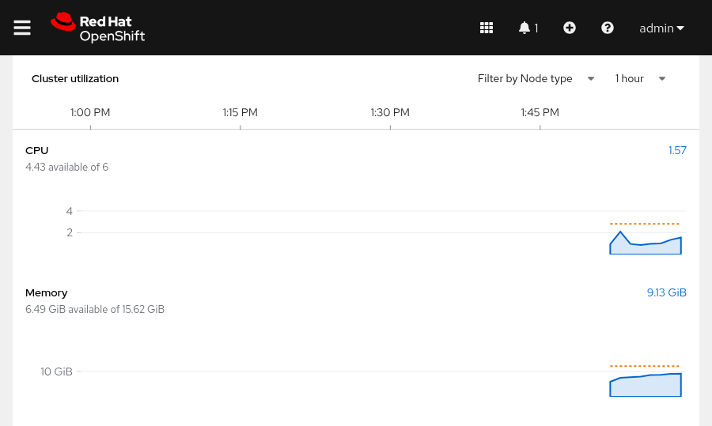
For any of the listed resources in the Cluster Utilization section, administrators can click the link for current resource usage. The link displays a window with a breakdown of top consumers for that resource. Top consumers can be sorted by project, by pod, or by node. The list of top consumers can be useful for identifying problematic pods or nodes. For example, a pod with an unexpected memory leak might appear at the top of the list.

Viewing Project Metrics
The Project Details page displays metrics that provide an overview of the resources that are used within the scope of a specific project. The Utilization section displays usage information about resources, such as CPU and memory, along with the ability to display the top consumers for each resource.
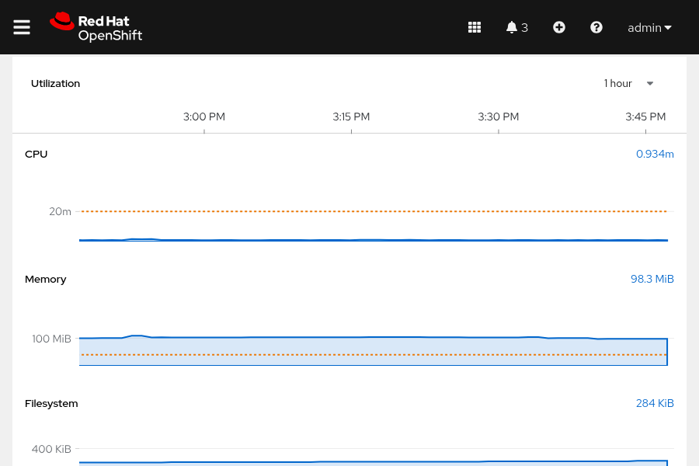
All metrics are pulled from Prometheus. Click any graph to go to the Metrics page. View the executed query, and inspect the data further.
If a resource quota is created for the project, then the current project request and limits appear on the Project Details page.

Viewing Resource Metrics
When troubleshooting, it is often useful to view metrics at a smaller granularity than for the entire cluster or project. The Metrics page displays time-series graphs of the CPU, memory, and file-system usage for a specific pod. A sudden change in these critical metrics, such as a CPU spike caused by high load, is visible on this page.
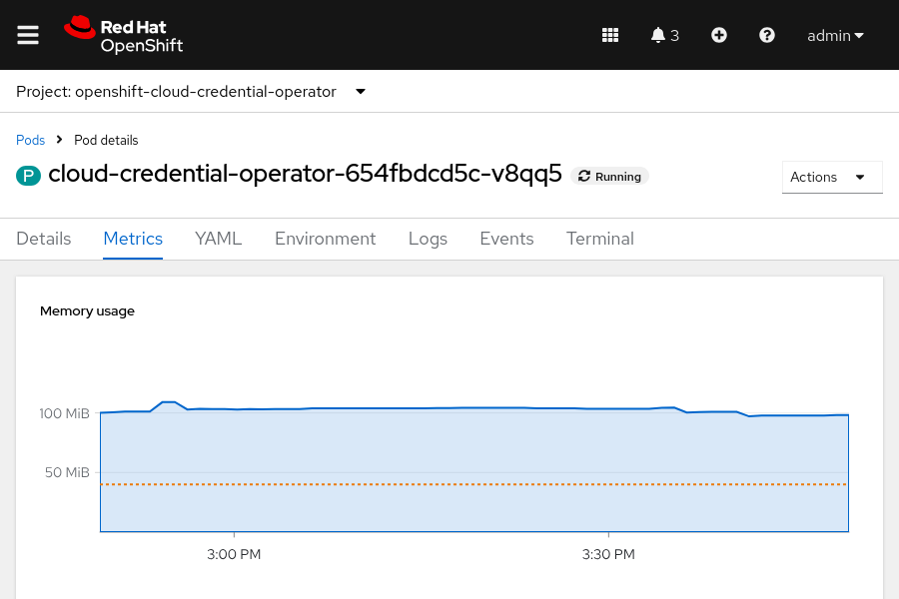
Figure 2.8: Time-series graphs showing various metrics for a pod

Performing Prometheus Queries in the Web Console
The Prometheus UI is a feature-rich tool for visualizing metrics and configuring alerts. The OpenShift web console provides an interface for executing Prometheus queries directly from the web console.
To perform a query, go to Observe → Metrics, enter a Prometheus Query Language expression in the text field, and click Run Queries. The results of the query are displayed as a time-series graph:
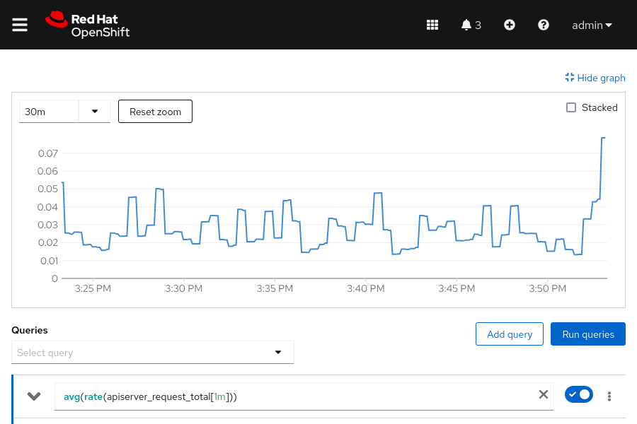
Figure 2.9: Using a Prometheus query to display a time-series graph

Note
The Prometheus Query Language is not discussed in detail in this course. Refer to the references section for a link to the official documentation.

Query Cluster Events and Alerts
Some developers consider OpenShift logs to be too low-level, thus making troubleshooting difficult. Fortunately, RHOCP provides a high-level logging and auditing facility called events. Kubernetes generates event objects in response to state changes in cluster objects, such as nodes, pods, and containers. Events signal significant actions, such as starting a container or destroying a pod.
To read events, use the get events command. The command lists the events for the current RHOCP project (namespace). You can display the events for a different project by adding the -n namespace option to the command. To list the events for all the projects, use the -A (or --all-namespaces) option.

Note
To sort the events by time, add the --sort-by .metadata.creationTimestamp option to the oc get events command.
The following get events command prints events in the openshift-kube-controller-manager namespace.
[user@host ~]$ oc get events -n openshift-kube-controller-manager
LAST SEEN TYPE REASON OBJECT MESSAGE
75d Normal LeaderElection lease/cert-recovery-controller-lock master01_...
...output omitted...
You can use the describe pod pod-name command to further narrow the results to a single pod. Refer to the Events field from the output of the oc describe pod pod-name command to review events for the specified pod.

Kubernetes Alerts
RHOCP includes a monitoring stack, which is based on the Prometheus open source project. The monitoring stack is configured to monitor the core RHOCP cluster components, by default. You can optionally configure the monitoring stack to also monitor user projects.
The components of the monitoring stack are installed in the openshift-monitoring namespace. Use the following get all command to display a list of all resources, their status, and their types in the openshift-monitoring namespace.
[user@host ~]$ oc get all -n openshift-monitoring
NAME READY STATUS RESTARTS AGE
pod/alertmanager-main-0 6/6 Running 48 75d
pod/cluster-monitoring-operator-55b4dbf86-mb4xd 1/1 Running 8 75d
pod/kube-state-metrics-75455b796c-8q28d 3/3 Running 27 75d
pod/prometheus-k8s-0 6/6 Running 48 75d
...output omitted...
The Prometheus Operator in the openshift-monitoring namespace creates, configures, and manages the Prometheus and Alertmanager instances. The prometheus-k8s-0 entry is the Prometheus pod. A cluster administrator can use the following command to get the alerts from the Prometheus API.
[user@host ~]$ oc -n openshift-monitoring exec -c prometheus \
prometheus-k8s-0 -- curl -s 'http://localhost:9090/api/v1/alerts' | jq
...output omitted...
An Alertmanager pod in the openshift-monitoring namespace receives alerts from Prometheus. Alertmanager uses alert receivers to send alerts to external notification systems. The alertmanager-main-0 pod is the Alertmanager for the cluster. Use the curl command to retrieve the fired alerts from the Alertmanager API.
[user@host ~]$ oc -n openshift-monitoring exec -c alertmanager \
alertmanager-main-0 -- curl -s 'http://localhost:9093/api/v2/alerts' | jq
...output omitted...

Check Node Status
RHOCP clusters can have several components, including at least one control plane and at least one compute node. The two components can occupy a single node. The following oc command, or the matching kubectl command, can display the overall health of all cluster nodes.
[user@host ~]$ oc cluster-info
The oc cluster-info output is high-level, and can verify that the cluster nodes are running. For a more detailed view into the cluster nodes, use the get nodes command.
[user@host ~]$ oc get nodes
NAME STATUS ROLES AGE VERSION
master01 Ready control-plane,master,worker 75d v1.31.6
The example shows a single master01 node with multiple roles. The STATUS value of Ready means that this node is healthy and can accept new pods. A STATUS value of NotReady means that a condition triggered the NotReady status and the node is not accepting new pods.
As with any other RHOCP resource, you can drill down into further details of the node resource with the describe node node-name command. For parsable output of the same information, use the -o json or the -o yaml output options with the get node node-name command. For more information about using and parsing these output formats, see the section called “ Inspect Kubernetes Resources ”.
The output of the get nodes node-name command with the -o json or -o yaml option is long. The following examples use the -jsonpath option or the jq processor to parse the get node node-name command output.
[user@host ~]$ oc get node master01 -o jsonpath=\
*'{"Allocatable:\n"}{.status.allocatable}{"\n\n"}
{"Capacity:\n"}{.status.capacity}{"\n"}'

Allocatable:
{"cpu":"5500m","ephemeral-storage":"75691125429","hugepages-1Gi":"0",
"hugepages-2Mi":"0","memory":"15225452Ki","pods":"250"}

Capacity:
{"cpu":"6","ephemeral-storage":"83295212Ki","hugepages-1Gi":"0",
"hugepages-2Mi":"0","memory":"16376428Ki","pods":"250"}
The JSONPath expression in the previous command extracts the allocatable and capacity measures for the master01 node. These measures help to understand the available resources on a node.
View the status object of a node to understand the current health of the node.
[user@host ~]$ oc get node master01 -o json | jq '.status.conditions'
[
{
"lastHeartbeatTime": "2025-08-05T15:32:36Z",
"lastTransitionTime": "2025-05-22T12:12:24Z",
"message": "kubelet has sufficient memory available",
"reason": "KubeletHasSufficientMemory",
"status": "False",
"type": "MemoryPressure"
},
{
"lastHeartbeatTime": "2025-08-05T15:32:36Z",
"lastTransitionTime": "2025-05-22T12:12:24Z",
"message": "kubelet has no disk pressure",
"reason": "KubeletHasNoDiskPressure",
"status": "False",
"type": "DiskPressure"
},
{
"lastHeartbeatTime": "2025-08-05T15:32:36Z",
"lastTransitionTime": "2025-05-22T12:12:24Z",
"message": "kubelet has sufficient PID available",
"reason": "KubeletHasSufficientPID",
"status": "False",
"type": "PIDPressure"
},
{
"lastHeartbeatTime": "2025-08-05T15:32:36Z",
"lastTransitionTime": "2025-08-05T14:41:42Z",
"message": "kubelet is posting ready status",
"reason": "KubeletReady",
"status": "True",
"type": "Ready"
}
]
If the status of the MemoryPressure condition is true, then the node is low on memory.
If the status of the DiskPressure condition is true, then the disk capacity of the node is low.
If the status of the PIDPressure condition is true, then too many processes are running on the node.
If the status of the Ready condition is false, then the node is not healthy and is not accepting pods.
More conditions indicate other potential problems with a node.
Table 2.5. Possible Node Conditions
Condition | Description
OutOfDisk | If true, then the node has insufficient free space on the node for adding new pods.
NetworkUnavailable | If true, then the network for the node is not correctly configured.
NotReady | If true, then one of the underlying components, such as the container runtime or network, is experiencing issues or is not yet configured.
SchedulingDisabled | Pods cannot be scheduled for placement on the node.

To gain deeper insight into a given node, you can view the logs of processes that run on the node. A cluster administrator can use the oc adm node-logs command to view node logs. Node logs might contain sensitive output, and thus are limited to privileged node administrators. Use oc adm node-logs node-name to filter the logs to a single node.
The oc adm node-logs command has other options to further filter the results.
Table 2.6. Filters for oc adm node-logs
Option Example | Description
--role master | Use the --role option to filter the output to nodes with a specified role.
-u kubelet | The -u option filters the output to a specified unit.
--path=cron | The --path option filters the output to a specific process under the /var/logs directory.
--tail 1 | Use --tail x to limit output to the last x log entries.

Use oc adm node-logs --help for a complete list of command options.
For example, to retrieve the most recent log entry for the crio service on the master01 node, you can use the following command.
[user@host ~]$ oc adm node-logs master01 -u crio --tail 1
-- Logs begin at Thu 2023-02-09 21:19:09 UTC, end at Fri 2023-03-17 15:11:43 UTC. --
Aug 05 15:16:09.519642 master01 crio[2783]: time="2025-08-05 15:30:09.519474755Z" level=info msg="Stopped pod sandbox...
...output omitted...
When you create a pod with the CLI, the oc or kubectl command is sent to the apiserver service, which then validates the command. The scheduler service reads the YAML or JSON pod definition, and then assigns pods to compute nodes. Each compute node runs a kubelet service that converts the pod manifest to one or more containers in the CRI-O container runtime.
Each compute node must have an active kubelet service and an active crio service. To verify the health of these services, first start a debug session on the node by using the debug command.
[user@host ~]$ oc debug node/node-name
Replace the node-name value with the name of your node.

Note
The debug command is covered in greater detail in a later section.
Within the debug session, change to the /host root directory so that you can run binaries in the host's executable path.
sh-4.4# chroot /host
Then, use the systemctl is-active calls to confirm that the services are active.
sh-4.4# for SERVICES in kubelet crio; do echo ---- $SERVICES ---- ;
systemctl is-active $SERVICES ; echo ""; done
---- kubelet ----
active

---- crio ----
active
For more details about the status of a service, use the systemctl status command.
sh-4.4# systemctl status kubelet
● kubelet.service - Kubernetes Kubelet
Loaded: loaded (/etc/systemd/system/kubelet.service; enabled; vendor preset: disabled)
Drop-In: /etc/systemd/system/kubelet.service.d
...output omitted...

Check Pod Status
With RHOCP, you can view logs in running containers and pods to ease troubleshooting. When a container starts, RHOCP redirects the container's standard output and standard error to a disk in the container's ephemeral storage. With this redirect, you can view the container logs by using logs commands, even after the container stops. However, the pod hosting the container must still exist.
In RHOCP, the following command returns the output for a container within a pod:
[user@host ~]$ oc logs pod-name -c container-name
Replace pod-name with the name of the target pod, and replace container-name with the name of the target container. The -c container-name argument is optional, if the pod has only one container. You must use the -c container-name argument to connect to a specific container in a multicontainer pod. Otherwise, the command defaults to the only running container and returns the output.
When debugging images and setup problems, it is useful to get an exact copy of a running pod configuration, and then troubleshoot it with a shell. If a pod is failing or does not include a shell, then the rsh and exec commands might not work. To resolve this issue, the debug command creates a copy of the specified pod and starts a shell in that pod.
By default, the debug command starts a shell inside the first container of the referenced pod. The debug pod is a copy of your source pod, with some additional modifications. For example, the pod labels are removed. The executed command is also changed to the '/bin/sh' command for Linux containers, or the 'cmd.exe' executable for Windows containers. Additionally, readiness and liveness probes are disabled.
A common problem for containers in pods is security policies that prohibit a container from running as a root user. You can use the debug command to test running a pod as a non-root user by using the --as-user option. You can also run a non-root pod as the root user with the --as-root option.
With the debug command, you can invoke other types of objects besides pods. For example, you can use any controller resource that creates a pod, such as a deployment, a build, or a job. The debug command also works with nodes, and with resources that can create pods, such as image stream tags. You can also use the --image=IMAGE option of the debug command to start a shell session by using a specified image.
If you do not include a resource type and name, then the debug command starts a shell session into a pod by using the OpenShift tools image.
[user@host ~]$ oc debug
The next example tests running a job pod as a non-root user.
[user@host ~]$ oc debug job/test --as-user=1000000
The following example creates a debug session for a node.
[user@host ~]$ oc debug node/master01
Starting pod/master01-debug-gdmkp ...
To use host binaries, run chroot /host
Pod IP: 192.168.50.10
If you don't see a command prompt, try pressing enter.
sh-5.1# chroot /host
sh-5.1#
The debug pod is deleted when the remote command completes, or when the user interrupts the shell.

Collect Information for Support Requests
When opening a support case, it is helpful to provide debugging information about your cluster to Red Hat Support. It is recommended that you provide the following information:
- Data gathered by using the oc adm must-gather command as a cluster administrator
- The unique cluster ID
The oc adm must-gather command collects resource definitions and service logs from your cluster that are most likely needed for debugging issues. This command creates a pod in a temporary namespace on your cluster, and the pod then gathers and downloads debugging information. By default, the oc adm must-gather command uses the default plug-in image, and writes into the ./must-gather.local. directory on your local system. To write to a specific local directory, you can also use the --dest-dir option, such as in the following example:
[user@host ~]$ oc adm must-gather --dest-dir /home/student/must-gather
Then, create a compressed archive file from the must-gather directory. For example, on a Linux-based system, you can run the following command:
[user@host ~]$ tar cvaf mustgather.tar must-gather/
Replace must-gather/ with the actual directory path.
Then, attach the compressed archive file to your support case in the Red Hat Customer Portal.
Similar to the oc adm must-gather command, the oc adm inspect command gathers information on a specified resource. For example, the following command collects debugging data for the openshift-apiserver and kube-apiserver cluster operators.
[user@host ~]$ oc adm inspect clusteroperator/openshift-apiserver \
clusteroperator/kube-apiserver
The oc adm inspect command can also use the --dest-dir option to specify a local directory to write the gathered information. The command shows all logs by default. Use the --since option to filter the results to logs that are later than a relative duration, such as 5s, 2m, or 3h.
[user@host ~]$ oc adm inspect clusteroperator/openshift-apiserver --since 10m

Guided Exercise: Assess the Health of an OpenShift Cluster
Verify the health of an OpenShift cluster by querying the status of its cluster operators, nodes, pods, and systemd services. Also verify cluster events and alerts.
Outcomes
- View the status and get information about cluster operators.
- Retrieve information about cluster pods and nodes.
- Retrieve the status of a node's systemd services.
- View cluster events and alerts.
- Retrieve debugging information for the cluster.
As the student user on the workstation machine, use the lab command to prepare your system for this exercise. This command ensures that all resources are available for this exercise.
[student@workstation ~]$ lab start cli-health
Instructions
- Retrieve the status and view information about cluster operators.
  - Log in to the OpenShift cluster as the admin user with the redhatocp password.
[student@workstation ~]$ oc login -u admin -p redhatocp https://api.ocp4.example.com:6443
Login successful
  - ...output omitted...
  - List the operators that users installed in the OpenShift cluster.
[student@workstation ~]$ oc get operators
NAME AGE
lvms-operator.openshift-storage 69d
  - metallb-operator.metallb-system 69d
  - List the cluster operators that are installed by default in the OpenShift cluster.
[student@workstation ~]$ oc get clusteroperators
NAME VERSION AVAILABLE PROGRESSING DEGRADED ...
authentication 4.18.6 True False False ...
baremetal 4.18.6 True False False ...
cloud-controller-manager 4.18.6 True False False ...
cloud-credential 4.18.6 True False False ...
cluster-autoscaler 4.18.6 True False False ...
config-operator 4.18.6 True False False ...
console 4.18.6 True False False ...
control-plane-machine-set 4.18.6 True False False ...
csi-snapshot-controller 4.18.6 True False False ...
dns 4.18.6 True False False ...
etcd 4.18.6 True False False ...
  - ...output omitted...
  - Use the describe command to view detailed information about the openshift-apiserver cluster operator, such as related objects, events, and version.
[student@workstation ~]$ oc describe clusteroperators openshift-apiserver
Name: openshift-apiserver
Namespace:
Labels: <none>
Annotations: exclude.release.openshift.io/internal-openshift-hosted: true
include.release.openshift.io/self-managed-high-availability: true
include.release.openshift.io/single-node-developer: true
API Version: config.openshift.io/v1
Kind: ClusterOperator
Metadata:
...output omitted...
Spec:
Status:
Conditions:
Last Transition Time: 2025-05-22T10:49:18Z
Message: All is well
Reason: AsExpected
Status: False
Type: Degraded
...output omitted...
Extension: <nil>
Related Objects:
Group: operator.openshift.io
Name: cluster
Resource: openshiftapiservers
Group:
Name: openshift-config
Resource: namespaces
Group:
Name: openshift-config-managed
Resource: namespaces
Group:
Name: openshift-apiserver-operator
Resource: namespaces
Group:
Name: openshift-apiserver
Resource: namespaces
...output omitted...
Versions:
Name: operator
Version: 4.18.6
Name: openshift-apiserver
Version: 4.18.6
  - Events: <none>
  - The Related Objects attribute includes information about the name, resource type, and groups for objects that are related to the operator.
  - List the pods in the openshift-apiserver-operator namespace. Then, view the detailed status of an openshift-apiserver-operator pod by using the JSON format and the jq command. Your pod names might differ.
[student@workstation ~]$ oc get pods -n openshift-apiserver-operator
NAME READY STATUS RESTARTS AGE
  - openshift-apiserver-operator-85fc9669d-g58sl 1/1 Running 12 81d
[student@workstation ~]$ oc get pod -n openshift-apiserver-operator \
openshift-apiserver-operator-85fc9669d-g58sl \
-o json | jq .status
{
"conditions": [
...output omitted...
{
"lastProbeTime": null,
"lastTransitionTime": "2025-08-11T17:52:20Z",
"status": "True",
"type": "Ready"
},
...output omitted...
],
"containerStatuses": [
{
...output omitted...
"name": "openshift-apiserver-operator",
"ready": true,
"restartCount": 12,
"started": true,
"state": {
"running": {
"startedAt": "2025-08-11T17:52:19Z"
}
}
}
],
"hostIP": "192.168.50.10",
...output omitted...
"phase": "Running",
"podIP": "10.8.0.17",
...output omitted...
  - }
- Retrieve the status, resource consumption, and events of cluster pods.
  - List the memory and CPU usage of all pods in the cluster. Use the --sum option to print the sum of the resource usage. The resource usage on your system probably differs.
[student@workstation ~]$ oc adm top pods -A --sum
NAMESPACE NAME CPU(cores) MEMORY(bytes)
...output omitted...
metallb-system metallb-operator-controller-manager-... 2m 58Mi
metallb-system metallb-operator-webhook-server-... 1m 27Mi
metallb-system speaker-nrvz4 4m 98Mi
...output omitted...
  - 505m 8982Mi
  - List the pods and their labels in the openshift-etcd namespace.
[student@workstation ~]$ oc get pods -n openshift-etcd --show-labels
NAME READY STATUS RESTARTS AGE LABELS
etcd-master01 5/5 Running 55 81d app=etcd,etcd=true,k8s-app=etcd,revision=2
installer-1-master01 0/1 Completed 0 81d app=installer
  - installer-2-master01 0/1 Completed 0 81d app=installer
  - List the resource usage of the containers in the etcd-master01 pod in the openshift-etcd namespace. The resource usage on your system probably differs.
[student@workstation ~]$ oc adm top pods etcd-master01 \
-n openshift-etcd --containers
POD NAME CPU(cores) MEMORY(bytes)
etcd-master01 etcd 44m 269Mi
etcd-master01 etcd-metrics 8m 30Mi
etcd-master01 etcd-readyz 4m 47Mi
etcd-master01 etcd-rev 1m 44Mi
  - etcd-master01 etcdctl 0m 0Mi
  - Display a list of all resources, their status, and their types in the openshift-monitoring namespace.
[student@workstation ~]$ oc get all -n openshift-monitoring
Warning: apps.openshift.io/v1 DeploymentConfig is deprecated in v4.14+, unavailable in v4.10000+
NAME READY STATUS ...
pod/alertmanager-main-0 6/6 Running ...
pod/cluster-monitoring-operator-56b769b58f-dtmqj 1/1 Running ...
pod/kube-state-metrics-75455b796c-8q28d 3/3 Running ...
...output omitted...
NAME TYPE CLUSTER-IP ...
service/alertmanager-main ClusterIP 172.30.90.122 ...
service/alertmanager-operated ClusterIP None ...
service/cluster-monitoring-operator ClusterIP None ...
service/kube-state-metrics ClusterIP None ...
  - ...output omitted...
  - View the logs of the alertmanager-main-0 pod in the openshift-monitoring namespace. The logs might differ on your system.
[student@workstation ~]$ oc logs alertmanager-main-0 -n openshift-monitoring
...output omitted...
ts=2025-08-11T17:50:17.481Z caller=coordinator.go:113 level=info component=configuration msg="Loading configuration file" file=/etc/alertmanager/config_out/alertmanager.env.yaml
ts=2025-08-11T17:50:17.483Z caller=coordinator.go:126 level=info component=configuration msg="Completed loading of configuration file" file=/etc/alertmanager/config_out/alertmanager.env.yaml
  - ...output omitted...
  - Retrieve the events for the openshift-kube-controller-manager namespace.
[student@workstation ~]$ oc get events -n openshift-kube-controller-manager
LAST SEEN TYPE REASON OBJECT ...
169m Normal LeaderElection lease/cert-recovery-controller-lock...
169m Normal LeaderElection lease/cluster-policy-controller-lock...
172m Normal Pulled pod/kube-controller-manager-master01...
  - ...output omitted...
- Retrieve information about cluster nodes.
  - View the status of the nodes in the cluster.
[student@workstation ~]$ oc get nodes
NAME STATUS ROLES AGE VERSION
  - master01 Ready control-plane,master,worker 81d v1.31.6
  - Retrieve the resource consumption of the master01 node. The resource usage on your system probably differs.
[student@workstation ~]$ oc adm top node
NAME CPU(cores) CPU% MEMORY(bytes) MEMORY%
  - master01 719m 13% 12069Mi 81%
  - Use a JSONPath filter to determine the capacity and allocatable CPU for the master01 node. The values might differ on your system.
[student@workstation ~]$ oc get node master01 -o jsonpath='Allocatable: {.status.allocatable.cpu}{"\n"}''Capacity: {.status.capacity.cpu}{"\n"}'
Allocatable: 5500m
  - Capacity: 6
  - Determine the number of allocatable pods for the node.
[student@workstation ~]$ oc get node master01 -o jsonpath=\
'Allocatable Pods: {.status.allocatable.pods}{"\n"}'
  - Allocatable Pods: 250
  - Use the describe command to view the events, resource requests, and resource limits for the node. The output might differ on your system.
[student@workstation ~]$ oc describe node master01
...output omitted...
Allocated resources:
(Total limits may be over 100 percent, i.e., overcommitted.)
Resource Requests Limits
-------- -------- ------
cpu 2809m (51%) 10m (0%)
memory 12359Mi (83%) 0 (0%)
ephemeral-storage 0 (0%) 0 (0%)
hugepages-1Gi 0 (0%) 0 (0%)
hugepages-2Mi 0 (0%) 0 (0%)
  - Events: <none>
- Retrieve the logs and status of the systemd services on the master01 node.
  - Display the logs of the node. Filter the logs to show the most recent log for the crio service. The logs might differ on your system.
[student@workstation ~]$ oc adm node-logs master01 -u crio --tail 1
-- Logs begin at Thu 2025-05-22 10 21:19:09 UTC, end at Thu 2025-05-22 10 16:57:00 UTC. --
May 22 10:46:12.108535 master01 systemd[1]: Starting Container Runtime Interface for OCI (CRI-O)...
May 22 10:46:12.655846 master01 crio[2698]: time="2025-05-22 10:46:12.655729195Z" level=info msg="Updating config from single file: /etc/crio/crio.conf"
  - ...output omitted...
  - Display the two most recent log entries of the kubelet service on the node. The logs might differ on your system.
[student@workstation ~]$ oc adm node-logs master01 -u kubelet --tail 2
-- Logs begin at Thu 2025-05-22 10 21:19:09 UTC, end at Thu 2025-05-22 10 16:57:00 UTC. --
Aug 11 20:45:05.086582 master01 kubenswrapper[3028]: I0811 20:45:05.086523 3028 kubelet_volumes.go:163] "Cleaned up orphaned pod volumes dir" podUID="a1c8c4ef-7604-426f-bc88-682cc4fb0d5e" path="/var/lib/kubelet/pods/a1c8c4ef-7604-426f-bc88-682cc4fb0d5e/volumes"
  - Aug 11 20:45:21.367632 master01 kubenswrapper[3028]: I0811 20:45:21.367580 3028 scope.go:117] "RemoveContainer" containerID="72ef...8dd0"
  - Create a debug session for the node. The, use the chroot /host command to access the host binaries.
[student@workstation ~]$ oc debug node/master01
Starting pod/master01-debug-945fs ...
To use host binaries, run `chroot /host`
Pod IP: 192.168.50.10
If you don't see a command prompt, try pressing enter.
sh-5.1# chroot /host
  - sh-5.1#
  - Verify the status of the kubelet service.
sh-5.1# systemctl status kubelet
● kubelet.service - Kubernetes Kubelet
Loaded: loaded (/etc/systemd/system/kubelet.service; enabled; preset: disabled)
Drop-In: /etc/systemd/system/kubelet.service.d
└─01-kubens.conf, 10-mco-default-madv.conf, 20-logging.conf, 20-nodenet.conf
Active: active (running) since Mon 2025-08-11 17:47:14 UTC; 3h 10min ago
Main PID: 3028 (kubelet)
Tasks: 35 (limit: 127707)
Memory: 779.7M
CPU: 27min 9.454s
  - ...output omitted...
  - Press Ctrl+C to quit the command.
  - Confirm that the crio service is active.
sh-5.1# systemctl is-active crio
  - active
  - Exit the debug pod.
sh-5.1# exit
exit
sh-5.1# exit
exit

  - Removing debug pod ...
- Retrieve debugging information for the cluster.
  - Retrieve debugging information of the cluster by using the oc adm must-gather command. Specify the /home/student/must-gather directory as the destination directory. This command might take several minutes to complete.
[student@workstation ~]$ oc adm must-gather --dest-dir /home/student/must-gather
[must-gather ] OUT 2025-08-12T16:37:58.163228054Z Using must-gather plug-in image: quay.io/openshift-release-dev/ocp-v4.0-art-dev@sha256:a81f...b12a
When opening a support case, bugzilla, or issue please include the following summary data along with any other requested information:
ClusterID: 6c8c6eed-26ed-4911-9df9-b081404842c8
ClientVersion: 4.18.6
ClusterVersion: Stable at "4.18.6"
ClusterOperators:
  - All healthy and stable
  - Verify that the debugging information exists in the destination directory.
[student@workstation ~]$ ls -1 ~/must-gather
event-filter.html
quay-io-openshift-release-dev-ocp-v4-0-art-dev-sha256...
must-gather.logs
  - timestamp
  - List the last five kubelet service logs, and confirm that an error occurred. Replace quay-io…​ with the generated directory name.
[student@workstation ~]$ tail -5 ~/must-gather/\
quay-io-openshift-release-dev-ocp-v4-0-art-dev-sha256...\gather.logs
2025-08-14T22:11:20.510531824Z Gathering data for ns/openshift-cluster-csi-drivers...
2025-08-14T22:11:21.166365975Z Wrote inspect data to must-gather.
2025-08-14T22:11:21.166420106Z error: inspection completed with the errors occurred while gathering data:
2025-08-14T22:11:21.166420106Z [skipping gathering secrets/support due to error: secrets "support" not found, skipping gathering endpoints/host-etcd-2 due to error: endpoints "host-etcd-2" not found]
  - 2025-08-14T22:11:21.352314360Z error: the server doesn't have a resource type "clusters"
  - Generate debugging information for the openshift-apiserver cluster operator. Specify the /home/student/inspect directory as the destination directory. Limit the debugging information to the last five minutes.
[student@workstation ~]$ oc adm inspect clusteroperator/openshift-apiserver \
--dest-dir /home/student/inspect --since 5m
Gathering data for ns/openshift-config...
Warning: apps.openshift.io/v1 DeploymentConfig is deprecated in v4.14+, unavailable in v4.10000+
Gathering data for ns/openshift-config-managed...
Gathering data for ns/openshift-apiserver-operator...
Gathering data for ns/openshift-apiserver...
Gathering data for ns/openshift-etcd-operator...
Wrote inspect data to /home/student/inspect.
  - ...output omitted...
  - Verify that the debugging information exists in the destination directory.
[student@workstation ~]$ ls -1 inspect/
cluster-scoped-resources
event-filter.html
namespaces
  - timestamp
  - Review the cluster.yaml file from the ~/inspect/cluster-scoped-resources/operator.openshift.io/openshiftapiservers directory.
[student@workstation ~]$ cat \
~/inspect/cluster-scoped-resources/operator.openshift.io/\
openshiftapiservers/cluster.yaml
apiVersion: operator.openshift.io/v1
kind: OpenShiftAPIServer
metadata:
annotations:
include.release.openshift.io/hypershift: "true"
include.release.openshift.io/ibm-cloud-managed: "true"
include.release.openshift.io/self-managed-high-availability: "true"
include.release.openshift.io/single-node-developer: "true"
release.openshift.io/create-only: "true"
creationTimestamp: "2025-05-22T10:40:34Z"
generation: 3
managedFields:
- apiVersion: operator.openshift.io/v1
fieldsType: FieldsV1
fieldsV1:
f:status:
f:conditions:
  - ...output omitted...
  - Delete the debugging information from your system.
  - [student@workstation ~]$ rm -rf must-gather inspect
Finish
On the workstation machine, use the lab command to complete this exercise. This step is important to ensure that resources from previous exercises do not impact upcoming exercises.
[student@workstation ~]$ lab finish cli-health

Summary
- You can use either the web console or the kubectl or oc commands to manage the RHOCP cluster.
- An RHOCP cluster can be managed from the web console or by using the kubectl or oc command-line interfaces (CLI).
- Use the --help option on any command to view detailed information about the command.
- Projects provide isolation between your application resources.
- Token authentication is the only guaranteed method to work with any RHOCP cluster, because enterprise SSO might replace the login form of the web console.
- All administrative tasks require creating, viewing, and changing the API resources.
- Kubernetes provides YAML- and JSON-formatted output options, which are ideal for parsing or scripting.
- Operators provide the means of monitoring applications, performing health checks, managing over-the-air (OTA) updates, and ensuring that applications remain in your specified state.
- The RHOCP web console incorporates useful graphs to visualize cluster and resource analytics.
- The RHOCP web console provides an interface for executing Prometheus queries, visualizing metrics, and configuring alerts.
- The monitoring stack is based on the Prometheus project, and it is configured to monitor the core RHOCP cluster components, by default.
- RHOCP provides the ability to view logs in running containers and pods to ease troubleshooting.
- You can use the oc adm must-gather command to collect resource definitions and service logs from your cluster.

Chapter 3. Run Applications as Containers and Pods
Create Linux Containers and Kubernetes Pods
Guided Exercise: Create Linux Containers and Kubernetes Pods
Find and Inspect Container Images
Guided Exercise: Find and Inspect Container Images
Troubleshoot Containers and Pods
Guided Exercise: Troubleshoot Containers and Pods
Lab: Run Applications as Containers and Pods
Quiz: Run Applications as Containers and Pods
Summary
Abstract
Goal | Run and troubleshoot containerized applications as unmanaged Kubernetes pods.
Sections | - Create Linux Containers and Kubernetes Pods (and Guided Exercise)  - Find and Inspect Container Images (and Guided Exercise)  - Troubleshoot Containers and Pods (and Guided Exercise)
Lab | - Run Applications as Containers and Pods
Create Linux Containers and Kubernetes Pods
Objectives
- Run containers inside pods and identify the host OS processes and namespaces that the containers use.
Running Containers in Pods
Kubernetes and Red Hat OpenShift offer many ways to create containers in pods. You can use one such way, the run command, with the kubectl or oc CLI to create and deploy an application in a pod from a container image. A container image contains immutable data that defines an application and its libraries.
Note
Container images are discussed in more detail elsewhere in the course.
Use the run command to create single pods for interactive debugging or temporary tasks. For enterprise applications, using declarative YAML manifests with workload resources such as Deployment resources is the recommended practice for ensuring reproducibility and manageability. The run command uses the following syntax:
oc run RESOURCE/NAME --image IMAGE [options]
For example, the following command deploys an Apache HTTPD application in a pod named web-server that uses the registry.access.redhat.com/ubi10/httpd-24 container image.
[user@host ~]$ oc run web-server \
--image registry.access.redhat.com/ubi10/httpd-24
You can use several options and flags with the run command. The --command option executes a custom command and its arguments in a container, rather than the default command that is defined in the container image. You must follow the --command option with a double dash (--) to separate the custom command and its arguments from the run command options. The following syntax is used with the --command option:
oc run RESOURCE/NAME --image IMAGE --command -- cmd arg1 ... argN
You can also use the double dash option to provide custom arguments to a default command in the container image.
oc run RESOURCE/NAME --image IMAGE -- arg1 arg2 ... argN
To start an interactive session with a container in a pod, include the -it options before the pod name. The -i option tells Kubernetes to keep open the standard input (stdin) on the container in the pod. The -t option tells Kubernetes to open a TTY session for the container in the pod. You can use the -it options to start an interactive, remote shell in a container. From the remote shell, you can then execute additional commands in the container. The following example starts an interactive remote shell, /bin/bash, in the default container in the my-app pod.
[user@host ~]$ oc run -it my-app --image registry.access.redhat.com/ubi10/ubi \
--command -- /bin/bash
If you don't see a command prompt, try pressing enter.
bash-5.1$
Note
Unless you include the --namespace or -n options, the run command creates containers in pods in the current selected project.
You can define a restart policy for a pod by using the --restart option. A pod restart policy determines how the cluster responds when containers in that pod exit. The accepted values are Always, OnFailure, or Never.
Policy | Description
Always | The cluster continuously tries to restart a container that exits, whether it exited successfully or with an error. This policy is the default.
OnFailure | The cluster restarts a container only if it exits with an error.
Never | The cluster does not try to restart exited or failed containers. Instead, the pods immediately fail and exit.
The following example command executes the date command in the container of the pod named my-app, redirects the date command output to the terminal, and defines Never as the pod restart policy.
[user@host ~]$ oc run -it my-app --image registry.access.redhat.com/ubi10/ubi \
--restart Never --command -- date
Mon Feb 20 22:36:55 UTC 2023
To automatically delete a pod after it exits, include the --rm option with the run command.
[user@host ~]$ oc run -it my-app --rm \
--image registry.access.redhat.com/ubi10/ubi --restart Never --command -- date
Mon Feb 20 22:38:50 UTC 2023
pod "my-app" deleted
For some containerized applications, you might need to specify environment variables for the application to work. To specify an environment variable and its value, include the --env= option with the run command.
[user@host ~]$ oc run mysql --image registry.redhat.io/rhel9/mysql-80 \
--env MYSQL_ROOT_PASSWORD=myP@$$123
pod/mysql created
User and Group IDs Assignment
When a project is created, Red Hat OpenShift adds annotations to the project that determine the user ID (UID) range and supplemental group ID (GID) for pods and their containers in the project. You can retrieve the annotations with the oc describe project project-name command.
[user@host ~]$ oc describe project my-app
Name: my-app
...output omitted...
Annotations: openshift.io/description=
openshift.io/display-name=
openshift.io/requester=developer
openshift.io/sa.scc.mcs=s0:c27,c4
openshift.io/sa.scc.supplemental-groups=1000710000/10000
openshift.io/sa.scc.uid-range=1000710000/10000
...output omitted...
The values for supplemental-groups and uid-range use the base/size format. In the 1000710000/10000 example, the 1000710000 number is the starting ID of the block that is allocated to this project. The 10000 number is the size of the block. Therefore, the project can assign up to 10,000 unique UIDs and GIDs to containers that are running within it, starting from the base ID of 1000710000.
With Red Hat OpenShift default security policies, regular cluster users cannot choose the USER or UIDs for their containers. When a regular cluster user creates a pod, Red Hat OpenShift ignores the USER instruction in the container image. Instead, Red Hat OpenShift assigns a random UID to the container's primary process from the uid-range that is defined in the project's annotations.
The primary group ID (GID) of the process is always 0, which is the root group. Because the process runs with a non-root UID but belongs to the root group, any files or directories that the container writes to must be owned by the root group and have group write permissions.
This feature is essential for security. Although the process in the container belongs to the root group, its high-numbered, non-root UID makes it an unprivileged account.
In contrast, when a cluster administrator creates a pod, the USER instruction in the container image is processed. For example, if the USER instruction for the container image is set to 0, then the process in the container runs as the root privileged account, with a UID of 0. Executing a container as a privileged account is a security risk. A privileged account in a container has unrestricted access to the container's host system. Unrestricted access means that the container could modify or delete system files, install software, or otherwise compromise its host. Red Hat therefore recommends that you run containers as rootless, or as an unprivileged user with only the necessary privileges for the container to run. By assigning a distinct block of UIDs to each project, Red Hat OpenShift ensures that containers in different projects do not run with the same UID, which is a critical security practice.
Pod Security
The Kubernetes Pod Security Admission (PSA) controller issues a warning when a pod is created without a defined security context. Red Hat OpenShift Container Platform 4.18 integrates the PSA controller, which enforces security profiles (privileged, baseline, restricted) at the namespace level. Security contexts grant or deny OS-level privileges to pods.
Red Hat OpenShift uses the Security Context Constraints (SCC) controller to provide safe defaults for pod security. SCCs grant pods the necessary permissions to meet the requirements of the enforced PSA profile. You can ignore pod security warnings in these course exercises. SCC controllers are discussed in more detail in the Red Hat OpenShift Administration II: Operating a Production Kubernetes Cluster (DO280) course.
Execute Commands in Running Containers
To execute a command in a running container in a pod, you can use the exec command with the oc CLI. The exec command uses the following syntax:
oc exec RESOURCE/NAME -- COMMAND [args...] [options]
The output of the executed command is sent to your terminal. In the following example, the exec command executes the date command in the my-app pod.
[user@host ~]$ oc exec my-app -- date
Tue Feb 21 20:43:53 UTC 2023
The specified command is executed in the first container of a pod. For multicontainer pods, include the -c or --container= options to specify which container is used to execute the command. The following example executes the date command in a container named ruby-container in the my-app pod.
[user@host ~]$ oc exec my-app -c ruby-container -- date
Tue Feb 21 20:46:50 UTC 2023
The exec command also accepts the -i and -t options to create an interactive session with a container in a pod. In the following example, Kubernetes sends stdin to the bash shell in the ruby-container container from the my-app pod, and sends stdout and stderr from the bash shell back to the terminal.
[user@host ~]$ oc exec my-app -c ruby-container -it -- bash -il
[1000780000@ruby-container /]$
In the previous example, a raw terminal is opened in the ruby-container container. From this interactive session, you can execute additional commands in the container. To terminate the interactive session, you must execute the exit command in the raw terminal.
[user@host ~]$ oc exec my-app -c ruby-container -it -- bash -il
[1000780000@ruby-container /]$ date
Tue Feb 21 21:16:00 UTC 2023
[1000780000@ruby-container] exit
Container Logs
Container logs are the standard output (stdout) and standard error (stderr) output of a container. You can retrieve logs with the logs pod/pod-name command that the oc CLI provides. The command includes the following options:

Option | Description
-l or --selector='' | Filter objects based on the specified key:value label constraint.
--tail= | Specify the number of lines of recent log files to display; the default value is -1 with no selectors, which displays all log lines.
-c or --container= | Print the logs of a specific container in a multicontainer pod. If this option is omitted, then logs are shown from the first container that is defined in the pod or from the container that the kubectl.kubernetes.io/default-container annotation on the pod specifies.
-f or --follow | Follow, or stream, logs for a container.
-p or --previous=true | Print the logs of a previous container instance in the pod, if it exists. This option is helpful for troubleshooting a pod that failed to start, because it prints the logs of the last attempt.
The following example restricts the oc logs command output to the 10 most recent log lines:
[user@host ~]$ oc logs postgresql-1-jw89j --tail=10
done
server stopped
Starting server...
2023-01-04 22:00:16.945 UTC [1] LOG: starting PostgreSQL 12.11 on x86_64-redhat-linux-gnu, compiled by gcc (GCC) 8.5.0 20210514 (Red Hat 8.5.0-10), 64-bit
2023-01-04 22:00:16.946 UTC [1] LOG: listening on IPv4 address "0.0.0.0", port 5432
2023-01-04 22:00:16.946 UTC [1] LOG: listening on IPv6 address "::", port 5432
2023-01-04 22:00:16.953 UTC [1] LOG: listening on Unix socket "/var/run/postgresql/.s.PGSQL.5432"
2023-01-04 22:00:16.960 UTC [1] LOG: listening on Unix socket "/tmp/.s.PGSQL.5432"
2023-01-04 22:00:16.968 UTC [1] LOG: redirecting log output to logging collector process
2023-01-04 22:00:16.968 UTC [1] HINT: Future log output will appear in directory "log".
You can also use the attach pod-name -c container-name -it command to connect to and start an interactive session on a running container in a pod. The -c container-name option is required for multicontainer pods. If the container name is omitted, then Kubernetes uses the kubectl.kubernetes.io/default-container annotation on the pod to select the container. Otherwise, the first container in the pod is chosen. You can use the interactive session to retrieve application log files and to troubleshoot application issues.
[user@host ~]$ oc attach my-app -it
If you don't see a command prompt, try pressing enter.
bash-4.4$
You can also retrieve logs from the web console by clicking the Logs tab of any pod.
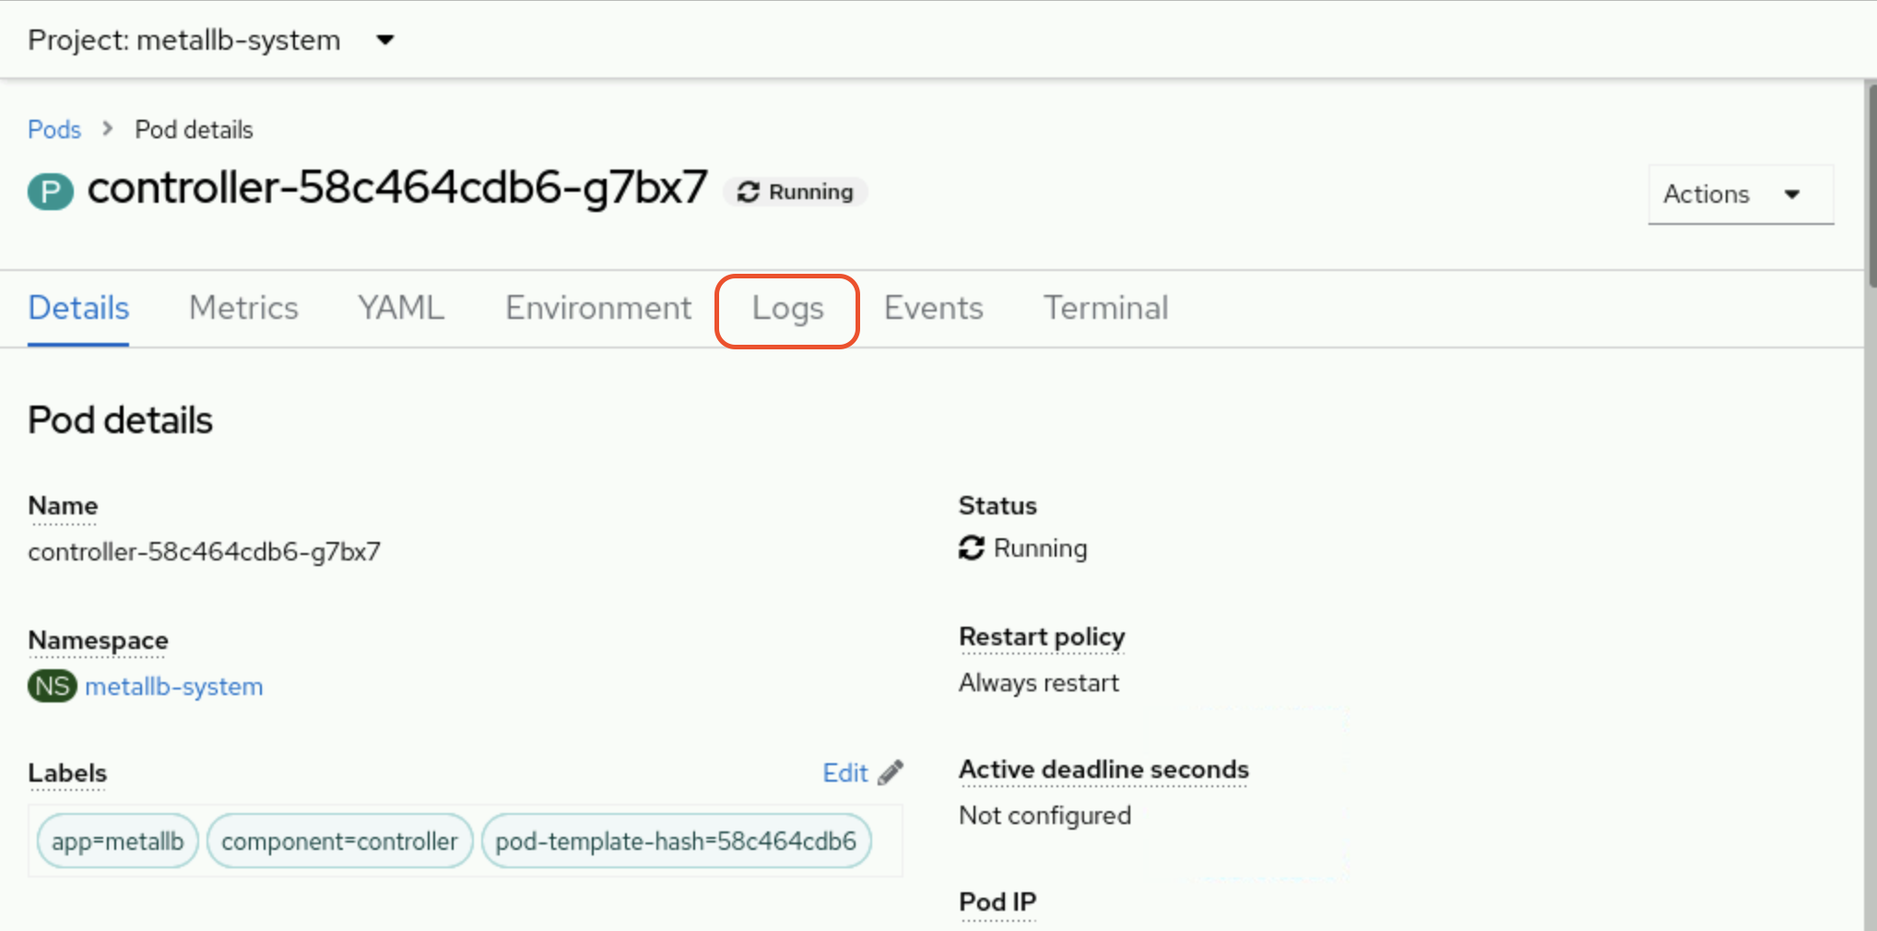
If you have more than one container, then you can change between them to list the logs of each one.
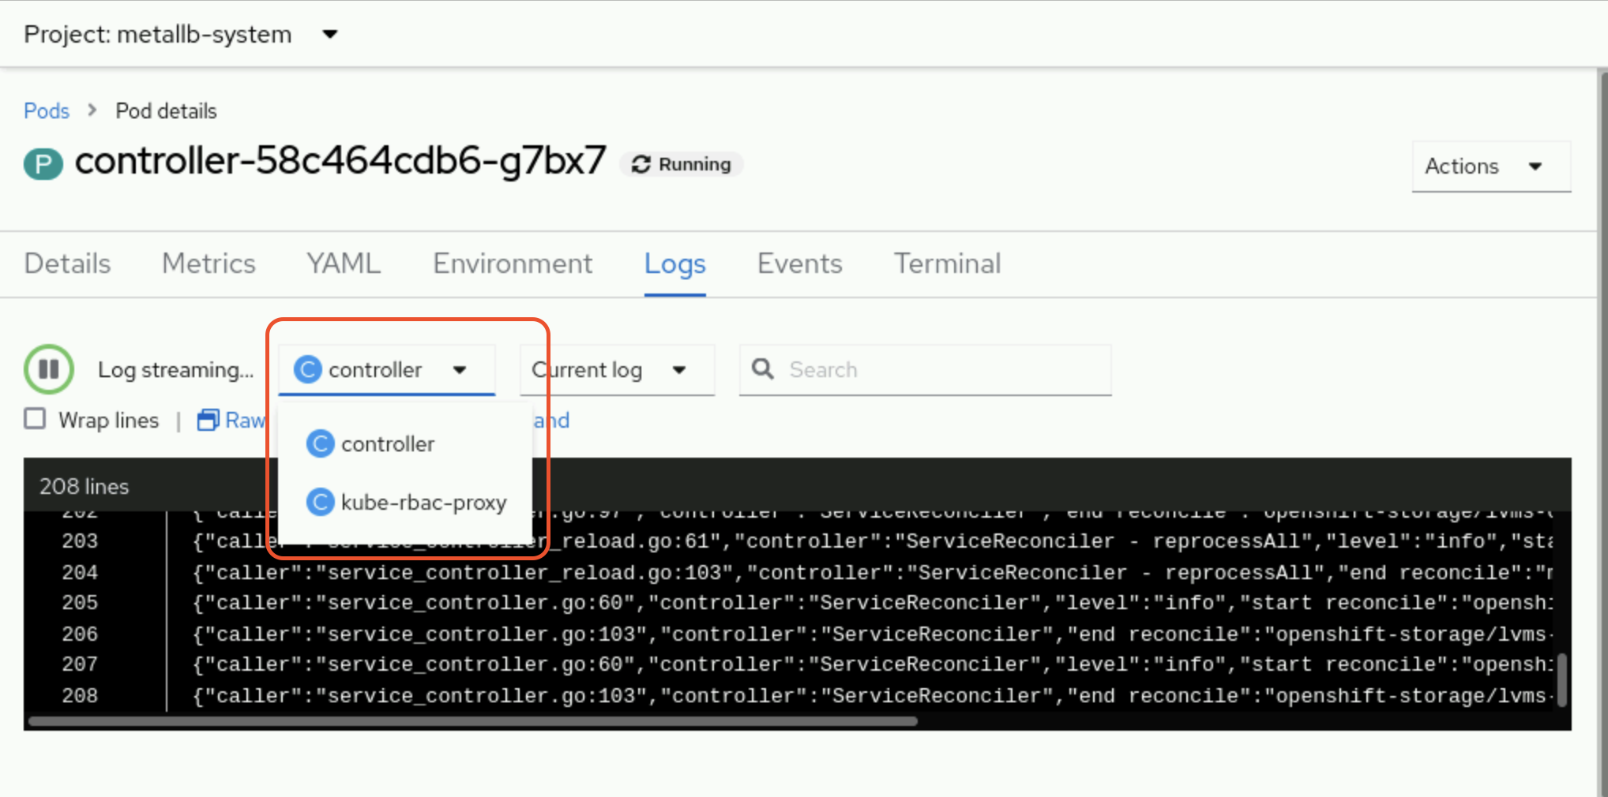
Deleting Resources
You can delete Kubernetes resources, such as pod resources, with the delete command. The delete command can delete resources by resource type and name, resource type and label, standard input (stdin), and with JSON or YAML-formatted files. The command accepts only one argument type at a time. For example, you can supply the resource type and name as a command argument.
[user@host ~]$ oc delete pod php-app
You can also delete pods from the web console by clicking Actions and then Delete Pod in the pod's principal menu.
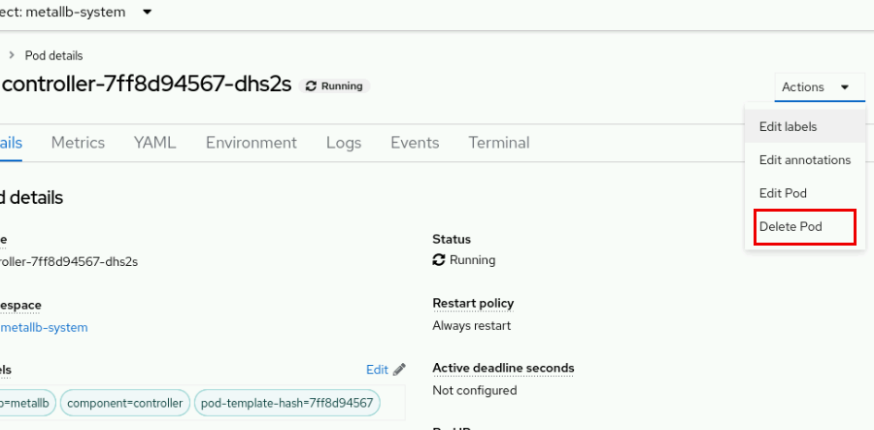
To select resources based on labels, you can include the -l option and the key:value label as a command argument.
[user@host ~]$ oc delete pod -l app=my-app
pod "php-app" deleted
pod "mysql-db" deleted
You can also provide the resource type and a JSON or YAML-formatted file that specifies the name of the resource. To use a file, you must include the -f option and provide the full path to the JSON or YAML-formatted file.
[user@host ~]$ oc delete pod -f ~/php-app.json
pod "php-app" deleted
You can also use stdin and a JSON or YAML-formatted file that includes the resource type and resource name with the delete command.
[user@host ~]$ cat ~/php-app.json | oc delete -f -
pod "php-app" deleted
Pods support graceful termination, which means that pods try to terminate their processes first before Kubernetes forcibly terminates the pods. To change the time period before a pod is forcibly terminated, you can include the --grace-period flag and a time period in seconds in your delete command. For example, to change the grace period to 10 seconds, use the following command:
[user@host ~]$ oc delete pod php-app --grace-period=10
To shut down the pod immediately, set the grace period to 1 second. You can also use the --now flag to set the grace period to 1 second.
[user@host ~]$ oc delete pod php-app --now
You can also forcibly delete a pod with the --force option. If you forcibly delete a pod, Kubernetes does not wait for a confirmation that the pod's processes ended, which can leave the pod's processes running until its node detects the deletion. Therefore, forcibly deleting a pod could result in inconsistency or data loss. Forcibly delete pods only if you are sure that the pod's processes are terminated.
[user@host ~]$ oc delete pod php-app --force
To delete all pods in a project, you can include the --all option.
[user@host ~]$ oc delete pods --all
pod "php-app" deleted
pod "mysql-db" deleted
Likewise, you can delete a project and its resources with the oc delete project project-name command.
[user@host ~]$ oc delete project my-app
project.project.openshift.io "my-app" deleted
The CRI-O Container Engine
A container engine is required to run containers. Worker and control plane nodes in a Red Hat OpenShift Container Platform cluster use the CRI-O container engine to run containers. Unlike tools such as Podman or Docker, the CRI-O container engine is a runtime that is designed and optimized specifically for running containers in a Kubernetes cluster. Because CRI-O meets the Kubernetes Container Runtime Interface (CRI) standards, the container engine can integrate with other Kubernetes and Red Hat OpenShift tools, such as networking and storage plug-ins.
Note
For more information about the Kubernetes Container Runtime Interface (CRI) standards, refer to the CRI-API repository at https://github.com/kubernetes/cri-api.
CRI-O provides a command-line interface to manage containers with the crictl command. The crictl command includes several subcommands to help you to manage containers. The following subcommands are commonly used with the crictl command:
Command | Description
crictl pods | List all pods on a node.
crictl image | List all images on a node.
crictl inspect | Retrieve the status of one or more containers.
crictl exec | Run a command in a running container.
crictl logs | Retrieve the logs of a container.
crictl ps | List running containers on a node.
To manage containers with the crictl command, you must first identify the node that is hosting your containers.
[user@host ~]$ oc get pods -o wide
NAME READY STATUS RESTARTS AGE IP NODE
postgresql-1-8lzf2 1/1 Running 0 20m 10.8.0.64 master01
postgresql-1-deploy 0/1 Completed 0 21m 10.8.0.63 master01
[user@host ~]$ oc get pod postgresql-1-8lzf2 \
-o jsonpath='{.spec.nodeName}{"\n"}'
master01
Next, you must connect to the identified node as a cluster administrator. Cluster administrators can use SSH to connect to a node or create a debug pod for the node. Regular users cannot connect to or create debug pods for cluster nodes. As a cluster administrator, you can create a debug pod for a node with the oc debug node/node-name command. Red Hat OpenShift creates the pod/node-name-debug pod in your currently selected project and automatically connects you to the pod. You must then enable access host binaries, such as the crictl command, with the chroot /host command. This command mounts the host's root file system in the /host directory within the debug pod shell. By changing the root directory to the /host directory, you can run binaries contained in the host's executable path.
[user@host ~]$ oc debug node/master01
Starting pod/master01-debug ...
To use host binaries, run chroot /host
Pod IP: 192.168.50.10
If you don't see a command prompt, try pressing enter.
sh-4.4# chroot /host
After enabling host binaries, you can use the crictl command to manage the containers on the node. For example, you can use the crictl ps and crictl inspect commands to retrieve the process ID (PID) of a running container. You can then use the PID to retrieve or enter the namespaces within a container, which is useful for troubleshooting application issues. To find the PID of a running container, you must first determine the container's ID. You can use the crictl ps command with the --name option to filter the command output to a specific container.
sh-5.1# crictl ps --name postgresql
CONTAINER IMAGE CREATED STATE NAME ATTEMPT POD ID POD
27943ae4f3024 image...7104 5...ago Running postgresql 0 5768...f015 po...
The default output of the crictl ps command is a table. You can find the short container ID under the CONTAINER column. You can also use the -o or --output options to specify the format of the crictl ps command as JSON or YAML and then parse the output. The parsed output displays the full container ID.
sh-5.1# crictl ps --name postgresql -o json | jq .containers[0].id
"2794...29a4"
After identifying the container ID, you can use the crictl inspect command and the container ID to retrieve the PID of the running container. By default, the crictl inspect command displays verbose output. You can use the -o or --output options to format the command output as JSON, YAML, a table, or as a Go template. If you specify the JSON format, you can then parse the output with the jq command. Likewise, you can use the grep command to limit the command output.
sh-5.1# crictl inspect -o json 27943ae4f3024 | jq .info.pid
43453
sh-5.1# crictl inspect 27943ae4f3024 | grep pid
"pid": 43453,
...output omitted...
Alternatively, use the built-in methods such as the go-template option to parse out the ID without using external tools.
sh-5.1# crictl inspect --output go-template \
--template '{{.info.pid}}' 27943ae4f3024
43453
After determining the PID of a running container, you can use the lsns -p PID command to list the system namespaces of a container.
sh-5.1# lsns -p 43453
NS TYPE NPROCS PID USER COMMAND
4026531835 cgroup 530 1 root /usr/lib/systemd/systemd --switche...
4026531837 user 530 1 root /usr/lib/systemd/systemd --switche...
4026537853 uts 8 43453 1000690000 postgres
4026537854 ipc 8 43453 1000690000 postgres
4026537856 net 8 43453 1000690000 postgres
4026538013 mnt 8 43453 1000690000 postgres
4026538014 pid 8 43453 1000690000 postgres
You can also use the PID of a running container with the nsenter command to enter a specific namespace of a running container. For example, you can use the nsenter command to execute a command within a specified namespace on a running container. The following example executes the ps -ef command within the process namespace of a running container.
sh-5.1# nsenter -t 43453 -p -r ps -ef
UID PID PPID C STIME TTY TIME CMD
1000690+ 1 0 0 18:49 ? 00:00:00 postgres
1000690+ 58 1 0 18:49 ? 00:00:00 postgres: logger
1000690+ 60 1 0 18:49 ? 00:00:00 postgres: checkpointer
1000690+ 61 1 0 18:49 ? 00:00:00 postgres: background writer
1000690+ 62 1 0 18:49 ? 00:00:00 postgres: walwriter
1000690+ 63 1 0 18:49 ? 00:00:00 postgres: autovacuum lau...
1000690+ 64 1 0 18:49 ? 00:00:00 postgres: stats collector
1000690+ 65 1 0 18:49 ? 00:00:00 postgres: logical replic...
root 7414 0 0 20:14 ? 00:00:00 ps -ef
The -t option specifies the PID of the running container as the target PID for the nsenter command. The -p option directs the nsenter command to enter the process or pid namespace. The -r option sets the top-level directory of the process namespace as the root directory, thus enabling commands to execute in the context of the namespace. You can also use the -a option to execute a command in all of the container's namespaces.
sh-5.1# nsenter -t 43453 -a ps -ef
UID PID PPID C STIME TTY TIME CMD
1000690+ 1 0 0 18:49 ? 00:00:00 postgres
1000690+ 58 1 0 18:49 ? 00:00:00 postgres: logger
1000690+ 60 1 0 18:49 ? 00:00:00 postgres: checkpointer
1000690+ 61 1 0 18:49 ? 00:00:00 postgres: background writer
1000690+ 62 1 0 18:49 ? 00:00:00 postgres: walwriter
1000690+ 63 1 0 18:49 ? 00:00:00 postgres: autovacuum lau...
1000690+ 64 1 0 18:49 ? 00:00:00 postgres: stats collector
1000690+ 65 1 0 18:49 ? 00:00:00 postgres: logical replic...
root 10058 0 0 20:45 ? 00:00:00 ps -ef

Guided Exercise: Create Linux Containers and Kubernetes Pods
Run a base OS container in a pod and compare the environment inside the container with its host node.
Outcomes
- Create a pod with a single container, and identify the pod and its container within the container engine of an OpenShift node.
- View the logs of a running container.
- Retrieve information inside a container, such as the operating system (OS) release and running processes.
- Identify the process ID (PID) and namespaces for a container.
- Identify the User ID (UID) and supplemental group ID (GID) ranges of a project.
- Compare the namespaces of containers in one pod versus in another pod.
- Inspect a pod with multiple containers, and identify the purpose of each container.
As the student user on the workstation machine, use the lab command to prepare your system for this exercise.
This command ensures that all resources are available for this exercise.
[student@workstation ~]$ lab start pods-containers
Instructions
- Log in to the OpenShift cluster and create the pods-containers project. Determine the UID and GID ranges for pods in the pods-containers project.
  - Log in to the OpenShift cluster as the developer user with the oc command.
[student@workstation ~]$ oc login -u developer -p developer \
https://api.ocp4.example.com:6443
Login successful
  - ...output omitted...
  - Create the pods-containers project.
[student@workstation ~]$ oc new-project pods-containers
Now using project "pods-containers" on server "https://api.ocp4.example.com:6443".
  - ...output omitted...
  - Identify the UID and GID ranges for pods in the pods-containers project.
[student@workstation ~]$ oc describe project pods-containers
Name: pods-containers
Created: 16 seconds ago
Labels: kubernetes.io/metadata.name=pods-containers
pod-security.kubernetes.io/audit=restricted
pod-security.kubernetes.io/audit-version=latest
pod-security.kubernetes.io/warn=restricted
pod-security.kubernetes.io/warn-version=latest
Annotations: openshift.io/description=
openshift.io/display-name=
openshift.io/requester=developer
openshift.io/sa.scc.mcs=s0:c28,c2
openshift.io/sa.scc.supplemental-groups=1000760000/10000
openshift.io/sa.scc.uid-range=1000760000/10000
Display Name: <none>
Description: <none>
Status: Active
Node Selector: <none>
Quota: <none>
  - Resource limits: <none>
  - Your UID and GID range values might differ from the previous output.
- As the developer user, create a pod called ubi9-user from a UBI9 base container image. The image is available in the registry.ocp4.example.com:8443/ubi9/ubi container registry. Set the restart policy to Never and start an interactive session. Configure the pod to execute the whoami and id commands to determine the UIDs, supplemental groups, and GIDs of the container user in the pod. Delete the pod afterward.
After the ubi-user pod is deleted, log in as the admin user and then re-create the ubi9-user pod. Retrieve the UIDs and GIDs of the container user. Compare the values to the values of the ubi9-user pod that the developer user created.
Afterward, delete the ubi9-user pod.
  - Use the oc run command to create the ubi9-user pod. Configure the pod to execute the whoami and id commands through an interactive bash shell session.
[student@workstation ~]$ oc run -it ubi9-user --restart 'Never' \
--image registry.ocp4.example.com:8443/ubi9/ubi \
-- /bin/bash -c "whoami && id"
1000760000
  - uid=1000760000(1000760000) gid=0(root) groups=0(root),1000760000
  - Your values might differ from the previous output.
Notice that the user in the container has the same UID that is identified in the pods-containers project. However, the GID of the user in the container is 0, which means that the user belongs to the root group. Any files and directories that the container processes might write to must have read and write permissions by GID=0 and have the root group as the owner.
Although the user in the container belongs to the root group, a UID value over 1000 means that the user is an unprivileged account. When a regular OpenShift user, such as the developer user, creates a pod, the containers within the pod run as unprivileged accounts.
  - Delete the pod.
[student@workstation ~]$ oc delete pod ubi9-user
  - pod "ubi9-user" deleted
  - Log in as the admin user with the redhatocp password.
[student@workstation ~]$ oc login -u admin -p redhatocp
Login successful.

You have access to 71 projects, the list has been suppressed. You can list all projects with 'oc projects'

  - Using project "pods-containers".
  - Re-create the ubi9-user pod as the admin user. Configure the pod to execute the whoami and id commands through an interactive bash shell session. Compare the values of the UID and GID for the container user to the values of the ubi9-user pod that the developer user created.
Note
It is safe to ignore pod security warnings when using a cluster-admin user that creates unmanaged pods. The admin user can create priviliged pods that the Security Context Constraints controller does not manage.
[student@workstation ~]$ oc run -it ubi9-user --restart 'Never' \
--image registry.ocp4.example.com:8443/ubi9/ubi \
-- /bin/bash -c "whoami && id"
Warning: would violate PodSecurity "restricted:v1.24": allowPrivilegeEscalation != false (container "ubi9-user" must set securityContext.allowPrivilegeEscalation=false), unrestricted capabilities (container "ubi9-user" must set securityContext.capabilities.drop=["ALL"]), runAsNonRoot != true (pod or container "ubi9-user" must set securityContext.runAsNonRoot=true), seccompProfile (pod or container "ubi9-user" must set securityContext.seccompProfile.type to "RuntimeDefault" or "Localhost")
root
  - uid=0(root) gid=0(root) groups=0(root)
  - Notice that the value of the UID is 0, which differs from the UID range value of the pod-containers project. The user in the container is the privileged account root user and belongs to the root group. When a cluster administrator creates a pod, the containers within the pod run as a privileged account by default.
  - Delete the ubi9-user pod.
[student@workstation ~]$ oc delete pod ubi9-user
  - pod "ubi9-user" deleted
- As the developer user, use the oc run command to create a ubi9-date pod from a UBI9 base container image. The image is available in the registry.ocp4.example.com:8443/ubi9/ubi container registry. Set the restart policy to Never, and configure the pod to execute the date command. Retrieve the logs of the ubi9-date pod to confirm that the date command executed. Delete the pod afterward.
  - Log in as the developer user with the developer password.
[student@workstation ~]$ oc login -u developer -p developer
Login successful.

You have one project on this server: "pods-containers"

  - Using project "pods-containers".
  - Create a pod called ubi9-date that executes the date command.
[student@workstation ~]$ oc run ubi9-date --restart 'Never' \
--image registry.ocp4.example.com:8443/ubi9/ubi -- date
  - pod/ubi9-date created
  - Wait a few moments for the creation of the pod. Then, retrieve the logs of the ubi9-date pod.
[student@workstation ~]$ oc logs ubi9-date
  - Mon Nov 28 15:02:55 UTC 2022
  - Delete the ubi9-date pod.
[student@workstation ~]$ oc delete pod ubi9-date
  - pod "ubi9-date" deleted
- Use the oc run ubi9-command -it command to create a ubi9-command pod with the registry.ocp4.example.com:8443/ubi9/ubi container image. Add the /bin/bash in the oc run command to start an interactive shell. Exit the pods and view the logs for the ubi9-command pod with the oc logs command. Then, connect to the ubi9-command pod with the oc attach command, and issue the following command:
- while true; do echo $(date); sleep 2; done
- This command executes the date and sleep commands to generate output to the console every two seconds. Use the oc logs command to retrieve the logs of the ubi9 pod, and confirm that the logs display the executed date and sleep commands.
  - Create a pod called ubi9-command and start an interactive shell.
[student@workstation ~]$ oc run ubi9-command -it \
--image registry.ocp4.example.com:8443/ubi9/ubi -- /bin/bash
If you don't see a command prompt, try pressing enter.
  - bash-5.1$
  - Exit the shell session.
bash-5.1$ exit
exit
  - Session ended, resume using 'oc attach ubi9-command -c ubi9-command -i -t' command when the pod is running
  - Use the oc logs command to view the logs of the ubi9-command pod.
[student@workstation ~]$ oc logs ubi9-command
  - bash-5.1$ [student@workstation ~]$
  - The pod's command prompt is returned. The oc logs command displays the pod's current stdout and stderr output in the console. Because you disconnected from the interactive session, the pod's current stdout is the command prompt, and not the commands that you executed previously.
  - Use the oc attach command to connect to the ubi9-command pod again. In the shell, execute the while true; do echo $(date); sleep 2; done command to continuously generate stdout output.
[student@workstation ~]$ oc attach ubi9-command -it
  - If you don't see a command prompt, try pressing enter.
bash-5.1$ while true; do echo $(date); sleep 2; done
Mon Nov 28 15:15:16 UTC 2022
Mon Nov 28 15:15:18 UTC 2022
Mon Nov 28 15:15:20 UTC 2022
Mon Nov 28 15:15:22 UTC 2022
  - ...output omitted...
  - Open another terminal window and view the logs for the ubi9-command pod with the oc logs command. Limit the log output to the last 10 entries with the --tail option. Confirm that the logs display the results of the command that you executed in the container.
[student@workstation ~]$ oc logs ubi9-command --tail=10
Mon Nov 28 15:15:16 UTC 2022
Mon Nov 28 15:15:18 UTC 2022
Mon Nov 28 15:15:20 UTC 2022
Mon Nov 28 15:15:22 UTC 2022
Mon Nov 28 15:15:24 UTC 2022
Mon Nov 28 15:15:26 UTC 2022
Mon Nov 28 15:15:28 UTC 2022
Mon Nov 28 15:15:30 UTC 2022
Mon Nov 28 15:15:32 UTC 2022
  - Mon Nov 28 15:15:34 UTC 2022
- Identify the name for the container in the ubi9-command pod. Identify the process ID (PID) for the container in the ubi9-command pod by using a debug pod for the pod's host node. Use the crictl command to identify the PID of the container in the ubi9-command pod. Then, retrieve the PID of the container in the debug pod.
  - Identify the container name in the ubi9-command pod with the oc get command. Specify the JSON format for the command output. Parse the JSON output with the jq command to retrieve the value of the .status.containerStatuses[].name object.
[student@workstation ~]$ oc get pod ubi9-command -o json | \
jq .status.containerStatuses[].name
  - "ubi9-command"
  - The ubi9-command pod has a single container of the same name.
  - Find the host node for the ubi9-command pod. Start a debug pod for the host with the oc debug command.
[student@workstation ~]$ oc get pods ubi9-command -o wide
NAME READY STATUS RESTARTS AGE IP NODE ...
  - ubi9-command 1/1 Running 2 (16m ago) 27m 10.8.0.26 master01 ...
[student@workstation ~]$ oc debug node/master01
  - Error from server (Forbidden): nodes "master01" is forbidden: User "developer" cannot get resource "nodes" in API group "" at the cluster scope
  - The debug pod fails because the developer user does not have the required permission to debug a host node.
  - Log in as the admin user with the redhatocp password. Start a debug pod for the host with the oc debug command. After connecting to the debug pod, run the chroot /host command to use host binaries, such as the crictl command-line tool.
[student@workstation ~]$ oc login -u admin -p redhatocp
Login successful.
  - ...output omitted...
[student@workstation ~]$ oc debug node/master01
Starting pod/master01-debug ...
To use host binaries, run `chroot /host`
Pod IP: 192.168.50.10
  - If you don't see a command prompt, try pressing enter
  - sh-4.4# chroot /host
  - Use the crictl ps command to retrieve the ubi9-command container ID. Specify the ubi9-command container with the --name option and use the JSON output format. Parse the JSON output with the jq -r command to get the RAW JSON output. Export the container ID as the $CID environment variable.
Note
When using jq without the -r flag, the container ID is wrapped in double quotes, which does not work with crictl commands. If the -r flag is not used, then you can add | tr -d '"' to the end of the command to trim the double quotes.
sh-5.1# crictl ps --name ubi9-command -o json | jq -r .containers[0].id
  - 81adbc6222d79ed9ba195af4e9d36309c18bb71bc04b2e8b5612be632220e0d6
  - sh-5.1# CID=$(crictl ps --name ubi9-command -o json | jq -r .containers[0].id)
sh-5.1# echo $CID
  - 81adbc6222d79ed9ba195af4e9d36309c18bb71bc04b2e8b5612be632220e0d6
  - Your container ID value might differ from the previous output.
  - Use the crictl inspect command to find the PID of the ubi9-command container. The PID value is in the .info.pid object in the crictl inspect output. Export the ubi9-command container PID as the $PID environment variable.
sh-5.1# crictl inspect $CID | grep pid
"pid": 365297,
"pids": {
"type": "pid"
...output omitted...
}
  - ...output omitted...
  - sh-5.1# PID=365297
  - Your PID values might differ from the previous output.
- Use the lsns command to list the system namespaces of the ubi9-command container. Confirm that the running processes in the container are isolated to different system namespaces.
  - View the system namespaces of the ubi9-command container with the lsns command. Specify the PID with the -p option and use the $PID environment variable. In the resulting table, the NS column contains the namespace values for the container.
sh-5.1# lsns -p $PID
NS TYPE NPROCS PID USER COMMAND
4026531835 cgroup 540 1 root /usr/lib/systemd/systemd --swit ...
4026531837 user 540 1 root /usr/lib/systemd/systemd --swit ...
4026536117 uts 1 153168 1000800000 /bin/bash
4026536118 ipc 1 153168 1000800000 /bin/bash
4026536120 net 1 153168 1000800000 /bin/bash
4026537680 mnt 1 153168 1000800000 /bin/bash
  - 4026537823 pid 1 153168 1000800000 /bin/bash
  - Your namespace values might differ from the previous output.
- Use the host debug pod to retrieve and compare the operating system (OS) and the GCC support library (libgcc) package version of the ubi9-command container and the host node.
  - Retrieve the OS for the host node with the cat /etc/redhat-release command.
sh-5.1# cat /etc/redhat-release
  - Red Hat Enterprise Linux CoreOS release 4.18
  - Use the crictl exec command and the $CID container ID variable to retrieve the OS of the ubi9-command container. Use the -it options to create an interactive terminal to execute the cat /etc/redhat-release command.
sh-5.1# crictl exec -it $CID cat /etc/redhat-release
  - Red Hat Enterprise Linux release 9.6 (Plow)
  - The ubi9-command container has a different OS from the host node.
  - Use the rpm -qi libgcc command to retrieve the libgcc package version of the host node.
sh-5.1$ rpm -qi libgcc
Name: libgcc
Version: 11.4.1
  - ...output omitted...
  - Use the crictl exec command and the $CID container ID variable to retrieve the glibc package version of the ubi9-command container. Use the -it options to create an interactive terminal to execute the rpm -qi libgcc command.
sh-5.1# crictl exec -it $CID rpm -qi libgcc
Name: libgcc
Version: 11.5.0
  - ...output omitted...
  - The ubi9-command container might have a different version of the libgcc package from its host.
- Exit the master01-debug pod and the ubi9-command pod.
  - Exit the master01-debug pod. You must issue the exit command to end the host binary access. Execute the exit command again to exit and remove the master01-debug pod.
sh-5.1# exit
  - exit
sh-4.4# exit
exit

Removing debug pod ...
  - Temporary namespace openshift-debug-bg7kn was removed.
  - Return to the terminal window that is connected to the ubi9-command pod. Press Ctrl+C and then execute the exit command. Confirm that the pod is still running.
...output omitted...
^C
bash-5.1$ exit
exit
  - Session ended, resume using 'oc attach ubi9-command -c ubi9-command -i -t' command when the pod is running
[student@workstation ~]$ oc get pods
NAME READY STATUS RESTARTS AGE
  - ubi9-command 1/1 Running 2 (6s ago) 35m
Finish
On the workstation machine, use the lab command to complete this exercise. This step is important to ensure that resources from previous exercises do not impact upcoming exercises.
[student@workstation ~]$ lab finish pods-containers

Find and Inspect Container Images

Objectives
- Find containerized applications in container registries and get information about the runtime parameters of supported and community container images.

Container Image Overview
A container is an isolated runtime environment where applications are executed as isolated processes. The isolation of the runtime environment ensures that applications do not interfere with other containers or system processes.
A container image contains a packaged version of your application, with all the necessary dependencies for the application to run. Images can exist without containers. However, containers depend on images, because containers use container images to build a runtime environment to execute applications.
Containers can be split into two similar but distinct concepts: container images and container instances. A container image contains immutable data that defines an application and its libraries. You can use container images to create container instances, which are running processes that are isolated by a set of kernel namespaces.
You can use each container image many times to create distinct container instances. These replicas can be split across multiple hosts. The application within a container is independent of the host environment.

Container Image Registries
Image registries are services that offer container images to download. Image creators and maintainers can store and distribute container images in a controlled manner to public or private audiences. Some examples of image registries include Quay.io, Red Hat Registry, Docker Hub, and Amazon ECR.

Red Hat Registry
Red Hat distributes container images through the Red Hat Ecosystem Catalog, https://catalog.redhat.com/, which provides a centralized searching utility. You can search the Red Hat Ecosystem Catalog for technical details about container images. The catalog hosts a large set of container images, including from major open source projects, such as Apache, MySQL, and Jenkins. Although many of the container images are publicly available, authentication to the website is required to access the container images that are not available in the public domain.
Because the Red Hat Ecosystem Catalog also contains software products other than container images, go to https://catalog.redhat.com/software/containers/explore to search for specific container images.
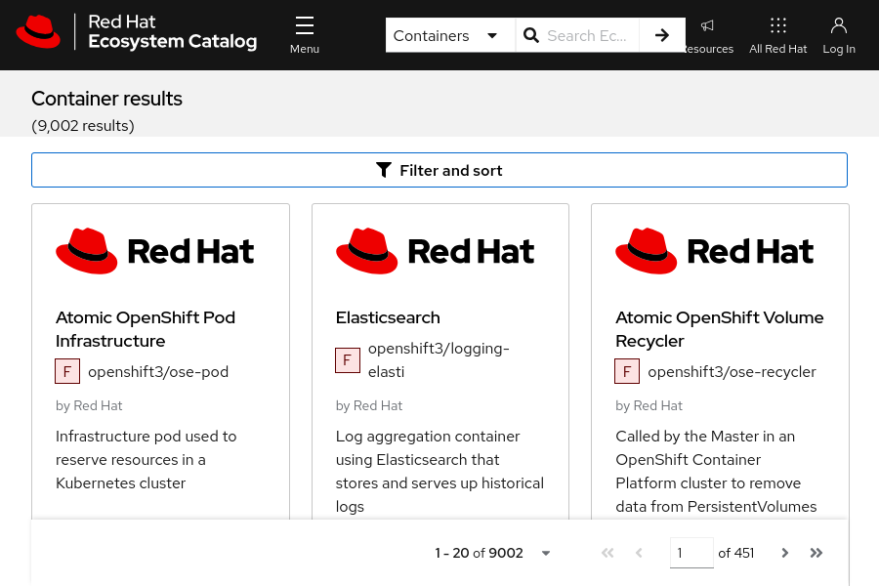
Figure 3.4: Red Hat Ecosystem Catalog
The details page of a container image includes relevant information, such as technical data, the installed packages within the image, or a security scan. You can navigate through these options by using the tabs on the website. You can also change the image version by selecting a specific tag.
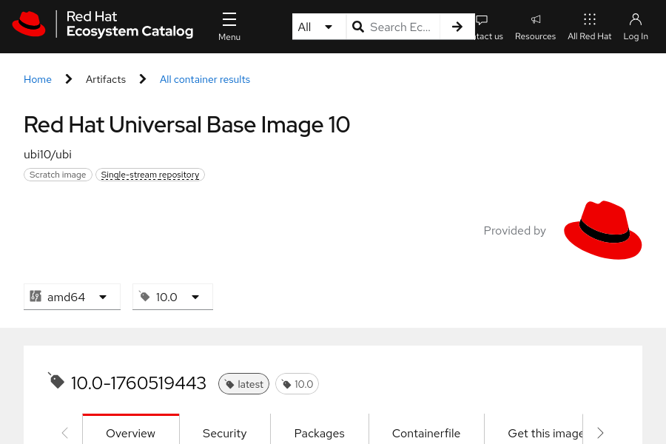
Figure 3.5: The Red Hat Universal Base Image 10 details page
The Red Hat internal security team validates all images in the container catalog. Red Hat rebuilds all components to avoid known security vulnerabilities.
Red Hat container images provide the following benefits:
- Trusted source: All container images use sources that Red Hat knows and trusts.
- Original dependencies: None of the container packages are altered, and they include only known libraries.
- Vulnerability-free: Container images are without known critical vulnerabilities in the platform components or layers.
- Runtime protection: All applications in container images run as non-root users to minimize the exposure surface to malicious or faulty applications.
- Red Hat Enterprise Linux (RHEL) compatible: Container images are compatible with all RHEL platforms, from bare metal to cloud.
- Red Hat support: Red Hat commercially supports the container images in the catalog.

Note
You must log in to the catalog website with a customer portal account or a Red Hat Developer account to use the stored container images in the registry.

Quay.io
Although the Red Hat Registry stores only images from Red Hat and certified providers, you can store your own images with Quay.io, which is another public image registry that Red Hat sponsors. Although storing public images in Quay is without cost, some options are available only for paying customers. Quay also offers an on-premise version of the product, to set up a localized image registry in your own servers.
Quay.io introduces features such as server-side image building, fine-grained access controls, and automatic scanning of images for known vulnerabilities.
Quay.io offers live images that creators regularly update. Quay.io users can create their namespaces, with fine-grained access control, and publish their created images to that namespace. Container Catalog users seldom push new images, and mostly consume trusted images from the Red Hat team.
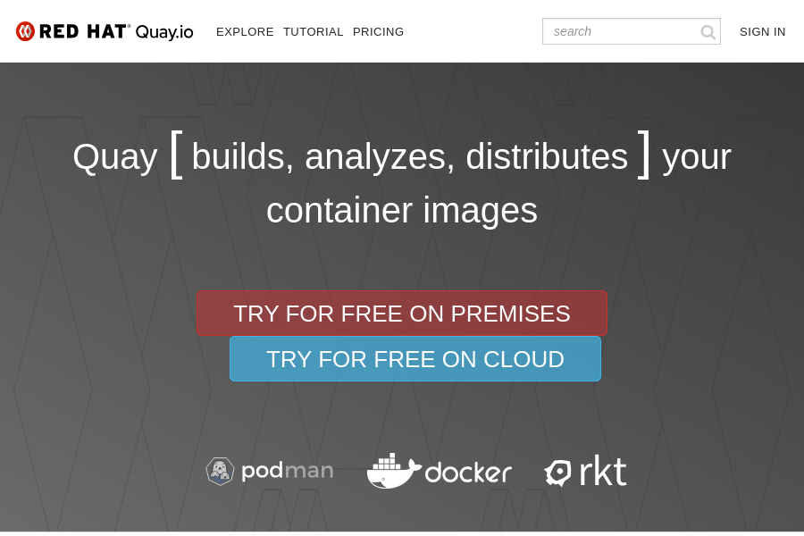
Figure 3.6: The Quay.io welcome page

Private Registries
Image creators or maintainers can choose to make their images publicly available. However, other image creators might prefer to keep their images private, for the following reasons:
- Company privacy and protection of secrets
- Legal restrictions and laws
- Avoidance of publishing images in development
In some cases, private images are preferred. Private images are more secure than images in public registries. Private registries give image creators control over image placement, distribution, and usage.

Public Registries
Other public registries, such as Docker Hub and Amazon ECR, are also available for storing, sharing, and consuming container images. These registries can include official images that the registry owners or the registry community users create and maintain. For example, Docker Hub hosts a Docker Official Image of a WordPress container image. Although the docker.io/library/wordpress container image is a Docker Official Image, the container image is not supported by WordPress, Docker, or Red Hat. Instead, the Docker Community, which is a global group of Docker Hub users, supports and maintains the container image. Support for this container image depends on the availability and skills of the Docker Community users.
Consuming container images from public registries brings risks. For example, a container image might include malicious code or vulnerabilities, which can compromise the host system that executes the container image. A host system can also be compromised by public container images, because the images often execute by using the privileged root user. Additionally, the software in a container image might not be correctly licensed, or violate licensing terms.
Before you use a container image from a public registry, review and test the container image for your environment. Also ensure that you have the correct permissions to use the software in the container image.

Container Image Identifiers
Several objects provide identifying information about a container image.
Registry
A registry is a content server, such as registry.access.redhat.com, to store and share container images. A registry consists of one or more repositories that contain tagged container images.
Name
The name identifies the container image repository, and contains a string of letters, numbers, and special characters. The name refers to the directory or container repository within the container registry where the container image is stored.
For example, consider the fully qualified domain name (FQDN) of the registry.access.redhat.com/ubi10/httpd-24:1-233 container image. The container image is in the ubi10/httpd-24 repository in the registry.access.redhat.com container registry.
ID or Hash
The ID or hash is the SHA (Secure Hash Algorithm) code to uniquely locate, pull, or verify an image within the registry. The SHA image ID cannot change, and always references the same container image content. The ID or hash is the unique identifier for a container image. For example, the sha256:4186a1ead13fc30796f951694c494e7630b82c320b81e20c020b3b07c888985b image ID always refers to the registry.access.redhat.com/ubi10/httpd-24:1 container image.
Tag
The tag is a label for a container image in a repository to distinguish the specific image from others, for version control. The tag comes after the image repository name and is delimited by a colon (:).
When an image tag is omitted, the floating tag, latest, is used as the default tag. A floating tag is an alias to another tag. In contrast, a fixed tag points to a specific container build. For example, the registry.access.redhat.com/ubi10/httpd-24:1 container image, 1 is the fixed tag for the image, and corresponds to the floating latest flag until a later image is registered.

Container Image Components
A container image is composed of multiple components.
Layers
Container images are created from instructions. Each instruction adds a layer to the container image. Each layer consists of the differences between it and the following layer. The layers are then stacked to create a read-only container image.
Metadata
Metadata includes the instructions and documentation for a container image.

Container Image Instructions and Metadata
Container image layers consist of instructions, or steps, and metadata for building the image. You can override instructions during container creation to adjust the container image according to your needs. Some instructions can affect the running container, and other instructions are for informational purposes only.
The following instructions affect the state of a running container:
ENV
Defines the available environment variables in the container. A container image might include multiple ENV instructions. Any container can recognize additional environment variables that are not listed in its metadata.
ARG
Defines build-time variables, typically to make a customizable container build. Developers commonly configure the ENV instructions by using the ARG instruction. ARG is useful for preserving the build-time variables for run time.
USER
Defines the active user in the container. Later instructions run as this user. It is a good practice to define a user other than root for security purposes. OpenShift does not honor the user in a container image, for regular cluster users. Only cluster administrators can run containers (pods) with their chosen user IDs (UIDs) and group IDs (GIDs).
ENTRYPOINT
Defines the executable to run when the container is started.
CMD
Defines the command to execute when the container is started. This command is passed to the executable that the ENTRYPOINT instruction defines. Base images define a default ENTRYPOINT executable, which is usually a shell executable, such as Bash.
WORKDIR
Defines the current working directory within the container. Later instructions execute within this directory.
Metadata is used for documentation purposes, and does not affect the state of a running container. You can also override the metadata values during container creation.
The following metadata is for information only, and does not affect the state of the running container:
EXPOSE
Specifies the network port that the application binds to within the container. This metadata does not automatically bind the port on the host, and is used only for documentation purposes.
VOLUME
Defines where to store data outside the container. The value shows the path where your container runtime mounts the directory inside the container. More than one path can be defined to create multiple volumes.
LABEL
Defines a key-value pair in the metadata of the image for organization and image selection.
Container engines are not required to honor metadata in a container image, such as USER or EXPOSE. A container engine can also recognize additional environment variables that are not listed in the container image metadata.

Base Images
A base image is the image that your resulting container image is built on. Your chosen base image determines the Linux distribution and any of the following components:
- Package manager
- Init system
- File-system layout
- Preinstalled dependencies and runtimes
The base image can also influence factors such as image size, vendor support, and processor compatibility.
Red Hat provides enterprise-grade container images that are engineered to be the base operating system layer for your containerized applications. These container images are intended as a common starting point for containers, and are known as universal base images (UBI). Red Hat UBI container images are Open Container Initiative (OCI) compliant images that contain portions of Red Hat Enterprise Linux. UBI container images include a subset of RHEL content. They provide a set of prebuilt runtime languages, such as Python and Node.js, and associated DNF repositories to add application dependencies. UBI-based images can be distributed without cost or restriction. These images can be deployed to both Red Hat and non-Red Hat platforms, and be pushed to your chosen container registry.
A Red Hat subscription is not required to use or distribute UBI-based images. However, Red Hat provides full support for containers that are built on UBI only if the containers are deployed to a Red Hat platform, such as an RHOCP cluster or RHEL.
Red Hat provides four UBI variants: standard, init, minimal, and micro. All UBI variants and UBI-based images use RHEL at their core and are available from the Red Hat Container Catalog. The main differences are as follows:
Standard
This image is the primary UBI, which includes DNF, systemd, and utilities such as gzip and tar.
Init
This image simplifies running multiple applications within a single container by managing them with systemd.
Minimal
This image is smaller than the init image and provides nice-to-have features. This image uses the microdnf minimal package manager instead of the full-sized version of DNF.
Micro
This image is the smallest available UBI, and includes only the minimum packages. For example, this image does not include a package manager.
Additionally, Red Hat provides language-specific runtime images, such as for python and node.js.

Inspecting and Managing Container Images
Various tools can inspect and manage container images, including the oc image command and Skopeo.

Skopeo
Skopeo is a tool to inspect and manage remote container images. With Skopeo, you can copy and synchronize container images from different container registries and repositories. You can copy an image from a remote repository and save it to a local disk. If you have the appropriate repository permissions, then you can delete an image from container registry. You can use Skopeo to inspect the configuration and contents of a container image, and to list the available tags for a container image. Unlike other container image tools, Skopeo can execute without a privileged account such as root. Skopeo does not require a running daemon to execute various operations.
Skopeo is executed with the skopeo command-line utility, which you can install with various package managers, such as DNF, Brew, or APT. The skopeo utility might already be installed on some Linux-based distributions. You can install the skopeo utility on Fedora, CentOS Stream 8 and later, and Red Hat Enterprise Linux 8 and later systems, by using the DNF package manager.
[user@host ~]$ sudo dnf -y install skopeo
The skopeo utility is currently not available as a packaged binary for Windows-based systems. However, the skopeo utility is available as a container image from the quay.io/skopeo/stable container repository. For more information about the Skopeo container image, refer to the skopeoimage overview guide in the Skopeo repository at https://github.com/containers/image_build/tree/main/skopeo
You can alternatively build skopeo from source code in a container, or build it locally without using a container. Refer to the installation guide in the Skopeo repository for more information about installing or building Skopeo from source code at https://github.com/containers/skopeo/blob/main/install.md#container-images
The skopeo utility provides commands for managing and inspecting container images and container image registries. For container registries that require authentication, you must first log in to a registry before you can execute additional skopeo commands.
[user@host ~]$ skopeo login quay.io

Note
OpenShift clusters are typically configured with registry credentials. When a pod is created from a container image in a remote repository, OpenShift authenticates to the container registry with the configured registry credentials, and then pulls the image, to copy from the remote repository. Because OpenShift automatically uses the registry credentials, you typically do not need to manually authenticate to a container registry when you create a pod. By contrast, the oc image command and the skopeo utility require you first to log in to a container registry.
After you log in to a container registry (if required), you can execute additional skopeo commands against container images in a repository. When you execute a skopeo command, you must specify the transport and the repository name. A transport is the mechanism to transfer container images between locations. Two common transports are docker and dir. The docker transport is used for container registries, and the dir transport is used for local directories.
The oc image command and other tools default to the docker transport, and so you do not need to specify the transport when executing commands. However, the skopeo utility does not define a default transport; you must specify the transport with the container image name. Most skopeo commands use the skopeo command [command options] transport://IMAGE-NAME format. For example, the following skopeo list-tags command lists all available tags in a registry.access.redhat.com/ubi10/httpd-24 container repository by using the docker transport:
[user@host ~]$ skopeo list-tags docker://registry.access.redhat.com/ubi10/httpd-24
{
"Repository": "registry.access.redhat.com/ubi10/httpd-24",
"Tags": [
"1",
...output omitted...
"latest"
...output omitted...
The skopeo utility includes other commands for container image management.
skopeo inspect
View detailed information for an image name, such as environment variables and available tags. Use the skopeo inspect [command options] transport://IMAGE-NAME command format. You can include the --config flag to view the configuration, metadata, and history of a container repository. The following example retrieves the configuration information for the registry.access.redhat.com/ubi10/httpd-24 container repository:
[user@host ~]$ skopeo inspect --config docker://registry.access.redhat.com/ubi10/httpd-24
...output omitted...
"config": {
"User": "1001",
"ExposedPorts": {
"8080/tcp": {},
"8443/tcp": {}
},
"Env": [
...output omitted...
"HTTPD_MAIN_CONF_PATH=/etc/httpd/conf",
"HTTPD_MAIN_CONF_MODULES_D_PATH=/etc/httpd/conf.modules.d",
"HTTPD_MAIN_CONF_D_PATH=/etc/httpd/conf.d",
"HTTPD_TLS_CERT_PATH=/etc/httpd/tls",
"HTTPD_VAR_RUN=/var/run/httpd",
"HTTPD_DATA_PATH=/var/www",
"HTTPD_DATA_ORIG_PATH=/var/www",
"HTTPD_LOG_PATH=/var/log/httpd"
],
"Entrypoint": [
"container-entrypoint"
],
"Cmd": [
"/usr/bin/run-httpd"
],
"WorkingDir": "/opt/app-root/src",
...output omitted...
}
...output omitted...
skopeo copy
Copy an image from one location or repository to another. Use the skopeo copy transport://SOURCE-IMAGE transport://DESTINATION-IMAGE format. For example, the following command copies the quay.io/skopeo/stable:latest container image to the skopeo repository in the registry.example.com container registry:
[user@host ~]$ skopeo copy docker://quay.io/skopeo/stable:latest \
docker://registry.example.com/skopeo:latest
skopeo delete
Delete a container image from a repository. Use the skopeo delete [command options] transport://IMAGE-NAME format. The following command deletes the skopeo:latest image from the registry.example.com container registry:
[user@host ~]$ skopeo delete docker://registry.example.com/skopeo:latest
skopeo sync
Synchronize one or more images from one location to another. Use this command to copy all container images from a source to a destination. Use the skopeo sync [command options] --src transport --dest transport SOURCE DESTINATION format. The following command synchronizes the registry.access.redhat.com/ubi10/httpd-24 container repository to the registry.example.com/httpd-24 container repository:
[user@host ~]$ skopeo sync --src docker --dest docker \
registry.access.redhat.com/ubi10/httpd-24 registry.example.com/httpd-24

Registry Credentials
Some registries require users to authenticate before accessing container images and metadata. For example, Red Hat containers that are based on RHEL typically require authenticated access:
[user@host ~]$ skopeo inspect docker://registry.redhat.io/rhel10/httpd-24
FATA[0000] Error parsing image name "docker://registry.redhat.io/rhel10/httpd-24": unable to retrieve auth token: invalid username/password: unauthorized: Please login to the Red Hat Registry using your Customer Portal credentials. Further instructions can be found here: https://access.redhat.com/RegistryAuthentication
You might choose a different image that does not require authentication, such as the UBI 10 image:
[user@host ~]$ skopeo inspect docker://registry.access.redhat.com/ubi10:latest
{
"Name": "registry.access.redhat.com/ubi10",
"Digest": "sha256:b515...",
"RepoTags": [
"10.0",
"10.0-1745487123",
...output omitted....
Alternatively, you must execute the skopeo login command for the registry before you can access protected images.
[user@host ~]$ skopeo login registry.redhat.io
Username: YOUR_USER
Password: YOUR_PASSWORD
Login Succeeded!
Skopeo stores the credentials in the ${XDG_RUNTIME_DIR}/containers/auth.json file, where ${XDG_RUNTIME_DIR} refers to a directory that is specific to the current user. The credentials are encoded in Base64 format:
[user@host ~]$ cat ${XDG_RUNTIME_DIR}/containers/auth.json
{
"auths": {
"registry.redhat.io": {
"auth": "dXNlcjpodW50ZXIy"
}
}
}
[user@host ~]$ echo -n dXNlcjpodW50ZXIy | base64 -d
user:hunter2

Note
For security reasons, the skopeo login command does not show your password in the interactive session. Although you do not see what you are typing, Skopeo registers every keystroke. After typing your full password in the interactive session, press Enter to start the login.

The oc image Command
The OpenShift command-line interface provides the oc image command. You can use this command to inspect, configure, or retrieve information about container images.
The oc image info command inspects and retrieves information about a container image. You can use the oc image info command to identify the ID or hash SHA and to list the image layers of a container image. You can also review container image metadata, such as environment variables, network ports, and commands. If a container image repository provides a container image in multiple architectures, such as AMD64 or ARM64, then you must include the --filter-by-os tag. For example, you can execute the following command to retrieve information about the registry.access.redhat.com/ubi10/httpd-24:10.0 container image that is based on the AMD64 architecture:
[user@host ~]$ oc image info registry.access.redhat.com/ubi10/httpd-24 \
--filter-by-os amd64
Name: registry.access.redhat.com/ubi10/httpd-24:10.0
Digest: sha256:b765...
...output omitted...
The oc image command provides more options for managing container images.
oc image append
Use this command to add layers to container images, and then push the container image to a registry.
oc image extract
You can use this command to extract or copy files from a container image to a local disk. Use this command to access the contents of a container image without first running the image as a container. A running container engine is not required.
oc image mirror
Copy, or mirror, container images from one container registry or repository to another. For example, you can use this command to mirror container images between public and private registries. You can also use this command to copy a container image from a registry to a disk. The command mirrors the HTTP structure of a container registry to a directory on a disk. The directory on the disk can then be served as a container registry.

Running Containers as Root
Running containers as the root user is a security risk, because an attacker could exploit the application, access the container, and exploit vulnerabilities to escape from the containerized environment and access the host system. Attackers might escape the containerized environment by exploiting bugs and vulnerabilities that are typically in the kernel or the container runtime.
Traditionally, when an attacker gains access to the container file system by using an exploit, the root user inside the container corresponds to the root user on the host system. If an attacker escapes the container isolation, then they have access to elevated privileges on the host system, which provides a vector of attack that could cause damage.
Containers that do not run as the root user might prove unsuitable for use in your application because of the following limitations:
Non-trivial Containerization
Some applications might require the root user. Depending on the application architecture, some applications might not be suitable for non-privileged containers, or might require additional experience to containerize.
For example, applications such as HTTPd and Nginx start a bootstrap process and then create a process with a non-privileged user, which interacts with external users. Such applications are non-trivial to containerize for non-privileged use.
Red Hat provides containerized versions of HTTPd and Nginx that do not require root privileges for production usage. You can peruse these validated containers in the Red Hat container registry (https://catalog.redhat.com/software/containers/explore).
Required Use of Privileged Utilities
Non-privileged containers cannot bind to privileged ports, such as the 80 or 443 ports. Red Hat advises against using privileged ports. Instead, use port forwarding to avoid the use of privileged ports within container definitions.
Similarly, non-privileged containers cannot use the ping utility by default, because it requires elevated privileges to establish raw sockets.

Guided Exercise: Find and Inspect Container Images
Use a supported MySQL container image to run server and client pods in Kubernetes; also test two community images and compare their runtime requirements.
Outcomes
- Locate and run container images from a container registry.
- Inspect remote container images and container logs.
- Set environment variables and override entry points for a container.
- Access files and directories within a container.
As the student user on the workstation machine, use the lab command to prepare your system for this exercise.
This command ensures that all resources are available for this exercise.
[student@workstation ~]$ lab start pods-images
Instructions
- Log in to the OpenShift cluster and create the pods-images project.
  - Log in to the OpenShift cluster as the developer user with the oc command.
[student@workstation ~]$ oc login -u developer -p developer \
https://api.ocp4.example.com:6443
  - ...output omitted...
  - Create the pods-images project.
[student@workstation ~]$ oc new-project pods-images
  - ...output omitted...
- Authenticate to registry.ocp4.example.com:8443, which is the classroom container registry. This private registry hosts certain copies and tags of community images from Docker and Bitnami, as well as some supported images from Red Hat. Use skopeo to log in as the developer user, and then retrieve a list of available tags for the registry.ocp4.example.com:8443/redhattraining/docker-nginx container repository.
  - Use the skopeo login command to log in as the developer user with the developer password.
[student@workstation ~]$ skopeo login registry.ocp4.example.com:8443
Username: developer
Password: developer
  - Login Succeeded!
  - The classroom registry contains a copy and specific tags of the docker.io/library/nginx container repository. Use the skopeo list-tags command to retrieve a list of available tags for the registry.ocp4.example.com:8443/redhattraining/docker-nginx container repository.
[student@workstation ~]$ skopeo list-tags \
docker://registry.ocp4.example.com:8443/redhattraining/docker-nginx
{
"Repository": "registry.ocp4.example.com:8443/redhattraining/docker-nginx",
"Tags": [
"1.23",
"1.23-alpine",
"1.23-alpine-perl",
"1.23-perl"
"latest"
]
  - }
- Create a docker-nginx pod from the registry.ocp4.example.com:8443/redhattraining/docker-nginx:1.23 container image. Investigate any pod failures.
  - Use the oc run command to create the docker-nginx pod.
[student@workstation ~]$ oc run docker-nginx \
--image registry.ocp4.example.com:8443/redhattraining/docker-nginx:1.23
  - pod/docker-nginx created
  - After a few moments, verify the status of the docker-nginx pod.
[student@workstation ~]$ oc get pods
NAME READY STATUS RESTARTS AGE
  - docker-nginx 0/1 Error 2 (23s ago) 4s
[student@workstation ~]$ oc get pods
NAME READY STATUS RESTARTS AGE
  - docker-nginx 0/1 CrashLoopBackOff 3 (29s ago) 38s
  - The docker-nginx pod failed to start.
  - Investigate the pod failure. Retrieve the logs of the docker-nginx pod to identify a possible cause of the pod failure.
[student@workstation ~]$ oc logs docker-nginx
...output omitted...
/docker-entrypoint.sh: Configuration complete; ready for start up
2025/08/24 18:51:45 [warn] 1#1: the "user" directive makes sense only if the master process runs with super-user privileges, ignored in /etc/nginx/nginx.conf:2
nginx: [warn] the "user" directive makes sense only if the master process runs with super-user privileges, ignored in /etc/nginx/nginx.conf:2
2025/08/24 18:51:45 [emerg] 1#1: mkdir() "/var/cache/nginx/client_temp" failed (13: Permission denied)
  - nginx: [emerg] mkdir() "/var/cache/nginx/client_temp" failed (13: Permission denied)
  - The pod failed to start because of permission issues for the nginx directories.
  - Create a debug pod for the docker-nginx pod.
[student@workstation ~]$ oc debug pod/docker-nginx
Starting pod/docker-nginx-debug-jf8h9 ...
Pod IP: 10.8.0.28
If you don't see a command prompt, try pressing enter.

  - $
  - From the debug pod, verify the permissions of the /etc/nginx and /var/cache/nginx directories.
$ ls -la /etc/ | grep nginx
  - drwxr-xr-x. 3 root root 132 Dev 14 2022 nginx
$ ls -la /var/cache | grep nginx
  - drwxr-xr-x. 2 root root 6 Dev 13 2022 nginx
  - Only the root user has permission to the nginx directories. The pod must therefore run as the privileged root user to work.
  - Retrieve the user ID (UID) of the docker-nginx user to determine whether the user is a privileged or unprivileged account. Then, exit the debug pod.
$ whoami
  - 1000770000
$ exit

  - Removing debug pod ...
  - Your UID value might differ from the previous output.
A UID over 0 means that the container's user is a non-root account. Recall that OpenShift default security policies prevent regular user accounts, such as the developer user, from running pods and their containers as privileged accounts.
  - Confirm that the docker-nginx:1.23 image requires the root privileged account. Use the oc image info command to view the configuration for the image.
[student@workstation ~]$ oc image info \
registry.ocp4.example.com:8443/redhattraining/docker-nginx:1.23

Name: registry.ocp4.example.com:8443/redhattraining/docker-nginx:1.23
Digest: sha256:d586...82ab
Media Type: application/vnd.docker.distribution.manifest.v2+json
Created: 2y ago
Image Size: 56.89MB in 6 layers
Layers: 31.41MB sha256:025c...84bb
25.47MB sha256:ec0f...9437
627B sha256:cc9f...c9be
958B sha256:defc...b074
774B sha256:8855...3b49
1.403kB sha256:f124...c7db
OS: linux
Arch: amd64
Entrypoint: /docker-entrypoint.sh
Command: nginx -g daemon off;
Exposes Ports: 80/tcp
Environment: PATH=/usr/local/sbin:/usr/local/bin:/usr/sbin:/usr/bin:/sbin:/bin
NGINX_VERSION=1.23.3
NJS_VERSION=0.7.9
PKG_RELEASE=1~bullseye
  - Labels: maintainer=NGINX Docker Maintainers <docker-maint@nginx.com>
  - The image configuration does not define USER metadata, which confirms that the image must run as the root privileged user.
  - The docker-nginx:1-23 container image must run as the root privileged user. OpenShift security policies prevent regular cluster users, such as the developer user, from running containers as the root user. Delete the docker-nginix pod.
[student@workstation ~]$ oc delete pod docker-nginx
  - pod "docker-nginx" deleted
- Create a bitnami-mysql pod, which uses a copy of the Bitnami community MySQL image. The image is available in the registry.ocp4.example.com:8443/redhattraining/bitnami-mysql container repository.
  - A copy and specific tags of the docker.io/bitnami/mysql container repository are hosted in the classroom registry. Use the skopeo list-tags command to identify available tags for the Bitnami MySQL community image in the registry.ocp4.example.com:8443/redhattraining/bitnami-mysql container repository.
[student@workstation ~]$ skopeo list-tags \
docker://registry.ocp4.example.com:8443/redhattraining/bitnami-mysql
{
"Repository": "registry.ocp4.example.com:8443/redhattraining/bitnami-mysql",
"Tags": [
"8.0.28",
"8.0.29",
"8.0.30",
"8.0.31",
"latest"
]
  - }
  - Retrieve the configuration of the bitnami-mysql:8.0.31 container image. Use the oc image info command to determine whether the image requires a privileged account by inspecting the image configuration for USER metadata.
[student@workstation ~]$ oc image info \
registry.ocp4.example.com:8443/redhattraining/bitnami-mysql:8.0.31
Name: registry.ocp4.example.com:8443/redhattraining/bitnami-mysql:8.0.31
Digest: sha256:2a5e...7725
Media Type: application/vnd.docker.distribution.manifest.v2+json
Created: 2y ago
Image Size: 154.8MB in 2 layers
Layers: 30.9MB sha256:f8c1...abb5
123.9MB sha256:31da...c470
OS: linux
Arch: amd64
Entrypoint: /opt/bitnami/scripts/mysql/entrypoint.sh
Command: /opt/bitnami/scripts/mysql/run.sh
User: 1001
Exposes Ports: 3306/tcp
  - ...output omitted...
  - The image defines the 1001 UID, which means that the image does not require a privileged account.
  - Create the bitnami-mysql pod with the oc run command. Use the registry.ocp4.example.com:8443/redhattraining/bitnami-mysql:8.0.31 container image. Then, wait a few moments and then retrieve the pod's status with the oc get command.
[student@workstation ~]$ oc run bitnami-mysql \
--image registry.ocp4.example.com:8443/redhattraining/bitnami-mysql:8.0.31
  - pod/bitnami-mysql created
[student@workstation ~]$ oc get pods
NAME READY STATUS RESTARTS AGE
  - bitnami-mysql 0/1 CrashLoopBackoff 2 (16s ago) 42s
  - The pod failed to start.
  - Examine the logs of the bitnami-mysql pod to determine the cause of the failure.
[student@workstation ~]$ oc logs bitnami-mysql
mysql 16:18:00.40
mysql 16:18:00.40 Welcome to the Bitnami mysql container
mysql 16:18:00.40 Subscribe to project updates by watching https://github.com/bitnami/containers
mysql 16:18:00.40 Submit issues and feature requests at https://github.com/bitnami/containers/issues
mysql 16:18:00.40
mysql 16:18:00.41 INFO ==> ** Starting MySQL setup **
mysql 16:18:00.42 INFO ==> Validating settings in MYSQL_*/MARIADB_* env vars
  - mysql 16:18:00.42 ERROR ==> The MYSQL_ROOT_PASSWORD environment variable is empty or not set. Set the environment variable ALLOW_EMPTY_PASSWORD=yes to allow the container to be started with blank passwords. This is recommended only for development.
  - The MYSQL_ROOT_PASSWORD environment variable must be set for the pod to start.
  - Delete and then re-create the bitnami-mysql pod. Specify redhat123 as the value for the MYSQL_ROOT_PASSWORD environment variable. After a few moments, verify the status of the pod.
[student@workstation ~]$ oc delete pod bitnami-mysql
  - pod "bitnami-mysql" deleted
[student@workstation ~]$ oc run bitnami-mysql \
--image registry.ocp4.example.com:8443/redhattraining/bitnami-mysql:8.0.31 \
--env MYSQL_ROOT_PASSWORD=redhat123
  - pod/bitnami-mysql created
[student@workstation ~]$ oc get pods
NAME READY STATUS RESTARTS AGE
  - bitnami-mysql 1/1 Running 0 20s
  - The bitnami-mysql pod successfully started.
  - Determine the UID of the container user in the bitnami-mysql pod. Compare this value to the UID in the container image and to the UID range of the pods-images project.
[student@workstation ~]$ oc exec -it bitnami-mysql -- /bin/bash -c "whoami && id"
1000770000
  - uid=1000770000(1000770000) gid=0(root) groups=0(root),1000770000
[student@workstation ~]$ oc describe project pods-images
Name: pods-images
...output omitted...
Annotations: openshift.io/description=
...output omitted...
openshift.io/sa.scc.supplemental-groups=1000770000/10000
openshift.io/sa.scc.uid-range=1000770000/10000
  - ...output omitted...
  - Your values for the UID of the container and the UID range of the project might differ from the previous output.
The container user UID is the same as the specified UID range in the namespace. Notice that the container user UID does not match the 1001 UID of the container image. For a container to use the specified UID of a container image, the pod must be created with a privileged OpenShift user account, such as the admin user.
- The private classroom registry hosts a copy of a supported MySQL image from Red Hat. Retrieve the list of available tags for the registry.ocp4.example.com:8443/rhel9/mysql-80 container repository. Compare the rhel9/mysql-80 container image release version that is associated with each tag.
  - Use the skopeo list-tags command to list the available tags for the rhel9/mysql-80 container image.
[student@workstation ~]$ skopeo list-tags \
docker://registry.ocp4.example.com:8443/rhel9/mysql-80
{
"Repository": "registry.ocp4.example.com:8443/rhel9/mysql-80",
"Tags": [
"1-224",
"1-224-source",
"1-228",
"1-228-source",
"1-237",
"latest",
"1"
]
  - }
  - Several tags are available:
    - The latest and 1 tags are floating tags, which are aliases to other tags, such as the 1-237 tag.
    - The 1-228 and 1-224 tags are fixed tags, which point to a build of a container.
    - The 1-228-source and 1-224-source tags are source containers, which provide the necessary sources and license terms to rebuild and distribute the images.
  - Use the skopeo inspect command to compare the rhel9/mysql-80 container image release versions and SHA IDs that are associated with the identified tags.
Note
To improve readability, the instructions truncate the SHA-256 strings.
On your system, the commands return the full SHA-256 strings.
[student@workstation ~]$ skopeo inspect \
docker://registry.ocp4.example.com:8443/rhel9/mysql-80:latest
...output omitted...
"Name": "registry.ocp4.example.com:8443/rhel9/mysql-80",
"Digest": "sha256:d282...f38f",
...output omitted...
"Labels":
...output omitted...
"name": "rhel9/mysql-80",
"release": "237",
  - ...output omitted...
  - You can also format the output of the skopeo inspect command with a Go template. Append the template objects with \n to add new lines between the results.
[student@workstation ~]$ skopeo inspect --format \
"Name: {{.Name}}\n Digest: {{.Digest}}\n Release: {{.Labels.release}}" \
docker://registry.ocp4.example.com:8443/rhel9/mysql-80:latest
Name: registry.ocp4.example.com:8443/rhel9/mysql-80
Digest: sha256:d282...f38f
  - Release: 237
[student@workstation ~]$ skopeo inspect --format \
"Name: {{.Name}}\n Digest: {{.Digest}}\n Release: {{.Labels.release}}" \
docker://registry.ocp4.example.com:8443/rhel9/mysql-80:1
Name: registry.ocp4.example.com:8443/rhel9/mysql-80
Digest: sha256:d282...f38f
  - Release: 237
[student@workstation ~]$ skopeo inspect --format \
"Name: {{.Name}}\n Digest: {{.Digest}}\n Release: {{.Labels.release}}" \
docker://registry.ocp4.example.com:8443/rhel9/mysql-80:1-237
Name: registry.ocp4.example.com:8443/rhel9/mysql-80
Digest: sha256:d282...f38f
  - Release: 237
  - The latest, 1, and 1-237 tags resolve to the same release versions and SHA IDs. The latest and 1 tags are floating tags for the 1-237 fixed tag.
- The classroom registry hosts a copy and certain tags of the registry.redhat.io/rhel9/mysql-80 container repository. Use the oc run command to create a rhel9-mysql pod from the registry.ocp4.example.com:8443/rhel9/mysql-80:1-237 container image. Verify the status of the pod and then inspect the container logs for any errors.
  - Create a rhel9-mysql pod with the registry.ocp4.example.com:8443/rhel9/mysql-80:1-237 container image.
[student@workstation ~]$ oc run rhel9-mysql \
--image registry.ocp4.example.com:8443/rhel9/mysql-80:1-237
  - pod/rhel9-mysql created
  - After a few moments, retrieve the pod's status with the oc get command.
[student@workstation ~]$ oc get pods
NAME READY STATUS RESTARTS AGE
bitnami-mysql 1/1 Running 0 12m
  - rhel9-mysql 0/1 CrashLoopBackoff 1 (2s ago) 16s
  - The pod failed to start.
  - Retrieve the logs for the rhel9-mysql pod to determine why the pod failed.
[student@workstation ~]$ oc logs rhel9-mysql
=> sourcing 20-validate-variables.sh ...
You must either specify the following environment variables:
MYSQL_USER (regex: '^[a-zA-Z0-9_]+$')
MYSQL_PASSWORD (regex: '^[a-zA-Z0-9_~!@#$%^&*()-=<>,.?;:|]+$')
MYSQL_DATABASE (regex: '^[a-zA-Z0-9_]+$')
Or the following environment variable:
MYSQL_ROOT_PASSWORD (regex: '^[a-zA-Z0-9_~!@\#$%^&*()-=<>,.?;:|]+$')
Or both.
Optional Settings:
MYSQL_LOWER_CASE_TABLE_NAMES (default: 0)
  - ...output omitted...
  - The pod failed because the required environment variables were not set for the container.
- Delete the rhel9-mysql pod. Create another rhel9-mysql pod and specify the necessary environment variables. Retrieve the status of the pod and inspect the container logs to confirm that the new pod is working.
  - Delete the rhel9-mysql pod with the oc delete command. Wait for the pod to delete before continuing to the next step.
[student@workstation ~]$ oc delete pod rhel9-mysql
  - pod "rhel9-mysql" deleted
  - Create another rhel9-mysql pod from the registry.ocp4.example.com:8443/rhel9/mysql-80:1-237 container image. Use the oc run command with the --env option to specify the following environment variables and their values:
Variable | Value
MYSQL_USER | redhat
MYSQL_PASSWORD | redhat123
MYSQL_DATABASE | worldx
[student@workstation ~]$ oc run rhel9-mysql \
--image registry.ocp4.example.com:8443/rhel9/mysql-80:1-237 \
--env MYSQL_USER=redhat \
--env MYSQL_PASSWORD=redhat123 \
--env MYSQL_DATABASE=worldx
  - pod/rhel9-mysql created
  - After a few moments, retrieve the status of the rhel9-mysql pod with the oc get command. View the container logs to confirm that the database on the rhel9-mysql pod is ready to accept connections.
[student@workstation ~]$ oc get pods
NAME READY STATUS RESTARTS AGE
bitnami-mysql 1/1 Running 0 10m
  - rhel9-mysql 1/1 Running 0 20s
[student@workstation ~]$ oc logs rhel9-mysql
...output omitted...
2025-08-26T20:14:14.333599Z 0 [System] [MY-013576] [Server] X Plugin ready for connections. Bind-address: '::' port: 33060, socket: /var/lib/mysql/mysqlx.sock
  - 2025-08-26T20:14:14.333641Z 0 [System] [MY-013576] [Server] /usr/libexec/mysqld: ready for connections. Version: '8.0.30' socket: '/var/lib/mysql/mysql.sock' port: 3306 Source distribution.
  - The rhel9-mysql pod is ready to accept connections.
- Determine the location of the MySQL database files for the rhel9-mysql pod. Confirm that the directory contains the worldx database.
  - Use the oc image command to inspect the rhel9/mysql-80:1-237 image in the registry.ocp4.example.com:8443 classroom registry.
[student@workstation ~]$ oc image info \
registry.ocp4.example.com:8443/rhel9/mysql-80:1-237
Name: registry.ocp4.example.com:8443/rhel9/mysql-80:1-237
...output omitted...
Command: run-mysqld
Working Dir: /opt/app-root/src
User: 27
Exposes Ports: 3306/tcp
Environment: container=oci
STI_SCRIPTS_URL=image:///usr/libexec/s2i
STI_SCRIPTS_PATH=/usr/libexec/s2i
APP_ROOT=/opt/app-root
PATH=/opt/app-root/src/bin:/opt/app-root/bin:/usr/local/sbin:/usr/local/bin:/usr/sbin:/usr/bin:/sbin:/bin
PLATFORM=el9
MYSQL_VERSION=8.0
APP_DATA=/opt/app-root/src
  - HOME=/var/lib/mysql
  - The container manifest sets the HOME environment variable for the container user to the /var/lib/mysql directory.
  - Use the oc exec command to list the contents of the /var/lib/mysql directory.
[student@workstation ~]$ oc exec -it rhel9-mysql -- ls -la /var/lib/mysql
total 12
drwxrwxr-x. 1 mysql root 102 Aug 26 16:28 .
drwxr-xr-x. 1 root root 19 Jan 17 2023 ..
drwxrwxr-x. 1 mysql root 4096 Aug 26 20:54 data
srwxrwxrwx. 1 mysql 1000770000 0 Aug 26 16:28 mysql.sock
-rw-------. 1 mysql 1000770000 2 Aug 26 16:28 mysql.sock.lock
srwxrwxrwx. 1 mysql 1000770000 0 Aug 26 16:28 mysqlx.sock
  - -rw-------. 1 mysql 1000770000 2 Aug 26 16:28 mysqlx.sock.lock
  - A data directory exists in the /var/lib/mysql directory.
  - Use the oc exec command again to list the contents of the /var/lib/mysql/data directory.
[student@workstation ~]$ oc exec -it rhel9-mysql \
-- ls -la /var/lib/mysql/data | grep worldx
  - drwxr-x---. 2 1000770000 root 6 Aug 26 16:28 worldx
  - The /var/lib/mysql/data directory contains the worldx database with the worldx directory.
- Determine the IP address of the rhel9-mysql pod. Next, create another MySQL pod, named mysqlclient, to access the rhel9-mysql pod. Confirm that the mysqlclient pod can view the available databases on the rhel9-mysql pod with the mysqlshow command.
  - Identify the IP address of the rhel9-mysql pod.
[student@workstation ~]$ MYSQL_IP=$(oc get pods rhel9-mysql -o=jsonpath='{.status.podIP}') && echo $MYSQL_IP
  - "10.8.0.69"
  - Note the IP address stored in the MYSQL_IP variable. Your IP address might differ from the previous output.
  - Use the oc run command to create a pod named mysqlclient that uses the registry.ocp4.example.com:8443/rhel9/mysql-80:1-237 container image. Set the value of the MYSQL_ROOT_PASSWORD environment variable to redhat123, and then confirm that the pod is running.
[student@workstation ~]$ oc run mysqlclient \
--image registry.ocp4.example.com:8443/rhel9/mysql-80:1-237 \
--env MYSQL_ROOT_PASSWORD=redhat123
  - pod/mysqlclient created
[student@workstation ~]$ oc get pods
NAME READY STATUS RESTARTS AGE
bitnami-mysql 1/1 Running 0 15m
mysqlclient 1/1 Running 0 19s
rhel9-mysql 1/1 Running 0 8m
Use the oc exec command with the -it options to execute the mysqlshow command on the mysqlclient pod. Connect as the redhat user and specify the host as the IP address of the rhel9-mysql pod. When prompted, enter redhat123 for the password, although no characters are shown.
[student@workstation ~]$ oc exec -it mysqlclient \
-- mysqlshow -u redhat -p -h $MYSQL_IP
Enter password: redhat123
+--------------------+
| Databases |
+--------------------+
| information_schema |
| performance_schema |
| worldx |
  - +--------------------+
  - The worldx database on the rhel9-mysql pod is accessible to the mysql-client pod.
Finish
On the workstation machine, use the lab command to complete this exercise. This step is important to ensure that resources from previous exercises do not impact upcoming exercises.
[student@workstation ~]$ lab finish pods-images

Troubleshoot Containers and Pods

Objectives
- Troubleshoot a pod by starting additional processes on its containers, changing their ephemeral file systems, and opening short-lived network tunnels.

Container Troubleshooting Overview
Containers are designed to be immutable and ephemeral. When changes are needed or a new container image is available, you can apply them to running containers without redeployment.
Updating a running container is best reserved for troubleshooting problematic containers. Red Hat does not generally recommend editing a running container to fix errors in a deployment. Changes to a running container are not captured in source control, but help to identify the needed corrections to the source code for the container functions. Capture these container updates in version control after you identify the necessary changes. Then, build a new container image and redeploy the application.
Custom alterations to a running container are incompatible with elegant architecture, reliability, and resilience for the environment.

CLI Troubleshooting Tools
Administrators use various tools to interact with, inspect, and alter running containers. Administrators can use commands such as oc get to gather initial details for a specified resource type. Other commands are available for detailed inspection of a resource, or to update a resource in real time.

Note
When interacting with the cluster containers, take suitable precautions with actively running components, services, and applications.
Use these tools to validate the functions and environment for a running container:
- oc describe: Display the details of a resource.
- oc edit: Edit a resource configuration by using the system editor.
- oc patch: Update a specific attribute or field for a resource.
- oc cp: Copy files and directories to and from containers.
- oc exec: Execute a command within a specified container.
- oc port-forward: Configure a port forwarder for a specified container.
- oc logs: Retrieve the logs for a specified container.
- oc rsync: Synchronize files and directories to and from containers.
- oc rsh: Start a remote shell within a specified container.

Editing Resources
Troubleshooting and remediation often begin with a phase of inspection and data gathering. When solving issues, the describe command can provide helpful details about the running resource, such as the definition of a container and its purpose.
The following example demonstrates use of the oc describe RESOURCE NAME command to retrieve information about a pod in the openshift-dns namespace:
[user@host ~]$ oc describe pod dns-default-lt13h
Name: dns-default-lt13h
Namespace: openshift-dns
Priority: 2000001000
Priority Class Name: system-node-critical
...output omitted...
Various CLI tools can apply a change that you determine is needed to a running container. The edit command opens the specified resource in the default editor for your environment. This editor is specified by setting either the KUBE_EDITOR or the EDITOR environment variable, or otherwise with the editor application in your operating system.
The following example demonstrates use of the oc edit RESOURCE NAME command to edit a running container:
[user@host ~]$ oc edit pod mongo-app-sw88b

# Please edit the object below. Lines beginning with a '#' will be ignored,
# and an empty file will abort the edit. If an error occurs while saving this file will be
# reopened with the relevant failures.
#
apiVersion: v1
kind: Pod
metadata:
annotations:
...output omitted...
You can also use the patch command to update fields of a resource.
The following example uses the patch command to update the container image that a pod uses:
[user@host ~]$ oc patch pod valid-pod --type='json' \
-p='[{"op": "replace", "path": "/spec/containers/0/image", \
"value":"http://registry.access.redhat.com/ubi8/httpd-24"}]'

Copy Files to and from Containers
Administrators can copy files and directories to or from a container to inspect, update, or correct functionality. Adding a configuration file or retrieving an application log are common use cases.

Note
To use the cp command with the oc CLI, the tar binary must be present in the container. If the binary is absent, then an error message appears and the operation fails.
The following example demonstrates copying a file from a running container to a local directory by using the oc cp SOURCE DEST command:
[user@host ~]$ oc cp apache-app-kc82c:/var/www/html/index.html /tmp/index.bak

[user@host ~]$ ls /tmp
index.bak
The following example demonstrates use of the oc cp SOURCE DEST command to copy a file from a local directory to a directory in a running container:
[user@host ~]$ oc cp /tmp/index.html apache-app-kc82c:/var/www/html/

[user@host ~]$ oc exec -it apache-app-kc82c -- ls /var/www/html
index.html

Note
Targeting a file path within a pod for either the SOURCE or DEST arguments uses the pod_name:path format, and can include the -c container_name option to specify a container within the pod. If you omit the -c container_name option, then the command targets the first container in the pod.
Additionally, when using the oc CLI, file and directory synchronization is available by using the oc rsync command.
The following example demonstrates use of the oc rsync SOURCE_NAME DEST command to synchronize files from a running container to a local directory.
[user@host ~]$ oc rsync apache-app-kc82c:/var/www/ /tmp/web_files

[user@host ~]$ ls /tmp/web_files
cgi-bin
html
The oc rsync command uses the rsync client on your local system to copy changed files to and from a pod container. The rsync binary must be available locally and within the container for this approach. If the rsync binary is not found, then a tar archive is created on the local system and is sent to the container. The container then uses the tar utility to extract files from the archive. Without the rsync and tar binaries, an error message occurs and the oc rsync command fails.

Note
For Linux-based systems, you can install the rsync client and the tar utility on a local system by using a package manager, such as DNF. For Windows-based systems, you can install the cwRsync client. For more information about the cwRysnc client, refer to https://www.itefix.net/cwrsync.

Remote Container Access
Exposing a network port for a container is routine, especially for containers that provide a service. In a cluster, port forwarding connections are made through the kubelet, which maps a local port on your system to a port on a pod. Configuring port forwarding creates a request through the Kubernetes API, and creates a multiplexed stream, such as HTTP/2, with a port header that specifies the target port in the pod. The kubelet delivers the stream data to the target pod and port, and vice versa for egress data from the pod.
When troubleshooting an application that typically runs without a need to connect locally, you can use the port-forwarding function to expose connectivity to the pod for investigation. With this function, an administrator can connect on the new port and inspect the problematic application. After you remediate the issue, the application can be redeployed without the port-forward connection.
To forward a local port to a pod's port, use the following command syntax:
[user@host ~]$ oc port-forward RESOURCE EXTERNAL_PORT:CONTAINER_PORT
The following example demonstrates the use of the oc port-forward command to listen locally on port 8080 and to forward connections to port 80 on the pod:
[user@host ~]$ oc port-forward nginx-app-cc78k 8080:80
Forwarding from 127.0.0.1:8080 -> 80
Forwarding from [::1]:8080 -> 80

Connect to Running Containers
Administrators use CLI tools to connect to a container via a shell for forensic inspections. With this approach, you can connect to, inspect, and run any available commands within the specified container.
The following example demonstrates use of the oc rsh POD_NAME command to connect to a container via a shell:
[user@host ~]$ oc rsh tomcat-app-jw53r
sh-4.4#
If you need to connect to a specific container in a pod, then use the -c container_name option to specify the container name. If you omit this option, then the command connects to the first container in the pod.
You can also connect to running containers from the RHOCP web console. Click Terminal from the Pod details page, and select the running container from the Connecting to menu. If you have more than one container, then you can change between them to connect to the CLI.
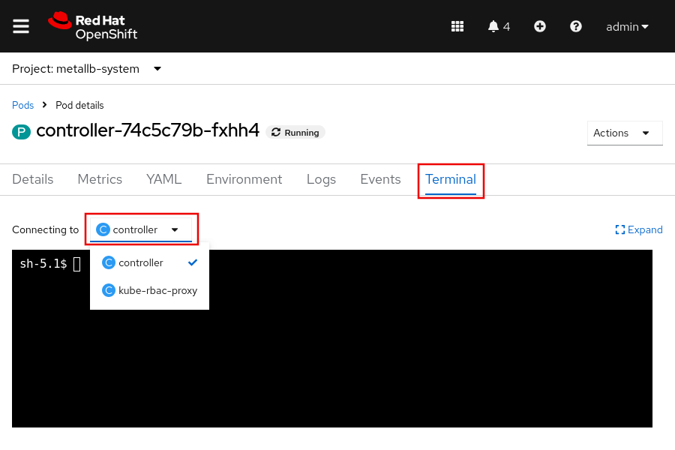

Execute Commands in a Container
Passing commands to execute within a container from the CLI is another method for troubleshooting a running container. Use this method to send a command to run within the container, or to connect to the container, when further investigation is necessary.
Use the following command to pass and execute commands in a container:
[user@host ~]$ oc exec POD | TYPE/NAME [-c container_name] -- COMMAND [arg1 ... argN]
If you omit the -c container_name option, then the command targets the first container in the pod.
The following examples demonstrate the use of the oc exec command to execute the ls command in a container to list the contents of the container's root directory:
[user@host ~]$ oc exec -it mariadb-lc78h -- ls /
bin boot dev etc help.1 home lib lib64 ...
...output omitted...
[user@host ~]$ oc exec mariadb-lc78h -- ls /
bin
boot
dev
etc
...output omitted...

Note
It is common to add the -it flags to the oc exec command. These flags instruct the command to send STDIN to the container and STDOUT/STDERR back to the terminal. The format of the command output is impacted by the inclusion of the -it flags.

Container Events and Logs
Reviewing the historical actions for a container can offer insights into both the lifecycle and health of the deployment. Retrieving the cluster logs provides the chronological details of the container actions. Administrators inspect this log output for information and issues that occur in the running container.
For the following commands, use the -c container_name to specify a container in the pod. If you omit this option, then the command targets the first container in the pod.
The following examples demonstrate use of the oc logs POD_NAME command to retrieve the logs for a pod:
[user@host ~]$ oc logs BIND9-app-rw43j
Defaulted container "dns" out of: dns
.:5353
[INFO] plugin/reload: Running configuration SHA512 = 7c3d...3587
CoreDNS-1.9.2
...output omitted...
In Kubernetes, an event resource is a report of an event somewhere in the cluster. You can use the oc get events command to view pod events in a namespace:
[user@host ~]$ oc get events
LAST SEEN TYPE REASON OBJECT MESSAGE
...output omitted...
21m Normal AddedInterface pod/php-app-5d9b84b588-kzfxd Add eth0 [10.8.0.93/23] from ovn-kubernetes
21m Normal Pulled pod/php-app-5d9b84b588-kzfxd Container image "registry.ocp4.example.com:8443/redhattraining/php-webapp:v4" already present on machine
21m Normal Created pod/php-app-5d9b84b588-kzfxd Created container php-webapp
21m Normal Started pod/php-app-5d9b84b588-kzfxd Started container php-webapp

Available Linux Commands in Containers
The use of Linux commands for troubleshooting applications can also help with troubleshooting containers. However, when connecting to a container, only the defined tools and applications within the container are available. You can augment the environment inside the container by adding the tools from this section or any other remedial tools to the container image.
Before you add tools to a container image, consider how the tools affect your container image:
- Additional tools increase the size of the image, which might impact container performance.
- Tools might require additional update packages and licensing terms, which can impact the ease of updating and distributing the container image.
- Hackers might exploit tools in the image.

Troubleshooting from Inside the Cluster
Administrators can alternatively author and deploy a container within the cluster for investigation and remediation. By creating a container image that includes the cluster troubleshooting tools, you have a reliable environment to perform these tasks from any computer with access to the cluster. This approach ensures that an administrator always has access to the tools for reliable troubleshooting and remediation of issues.
Additionally, administrators should plan to author a container image that provides the most valuable troubleshooting tools for containerized applications. In this way, you deploy this "toolbox" container to supplement the forensic process and to provide an environment with the required commands and tools for troubleshooting problematic containers. For example, the toolbox container can test how resources operate inside a cluster, such as to confirm whether a pod can connect to resources outside the cluster. Regular cluster users can also create a toolbox container to help with application troubleshooting. For example, a regular user could run a pod with a MySQL client to connect to another pod that runs a MySQL server.
Although this approach falls outside the focus of this course, because it is more application-level remediation than container-level troubleshooting, it is important to realize that containers have such capacity.

Guided Exercise: Troubleshoot Containers and Pods
Troubleshoot and fix a failed MySQL pod and manually initialize a database with test data.
Outcomes
- Investigate errors with creating a pod.
- View the status, logs, and events for a pod.
- Copy files into a running pod.
- Connect to a running pod by using port forwarding.
As the student user on the workstation machine, use the lab command to prepare your system for this exercise. This command ensures that the cluster and all exercise resources are available.
[student@workstation ~]$ lab start pods-troubleshooting
Instructions
- Log in to the OpenShift cluster and create the pods-troubleshooting project.
  - Open a new terminal window and log in to the OpenShift cluster as the developer user with developer as the password.
[student@workstation ~]$ oc login -u developer -p developer \
https://api.ocp4.example.com:6443
Login successful.
  - ...output omitted...
  - Create the pods-troubleshooting project.
[student@workstation ~]$ oc new-project pods-troubleshooting
Now using project "pods-troubleshooting" on server "https://api.ocp4.example.com:6443".
  - ...output omitted...
- Create the MySQL mysql-server pod. Use the registry.ocp4.example.com:8443/rhel9/mysql-80:1228 container image for the pod. Specify the following environment variables:
Variable | Value
MYSQL_USER | redhat
MYSQL_PASSWORD | redhat123
MYSQL_DATABASE | world
  - Use the oc run command to create the mysql-server pod. Specify the environment values with the --env option.
[student@workstation ~]$ oc run mysql-server \
--image registry.ocp4.example.com:8443/rhel9/mysql-80:1228 \
--env MYSQL_USER=redhat \
--env MYSQL_PASSWORD=redhat123 \
--env MYSQL_DATABASE=world
  - pod/mysql-server created
  - Retrieve the status of the pod by using the oc get pods command. Execute the oc get pods command a few times to view the status updates for the pod.
[studet@workstation ~]$ oc get pods
NAME READY STATUS RESTARTS AGE
  - mysql-server 0/1 ImagePullBackoff 0 45s
  - The pod fails to start.
- Identify the root cause of the pod's failure to start.
  - Use the oc logs command to retrieve the pod's logs.
[student@workstation ~]$ oc logs mysql-server
  - Error from server (BadRequest): container "mysql-server" in pod "mysql-server" is waiting to start: trying and failing to pull image
  - The logs state that the pod cannot pull the container image.
  - Retrieve the events log with the oc get events command.
student@workstation ~]$ oc get events
LAST SEEN TYPE REASON OBJECT MESSAGE
33s Normal Scheduled pod/mysql-server Successfully assigned pods-troubleshooting/mysql-server to master01
31s Normal AddedInterface pod/mysql-server Add eth0 [10.8.0.68/23] from ovn-kubernetes
16s Normal Pulling pod/mysql-server Pulling image "registry.ocp4.example.com:8443/rhel9/mysql-80:1228"
16s Warning Failed pod/mysql-server Failed to pull image "registry.ocp4.example.com:8443/rhel9/mysql-80:1228": initializing source docker://registry.ocp4.example.com:8443/rhel9/mysql-80:1228: reading manifest 1228 in registry.ocp4.example.com:8443/rhel9/mysql-80: manifest unknown
16s Warning Failed pod/mysql-server Error: ErrImagePull
4s Normal BackOff pod/mysql-server Back-off pulling image "registry.ocp4.example.com:8443/rhel9/mysql-80:1228"
  - 4s Warning Failed pod/mysql-server Error: ImagePullBackOff
  - The output states that the image pull failed because the 1228 manifest is unknown. This failure could mean that the manifest, or image tag, does not exist in the repository.
  - Authenticate to the container repository with the skopeo login command as the developer user with developer as the password.
[student@workstation ~]$ skopeo login registry.ocp4.example.com:8443
Username: developer
Password: developer
  - Login Succeeded!
  - Use the skopeo inspect command to retrieve the available manifests in the registry.ocp4.example.com:8443/rhel9/mysql-80 repository.
[student@workstation ~]$ skopeo inspect \
docker://registry.ocp4.example.com:8443/rhel9/mysql-80
...output omitted...
"Name": "registry.ocp4.example.com:8443/rhel9/mysql-80",
"Digest": "sha256:5098...72a1",
"RepoTags": [
"1",
"1-224",
"1-224-source",
"1-228",
"1-228-source",
"1-237",
"latest"
],
  - ...output omitted...
  - The 1228 manifest, or tag, is not available in the repository, which means that the registry.ocp4.example.com:8443/rhel9/mysql-80:1228 image does not exist. However, the 1-228 tag does exist.
- Update the pod's configuration to use the registry.ocp4.example.com:8443/rhel9/mysql-80:1-228 container image. Confirm that the pod is re-created after editing the resource.
  - Locate the .spec.containers.image object. Use the oc edit command to update the value to the registry.ocp4.example.com:8443/rhel9/mysql-80:1-228 container image, and save the change.
[student@workstation ~]$ oc edit pod/mysql-server
...output omitted...
apiVersion: v1
kind: Pod
metadata:
...output omitted...
spec:
containers:
- image: registry.ocp4.example.com:8443/rhel9/mysql-80:1-228
  - ...output omitted...
  - Verify the status of the mysql-server pod with the oc get command. The pod's status might take a few moments to update after the resource edit. Repeat the oc get command until the pod's status changes.
[student@workstation ~]$ oc get pods
NAME READY STATUS RESTARTS AGE
  - mysql-server 1/1 Running 0 10m
  - The mysql-server pod successfully pulled the image and created the container. The pod now shows a Running status.
- Copy the ~/DO180/labs/pods-troubleshooting/world_x.sql file to the mysql-server pod. Then, connect to the pod and execute the world_x.sql file to populate the world database.
  - Use the oc cp command to copy the world_x.sql file in the ~/DO180/labs/pods-troubleshooting directory to the /tmp/ directory on the mysql-server pod.
[student@workstation ~]$ oc cp ~/DO180/labs/pods-troubleshooting/world_x.sql \
  - mysql-server:/tmp/
  - Confirm that the world_x.sql file is accessible within the mysql-server pod with the oc exec command.
[student@workstation ~]$ oc exec -it pod/mysql-server -- ls -la /tmp/
total 548
drwxrwxrwx. 1 root root 25 Aug 15 01:53 .
dr-xr-xr-x. 1 root root 50 Aug 15 01:50 ..
  - -rw-r--r--. 1 1000750000 root 558791 Aug 15 01:53 world_x.sql
  - Connect to the mysql-server pod with the oc rsh command. Confirm that you can access the MySQL database.
[student@workstation ~]$ oc rsh mysql-server
  - sh-5.1$
  - Log in to MySQL as the redhat user with redhat123 as the password.
sh-5.1$ mysql -u redhat -p
Enter password: redhat123
Welcome to the MySQL monitor. Commands end with ; or \g.
...output omitted...
  - mysql>
  - From the MySQL prompt, select the world database.
mysql> USE world
  - Database changed
  - Source the world_x.sql script inside the pod to initialize and populate the world database.
mysql> SOURCE /tmp/world_x.sql
Query OK, 1 row affected (0.00 sec)
  - ...output omitted...
  - Execute the SHOW TABLES; command to confirm that the database now contains tables. Then, exit the database and the pod.
mysql> SHOW TABLES;
-----------------
| Tables_in_test |
-----------------
| city |
| country |
| countryinfo |
| countrylanguage |
-----------------
4 rows in set (0.00 sec)
mysql> exit
Bye
sh-5.1$ exit
exit
  - [student@workstation ~]$
- Configure port forwarding and then use the MySQL client on the terminal to connect to the world database on the mysql-server pod. Confirm that you can access data within the world database from the terminal.
  - From the terminal, use the oc port-forward command to forward the 3306 local port to the 3306 port on the mysql-server pod.
[student@workstation ~]$ oc port-forward mysql-server 3306:3306
Forwarding from 127.0.0.1:3306 -> 3306
  - Forwarding from [::1]:3306 -> 3306
  - Open another terminal window on the workstation machine. Connect to the world database with the local MySQL client on the workstation machine. Log in as the redhat user with the redhat123 password. Specify the host as the localhost 127.0.0.1 IP address and use 3306 as the port.
[student@workstation ~]$ mysql -u redhat -p -h 127.0.0.1 -P 3306
Enter password: redhat123
Welcome to the MySQL monitor. Commands end with ; or \g.
...output omitted...
  - mysql>
  - Select the world database.
mysql> USE world
Reading table information for completion of table and columns names
You can turn off this feature to get a quicker startup with -A

  - Database changed
  - Use the SHOW TABLES; command to list the tables in the world database.
mysql> SHOW TABLES;
-----------------
| Tables_in_test |
-----------------
| city |
| country |
| countryinfo |
| countrylanguage |
-----------------
  - 4 rows in set (0.01 sec)
  - Confirm that you can retrieve data from the country table. Execute the SELECT COUNT(*) FROM country command to retrieve the number of countries within the country table.
mysql> SELECT COUNT(*) FROM country;
----------
| COUNT(*) |
----------
| 239 |
----------
  - 1 row in set (0.01 sec)
  - Exit the database.
mysql> exit
Bye
  - [student@workstation ~]$
  - Close the second terminal window.
  - Return to the terminal that is executing the oc port-forward command. Press Ctrl+C to end the connection.
[student@workstation ~]$ oc port-forward mysql-server 3306:3306
Forwarding from 127.0.0.1:3306 -> 3306
Forwarding from [::1]:3306 -> 3306
Handling connection for 3306
Handling connection for 3306
  - ^C[student@workstation ~]$
Finish
On the workstation machine, use the lab command to complete this exercise. This step is important to ensure that resources from previous exercises do not impact upcoming exercises.
[student@workstation ~]$ lab finish pods-troubleshooting

Lab: Run Applications as Containers and Pods
Run a web server as a pod and insert a debug page that displays diagnostic information.
Outcomes
- Deploy a pod from a container image.
- Retrieve the status and events of a pod.
- Troubleshoot a failed pod.
- Edit pod resources.
- Copy files to a running pod for diagnostic purposes.
- Use port forwarding to connect to a running pod.
As the student user on the workstation machine, use the lab command to prepare your system for this exercise.
This command ensures that exercise resources are available.
[student@workstation ~]$ lab start pods-review
Instructions
The API URL of your OpenShift cluster is https://api.ocp4.example.com:6443, and the oc command is already installed on your workstation machine.
Log in to the OpenShift cluster as the developer user with developer as the password.
Use the pods-review project for your work.
- Log in to the OpenShift cluster and change to the pods-review project.
  - Log in to the OpenShift cluster.
[student@workstation ~]$ oc login -u developer -p developer \
https://api.ocp4.example.com:6443
  - ...output omitted...
  - Select the pods-review project.
[student@workstation ~]$ oc project pods-review
  - Already on project "pods-review" on server "https://api.ocp4.example.com:6443".
- Deploy a pod named webphp that uses the registry.ocp4.example.com:8443/redhattraining/webphp:v1 container image. Determine why the pod fails to start.
  - Deploy a pod named webphp that uses the registry.ocp4.example.com:8443/redhattraining/webphp:v1 container image.
[student@workstation ~]$ oc run webphp \
--image=registry.ocp4.example.com:8443/redhattraining/webphp:v1
  - pod/webphp created
  - After a few moments, observe the status of the webphp pod.
[student@workstation ~]$ oc get pods
NAME READY STATUS RESTARTS AGE
webphp 0/1 CrashLoopBackOff 1 (4s ago) 7s
[student@workstation ~]$ oc get pods
NAME READY STATUS RESTARTS AGE
  - webphp 0/1 Error 2 (24s ago) 7s
  - The pod failed to start.
  - Retrieve the cluster events.
[student@workstation ~]$ oc get events
LAST SEEN TYPE REASON OBJECT MESSAGE
3m25s Normal Scheduled pod/webphp Successfully assigned pods-review/webphp to master01
3m23s Normal AddedInterface pod/webphp Add eth0 [10.8.0.73/23] from ovn-kubernetes
3m23s Normal Pulling pod/webphp Pulling image "registry.ocp4.example.com:8443/redhattraining/webphp:v1"
3m15s Normal Pulled pod/webphp Successfully pulled image "registry.ocp4.example.com:8443/redhattraining/webphp:v1" in 9.432s (9.432s including waiting). Image size: 292899537 bytes.
104s Normal Created pod/webphp Created container webphp
104s Normal Started pod/webphp Started container webphp
104s Normal Pulled pod/webphp Container image "registry.ocp4.example.com:8443/redhattraining/webphp:v1" already present on machine
  - 103s Warning BackOff pod/webphp Back-off restarting failed container webphp in pod webphp_pods-review(1a1d3055-5250-4a80-9600-9008a5a4b601)
  - Retrieve the logs for the webphp pod.
[student@workstation ~]$ oc logs webphp
[15-Aug-2025 18:46:56] NOTICE: [pool www] 'user' directive is ignored when FPM is not running as root
[15-Aug-2025 18:46:56] NOTICE: [pool www] 'group' directive is ignored when FPM is not running as root
[15-Aug-2025 18:46:56] ERROR: unable to bind listening socket for address '/run/php-fpm/www.sock': Permission denied (13)
[15-Aug-2025 18:46:56] ERROR: FPM initialization failed
AH00558: httpd: Could not reliably determine the server's fully qualified domain name, using 10.8.0.78. Set the 'ServerName' directive globally to suppress this message
(13)Permission denied: AH00058: Error retrieving pid file run/httpd.pid
  - AH00059: Remove it before continuing if it is corrupted.
  - The logs indicate permission issues with the /run directory within the pod.
- Troubleshoot the failed webphp pod by creating a debug pod.
  - Create a debug pod to troubleshoot the failed webphp pod.
[student@workstation ~]$ oc debug pod/webphp
Starting pod/webphp-debug-mfbxx ...
Pod IP: 10.8.0.87
If you don't see a command prompt, try pressing enter.
  - sh-4.4$
  - List the contents of the /run directory to retrieve the permissions, owners, and groups.
sh-4.4$ ls -la /run
total 0
drwxr-xr-x. 1 root root 42 Aug 15 18:47 .
dr-xr-xr-x. 1 root root 17 Aug 15 18:47 ..
-rw-r--r--. 1 root root 0 Aug 15 18:47 .containerenv
drwx--x---. 3 root apache 26 Dec 20 18:42 httpd
drwxr-xr-x. 2 root root 6 Nov 3 11:10 lock
drwxr-xr-x. 2 root root 6 Dec 20 18:42 php-fpm
  - drwxr-xr-x. 4 root root 80 Aug 15 18:47 secrets
  - The /run/httpd directory grants read, write, and execute permissions to the root user, but does not provide permissions for the root group.
  - Retrieve the UID and GID of the user in the container. Determine whether the user is a privileged user and belongs to the root group.
sh-4.4$ id
  - uid=1000770000(1000680000) gid=0(root) groups=0(root),1000770000
  - Your UID and GID values might differ from the previous output.
The user is an unprivileged, non-root user and belongs to the root group, which does not have access to the /run directory. Therefore, the user in the container cannot access the files and directories that the container processes use, which is required for arbitrarily assigned UIDs.
  - Exit the debug pod.
sh-4.4$ exit
exit

  - Removing debug pod ...
- The application developer resolved the identified issue in the registry.ocp4.example.com:8443/redhattraining/webphp:v2 container image. In a terminal window, edit the webphp pod resource to use the v2 image tag. Retrieve the status of the webphp pod. Then, confirm that the user in the container is an unprivileged user and belongs to the root group. Confirm that the root group permissions are correct for the /run/httpd directory.
  - Use the terminal to edit the webphp pod resource.
  - [student@workstation ~]$ oc edit pod/webphp
  - Update the .spec.containers.image object value to use the :v2 image tag.
...output omitted...
spec:
containers:
- image: registry.ocp4.example.com:8443/redhattraining/webphp:v2
imagePullPolicy: IfNotPresent
  - ...output omitted...
  - Verify the status of the webphp pod.
[student@workstation ~]$ oc get pods
NAME READY STATUS RESTARTS AGE
  - webphp 1/1 Running 9 (2m9s ago) 18m
  - Retrieve the UID and GID of the user in the container to confirm that the user is an unprivileged user.
[student@workstation ~]$ oc exec -it webphp -- id
  - uid=1000680000(1000680000) gid=0(root) groups=0(root),1000680000
  - Your UID and GID values might differ from the previous output.
  - Confirm that the permissions for the /run/httpd directory are correct.
[student@workstation ~]$ oc exec -it webphp -- ls -la /run/
total 0
drwxr-xr-x. 1 root root 70 Dec 20 19:01 .
dr-xr-xr-x. 1 root root 39 Dec 20 19:01 ..
-rw-r--r--. 1 root root 0 Dec 20 18:45 .containerenv
drwxrwx---. 1 root root 41 Dec 20 19:01 httpd
drwxr-xr-x. 2 root root 6 Oct 26 11:10 lock
drwxrwxr-x. 1 root root 41 Dec 20 19:01 php-fpm
  - drwxr-xr-x. 4 root root 80 Dec 20 19:01 secrets
- Connect port 8080 on the Workstation machine to port 8080 on the webphp pod. In a new terminal window, retrieve the content of the pod's 127.0.0.1:8080/index.php web page to confirm that the pod is operational.
Note
The terminal window that you connect to the webphp pod must remain open for the remainder of the lab. This connection is necessary for the final lab step and for the lab grade command.
  - Connect to port 8080 on the webphp pod.
[student@workstation ~]$ oc port-forward pod/webphp 8080:8080
Forwarding from 127.0.0.1:8080 -> 8080
  - Forwarding from [::1]:8080 -> 8080
  - Open a second terminal window and then retrieve the 127.0.0.1:8080/index.php web page on the webphp pod.
[student@workstation ~]$ curl 127.0.0.1:8080/index.php
<html>
<body>
Hello, World!
</body>
  - </html>
- An issue occurs with the PHP application that is running on the webphp pod. To debug the issue, the application developer requires diagnostic and configuration information for the PHP instance that is running on the webphp pod.
The ~/DO180/labs/pods-review directory contains a phpinfo.php file to generate debugging information for a PHP instance. Copy the phpinfo.php file to the /var/www/html/ directory on the webphp pod.
Then, confirm that the PHP debugging information is displayed when accessing the 127.0.0.1:8080/phpinfo.php from a web browser.
Note
After running the lab grade command in the second terminal, return to the terminal that is executing the oc port-forward command, and press Ctrl+C to end the connection.
[student@workstation ~]$ oc port-forward pod/webphp 8080:8080
Forwarding from 127.0.0.1:8080 -> 8080
Forwarding from [::1]:8080 -> 8080
Handling connection for 8080
- ^C[student@workstation ~]$
  - In the second terminal, copy the ~/DO180/labs/pods-review/phpinfo.php file to the webphp pod as the /var/www/html/phpinfo.php file.
[student@workstation ~]$ oc cp ~/DO180/labs/pods-review/phpinfo.php \
  - webphp:/var/www/html/phpinfo.php
  - Open a web browser and access the 127.0.0.1:8080/phpinfo.php web page. Confirm that PHP debugging information is displayed.
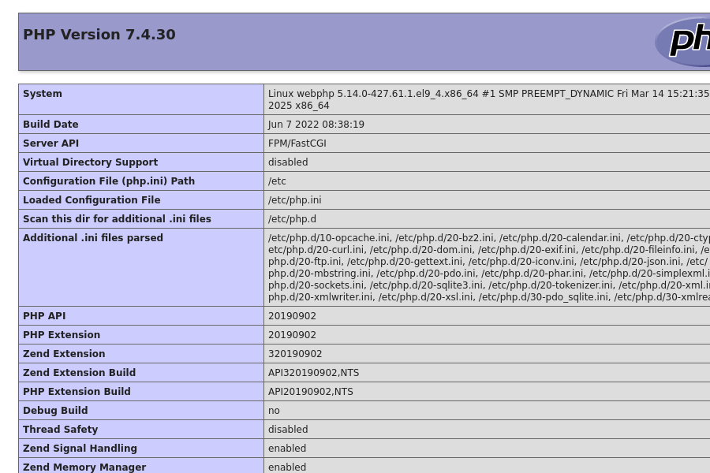
PHP debugging information
Evaluation
As the student user on the workstation machine, use the lab command to grade your work. Correct any reported failures and rerun the command until successful.
[student@workstation ~]$ lab grade pods-review
Finish
As the student user on the workstation machine, use the lab command to complete this exercise. This step is important to ensure that resources from previous exercises do not impact upcoming exercises.
[student@workstation ~]$ lab finish pods-review

Chapter 4. Deploy Managed and Networked Applications on Kubernetes
Deploy Applications from an Image and from a Template
Guided Exercise: Deploy Applications from an Image and from a Template
Manage Long-lived and Short-lived Applications by Using the Kubernetes Workload API
Guided Exercise: Manage Long-lived and Short-lived Applications by Using the Kubernetes Workload API
Kubernetes Pod and Service Networks
Guided Exercise: Kubernetes Pod and Service Networks
Scale and Expose Applications to External Access
Guided Exercise: Scale and Expose Applications to External Access
Lab: Deploy Managed and Networked Applications on Kubernetes
Summary
Abstract
Goal | Deploy applications and expose them to network access from inside and outside a Kubernetes cluster.
Sections | - Deploy Applications from an Image and from a Template (and Guided Exercise)  - Manage Long-lived and Short-lived Applications by Using the Kubernetes Workload API (and Guided Exercise)  - Kubernetes Pod and Service Networks (and Guided Exercise)  - Scale and Expose Applications to External Access (and Guided Exercise)
Lab | - Deploy Managed and Networked Applications on Kubernetes

Deploy Applications from an Image and from a Template

Objectives
- Identify the main resources and settings that Kubernetes uses to manage long-lived applications and demonstrate how OpenShift simplifies common application deployment workflows.

Deploying Applications
Microservices and DevOps are growing trends in enterprise software. Containers and Kubernetes gained popularity alongside those trends, and became categories of their own. Container-based infrastructures support most types of traditional and modern applications.
The application term can refer to a software system or to a service within it. Given this ambiguity, it is clearer to refer directly to resources, services, and other components.

Resources and Resource Definitions
Kubernetes manages applications, or services, as a loose collection of resources. Resources are configuration pieces for components in the cluster. When you create a resource, the corresponding component is not created immediately. Instead, the cluster is responsible for eventually creating the component.
A resource type represents a specific component type, such as a pod. Kubernetes ships with many default resource types, some of which overlap in function. Red Hat OpenShift Container Platform (RHOCP) includes the default Kubernetes resource types, and provides other resource types of its own. To add resource types, you can create or import CRDs.

Managing Resources
You can add, view, and edit resources in various formats, including YAML and JSON format. Traditionally, YAML is the most common format.
You can delete resources in batch by using label selectors or by deleting the entire project or namespace. For example, the following command deletes only deployments with the app=my-app label:
[user@host ~]$ oc delete deployment -l app=my-app
deployment.apps "my-app" deleted
Similar to creation, deleting a resource is not immediate, but is instead a request for eventual deletion.

Note
Commands that are executed without specifying a namespace are executed in the user's current namespace.

Common Resource Types and Their Uses
The following resources are standard OpenShift resources:

Templates
Similar to projects, templates are an RHOCP addition to Kubernetes. A template is a YAML manifest that contains parameterized definitions of one or more resources. RHOCP provides predefined templates in the openshift namespace.
You can process a template into a list of resources by using the oc process command, which replaces values and generates resource definitions. The resulting resource definitions create or update resources in the cluster by supplying them to the oc apply command.
For example, the following command processes the mysql-template.yaml template file and generates four resource definitions:
[user@host ~]$ oc process -f mysql-template.yaml -o yaml
apiVersion: v1
items:
- apiVersion: v1
kind: Secret
...output omitted...
- apiVersion: v1
kind: Service
...output omitted...
- apiVersion: v1
kind: PersistentVolumeClaim
...output omitted...
- apiVersion: apps/v1
kind: Deployment
...output omitted...
The --parameters option instead displays the parameters of a template. For example, the following command lists the parameters of the mysql-template.yaml file.
[user@host ~]$ oc process -f mysql-template.yaml --parameters
NAME DESCRIPTION ...output omitted...
...output omitted...
MYSQL_USER Username for MySQL user ...output omitted...
MYSQL_PASSWORD Password for the MySQL connection ...output omitted...
MYSQL_ROOT_PASSWORD Password for the MySQL root user. ...output omitted...
MYSQL_DATABASE Name of the MySQL database accessed. ...output omitted...
VOLUME_CAPACITY Volume space available for data, ...output omitted...
You can use templates with the new-app command from RHOCP. In the following example, the new-app command uses the mysql-persistent template to create a MySQL application and its supporting resources:
[user@host ~]$ oc new-app --template mysql-persistent
--> Deploying template "db-app/mysql-persistent" to project db-app
...output omitted...
The following service(s) have been created in your project: mysql.

Username: userQSL
Password: pyf0yElPvFWYQQou
Database Name: sampledb
Connection URL: mysql://mysql:3306/
...output omitted...
* With parameters:
* Memory Limit=512Mi
* Namespace=openshift
* Database Service Name=mysql
* MySQL Connection Username=userQSL # generated
* MySQL Connection Password=pyf0yElPvFWYQQou # generated
* MySQL root user Password=HHbdurqWO5gAog2m # generated
* MySQL Database Name=sampledb
* Volume Capacity=1Gi
* Version of MySQL Image=8.0-el8

--> Creating resources ...
secret "mysql" created
service "mysql" created
persistentvolumeclaim "mysql" created
deployment.apps "mysql" created
--> Success
...output omitted...
Several resources are created to meet the requirements of the deployment, including a secret, a service, and a persistent volume claim.

Note
You can specify environment variables to be configured in creating your application.
You can also use templates, helm charts, builder images, or devfiles to create applications from the web console by using the Developer Catalog page. From the Developer perspective, go to the +Add menu and click All Services in the Developer Catalog section to open the catalog.
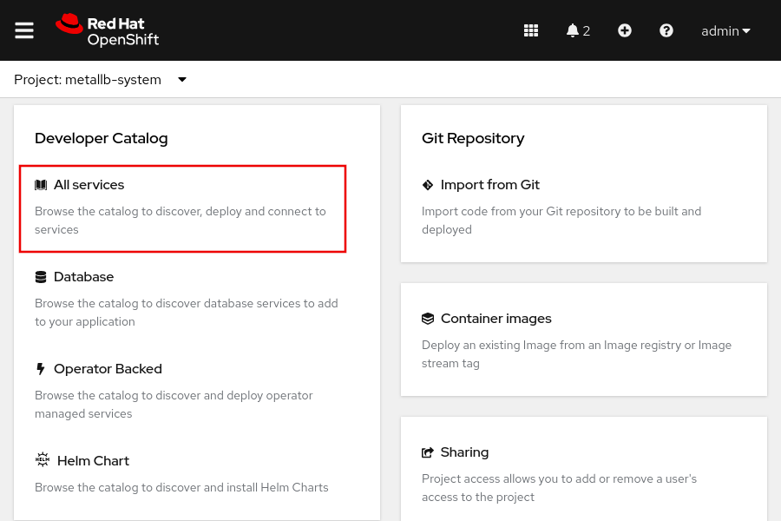
Then, enter the application name in the filter box to search for an application's template. You can instantiate a template and change the default values, such as the Git repository, the memory limits, and the application version.
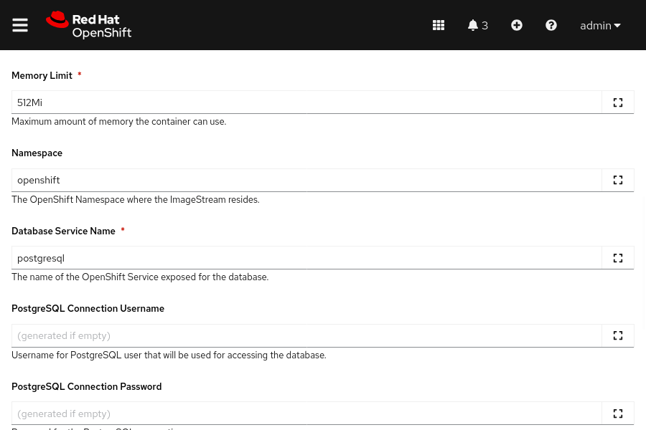
You can also create an application from the Topology menu, and by clicking Start building application or clicking the book icon.
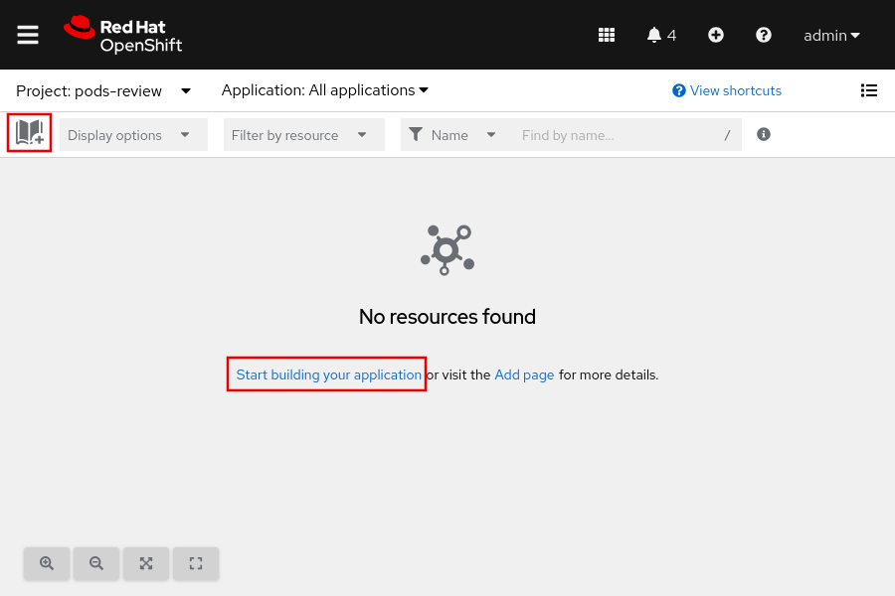

Pod
A pod is the smallest compute unit that you can define, deploy, and manage in RHOCP. A pod runs one or more containers that represent a single application. Containers in the pod share resources, such as networking and storage.
The following example shows the definition of a pod:
apiVersion: v1
kind: Pod
metadata:
annotations: {}
labels:
deployment: docker-registry-1
name: registry
namespace: pod-registries
spec:
containers:
- env:
- name: OPENSHIFT_CA_DATA
value:
image: openshift/origin-docker-registry:v0.6.2
imagePullPolicy: IfNotPresent
name: registry
ports:
- containerPort: 5000
protocol: TCP
resources: {}
securityContext: {}
volumeMounts:
- mountPath: /registry
name: registry-storage
dnsPolicy: ClusterFirst
imagePullSecrets:
- name: default-dockercfg-at06w
restartPolicy: Always
serviceAccount: default
volumes:
- emptyDir: {}
name: registry-storage
status:
conditions: {}
The resource kind is set to Pod.
Information that describes your application, such as the name, project, attached labels, and annotations.
Section where the application requirements are specified, such as the container name, the container image, environment variables, volume mounts, network configuration, and volumes.
Indicates the last condition of the pod, such as the last probe time, the last transition time, the status setting as true or false, and more.

Deployments
A deployment describes the intended state of a component of the application as a pod template. A deployment manages one or more replica sets.
The following example shows the definition of a deployment:
apiVersion: apps/v1
kind: Deployment
metadata:
name: hello-openshift
spec:
replicas: 1
selector:
matchLabels:
app: hello-openshift
template:
metadata:
labels:
app: hello-openshift
spec:
containers:
- name: hello-openshift
image: openshift/hello-openshift:latest
ports:
- containerPort: 80
The resource kind is set to Deployment.
Name of the deployment resource.
Number of running instances.
Section to define the metadata, labels, and the container information of the deployment resource.
Name of the container.
Resource of the image for creating the deployment resource.
Port configuration, such as the port number, the name of the port, and the protocol.

Projects
RHOCP adds projects to enhance the function of Kubernetes namespaces. A project is a Kubernetes namespace with additional annotations, and is the primary method for managing access to resources for regular users. Projects can be created from templates and must use RBAC for organization and permission management. Administrators must grant cluster users access to a project. If a cluster user is allowed to create projects, then the user automatically has access to their created projects.
Projects provide logical and organizational isolation to separate your application component resources. Resources in one project can access resources in other projects, but not by default.
The following example shows the definition of a project:
apiVersion: project.openshift.io/v1
kind: Project
metadata:
name: test
spec:
finalizers:
- kubernetes
The resource kind is set to Project.
Name of the project.
A finalizer is a special metadata key that tells Kubernetes to wait until a specific condition is met before it fully deletes a resource.

Services
You can configure internal pod-to-pod network communication in RHOCP by using a service. Applications send requests to the service name and port. RHOCP provides a virtual network, which reroutes such requests to the pods that the service targets by using labels.
The following example shows the definition of a service:
apiVersion: v1
kind: Service
metadata:
name: docker-registry
namespace: test
spec:
selector:
app: MyApp
ports:
- protocol: TCP
port: 80
targetPort: 9376
The resource kind is set to Service.
Name of the service.
Project name where the service resource exists.
The label selector identifies all pods with the attached app=MyApp label and adds the pods to the service endpoints.
Internet protocol is set to TCP.
Port that the service listens on.
Port on the backing pods, which the service forwards connections to.

Persistent Volume Claims
RHOCP uses the Kubernetes persistent volume (PV) framework to enable cluster administrators to provision persistent storage for a cluster. Developers can use persistent volume claims (PVCs) to request PV resources without having specific knowledge of the underlying storage infrastructure. After a PV is bound to a PVC, that PV cannot then be bound to additional PVCs. Because PVCs are namespaced objects and PVs are globally scoped objects, this binding effectively scopes a bound PV to a single namespace until the binding PVC is deleted.
The following example shows the definition of a persistent volume claim:
apiVersion: v1
kind: PersistentVolumeClaim
metadata:
name: mysql-pvc
spec:
accessModes:
- ReadWriteOnce
resources:
requests:
storage: 1Gi
storageClassName: nfs-storage
status: {}
The resource kind is set to PersistentVolumeClaim.
Name of the service.
The access mode, to define the read/write and mount permissions.
The storage of the PVC.
Name of the StorageClass that the claim requires.

Secrets
Secrets provide a mechanism to hold sensitive information, such as passwords, private source repository credentials, sensitive configuration files, and credentials to an external resource, such as an SSH key or an OAuth token. You can mount secrets into containers by using a volume plug-in. Kubernetes can also use secrets to perform actions, such as on pods, declaring environment variables. Secrets can store any type of data. Kubernetes and OpenShift support different types of secrets, such as service account tokens, SSH keys, and TLS certificates.
The following example shows the definition of a secret:
apiVersion: v1
kind: Secret
metadata:
name: example-secret
namespace: my-app
type: Opaque
data:
username: bXl1c2VyCg==
password: bXlQQDU1Cg==
stringData:
hostname: myapp.mydomain.com
secret.properties: |
property1=valueA
property2=valueB
The resource kind is set to Secret.
Name of the service.
Project name where the service resource exists.
Specifies the type of secret.
Specifies the encoded string and data.
Specifies the decoded string and data.

Managing Resources from the Command Line
Many Kubernetes and RHOCP commands can create and modify cluster resources. Some commands are part of core Kubernetes, whereas others are exclusive additions to RHOCP.
The resource management commands generally fall into one of two categories:
- An imperative command instructs what the cluster does.
- A declarative command defines the state that the cluster attempts to match.

Imperative Resource Management
The create command is an imperative way to create resources, and is included in both of the oc and kubectl commands. For example, the following command creates a deployment named my-app that creates pods that are based on the specified image.
[user@host ~]$ oc create deployment my-app --image example.com/my-image:dev
deployment.apps/my-app created
Use the set command to define attributes on a resource, such as environment variables. For example, the following command adds the TEAM=red environment variable to the preceding deployment.
[user@host ~]$ oc set env deployment/my-app TEAM=red
deployment.apps/my-app updated
Another imperative approach to creating a resource is the run command. In the following example, the run command creates the example-pod pod.
[user@host ~]$ oc run example-pod \
--image=registry.access.redhat.com/ubi8/httpd-24 \
--env GREETING='Hello from the awesome container' \
--port 8080
pod/example-pod created
The pod .metadata.name definition
The image for the single container in this pod
The environment variable for the single container in this pod
The port metadata definition
The imperative commands are a faster way of creating pods, because such commands do not require a pod object definition. Versioning and incremental changes require declarative manifests.
Generally, developers test a deployment by using imperative commands, and then use the imperative commands to generate the pod object definition. Use the --dry-run=client option to avoid creating the object in RHOCP. Additionally, use the -o yaml or -o json option to configure the definition format.
The following command is an example of generating the YAML definition for the example-pod pod:
[user@host ~]$ oc run example-pod \
--image=registry.access.redhat.com/ubi8/httpd-24 \
--env GREETING='Hello from the awesome container' \
--port 8080 \
--dry-run=client -o yaml
apiVersion: v1
kind: Pod
metadata:
creationTimestamp: null
labels:
run: example-pod
name: example-pod
spec:
containers:
...output omitted...
Managing resources in this way is imperative, because you are instructing the cluster what to do rather than declaring the intended outcomes.

Declarative Resource Management
Using the create command does not guarantee that you are creating resources imperatively. For example, providing a manifest declaratively creates the resources that are defined in the YAML file, such as in the following command.
[user@host ~]$ oc create -f my-app-deployment.yaml
deployment.apps/my-app created
RHOCP adds the new-app command, which provides another declarative way to create resources. This command uses heuristics to automatically determine which types of resources to create based on the specified parameters. For example, the following command deploys the my-app application by creating several resources, including a deployment resource, from a YAML manifest file:
[user@host ~]$ oc new-app --file=./example/my-app.yaml
...output omitted...
--> Creating resources ...
imagestream.image.openshift.io "my-app" created
deployment.apps "my-app" created
services "my-app" created
...output omitted...
In both of the preceding create and new-app examples, you are declaring the intended state of the resources, and so they are declarative.
You can also use the new-app command with templates for resource management. A template describes the intended state of resources that must be created for an application to run, such as deployments and services. Supplying a template to the new-app command is a form of declarative resource management.
The new-app command also includes options, such as the --param option, that customize an application deployment declaratively. For example, when the new-app is used with a template, you can include the --param option to override a parameter value in the template.
[user@host ~]$ oc new-app --template mysql-persistent \
--param MYSQL_USER=operator --param MYSQL_PASSWORD=myP@55 \
--param MYSQL_DATABASE=mydata \
--param DATABASE_SERVICE_NAME=db
--> Deploying template "db-app/mysql-persistent" to project db-app
...output omitted...
The following service(s) have been created in your project: db.

Username: operator
Password: myP@55
Database Name: mydata
Connection URL: mysql://db:3306/
...output omitted...
* With parameters:
* Memory Limit=512Mi
* Namespace=openshift
* Database Service Name=db
* MySQL Connection Username=operator
* MySQL Connection Password=myP@55
* MySQL root user Password=tlH8BThuVgnIrCon # generated
* MySQL Database Name=mydata
* Volume Capacity=1Gi
* Version of MySQL Image=8.0-el8

--> Creating resources ...
secret "db" created
service "db" created
persistentvolumeclaim "db" created
--> Success
...output omitted...
Similar to the create command, you can use the new-app command imperatively. When using a container image with the new-app command, you are instructing the cluster what to do, rather than declaring the intended outcomes. For example, the following command deploys the example.com/my-app:dev image by creating several resources, including a deployment resource:
[user@host ~]$ oc new-app --image example.com/my-app:dev
...output omitted...
--> Creating resources ...
imagestream.image.openshift.io "my-app" created
deployment.apps "my-app" created
...output omitted...
You can also supply a Git repository to the new-app command. The following command creates an application named httpd24 by using a Git repository:
[user@host ~]$ oc new-app https://github.com/apache/httpd.git#2.4.56
...output omitted...
--> Creating resources ...
imagestream.image.openshift.io "httpd24" created
deployment.apps "httpd24" created
...output omitted...

Retrieving Resource Information
You can supply the all argument to commands, to specify a list of common resource types. However, the all option does not include every resource type. Instead, all is a shorthand form for a predefined subset of types. When you use this command argument, ensure that all includes any intended types to address.
You can view detailed information about a resource, such as the defined parameters, by using the describe command. For example, RHOCP provides templates in the openshift project to use with the oc new-app command. The following example command displays detailed information about the mysql-ephemeral template:
[user@host ~]$ oc describe template mysql-ephemeral -n openshift
Name: mysql-ephemeral
Namespace: openshift
...output omitted...
Parameters:
Name: MEMORY_LIMIT
Display Name: Memory Limit
Description: Maximum amount of memory the container can use.
Required: true
Value: 512Mi

Name: NAMESPACE
Display Name: Namespace
Description: The OpenShift Namespace where the ImageStream resides.
Required: false
Value: openshift
...output omitted...
Objects:
Secret ${DATABASE_SERVICE_NAME}
Service ${DATABASE_SERVICE_NAME}
The oc describe command cannot generate structured output, such as the YAML or JSON formats. A structured format is required for the oc describe command to parse or filter the output with tools such as JSONPath or Go templates." Instead, use the oc get command to generate and to parse the structured output of a resource.

Guided Exercise: Deploy Applications from an Image and from a Template
Deploy a database from a container image and from a template by using the OpenShift command-line interface and compare the resources and attributes that each method generates.
Outcomes
- Deploy a database from a container image.
- Deploy a database from a template.
As the student user on the workstation machine, use the lab command to prepare your system for this exercise. This command ensures that the cluster is accessible and that all resources are available for this exercise.
[student@workstation ~]$ lab start deploy-newapp
Instructions
- As the developer user, create a project and verify that it is not empty after creation.
  - Log in to the OpenShift cluster as the developer user with developer as the password.
[student@workstation ~]$ oc login -u developer -p developer \
https://api.ocp4.example.com:6443
Login successful
  - ...output omitted...
  - Create a project named deploy-newapp.
[student@workstation ~]$ oc new-project deploy-newapp
Now using project "deploy-newapp" on server "https://api.ocp4.example.com:6443".
  - ...output omitted...
  - The new project is automatically selected.
  - Verify that no pod resources exist in the deploy-newapp project.
[student@workstation ~]$ oc get pods
  - No resources found in deploy-newapp namespace.
  - Verify that the new project contains other types of resources, such as service accounts and secrets.
[student@workstation ~]$ oc get serviceaccounts,secrets
NAME SECRETS AGE
serviceaccount/builder 1 20s
serviceaccount/default 1 20s
serviceaccount/deployer 1 20s

NAME TYPE DATA AGE
secret/builder-dockercfg-sczxg kubernetes.io/dockercfg 1 15s
secret/default-dockercfg-gsnqj kubernetes.io/dockercfg 1 15s
  - secret/deployer-dockercfg-6f8nm kubernetes.io/dockercfg 1 15s
- Create two PostgreSQL instances by using the oc new-app command with different options.
  - View the mysql-persistent template definition to inspect the resources that it creates. Specify the project that houses the template by using the -n openshift option.
[student@workstation ~]$ oc describe template mysql-persistent -n openshift
Name: mysql-persistent
Namespace: openshift
...output omitted...
Objects:
Secret ${DATABASE_SERVICE_NAME}
Service ${DATABASE_SERVICE_NAME}
PersistentVolumeClaim ${DATABASE_SERVICE_NAME}
  - Deployment.apps ${DATABASE_SERVICE_NAME}
  - The objects attribute specifies several resource definitions that are applied on using the template. These resources include one of each of the following types: secret, service (svc), persistent volume claim (pvc), and deployment.
  - Create an instance by using the mysql-persistent template. Specify the application name to mysql, and attach a custom team=red label to the created resources.
[student@workstation ~]$ oc new-app --name mysql \
--template mysql-persistent \
-l team=red \
-p MYSQL_USER=developer \
-p MYSQL_PASSWORD=developer
...output omitted...
--> Creating resources with label team=red ...
secret "mysql" created
service "mysql" created
persistentvolumeclaim "mysql" created
deployment.apps "mysql" created
--> Success
  - ...output omitted...
  - The template creates resources of the types from the preceding step.
  - Run the watch command with the oc get pods command, and wait until the pod is running. The name of the pod is different in your cluster.
[student@workstation ~]$ watch oc get pods
NAME READY STATUS RESTARTS AGE
  - mysql-8d7d996f-qn798 1/1 Running 0 60s
  - Press Ctrl+C to end the watch command after the pod displays Running in the STATUS column.
  - Create an instance by using a container image. Specify a name option and attach a custom team=blue label to the created resources.
[student@workstation ~]$ oc new-app --name db-image -l team=blue \
--image registry.ocp4.example.com:8443/rhel9/mysql-80:1 \
-e MYSQL_USER=developer \
-e MYSQL_PASSWORD=developer \
-e MYSQL_ROOT_PASSWORD=redhat
...output omitted...
--> Creating resources with label team=blue ...
imagestream.image.openshift.io "db-image" created
deployment.apps "db-image" created
service "db-image" created
--> Success
  - ...output omitted...
  - The command creates predefined resources that are needed to deploy an image. These resource types are image stream (is), deployment, and service (svc). Image streams and services are discussed in more detail elsewhere in the course.
  - Run the watch command with the oc get pods command, and wait until the pods are running. The command lists all pods and the value of the team label for each pod. The names of the pods are different in your cluster.
[student@workstation ~]$ watch oc get pods -L team
NAME READY STATUS RESTARTS AGE TEAM
db-image-8d4b97594-6jb85 1/1 Running 0 55s blue
  - mysql-8d7d996f-qn798 1/1 Running 0 1m30s
  - Press Ctrl+C to end the watch command after the pods display Running in the STATUS column.
Without a readinessProbe, the db-image pod shows as ready before the MySQL service is ready for requests. Readiness probes are discussed elsewhere in the course.
Notice that only the db-image pod has a label that contains the word team. Pods that the mysql-persistent template creates do not have the team=red label, because the template does not define this label in its pod specification template.
- Compare the resources that each image and template method creates.
  - View the template-based pod and observe that it contains a readiness probe.
[student@workstation ~]$ oc get pods -l deployment=mysql \
-o jsonpath='{.items[0].spec.containers[0].readinessProbe}' | jq
{
"exec": {
"command": [
"/bin/sh",
"-i",
"-c",
"MYSQL_PWD=\"$MYSQL_PASSWORD\" mysqladmin -u $MYSQL_USER ping"
]
},
"failureThreshold": 3,
"initialDelaySeconds": 5,
"periodSeconds": 10,
"successThreshold": 1,
"timeoutSeconds": 1
  - }
  - Note
The results of the preceding oc command are passed to the jq command, which formats the JSON output.
  - Observe that the image-based pod does not contain a readiness probe.
[student@workstation ~]$ oc get pods -l deployment=db-image \
  - -o jsonpath='{.items[0].spec.containers[0].readinessProbe}' | jq
  - Observe that the template-based pod has a memory resource limit, which restricts allocated memory to the resulting pods. Resource limits are discussed in more detail elsewhere in the course.
[student@workstation ~]$ oc get pods -l deployment=mysql \
-o jsonpath='{.items[0].spec.containers[0].resources.limits}' | jq
{
"memory": "512Mi"
  - }
  - Observe that the image-based pod has no resource limits.
[student@workstation ~]$ oc get pods -l deployment=db-image \
-o jsonpath='{.items[0].spec.containers[0].resources}' | jq
  - {}
  - Retrieve secrets in the project. Notice that the template produced a secret, whereas the pod that was created with only an image did not produce a secret.
[student@workstation ~]$ oc get secrets
NAME TYPE DATA AGE
...output omitted...
  - mysql Opaque 4 3m
- Explore filtering resources via labels.
  - Observe that when a label is not supplied, all services are shown.
[student@workstation ~]$ oc get services
NAME TYPE CLUSTER-IP EXTERNAL-IP PORT(S) AGE
db-image ClusterIP 172.30.38.113 <none> 3306/TCP 1m30s
  - mysql ClusterIP 172.30.95.52 <none> 3306/TCP 2m30s
  - Observe that when a label is supplied, only the services with the label are shown.
[student@workstation ~]$ oc get services -l team=red
NAME TYPE CLUSTER-IP EXTERNAL-IP PORT(S) AGE
  - mysql ClusterIP 172.30.95.52 <none> 3306/TCP 2m43s
  - Observe that not all resources include a label, such as the pods that are created with the template.
[student@workstation ~]$ oc get pods -l team=red
  - No resources found in deploy-newapp namespace.
- Use labels to delete only the resources that are associated with the template-based deployment.
  - Delete only the resources that use the team=red label by using the oc delete all -l command.
[student@workstation ~]$ oc delete all -l team=red
service "mysql" deleted
deployment.apps "mysql" deleted
  - ...output omitted...
  - Because the oc delete all -l command does not delete the secret and PVC resources, delete those resources manually by running the following command:
[studen@workstation ~]$ oc delete secret,pvc -l team=red
secret "mysql" deleted
  - persistentvolumeclaim "mysql" deleted
  - Observe that the resources that the template created are deleted.
[student@workstation ~]$ oc get secret,svc,pvc,deployment -l team=red
...output omitted...
  - No resources found in deploy-newapp namespace.
  - Observe that the image-based resources remain unchanged.
[student@workstation ~]$ oc get is,deployment,svc
NAME IMAGE REPOSITORY ...
imagestream.image.openshift.io/db-image image-registry.openshift... ...
NAME READY UP-TO-DATE AVAILABLE AGE
deployment.apps/db-image 1/1 1 1 46m

NAME TYPE CLUSTER-IP EXTERNAL-IP PORT(S) AGE
  - service/db-image ClusterIP 172.30.71.0 <none> 3306/TCP 46m
Finish
On the workstation machine, use the lab command to complete this exercise. This step is important to ensure that resources from previous exercises do not impact upcoming exercises.
[student@workstation ~]$ lab finish deploy-newapp

Manage Long-lived and Short-lived Applications by Using the Kubernetes Workload API

Objectives
- Deploy containerized applications as pods that Kubernetes workload resources manage.

Kubernetes Workload Resources
The Kubernetes Workloads API consists of resources that represent various types of cluster tasks, jobs, and workloads. The Workloads API is composed of various Kubernetes APIs and extensions that simplify the deployment and management of applications. The following are Workload API resource type that are most often used:
- Jobs
- CronJobs
- Deployments
- DaemonSets
- StatefulSets

Jobs
A job resource represents a one-time task to perform on the cluster. As with most cluster tasks, the jobs are executed via pods. If a job's pod fails, then the cluster retries a number of times that the job specifies. The job does not run again after a specified number of successful completions.
Jobs differ from using the oc run command which creates only a pod. The pod is not managed by a higher-level controller. If the node where the pod is running fails, the pod is not rescheduled. The pod is not automatically restarted if its process exits with an error code.
Common uses for jobs include the following tasks:
- Initializing or migrating a database
- Calculating one-off metrics from information within the cluster
- Creating or restoring from a data backup
The following example command creates a job that logs the date and time:
[user@host ~]$ oc create job \
date-job \
--image registry.access.redhat.com/ubi9/ubi \
-- /bin/bash -c "date"
Creates a job resource.
Specifies a job name of date-job.
Sets registry.access.redhat.com/ubi9/ubi as the container image for the job pods.
Specifies the command to run within the pods.
You can also create a job from the web console by clicking the Workloads → Jobs menu. Click Create Job and customize the YAML manifest.

Cron Jobs
A cron job resource builds on a regular job resource by allowing you to specify how often the job should run. Cron jobs are useful to create periodic tasks that recur, such as backups or report generation. Cron jobs can also schedule individual tasks for a specific time, such as to schedule a job for a low activity period. Similar to the crontab cron table file on a Linux system, the CronJob resource uses the Cron format to schedule cron jobs. A CronJob resource creates a job resource based on the configured time zone on the control plane node that runs the cron job controller.
In OpenShift Container Platform 4.18, you can specify a time zone for the cron job schedule to ensure consistent timing regardless of the node's location.
The following example command creates a cron job named date that prints the system date and time every minute:
[user@host ~]$ oc create cronjob date-cronjob \
--image registry.access.redhat.com/ubi9/ubi \
--schedule "*/1 * * * *" \
-- date
Creates a cron job resource with a name of date-cronjob.
Sets the registry.access.redhat.com/ubi9/ubi as the container image for the job pods.
Specifies the schedule for the job in Cron format.
The command to execute within the pods.
You can also create a cronjob from the web console by clicking the Workloads → CronJobs menu. Click Create CronJob and customize the YAML manifest.

Deployments
A deployment creates a replica set to maintain pods. A replica set maintains a specified number of replicas of a pod. Replica sets use selectors, such as a label, to identify pods that are part of the set. Pods are created or removed until the replicas reach the number that the deployment specifies. Replica sets are not managed directly. Instead, deployments indirectly manage replica sets.
Unlike a job, a deployment's pods are re-created after a crash or deletion, because deployments use replica sets.

Note
OpenShift previously provided deployment configs as an extension to deployments, that offers additional features like automatic triggers for builds and image changes. However, deployment configs are deprecated in OpenShift 4.18 and later, and new workloads should use standard Kubernetes deployments for better alignment with upstream Kubernetes and future compatibility.
The following example command creates a deployment:
[user@host ~]$ oc create deployment \
my-deployment \
--image registry.access.redhat.com/ubi9/ubi \
--replicas 3
Creates a deployment resource.
Specifies my-deployment as the deployment name.
Sets registry.access.redhat.com/ubi9/ubi as the container image for the pods.
Sets the deployment to maintain three instances of the pod.
You can also create a deployment from the web console by clicking the Deployments tab in the Workloads menu.
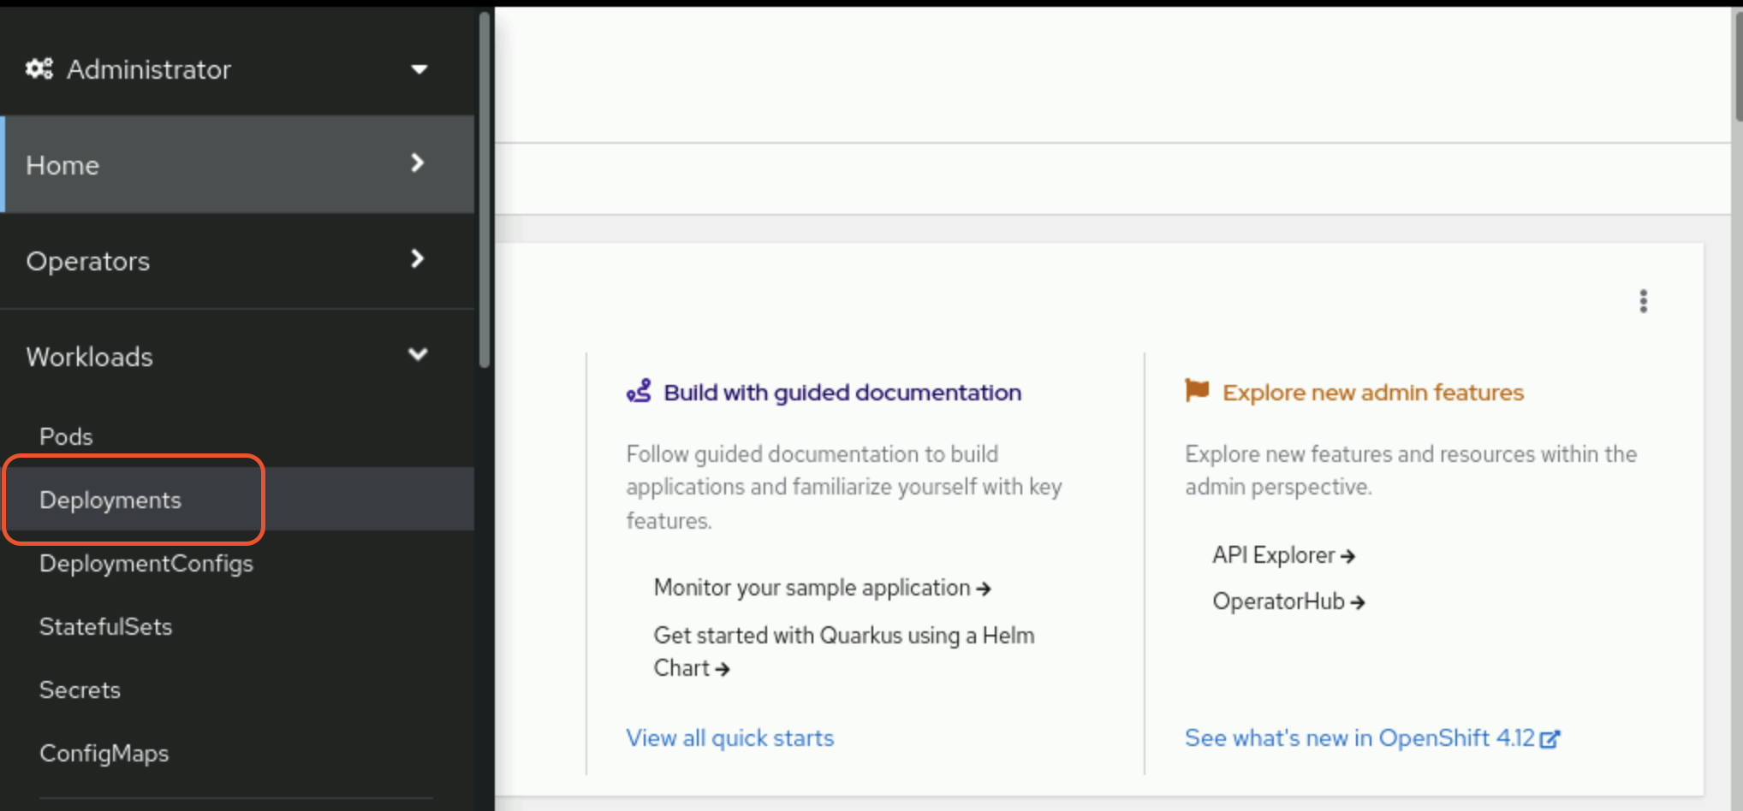
Click Create Deployment and customize the form or the YAML manifest.
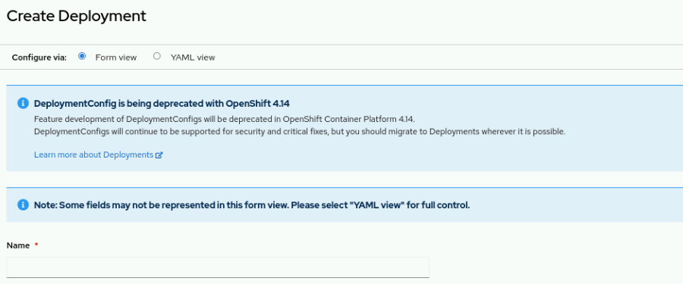
Pods in a replica set are identical and match the pod template in the replica set definition. If the number of replicas is not met, then a new pod is created from the template. For example, if a pod crashes or is otherwise deleted, then a new pod is created to replace it.
Labels are a type of resource metadata that are represented as string key-value pairs. A label indicates a common trait for resources with that label. For example, you might attach a layer=frontend label to resources that relate to an application's UI components.
Many oc commands accept a label to filter affected resources. For example, the following command deletes all pods with the environment=testing label:
[user@host ~]$ oc delete pod -l environment=testing
By liberally applying labels to resources, you can cross-reference resources and craft precise selectors. A selector is a query object that describes the attributes of matching resources.
Certain resources use selectors to find other resources. In the following YAML excerpt, an example replica set uses a selector to match its pods.
apiVersion: apps/v1
kind: ReplicaSet
...output omitted...
spec:
replicas: 1
selector:
matchLabels:
app: httpd
pod-template-hash: 7c84fbdb57
...output omitted...

Daemonsets
A daemon set ensures that all, or some, nodes run a copy of a pod. As nodes are added to the cluster, pods are added to them. As nodes are removed from the cluster, those pods are garbage collected. Delete the daemon set to clean up the pods it created.
Common uses for daemon sets include running storage daemons, log collectors, or monitoring agents on every node.
The following example command creates a daemon set:
[user@host ~]$ oc create daemonset my-daemonset \
--image registry.access.redhat.com/ubi9/ubi
Creates a daemon set resource.
Sets registry.access.redhat.com/ubi9/ubi as the container image for the pods.
You can also create a daemon set from the web console by clicking the Workloads → DaemonSets menu. Click Create DaemonSet and customize the YAML manifest.

Stateful Sets
Similar to deployments, stateful sets manage a set of pods based on a container specification. However, each pod that a stateful set creates is unique. Pod uniqueness is useful when, for example, a pod needs a unique network identifier or persistent storage.
As their name implies, stateful sets are for pods that require a state within the cluster. Deployments are used for stateless pods.
Stateful sets are covered further in a later chapter.

Guided Exercise: Manage Long-lived and Short-lived Applications by Using the Kubernetes Workload API
Deploy a batch application managed by a job resource and a database server that a deployment resource manages by using the Kubernetes command-line interface.
Outcomes
In this exercise, you deploy a database server and a batch application, both managed by workload resources that the deployment resources manage.
- Create deployments.
- Update environment variables on a pod template.
- Create and run job resources.
- Retrieve the logs and termination status of a job.
- View the pod template of a job resource.
As the student user on the workstation machine, use the lab command to prepare your system for this exercise.
This command ensures resource availability for the exercise.
[student@workstation ~]$ lab start deploy-workloads
Instructions
- As the developer user, create a MySQL deployment in a new project.
  - Log in as the developer user with the developer password.
[student@workstation ~]$ oc login -u developer -p developer \
https://api.ocp4.example.com:6443
  - ...output omitted...
  - Create a project named deploy-workloads.
[student@workstation ~]$ oc new-project deploy-workloads
Now using project "deploy-workloads" on server "https://api.ocp4.example.com:6443".
  - ...output omitted...
  - Create a deployment that runs an ephemeral MySQL server.
[student@workstation ~]$ oc create deployment my-db \
--image registry.ocp4.example.com:8443/rhel9/mysql-80:1
  - deployment.apps/my-db created
  - Retrieve the status of the deployment.
[student@workstation ~]$ oc get deployments
NAME READY UP-TO-DATE AVAILABLE AGE
  - my-db 0/1 1 0 67s
  - The deployment never shows a ready instance.
  - Retrieve the status of the created pod. Your pod name might differ from the output.
[student@workstation ~]$ oc get pods
NAME READY STATUS RESTARTS AGE
  - my-db-8567b478dd-d28f7 0/1 CrashLoopBackOff 4 (60s ago) 2m35s
  - The pod fails to start and repeatedly crashes. If the pod status shows Pending, allow a few minutes for it to crash before proceeding.
  - Review the logs for the pod to determine why it fails to start.
[student@workstation ~]$ oc logs deploy/my-db
...output omitted...
You must either specify the following environment variables:
MYSQL_USER (regex: '^$')
MYSQL_PASSWORD (regex: '^[a-zA-Z0-9_~!@#$%^&*()-=<>,.?;:|]$')
MYSQL_DATABASE (regex: '^$')
Or the following environment variable:
MYSQL_ROOT_PASSWORD (regex: '^[a-zA-Z0-9_~!@#$%^&*()-=<>,.?;:|]$')
  - ...output omitted...
  - Note that the container fails to start due to missing environment variables.
- Fix the database deployment and verify that the server runs.
  - Set the MYSQL_USER, MYSQL_PASSWORD, and MYSQL_DATABASE environment variables.
[student@workstation ~]$ oc set env deployment/my-db \
MYSQL_USER=developer \
MYSQL_PASSWORD=developer \
MYSQL_DATABASE=sampledb
  - deployment.apps/my-db updated
  - Retrieve the list of deployments and observe that the my-db deployment has a running pod.
[student@workstation ~]$ oc get deployments
NAME READY UP-TO-DATE AVAILABLE AGE
  - my-db 1/1 1 1 4m50s
  - Retrieve the internal IP address of the MySQL pod within the list of all pods.
[student@workstation ~]$ oc get pods -o wide
NAME READY STATUS RESTARTS AGE IP ...
  - my-db-748c97d478-g8xc9 1/1 Running 0 64s 10.8.0.91 ...
  - The -o wide option provides additional output, such as IP addresses. Your IP address value might differ from the previous output.
  - Store the IP address of the MySQL pod as a variable for use in the next step.
[student@workstation ~]$ DB_IP=$(oc get pods my-db-7459cb94-zdb5p \
  - -o=jsonpath='{.status.podIP}')
  - Verify that the database server runs by executing a query. This command uses the variable that contains the IP address from preceding step.
[student@workstation ~]$ oc run -it db-test --restart=Never \
--image registry.ocp4.example.com:8443/rhel9/mysql-80:1 \
-- mysql sampledb -h $DB_IP -u developer --password=developer \
-e "select 1;"
...output omitted...
---
| 1 |
---
| 1 |
  - ---
- Delete the database server pod and observe that the deployment causes the pod to be re-created.
  - Delete the existing MySQL pod by using the label that is associated with the deployment.
[student@workstation ~]$ oc delete pod -l app=my-db
  - pod "my-db-84c8995d5-2sssl" deleted
  - Retrieve the information for the MySQL pod and observe that it is newly created. Your pod name might differ in your output.
[student@workstation ~]$ oc get pod -l app=my-db
NAME READY STATUS RESTARTS AGE
  - my-db-fbccb9447-p99jd 1/1 Running 0 6s
- Create and apply a job resource that prints the time and date repeatedly.
  - Create a job resource called date-loop that runs a script. Ignore the warning.
[student@workstation ~]$ oc create job date-loop \
--image registry.ocp4.example.com:8443/ubi9/ubi \
-- /bin/bash -c "for i in {1..30}; do date; done"
  - job.batch/date-loop created
  - Retrieve the job resource to review the pod specification.
[student@workstation ~]$ oc get job date-loop -o yaml
...output omitted...
spec:
containers:
- command:
- /bin/bash
- -c
- for i in {1..30}; do date; done
image: registry.ocp4.example.com:8443/ubi9/ubi
imagePullPolicy: Always
name: date-loop
resources: {}
terminationMessagePath: /dev/termination-log
terminationMessagePolicy: File
dnsPolicy: ClusterFirst
restartPolicy: Never
schedulerName: default-scheduler
securityContext: {}
terminationGracePeriodSeconds: 30
  - ...output omitted...

The command object, which specifies the defined script to execute within the pod.
Sets the container image for the pod.
Defines the restart policy for the pod. Kubernetes does not restart the job pod after the pod exits.
  - List the jobs to see that the date-loop job completed successfully.
[student@workstation ~]$ oc get jobs
NAME COMPLETIONS DURATION AGE
  - date-loop 1/1 7s 8s
  - You might need to wait for the script to finish and run the command again.
  - Retrieve the logs for the associated pod. The log values might differ in your output.
[student@workstation ~]$ oc logs job/date-loop
Fri Nov 18 14:50:56 UTC 2022
Fri Nov 18 14:50:59 UTC 2022
  - ...output omitted...
- Delete the pod for the date-loop job and observe that the pod is not created again.
  - Delete the associated pod.
[student@workstation ~]$ oc delete pod -l job-name=date-loop
  - pod "date-loop-wvn2q" deleted
  - View the list of pods and observe that the pod is not re-created for the job.
[student@workstation ~]$ oc get pod -l job-name=date-loop
  - No resources found in deploy-workloads namespace.
  - Verify that the job status is still listed as successfully completed.
[student@workstation ~]$ oc get job -l job-name=date-loop
NAME COMPLETIONS DURATION AGE
  - date-loop 1/1 7s 7m36s
Finish
On the workstation machine, use the lab command to complete this exercise. This step is important to ensure that resources from previous exercises do not impact upcoming exercises.
[student@workstation ~]$ lab finish deploy-workloads

Kubernetes Pod and Service Networks

Objectives
- Interconnect application pods inside the same cluster by using Kubernetes services.

The Software-defined Network
Kubernetes implements software-defined networking (SDN) through Open Virtual Network (OVN)-Kubernetes to manage the network infrastructure of the cluster. OVN-Kubernetes creates a virtual network that encompasses all cluster nodes. The virtual network enables communication between any container or pod within the cluster. Cluster node processes that Kubernetes pods manage have access to the OVN-Kubernetes network. However, the OVN-Kubernetes network remains inaccessible from outside the cluster or by regular processes on cluster nodes.
With the OVN-Kubernetes model, you can manage network services through the abstraction of multiple networking layers. With OVN-Kubernetes, you can manage network traffic and network resources programmatically to enable organization teams to determine how to expose their application.
The OVN-Kubernetes implementation creates a model that is compatible with traditional networking practices. The model makes pods that are similar to virtual machines in terms of port allocation, IP address leasing, and reservation.
With the OVN-Kubernetes design, you do not need to modify how application components communicate with each other. The OVN-Kubernetes design assists in containerizing legacy applications. If your application consists of multiple services that communicate over the TCP/UDP stack, then this approach remains effective because containers within a pod use the same network stack.
The following diagram illustrates how all pods connect to a shared network:
Figure 4.6: How OVN-Kubernetes manages the network
Among the features of OVN-Kubernetes, open standards enable vendors to propose solutions for centralized management, dynamic routing, and tenant isolation.

Kubernetes Networking
Networking in Kubernetes provides a scalable method for communication between containers and offers the following capabilities:
- Highly coupled container-to-container communications
- Pod-to-pod communications
- Pod-to-service communications
- External-to-service communication: Covered in the section called “ Scale and Expose Applications to External Access ”
Kubernetes automatically assigns an IP address to each pod. However, pod IP addresses remain unstable because pods are ephemeral. Pods continuously create and delete themselves across the nodes in the cluster. For example, when you deploy a new version of your application, Kubernetes deletes the existing pods and then deploys new ones.
All containers within a pod share networking resources. The IP address and MAC address that are assigned to the pod are shared among all containers in the pod. Thus, all containers within a pod can access each other's ports via the loopback address, which is localhost. Ports that are bound to localhost are available to all containers that are running within the pod but not to containers outside it.
By default, pods can communicate with each other even if they run on different cluster nodes or belong to different Kubernetes namespaces. Every pod is assigned an IP address in a flat shared networking namespace that has full communication with other physical computers and containers across the network. All pods are assigned a unique IP address from a Classless Inter-Domain Routing (CIDR) range of host addresses. The shared address range places all pods in the same subnet.
Because all the pods are on the same subnet, pods on all nodes can communicate with pods on any other node without the aid of Network Address Translation (NAT). Kubernetes also provides a service subnet, which links the stable IP address of a service resource to a set of specified pods. The traffic is forwarded in a transparent way to the pods; an agent, which OVN-Kubernetes manages, handles routing rules to direct traffic to pods that match the service resource selectors. Thus, pods function similarly to virtual machines or to physical hosts regarding port allocation, networking, naming, service discovery, load balancing, application configuration, and migration.
The following illustration gives further insight into how the infrastructure components work along with the pod and service subnets to enable network access between pods inside an OpenShift instance.
Figure 4.7: Network access between pods in a cluster
The shared networking namespace of pods enables a straightforward communication model. However, the dynamic nature of pods presents a problem. Pods can be added on the fly to handle increased traffic. Likewise, pods can be dynamically scaled down. If a pod fails, then Kubernetes automatically replaces the pod with a new one. These events change pod IP addresses.
Figure 4.8: Problem with direct access to pods
In the diagram, the Before side shows a Front-end container that is running in a pod with a 10.8.0.1 IP address. The container also shows a Back-end container that is running in a pod with a 10.8.0.2 IP address. In this example, an event occurs that causes the Back-end container to fail. A pod can fail for many reasons. In response to the failure, Kubernetes creates a pod for the Back-end container that uses a new IP address of 10.8.0.4.
From the After side of the diagram, the Front-end container now has an invalid reference to the Back-end container because of the IP address change. Kubernetes resolves this problem with service resources.

Using Services
Containers inside Kubernetes pods must not connect directly to each other's dynamic IP address. Instead, Kubernetes assigns a stable IP address to a service resource that is linked to a set of specified pods. The service acts as a virtual network load balancer for the pods that are linked to it.
If pods are restarted, replicated, or rescheduled to different nodes, then the service endpoints are updated. The updated endpoints provide scalability and fault tolerance for your application. Unlike the IP addresses of pods, the IP addresses of services do not change. Service IP stability provides scalability and fault tolerance for your application.
Figure 4.9: Services resolve pod failure issues
In the diagram, the Before side shows that a Front-end container references the stable IP address of the Back-end service, instead of to the IP address of the pod that is running the Back-end container. When the Back-end container fails, Kubernetes creates a pod with the New back-end container to replace the failed pod. In response to the change, Kubernetes removes the failed pod from the service endpoints. Kubernetes then adds the IP address of the New back-end container pod to the service endpoints.
With the service in place, requests from the Front-end container to the Back-end container continue to function. The service updates dynamically with the IP address change. A service provides a permanent, static IP address for a group of pods that belong to the same deployment or replica set for an application. Until you delete the service, the assigned IP address does not change, and the cluster does not reuse it.
Most real-world applications do not run as a single pod. Applications need to scale horizontally. Multiple pods run the same containers to meet growing user demand. A Deployment resource manages multiple pods that execute the same container. A service provides a single IP address for the entire set. The service performs load balancing for client requests among member pods.
With services, containers in one pod can establish network connections to containers in another pod. The pods that the service tracks do not need to exist on the same compute node or in the same namespace or project. Because a service provides a stable IP address for other pods to use, a pod does not need to discover the new IP address of another pod after a restart. The service provides a stable IP address to use, no matter which compute node runs the pod after each restart.
Figure 4.10: Service with pods on many nodes
The Service object provides a stable IP address for the Client container on Node X. The stable IP address enables the Client container to send a request to any of the API containers.
Kubernetes uses labels on pods to select those pods that are associated with a service. To include a pod in a service, the pod labels must include each of the selector fields of the service.
Figure 4.11: Service selector match to pod labels
In this example, the selector has a key-value pair of app: myapp. Thus, pods with a matching label of app: myapp are included in the set that is associated with the service. The selector attribute of a service identifies the set of pods that form the endpoints for the service. Each pod in the set is an endpoint for the service.
To create a service for a deployment, use the oc expose command:
[user@host ~]$ oc expose deployment/<deployment-name> [--selector <selector>]
[--port <port>][--target-port <target port>][--protocol <protocol>][--name <name>]
The oc expose command uses the --selector option to specify label selectors. When you omit the --selector option, the command applies a selector that matches the replication controller or the replica set.
The --port option specifies the port that the service listens on. This port is available only to pods within the cluster. If a port value is not provided, then the port is copied from the configuration of the deployment.
The --target-port option specifies the name or number of the container port that the service uses to communicate with the pods. If you do not provide a port value, then the port is copied from the configuration of the deployment.
The --protocol option determines the network protocol for the service. TCP is used by default.
The --name option explicitly names the service. If you do not specify a name, then the service uses the same name as the deployment.
To view the selector that a service uses, use the -o wide option with the oc get command.
[user@host ~]$ oc get service db-pod -o wide
NAME TYPE CLUSTER-IP EXTERNAL-IP PORT(S) AGE SELECTOR
db-pod ClusterIP 172.30.108.92 <none> 3306/TCP 108s app=db-pod
In this example, db-pod is the name of the service. Pods must use the app=db-pod label to be included in the host list for the db-pod service. To see the endpoints that a service uses, use the oc get endpoints command.
[user@host ~]$ oc get endpoints
NAME ENDPOINTS AGE
db-pod 10.8.0.86:3306,10.8.0.88:3306 27s
This example illustrates a service with two pods in the host list. The oc get endpoints command returns the service endpoints in the current selected project. Add the name of the service to the command to show only the endpoints of a single service. Use the --namepace option to view the endpoints in a different namespace.
Use the oc describe deployment <deployment name> command to view the deployment selector.
[user@host ~]$ oc describe deployment db-pod
Name: db-pod
Namespace: deploy-services
CreationTimestamp: Wed, 18 Jan 2023 17:46:03 -0500
Labels: app=db-pod
Annotations: deployment.kubernetes.io/revision: 2
Selector: app=db-pod
...output omitted...
You can view or parse the selector from the YAML or JSON output for the deployment resource from the spec.selector.matchLabels object. In this example, the -o yaml option of the oc get command returns the selector label that the deployment uses.
[user@host ~]$ oc get deployment/<deployment_name> -o yaml
...output ommitted...
selector:
matchLabels:
app: db-pod
...output ommitted...

Kubernetes DNS for Service Discovery
Kubernetes uses an internal Domain Name System (DNS) server that the DNS operator deploys. The DNS operator creates a default cluster DNS name, and assigns DNS names to services that you define. The DNS operator implements the DNS API from the operator.openshift.io API group. The operator deploys CoreDNS, creates a service resource for CoreDNS, and configures the kubelet component to instruct pods to use the CoreDNS service IP address for name resolution. When a service does not have a cluster IP address, the DNS operator assigns a DNS record that resolves to the set of IP addresses of the pods behind the service.
The DNS server discovers a service from a pod by using the internal DNS server, which is visible only to pods. Each service is dynamically assigned a Fully Qualified Domain Name (FQDN) that uses the following format:
SVC-NAME.PROJECT-NAME.svc.CLUSTER-DOMAIN
When a pod is created, Kubernetes provides the container with a /etc/resolv.conf file with similar contents to the following items:
[user@host ~]$ cat /etc/resolv.conf
nameserver 172.30.0.10
search deploy-services.svc.cluster.local svc.cluster.local cluster.local
options ndots:5
In this example, deploy-services is the project name for the pod, and cluster.local is the cluster domain.
The nameserver directive provides the IP address of the Kubernetes internal DNS server. The options ndots directive specifies the number of dots that must appear in a name to qualify for an initial absolute query. Alternative hostname values are derived by appending values from the search directive to the name that you send to the DNS server.
In the search directive in this example, the svc.cluster.local entry enables any pod to communicate with another pod in the same cluster by using the service name and project name:
SVC-NAME.PROJECT-NAME
The first entry in the search directive enables a pod to use the service name to specify another pod in the same project. In Red Hat OpenShift Container Platform (RHOCP), a project is also the namespace for the pod. The service name alone is sufficient for pods in the same RHOCP project:
SVC-NAME

Kubernetes Networking Drivers
Container Network Interface (CNI) plug-ins provide a common interface between the network provider and the container runtime. CNI defines the specifications for plug-ins that configure network interfaces inside containers. Plug-ins that are written to the specification enable different network providers to control the RHOCP cluster network.
Red Hat provides the following CNI plug-ins for a RHOCP cluster:
- OVN-Kubernetes: The default plug-in for first-time installations of RHOCP 4.10 and later versions.
- OpenShift SDN: An earlier plug-in from RHOCP 3.x; it is incompatible with some later features of RHOCP 4.x.
Certified CNI-plugins from other vendors are also compatible with an RHOCP cluster.
The SDN uses CNI plug-ins to create Linux namespaces to partition the usage of resources and processes on physical and virtual hosts. With this implementation, containers inside pods can share network resources, such as devices, IP stacks, firewall rules, and routing tables. The SDN allocates a unique routable IP to each pod, so that you can access the pod from any other service in the same network.
In OpenShift 4.18, OVN-Kubernetes serves as the default network provider and OpenShift SDN is deprecated.
OVN-Kubernetes uses OVN to manage the cluster network. A cluster that uses the OVN-Kubernetes plug-in also runs Open vSwitch (OVS) on each node. OVN configures OVS on each node to implement the declared network configuration.

The OpenShift Cluster Network Operator
RHOCP provides a Cluster Network Operator (CNO) that configures OpenShift cluster networking. The CNO serves as an OpenShift cluster operator that loads and configures CNI plug-ins. As a cluster administrator, execute the following command to observe the status of the CNO:
[user@host ~]$ oc get -n openshift-network-operator deployment/network-operator
NAME READY UP-TO-DATE AVAILABLE AGE
network-operator 1/1 1 1 41d
An administrator configures the CNO at installation time. To view the configuration, use the following command:
[user@host ~]$ oc describe network.config/cluster
Name: cluster
...output omitted...
Spec:
Cluster Network:
Cidr: 10.128.0.0/14
Host Prefix: 23
External IP:
Policy:
Network Type: OVNKubernetes
Service Network:
172.30.0.0/16
...output omitted...
The Cluster Network CIDR defines the range of IP addresses for all pods in the cluster.
The Service Network CIDR defines the range of IP addresses for all services in the cluster.

Guided Exercise: Kubernetes Pod and Service Networks
Deploy a database server and access it through a Kubernetes service.
Outcomes
Deploy a database server, and access it indirectly through a Kubernetes service, and also directly pod-to-pod for troubleshooting.
As the student user on the workstation machine, use the lab command to prepare your system for this exercise.
This command ensures that all resources are available for this exercise. It also creates the deploy-services project and the /home/student/DO180/labs/deploy-services/resources.txt file. The resources.txt file contains commands that you can copy and paste to use in this exercise.
[student@workstation ~]$ lab start deploy-services

Note
It is safe to ignore pod security warnings for exercises in this course. OpenShift uses the Security Context Constraints controller to provide safe defaults for pod security.
Instructions
- Log in to the OpenShift cluster as the developer user with developer as the password. Use the deploy-services project.
  - Log in to the OpenShift cluster.
[student@workstation ~]$ oc login -u developer -p developer \
https://api.ocp4.example.com:6443
Login successful.
  - ...output omitted...
  - Set the deploy-services project as the active project.
[student@workstation ~]$ oc project deploy-services
  - ...output omitted...
- Use the registry.ocp4.example.com:8443/rhel8/mysql-80 container image to create a MySQL deployment named db-pod. Add the missing environment variables for the pod to run.
  - Create the db-pod deployment.
[student@workstation ~]$ oc create deployment db-pod --port 3306 \
--image registry.ocp4.example.com:8443/rhel8/mysql-80
  - deployment.apps/db-pod created
  - Add the environment variables.
[student@workstation ~]$ oc set env deployment/db-pod \
MYSQL_USER=user1 \
MYSQL_PASSWORD=mypa55w0rd \
MYSQL_DATABASE=items
  - deployment.apps/db-pod updated
  - Confirm that the pod is running.
[student@workstation ~]$ oc get pods
NAME READY STATUS RESTARTS AGE
  - db-pod-6ccc485cfc-vrc4r 1/1 Running 0 2m30s
  - Your pod name might differ from the previous output.
- Expose the db-pod deployment to create a ClusterIP service.
  - View the deployment for the pod.
[student@workstation ~]$ oc get deployment
NAME READY UP-TO-DATE AVAILABLE AGE
  - db-pod 1/1 1 1 3m36s
  - Expose the db-pod deployment to create a service.
[student@workstation ~]$ oc expose deployment/db-pod
  - service/db-pod exposed
- Validate the service. Verify that the service selector matches the pod label. Then, confirm that the db-pod service endpoint matches the pod IP address.
  - Identify the selector for the db-pod service. Use the oc get service command with the -o wide option.
[student@workstation ~]$ oc get service db-pod -o wide
NAME TYPE CLUSTER-IP EXTERNAL-IP PORT(S) AGE SELECTOR
  - db-pod ClusterIP 172.30.108.92 <none> 3306/TCP 108s app=db-pod
  - The selector shows an app=db-pod key:value pair.
  - Capture the pod name in a variable.
[student@workstation ~]$ PODNAME=$(oc get pods \
  - -o jsonpath='{.items[0].metadata.name}')
  - Query the label on the pod.
[student@workstation ~]$ oc get pod $PODNAME --show-labels
NAME READY STATUS RESTARTS AGE LABELS
  - db-pod-6ccc485cfc-vrc4r 1/1 Running 0 6m50s app=db-pod ...
  - The label list includes the app=db-pod key-value pair, which matches the service selector.
  - Retrieve the endpoints for the db-pod service.
[student@workstation ~]$ oc get endpoints
NAME ENDPOINTS AGE
  - db-pod 10.8.0.85:3306 4m38s
  - The endpoint IP is different in your output.
  - Verify that the service endpoint matches the pod IP address. Use the oc get pods command with the -o wide option.
[student@workstation ~]$ oc get pods -o wide
NAME READY STATUS RESTARTS AGE IP ...
  - db-pod-6ccc485cfc-vrc4r 1/1 Running 0 54m 10.8.0.85 ...
  - The service endpoint resolves to the pod's IP address.
- Delete and re-create the db-pod deployment. Confirm that the db-pod service endpoint automatically resolves to the new pod's IP address.
  - Delete the db-pod deployment.
[student@workstation ~]$ oc delete deployment.apps/db-pod
  - deployment.apps "db-pod" deleted
  - Verify that the service still exists without the deployment.
[student@workstation ~]$ oc get service
NAME TYPE CLUSTER-IP EXTERNAL-IP PORT(S) AGE
  - db-pod ClusterIP 172.30.108.92 <none> 3306/TCP 9m53s
  - Confirm that the service endpoints list is empty.
[student@workstation ~]$ oc get endpoints
NAME ENDPOINTS AGE
  - db-pod <none> 12m
  - Re-create the db-pod deployment.
[student@workstation ~]$ oc create deployment db-pod --port 3306 \
--image registry.ocp4.example.com:8443/rhel8/mysql-80
  - deployment.apps/db-pod created
  - Add the environment variables.
[student@workstation ~]$ oc set env deployment/db-pod \
MYSQL_USER=user1 \
MYSQL_PASSWORD=mypa55w0rd \
MYSQL_DATABASE=items
  - deployment.apps/db-pod updated
  - Confirm that the new pod has the app=db-pod selector.
[student@workstation ~]$ oc get pods --selector app=db-pod -o wide
NAME READY STATUS RESTARTS AGE IP ...
  - db-pod-6ccc485cfc-l2x 1/1 Running 0 32s 10.8.0.85 ...
  - The pod name might differ, and the pod IP address might also change.
  - Confirm that the endpoints include the new pod.
[student@workstation ~]$ oc get endpoints
NAME ENDPOINTS AGE
  - db-pod 10.8.0.85:3306 16m
- Create a pod to identify the available DNS name assignments for the service.
  - Create a pod named shell for troubleshooting. Use the oc run command with the registry.ocp4.example.com:8443/openshift4/network-tools-rhel8 image.
[student@workstation ~]$ oc run shell -it \
--image registry.ocp4.example.com:8443/openshift4/network-tools-rhel8
If you don't see a command prompt, try pressing enter.
  - bash-4.4$
  - View the /etc/resolv.conf file from the shell pod to identify the cluster-domain name.
bash-4.4$ cat /etc/resolv.conf
search deploy-services.svc.cluster.local svc.cluster.local ...
nameserver 172.30.0.10
  - options ndots:5
  - The container uses the search directive values as suffixes for DNS queries. The cluster-domain name follows svc.
  - Test the available DNS names with the nc and echo commands.
bash-4.4$ nc -z db-pod.deploy-services 3306 && \
echo "Connection success to db-pod.deploy-services:3306" || \
echo "Connection failed"
  - Connection success to db-pod.deploy-services:3306
  - Exit the interactive session.
bash-4.4$ exit
  - Session ended, resume using 'oc attach shell -c shell -i -t' command when the pod is running
  - Delete the shell pod.
[student@workstation ~]$ oc delete pod shell
  - pod "shell" deleted
- Test pod communications across namespaces with a new project.
  - Create a second namespace with the oc new-project command.
[student@workstation ~]$ oc new-project deploy-services-2
Now using project "deploy-services-2" on server "https://api.ocp4.example.com:6443".
  - ...output omitted...
  - Test DNS name access from a pod in the new namespace.
[student@workstation ~]$ oc run shell -it --rm \
--image registry.ocp4.example.com:8443/openshift4/network-tools-rhel8 \
--restart Never -- nc -z db-pod.deploy-services.svc.cluster.local 3306 && \
echo "Connection success to db-pod.deploy-services.svc.cluster.local:3306" || \
echo "Connection failed"
pod "shell" deleted
  - Connection success to db-pod.deploy-services.svc.cluster.local:3306
  - Return to the deploy-services project.
[student@workstation ~]$ oc project deploy-services
  - Now using project "deploy-services" on server "https://api.ocp4.example.com:6443".
- Use a Kubernetes job to add initialization data to the database.
  - Create a job named mysql-init by using the registry.ocp4.example.com:8443/redhattraining/do180-dbinit:v1 image. This image, which is based on mysql-80, includes a script to add initial records.
[student@workstation ~]$ oc create job mysql-init \
--image registry.ocp4.example.com:8443/redhattraining/do180-dbinit:v1 \
-- /bin/bash -c "mysql -uuser1 -pmypa55w0rd --protocol tcp \
-h db-pod -P3306 items </tmp/db-init.sql"
  - job.batch/mysql-init created
  - The -h option directs the command to the db-pod service short name. The -- option separates oc arguments from the pod command. The /tmp/db-init.sql file, which is included in the image, contains the following queries:
DROP TABLE IF EXISTS `Item`;
CREATE TABLE `Item` (`id` BIGINT not null auto_increment primary key, `description` VARCHAR(100), `done` BIT);
INSERT INTO `Item` (`id`,`description`,`done`) VALUES (1,'Pick up newspaper', 0);
  - INSERT INTO `Item` (`id`,`description`,`done`) VALUES (2,'Buy groceries', 1);
  - Confirm the mysql-init job status, and wait for its completion.
[student@workstation ~]$ oc get job
NAME STATUS COMPLETIONS DURATION AGE
  - mysql-init Complete 1/1 28s 42s
  - Check the mysql-init pod status.
[student@workstation ~]$ oc get pods
NAME READY STATUS RESTARTS AGE
db-pod-6ccc485cfc-2lklx 1/1 Running 0 4h24m
  - mysql-init-ln9cg 0/1 Completed 0 23m
  - Delete the mysql-init job.
[student@workstation ~]$ oc delete job mysql-init
  - job.batch "mysql-init" deleted
  - Verify that the mysql-init pod is deleted.
[student@workstation ~]$ oc get pods
NAME READY STATUS RESTARTS AGE
  - db-pod-6ccc485cfc-2lklx 1/1 Running 0 4h2
- Create a query-db pod to query the database service.
  - Create the query-db pod. Use the MySQL client to query the db-pod service.
[student@workstation ~]$ oc run query-db -it --rm \
--image registry.ocp4.example.com:8443/redhattraining/do180-dbinit:v1 \
--restart Never \
-- mysql -uuser1 -pmypa55w0rd --protocol tcp \
-h db-pod -P3306 items -e 'select * from Item;'
mysql: [Warning] Using a password on the command line interface can be insecure.
+----+-------------------+------------+
| id | description | done |
+----+-------------------+------------+
| 1 | Pick up newspaper | 0x00 |
| 2 | Buy groceries | 0x01 |
+----+-------------------+------------+
  - pod "query-db" deleted
- Use pod-to-pod communication for troubleshooting.
  - Confirm the IP address of the MySQL database pod.
[student@workstation ~]$ oc get pods -o wide
NAME READY STATUS RESTARTS AGE IP ...
  - db-pod-6ccc485cfc-2lklx 1/1 Running 0 4h5 10.8.0.69 ...
  - Your pod IP address might differ.
  - Capture the IP address in an environment variable.
[student@workstation ~]$ POD_IP=$(oc get pod -l app=db-pod \
  - -o jsonpath='{.items[0].status.podIP}')
  - Create a test pod named shell. Use nc to test the $POD_IP and port 3306.
[student@workstation ~]$ oc run shell --env POD_IP=$POD_IP -it --rm \
--image registry.ocp4.example.com:8443/openshift4/network-tools-rhel8 \
--restart Never \
-- nc -z $POD_IP 3306 && echo "Connection success to $POD_IP:3306" || \
echo "Connection failed"
pod "shell" deleted
  - Connection success to 10.8.0.69:3306
Finish
On the workstation machine, use the lab command to complete this exercise. This step is important to ensure that resources from previous exercises do not impact upcoming exercises.
[student@workstation ~]$ lab finish deploy-services

Scale and Expose Applications to External Access

Objectives
- Expose applications to clients outside the cluster by using Kubernetes ingress and OpenShift routes.

Outcomes
- Allocate IP addresses for pods and services in a Red Hat OpenShift Container Platform (RHOCP) cluster.
- Configure services to enable communication between pods.
- Expose applications to external networks by using routes and ingress objects.

IP Addresses for Pods and Services
Real-world applications typically require multiple pods to scale horizontally. To meet growing user demand, RHOCP deploys many pods that run the same containers from a single pod resource definition. A Service resource defines a single IP and port combination. The resource assigns a stable IP address to a pool of pods. The resource balances client requests across those pods.
RHOCP assigns each service a unique IP address for clients to connect to. The assignment uses a round-robin load-balancing strategy by default. The service IP address originates from an internal OVN-Kubernetes network. The network, which is separate from the pod network, is accessible only to pods within the cluster. RHOCP adds each pod to match the selector of the service as an endpoint.

Note
OVN-Kubernetes, which is the default network provider starting with RHOCP 4.18, manages pod-to-pod and service-to-pod communication. The provider ensures efficient traffic routing within the cluster.
Containers within Kubernetes pods must avoid connecting directly to dynamic IP addresses of other pods. Instead, services link stable OVN-Kubernetes IP addresses to pods to ensure scalability and fault tolerance. When pods restart, replicate, or reschedule to different nodes, RHOCP updates the service endpoints accordingly.

Service Types
RHOCP offers several service types to meet diverse application needs, cluster infrastructure, and security requirements.
ClusterIP
The ClusterIP type, which is the default unless otherwise specified, assigns a cluster-internal IP address to the service. The assignment makes the service accessible only within the RHOCP cluster.
ClusterIP services enable pod-to-pod communication. RHOCP allocates IP addresses from a dedicated service network. The network, which is accessible only inside the cluster, supports internal communication. Most applications benefit from this service type because Kubernetes automates management of the service.
LoadBalancer
The LoadBalancer type directs RHOCP to provision a load balancer of the cloud provider. The load balancer assigns an externally accessible IP address to the application.
Use caution when deploying LoadBalancer services because costs can be high when assigning a load balancer to every application. These services expose applications to external networks. The exposure requires additional security configurations to prevent unauthorized access.
ExternalIP
The ExternalIP service redirects traffic from a virtual IP address on a cluster node to a pod. A cluster administrator assigns the virtual IP address to a node. The administrator configures failover to another node if needed.

Warning
Starting with RHOCP 4.18, ExternalIP is a legacy feature due to security concerns. Direct network connections to cluster nodes, which this service requires, conflict with most security policies. Use the LoadBalancer or the NodePort type unless the ExternalIP type meets specific requirements.
RHOCP configures Network Address Translation (NAT) rules to route traffic from the virtual IP address to the pod. Administrators must ensure that external IP addresses route correctly to nodes. Additional security measures protect the cluster from external access.
NodePort
The NodePort service exposes a service on a specific port, with a default range of 30000–32767, on the IP address of each cluster node. Each node redirects traffic from this port to the endpoints of the service.

Warning
NodePort services require direct network connections to cluster nodes, which poses a security risk. Implement strict firewall rules and access controls to mitigate risks.
ExternalName
The ExternalName service maps a Kubernetes service to an external DNS name that is specified in the externalName field. The Kubernetes DNS server returns the externalName in a Canonical Name (CNAME) record. The record directs clients to resolve the external name to an IP address.

Using Routes for External Connectivity
RHOCP provides Route resources to expose applications to external networks. Route resources support HTTP, HTTPS, TCP, and other protocols, and prioritize HTTP and TLS-based applications for external exposure. Non-HTTP applications, such as databases, typically remain internal. Route and Ingress resources handle ingress traffic in RHOCP.
A Route resource assigns a publicly accessible hostname to an application. The OpenShift ingress controller, which is HAProxy-based, redirects traffic from a public IP address to pods. The OpenShift ingress controller is the default, with support for third-party ingress controllers that are deployed in parallel. Route resources offer advanced features, which surpass standard Kubernetes Ingress capabilities. Features include TLS re-encryption, passthrough, and split traffic for blue-green deployments.
To create a route by using the oc CLI, use the following command:
[user@host ~]$ oc expose service api-frontend --hostname api.apps.acme.com
The --target-port option of the oc expose command specifies the name or number of the container port that the service uses to communicate with the pods. If you provide no port value, then the port copies from the configuration of the deployment.
Omitting the --hostname option prompts RHOCP to generate a hostname in the <route-name>-<project-name>.<default-domain> format. For example, a frontend route in an api project with a wildcard domain of apps.example.com becomes frontend-api.apps.example.com.

Important
The DNS server for the wildcard domain resolves all names to configured IPs. The server does not recognize specific route hostnames. The OpenShift ingress controller treats route hostnames as HTTP virtual hosts. Invalid or non-existent route hostnames trigger an HTTP 503 error.
When creating a route, configure the following settings:
- Service Name: Specifies the service to determine target pods.
- Hostname: Sets the route hostname as a subdomain of the cluster wildcard domain, which RHOCP can autogenerate.
- Path: Defines an optional path for path-based routing.
- Target Port: Matches the targetPort in the service, and specifies the listening port of the application.
- Encryption Strategy: Chooses secure (TLS) or insecure routing.
The following example shows a minimal route definition:
kind: Route
apiVersion: route.openshift.io/v1
metadata:
name: a-simple-route
labels:
app: API
name: api-frontend
spec:
host: api.apps.acme.com
to:
kind: Service
name: api-frontend
port:
targetPort: 8443
Specifies a unique route name.
Defines selectors for the route.
Sets the hostname, which is a subdomain of the cluster wildcard domain.
Identifies the service to redirect traffic to, by determining target pods.
Maps the router port to the endpoint port of the service.

Note
Some ecosystem components integrate with Ingress resources but not with Route resources. Starting with RHOCP 4.18, creating an Ingress object automatically generates a managed Route object, which is deleted when the Ingress object is removed.
To delete a route, use the following command:
[user@host ~]$ oc delete route a-simple-route
To create a route from the RHOCP web console, go to Networking → Routes. Click Create Route. Customize the name, hostname, path, and target service by using the form or the YAML editor.
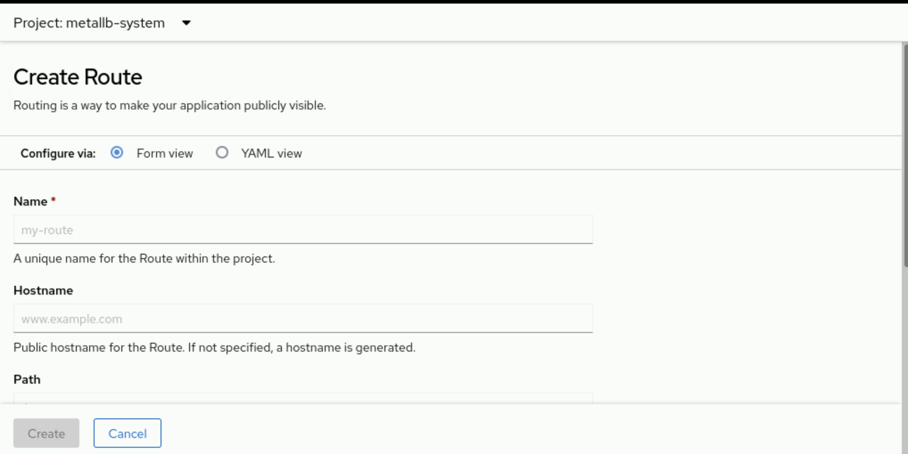

Using Ingress Objects for External Connectivity
A Kubernetes Ingress resource provides similar functions to RHOCP Route resources, and supports HTTP, HTTPS, Server Name Indication (SNI), and TLS with SNI. The OpenShift ingress controller processes Ingress objects, and enables features such as TLS termination, path redirection, and sticky sessions.

Note
Although Ingress resources are standard in Kubernetes, Route resources are preferred for advanced features and native integration with the OpenShift ingress controller.
To create an Ingress object, use the following command:
[user@host ~]$ oc create ingress ingr-sakila --rule="ingr-sakila.apps.ocp4.example.com/*=sakila-service:8080"
The following example shows a minimal Ingress definition:
apiVersion: networking.k8s.io/v1
kind: Ingress
metadata:
name: frontend
spec:
rules:
- host: www.example.com
http:
paths:
- path: /
pathType: Prefix
backend:
service:
name: frontend
port:
number: 80
tls:
- hosts:
- www.example.com
secretName: example-com-tls-certificate
Specifies a unique name for the Ingress object.
Sets the hostname for inbound traffic.
Identifies the service to redirect traffic to.
Defines the port for the service back end.
Configures TLS for secure paths, which requires a matching host and a certificate secret.
To delete an Ingress object, use the following command:
[user@host ~]$ oc delete ingress frontend

Sticky Sessions
Sticky sessions ensure that stateful application traffic reaches the same pod for a user session. The OpenShift ingress controller can use cookies to manage session persistence for Route and Ingress resources. The controller selects a pod for a user request. The controller generates a cookie. The controller includes the cookie in the response. The client sends the cookie with subsequent requests, which enables the controller to route traffic to the same pod.
To configure session persistence for an Ingress object by using a cookie, use the following command:
[user@host ~]$ oc annotate ingress ingr-example ingress.kubernetes.io/affinity=cookie
To configure session persistence for a Route object with a custom cookie named myapp, use the following command:
[user@host ~]$ oc annotate route route-example router.openshift.io/cookie_name=myapp
To capture the route hostname, use the following command:
[user@host ~]$ ROUTE_NAME=$(oc get route route-example -o jsonpath='{.spec.host}')
To access the route and save the cookie, use the following command:
[user@host ~]$ curl $ROUTE_NAME -k -c /tmp/cookie_jar
To use the saved cookie for subsequent requests, use the following command:
[user@host ~]$ curl $ROUTE_NAME -k -b /tmp/cookie_jar
Using the saved cookie ensures that requests reach the same pod.

Note
Cookies cannot be set on passthrough routes because the HTTP traffic is encrypted, and the router does not terminate TLS or read the contents of the request.

Load Balance and Scale Applications
Administrators and developers can scale the number of replica pods in a deployment to handle traffic surges or to conserve resources.
To scale a deployment, use the following command:
[user@host ~]$ oc scale --replicas=5 deployment/scale
The deployment updates the replica set. The replica set creates or deletes pods to match the intended replica count.
Avoid modifying a replica set directly, because the deployment controller manages these changes.

Load Balance Pods
A Kubernetes Service resource functions as an internal load balancer, by providing access to a workload via the service name. The service distributes incoming connections across replicated pods. The OpenShift ingress controller uses the selector of the service to identify the service and endpoints. When both the controller and a service provide load balancing, RHOCP relies on the controller to direct traffic to pods. The controller detects changes in IP addresses of the service. The controller updates the configuration. Custom controllers can propagate API object changes to external routing solutions.
The OpenShift ingress controller maps external hostnames. The controller balances service endpoints over protocols that include distinguishing information, such as HTTP host headers.

Guided Exercise: Scale and Expose Applications to External Access
Deploy one web server and access it through a Kubernetes ingress; and deploy another web server and access it through an OpenShift route.
Outcomes
In this exercise, you deploy two web applications to access them through an ingress object and a route, and scale them to verify the load-balance between the pods.
- Deploy two web applications.
- Create a route and an ingress object to access the web applications.
- Enable the sticky sessions for the web applications.
- Scale the web applications to load-balance the service.
As the student user on the workstation machine, use the lab command to prepare your system for this exercise. This command ensures that the cluster is accessible.
[student@workstation ~]$ lab start deploy-routes
Instructions
- Create two web application deployments, named satir-app and sakila-app. Use the registry.ocp4.example.com:8443/httpd-app:v1 container image for both deployments.
  - Log in to the OpenShift cluster as the developer user with developer as the password.
[student@workstation ~]$ oc login -u developer -p developer \
https://api.ocp4.example.com:6443
Login successful
You have one project on this server: "web-applications"
  - ...output omitted...
  - Change to the web-applications project.
[student@workstation ~]$ oc project web-applications
Now using project "web-applications" on server "https://api.ocp4.example.com:6443".
  - ...output omitted...
  - Create the satir-app web application deployment by using the registry.ocp4.example.com:8443/redhattraining/do180-httpd-app:v1 container image.
[student@workstation ~]$ oc create deployment satir-app \
--image registry.ocp4.example.com:8443/redhattraining/do180-httpd-app:v1
  - deployment.apps/satir-app created
  - After a few moments, verify that the deployment is successful.
[student@workstation ~]$ oc get pods
NAME READY STATUS RESTARTS ...
  - satir-app-787b7d7858-5dfsh 1/1 Running 0 ...
[student@workstation ~]$ oc get deploy/satir-app
NAME READY UP-TO-DATE AVAILABLE AGE
  - satir-app 1/1 1 1 6m39s
  - Create the sakila-app web application deployment by using the registry.ocp4.example.com:8443/redhattraining/do180-httpd-app:v1 image.
[student@workstation ~]$ oc create deployment sakila-app \
--image registry.ocp4.example.com:8443/redhattraining/do180-httpd-app:v1
  - deployment.apps/sakila-app created
  - Wait a few moments and then verify that the deployment is successful.
[student@workstation ~]$ oc get pods
NAME READY STATUS RESTARTS ...
sakila-app-6694...5kpd 1/1 Running 0 ...
  - satir-app-787b7...dfsh 1/1 Running 0 ...
[student@workstation ~]$ oc get deploy
NAME READY UP-TO-DATE AVAILABLE AGE
sakila-app 1/1 1 1 41s
  - satir-app 1/1 1 1 62m
- Create services for the web application deployments. Then, use the services to create a route for the satir-app application and an ingress object for the sakila-app application.
  - Expose the satir-app deployment. Name the service satir-svc, and specify port 8080 as the port and target port.
[student@workstation ~]$ oc expose deployment satir-app --name satir-svc \
--port 8080 --target-port 8080
  - service/satir-svc exposed
  - Expose the sakila-app deployment to create the sakila-svc service.
[student@workstation ~]$ oc expose deployment sakila-app --name sakila-svc \
--port 8080 --target-port 8080
  - service/sakila-svc exposed
  - Verify the status of the services.
[student@workstation ~]$ oc get services
NAME TYPE CLUSTER-IP EXTERNAL-IP PORT(S) ...
sakila-svc ClusterIP 172.30.230.41 <none> 8080/TCP ...
  - satir-svc ClusterIP 172.30.143.15 <none> 8080/TCP ...
  - Verify the status of the endpoints.
[student@workstation ~]$ oc get endpoints
NAME ENDPOINTS AGE
sakila-svc 10.8.0.66:8080 25s
  - satir-svc 10.8.0.65:8080 43s
  - Verify the status of the pods.
[student@workstation ~]$ oc get pods -o wide
NAME READY STATUS RESTARTS AGE IP ...
sakila-app-6694...5kpd 1/1 Running 0 92s 10.8.0.66 ...
  - satir-app-787b7...dfsh 1/1 Running 0 2m49s 10.8.0.65 ...
  - Expose the satir-svc service to create a route named satir for the satir-app web application. (create a route named satir-app to expose the web application to external access. )
[student@workstation ~]$ oc expose service satir-svc --name satir
  - route.route.openshift.io/satir exposed
Access the file-sharing route in a web browser to test the connection between the web application and the database server.
- [student@workstation ~]$ oc get routes
- NAME HOST/PORT ...
- file-sharing file-sharing-storage-review.apps.ocp4.example.com
Test the connectivity between the web application and the database server. In a web browser, go to http://file-sharing-storage-review.apps.ocp4.example.com, and verify that the Connected successfully message is displayed.

[student@workstation ~]$ oc get routes
NAME HOST/PORT ... SERVICES PORT ...
  - satir satir-web-applications.apps.ocp4.example.com ... satir-svc 8080 ...
  - Create an ingress object named ingr-sakila for the sakila-svc service. Configure the --rule option with the following values:
Field | Value
Host | ingr-sakila.apps.ocp4.example.com
Service name | sakila-svc
Port number | 8080
[student@workstation ~]$ oc create ingress ingr-sakila \
--rule "ingr-sakila.apps.ocp4.example.com/*=sakila-svc:8080"
  - ingress.networking.k8s.io/ingr-sakila created
[student@workstation ~]$ oc get ingress
NAME ... HOSTS ADDRESS PORTS ...
  - ingr-sakila ... ingr-sakila.apps.ocp4.example.com router...com 80 ...
  - Confirm that a route exists for the ingr-sakila ingress object.
[student@workstation ~]$ oc get routes
NAME HOST/PORT ... SERVICES PORT
ingr-sakila... ingr-sakila.apps.ocp4.example.com ... sakila-svc <all>
  - satir satir-web-applications.apps.ocp4.example.com ... satir-svc 8080
  - A specific port is not assigned to routes that ingress objects created. By contrast, a route that an exposed service created is assigned the same ports as the service.
  - Use the curl command to access the ingr-sakila ingress object and the satir route. The output states the name of the pod that is servicing the request.
[student@workstation ~]$ curl ingr-sakila.apps.ocp4.example.com
  - Welcome to Red Hat Training, from sakila-app-66947cdd78-x5kpd
[student@workstation ~]$ curl satir-web-applications.apps.ocp4.example.com
  - Welcome to Red Hat Training, from satir-app-787b7d7858-bdfsh
- Scale the web application deployments to load-balance their services. Scale the sakila-app deployment to two replicas, and scale the satir-app deployment to three replicas.
  - Scale the sakila-app deployment with two replicas.
[student@workstation ~]$ oc scale deployment sakila-app --replicas 2
  - deployment.apps/sakila-app scaled
  - Wait a few moments and then verify the status of the replica pods.
[student@workstation ~]$ oc get pods
NAME READY STATUS RESTARTS ...
sakila-app-6694...5kpd 1/1 Running 0 ...
sakila-app-6694...rfzg 1/1 Running 0 ...
  - satir-app-787b...dfsh 1/1 Running 0 ...
  - Scale the satir-app deployment with three replicas.
[student@workstation ~]$ oc scale deployment satir-app --replicas 3
  - deployment.apps/satir-app scaled
  - Wait a few moments and then verify the status of the replica pods.
[student@workstation ~]$ oc get pods -o wide
NAME READY STATUS RESTARTS ... IP ...
sakila-app-6694...5kpd 1/1 Running 0 ... 10.8.0.66 ...
sakila-app-6694...rfzg 1/1 Running 0 ... 10.8.0.67 ...
satir-app-787b...dfsh 1/1 Running 0 ... 10.8.0.65 ...
satir-app-787b...z8xm 1/1 Running 0 ... 10.8.0.69 ...
  - satir-app-787b...7bhj 1/1 Running 0 ... 10.8.0.70 ...
  - Retrieve the service endpoints to confirm that the services are load-balanced between the additional replica pods.
[student@workstation ~]$ oc get endpoints
NAME ENDPOINTS ...
sakila-svc 10.8.0.66:8080,10.8.0.67:8080 ...
  - satir-svc 10.8.0.65:8080,10.8.0.69:8080,10.8.0.70:8080 ...
- Enable the sticky sessions for the sakila-app web application. Then, use the curl command to confirm that the sticky sessions are working for the ingr-sakila object.
  - Configure a cookie for the ingr-sakila ingress object.
[student@workstation ~]$ oc annotate ingress ingr-sakila \
ingress.kubernetes.io/affinity=cookie
  - ingress.networking.k8s.io/ingr-sakila annotated
  - Use the curl command to access the ingr-sakila ingress object. The output states the name of the pod that is servicing the request. Notice that the connection is load-balanced between the replicas.
[student@workstation ~]$ for i in {1..10}; do \
curl ingr-sakila.apps.ocp4.example.com ; done
Welcome to Red Hat Training, from sakila-app-66947cdd78-x5kpd
Welcome to Red Hat Training, from sakila-app-66947cdd78-xrfzg
Welcome to Red Hat Training, from sakila-app-66947cdd78-x5kpd
  - ...output omitted...
  - Use the curl command to save the ingr-sakila ingress object cookie to the /tmp/cookie_jar file.
[student@workstation ~]$ curl ingr-sakila.apps.ocp4.example.com \
-c /tmp/cookie_jar
  - Welcome to Red Hat Training, from sakila-app-66947cdd78-xrfzg
  - Confirm that the cookie exists in the /tmp/cookie_jar file.
[student@workstation ~]$ cat /tmp/cookie_jar
...output omitted...
  - #HttpOnly_ingr-sakila.apps.ocp4.example.com FALSE / FALSE 0 b9b484110526b4b1b3159860d3aebe04 921e139c5145950d00424bf3b0a46d22
  - The cookie provides session stickiness for connections to the ingr-sakila route. Use the curl command and the cookie in the /tmp/cookie_jar file to connect to the ingr-sakila route again. Confirm that you are connected to the same pod that handled the request in the previous step.
[student@workstation ~]$ for i in {1..10}; do \
curl ingr-sakila.apps.ocp4.example.com -b /tmp/cookie_jar; done
Welcome to Red Hat Training, from sakila-app-66947cdd78-xrfzg
Welcome to Red Hat Training, from sakila-app-66947cdd78-xrfzg
Welcome to Red Hat Training, from sakila-app-66947cdd78-xrfzg
  - ...output omitted...
  - Use the curl command to connect to the ingr-sakila route without the cookie. Observe that session stickiness occurs only with the cookie.
[student@workstation ~]$ for i in {1..10}; do \
curl ingr-sakila.apps.ocp4.example.com ; done
Welcome to Red Hat Training, from sakila-app-66947cdd78-x5kpd
Welcome to Red Hat Training, from sakila-app-66947cdd78-xrfzg
Welcome to Red Hat Training, from sakila-app-66947cdd78-x5kpd
  - ...output omitted...
- Enable the sticky sessions for the satir-app web application. Then, use the curl command to confirm that sticky sessions are active for the satir route.
  - Configure a cookie with the hello value for the satir route.
[student@workstation ~]$ oc annotate route satir \
router.openshift.io/cookie_name="hello"
  - route.route.openshift.io/satir annotated
  - Use the curl command to access the satir route. The output states the name of the pod that is servicing the request. Notice that the connection is load-balanced between the three replica pods.
[student@workstation ~]$ for i in {1..10}; do \
curl satir-web-applications.apps.ocp4.example.com; done
Welcome to Red Hat Training, from satir-app-787b7d7858-bdfsh
Welcome to Red Hat Training, from satir-app-787b7d7858-gz8xm
Welcome to Red Hat Training, from satir-app-787b7d7858-q7bhj
  - ...output omitted...
  - Use the curl command to save the hello cookie to the /tmp/cookie_jar file.
[student@workstation ~]$ curl satir-web-applications.apps.ocp4.example.com \
-c /tmp/cookie_jar
  - Welcome to Red Hat Training, from satir-app-787b7d7858-q7bhj
  - Confirm that the hello cookie exists in the /tmp/cookie_jar file.
[student@workstation ~]$ cat /tmp/cookie_jar
...output omitted...
  - #HttpOnly_satir-web-applications.apps.ocp4.example.com FALSE / FALSE 0 hello b7dd73d32003e513a072e25a32b6c881
  - The hello cookie provides session stickiness for connections to the satir route. Use the curl command and the hello cookie in the /tmp/cookie_jar file to connect to the satir route again. Confirm that you are connected to the same pod that handled the request in the previous step.
[student@workstation ~]$ for i in {1..10}; do \
curl satir-web-applications.apps.ocp4.example.com -b /tmp/cookie_jar; done
Welcome to Red Hat Training, from satir-app-787b7d7858-q7bhj
Welcome to Red Hat Training, from satir-app-787b7d7858-q7bhj
Welcome to Red Hat Training, from satir-app-787b7d7858-q7bhj
  - ...output omitted...
  - Use the curl command to connect to the satir route without the hello cookie. Observe that session stickiness occurs only with the cookie.
[student@workstation ~]$ for i in {1..10}; do \
curl satir-web-applications.apps.ocp4.example.com; done
Welcome to Red Hat Training, from satir-app-787b7d7858-gz8xm
Welcome to Red Hat Training, from satir-app-787b7d7858-q7bhj
Welcome to Red Hat Training, from satir-app-787b7d7858-bdfsh
  - ...output omitted...
Finish
On the workstation machine, use the lab command to complete this exercise. This step is important to ensure that resources from previous exercises do not impact upcoming exercises.
[student@workstation ~]$ lab finish deploy-routes

Summary
- Many resources in Kubernetes and RHOCP create or affect pods.
- Resources are created imperatively or declaratively. The imperative strategy instructs the cluster what to do. The declarative strategy defines the state that the cluster matches.
- The oc new-app command creates resources that are determined via heuristics.
- A deployment is the main way to deploy an application in RHOCP.
- The workload API includes several resources to create pods. The choice between resources depends on for how long and how often the pod needs to run.
- A job resource executes a one-time task on the cluster via a pod. The cluster retries the job until it succeeds, or it retries a specified number of attempts.
- Resources are organized into projects and are selected via labels.
- A route connects a public-facing IP address and a DNS hostname to an internal-facing service IP address. Services provide network access between pods, whereas routes provide network access to pods from users and applications outside the RHOCP cluster.

Chapter 5. Manage Storage for Application Configuration and Data
Externalize the Configuration of Applications
Guided Exercise: Externalize the Configuration of Applications
Provision Persistent Data Volumes
Guided Exercise: Provision Persistent Data Volumes
Selecting a Storage Class for an Application
Guided Exercise: Selecting a Storage Class for an Application
Manage Non-shared Storage with Stateful Sets
Guided Exercise: Manage Non-shared Storage with Stateful Sets
Lab: Manage Storage for Application Configuration and Data
Summary
Abstract
Goal | Externalize application configurations in Kubernetes resources and provision storage volumes for persistent data files.
Sections | - Externalize the Configuration of Applications (and Guided Exercise)  - Provision Persistent Data Volumes (and Guided Exercise)  - Selecting a Storage Class for an Application (and Guided Exercise)  - Manage Non-shared Storage with Stateful Sets (and Guided Exercise)
Lab | - Manage Storage for Application Configuration and Data

Externalize the Configuration of Applications

Objectives
- Configure applications by using Kubernetes secrets and configuration maps to initialize environment variables and to provide text and binary configuration files.

Configuring Kubernetes Applications
When an application is run in Kubernetes with a pre-existing image, the application uses the default configuration. This action is valid for testing purposes. However, for production environments, you might need to customize your applications before deploying them.
With Kubernetes, you can use manifests in JSON and YAML formats to specify the intended configuration for each application. You can define the name of the application, labels, the image source, storage, environment variables, and more.
The following snippet shows an example of a YAML manifest file of a deployment:
apiVersion: apps/v1
kind: Deployment
metadata:
name: hello-deployment
spec:
replicas: 1
selector:
matchLabels:
app: hello-deployment
template:
metadata:
labels:
app: hello-deployment
spec:
containers:
- env:
- name: ENV_VARIABLE_1
valueFrom:
secretKeyRef:
key: hello
name: world
image: quay.io/hello-image:latest
API version of the resource.
Deployment resource type.
In this section, you specify the metadata of your application, such as the name.
You can define the general configuration of the resource that is applied to the deployment, such as the number of replicas (pods), the selector label, and the template data.
In this section, you specify the configuration for your application, such as the image name, the container name, ports, environment variables, and more.
You can define the environment variables to configure your application needs.
Sometimes, your application requires using a combination of files. For example, at the time of creation, a database deployment must have preloaded databases and data. You most commonly configure applications by using environment variables, external files, or command-line arguments. This process of configuration externalization ensures that the application is portable across environments when the container image, external files, and environment variables are available in the environment where the application runs.
Kubernetes provides a mechanism to externalize the configuration of your applications by using configuration maps and secrets.
You can use configuration maps to inject containers with configuration data. The ConfigMap (configuration map) namespaced objects provide ways to inject configuration data into containers, which helps to maintain platform independence of the containers. These objects can store fine-grained information, such as individual properties, or coarse-grained information, such as entire configuration files or JSON blobs (JSON sections). The information in configuration maps does not require protection.
The following listing shows an example of a configuration map:
apiVersion: v1
kind: ConfigMap
metadata:
name: example-configmap
namespace: my-app
data:
example.property.1: hello
example.property.2: world
example.property.file: |-
property.1=value-1
property.2=value-2
property.3=value-3
binaryData:
bar: R0lGODlhAgACAIABAO4AAP///yH5BAEHAAEALAAAAAACAAIAAAIDRAIFADs=
ConfigMap resource type.
Contains the configuration data.
Points to an encoded file in base64 that contains non-UTF-8 data, for example, a binary Java keystore file. Place a key followed by the encoded file.
Applications often require access to sensitive information. For example, a back-end web application requires access to database credentials to query a database. Kubernetes and OpenShift use secrets to hold sensitive information. For example, you can use secrets to store the following types of sensitive information:
- Passwords
- Sensitive configuration files
- Credentials to an external resource, such as an SSH key or OAuth token
The following listing shows an example of a secret:
apiVersion: v1
kind: Secret
metadata:
name: example-secret
namespace: my-app
type: Opaque
data:
username: bXl1c2VyCg==
password: bXlQQDU1Cg==
stringData:
hostname: myapp.mydomain.com
secret.properties: |
property1=valueA
property2=valueB
Specifies the type of secret.
Specifies the encoded string and data.
Specifies the decoded string and data.
A secret is a namespaced object and it can store any type of data. Data in a secret is Base64-encoded, and is not stored in plain text. Secret data is not encrypted; you can decode the secret from Base64 format to access the original data. The following example shows the decoded values for the username and password objects from the example-secret secret:
[user@host ~]$ echo bXl1c2VyCg== | base64 --decode
myuser
[user@host ~]$ echo bXlQQDU1Cg== | base64 --decode
myP@55
Kubernetes and OpenShift support the following types of secrets:
- Opaque secrets: An opaque secret store key and value pairs that contain arbitrary values, and are not validated to conform to any convention for key names or values.
- Service account tokens: Store a token credential for applications that authenticate to the Kubernetes API.
- Basic authentication secrets: Store the needed credentials for basic authentication. The data parameter of the secret object must contain the user and the password keys that are encoded in the Base64 format.
- SSH keys: Store data that is used for SSH authentication.
- TLS certificates: Store a certificate and a key that are used for TLS.
- Docker configuration secrets: Store the credentials for accessing a container image registry.
When you store information in a specific secret resource type, Kubernetes validates that the data conforms to the type of secret.

Note
By default, configuration maps and secrets are not encrypted. To encrypt your secret data at rest, you must encrypt the Etcd database. When enabled, Etcd encrypts the following resources: secrets, configuration maps, routes, OAuth access tokens, and OAuth authorization tokens. Encrypting the Etcd database is outside the scope of the course.

Creating Secrets
If a pod requires access to sensitive information, then create a secret for the information before you deploy the pod. Both the oc and kubectl command-line tools provide the create secret command. Use one of the following commands to create a secret:
- Create a generic secret that contains key-value pairs from literal values that are typed on the command line:
[user@host ~]$ oc create secret generic secret_name \
--from-literal key1=secret1 \
- --from-literal key2=secret2
- Create a generic secret by using key names that are specified on the command line and values from files:
Confirm the creation of the secret.
oc get secrets secret_name

[user@host ~]$ kubectl create secret generic ssh-keys \
--from-file id_rsa=/path-to/id_rsa \
- --from-file id_rsa.pub=/path-to/id_rsa.pub
- Create a TLS secret that specifies a certificate and the associated key:
[user@host ~]$ oc create secret tls secret-tls \
- --cert /path-to-certificate --key /path-to-key
To create an opaque secret from the web console, click the Workloads → Secrets menu. Click Create and select Key/value secret. Complete the form with the key name, and specify the value by writing it in the following section, or by extracting it from a file.
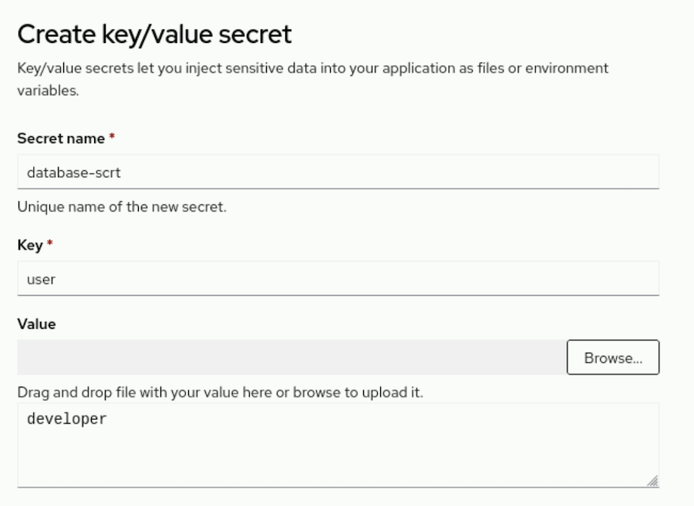
To create a secret from the web console that stores the credentials for accessing a container image registry, click the Workloads → Secrets menu. Click Create and select Image pull secret. Complete the form or upload a configuration file with the secret name, select the authentication type, and add the registry server address, the username, password, and email credentials.
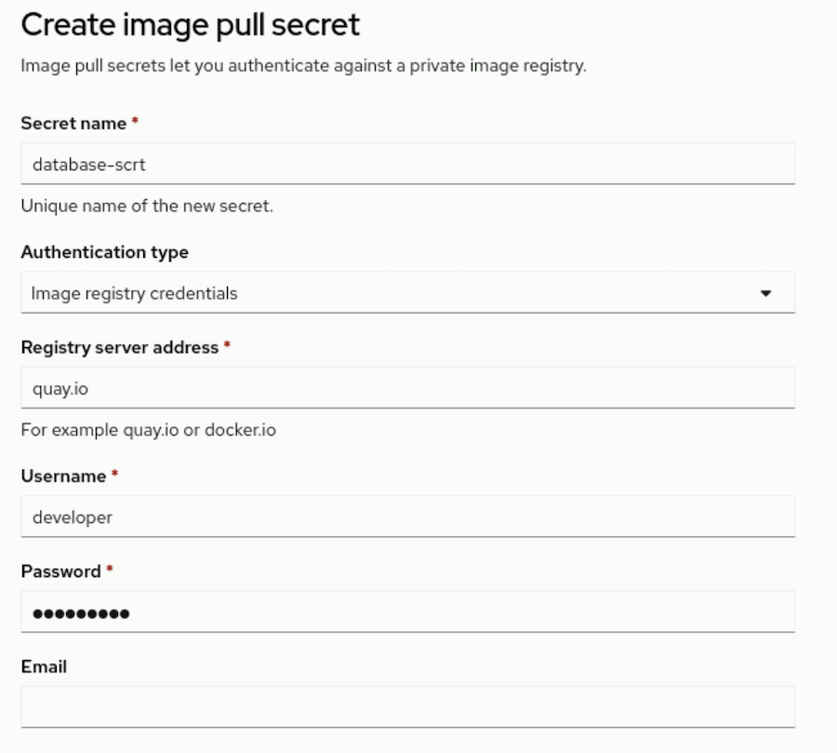

Creating Configuration Maps
The syntax for creating a configuration map and for creating a secret closely match. You can enter key-value pairs on the command line, or use the content of a file as the value of a specified key. You can use either the oc or kubectl command-line tools to create a configuration map. The following command shows how to create a configuration map:
[user@host ~]$ kubectl create configmap my-config \
--from-literal key1=config1 --from-literal key2=config2
You can also use the cm shortname to create a configuration map.
[user@host ~]$ oc create cm my-config \
--from-literal key1=config1 --from-literal key2=config2
To create a configuration map from the web console, click the Workloads → ConfigMaps menu. Click Create ConfigMap and complete the configuration map by using the form view or the YAML view.
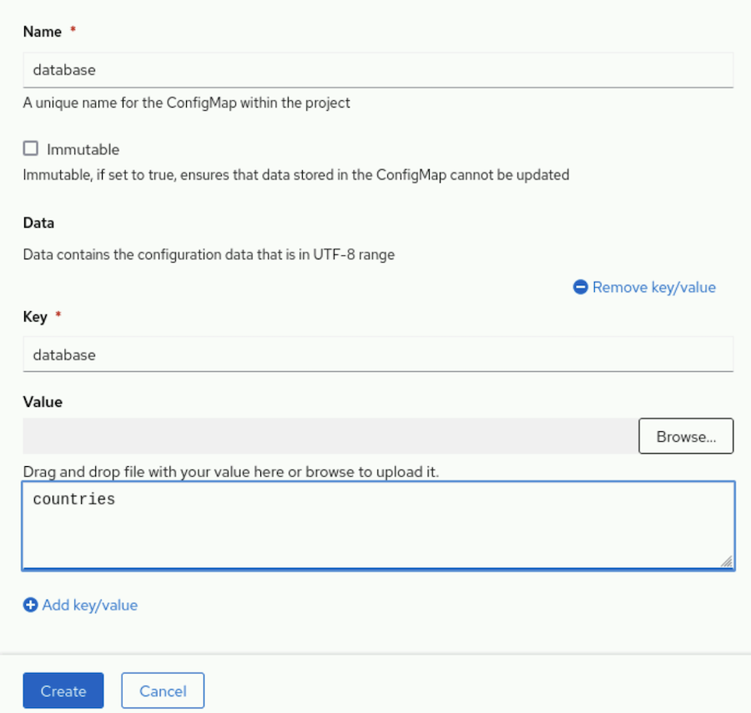
You can use files on each key that you add by clicking Browse beside the Value field. The Key field must be the name of the added file in the Value field.
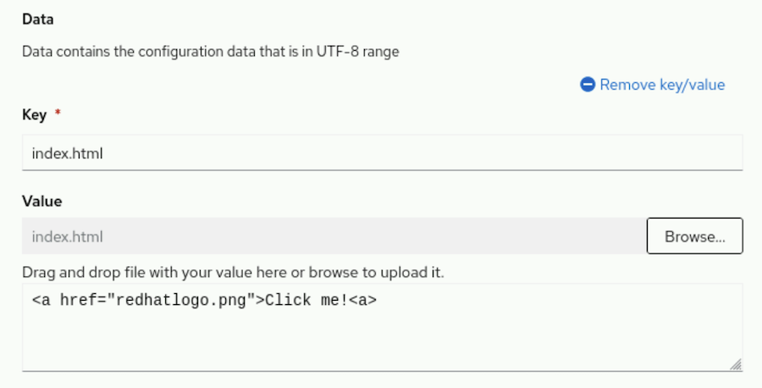

Note
Use a binary data key instead of a data key if the file uses the binary format, such as a PNG file.

Using Configuration Maps and Secrets to Initialize Environment Variables
You can use configuration maps to populate individual environment variables that configure your application. Unlike secrets, the information in configuration maps does not require protection. The following listing shows an initialization example of environment variables:
apiVersion: v1
kind: ConfigMap
metadata:
name: config-map-example
namespace: example-app
data:
database.name: sakila
database.user: redhat
The project where the configuration map resides. ConfigMap objects can be referenced only by pods in the same project.
Initializes the database.name variable to the sakila value.
Initializes the database.user variable to the redhat value.
You can then use the configuration map to populate environment variables for your application. The following example shows a pod resource that populates specific environment variables by using a configuration map.
apiVersion: v1
kind: Pod
metadata:
name: config-map-example-pod
namespace: example-app
spec:
containers:
- name: example-container
image: registry.example.com/mysql-80:1-237
command: [ "/bin/sh", "-c", "env" ]
env:
- name: MYSQL_DATABASE
valueFrom:
configMapKeyRef:
name: config-map-example
key: database.name
- name: MYSQL_USER
valueFrom:
configMapKeyRef:
name: config-map-example
key: database.user
optional: true
The attribute to specify environment variables for the pod.
The name of a pod environment variable where you are populating a key's value.
Name of the ConfigMap object to pull the environment variables from.
The environment variable to pull from the ConfigMap object.
Sets the environment variable as optional. The pod is started even if the specified ConfigMap object and keys do not exist.
The following example shows a pod resource that injects all environment variables from a configuration map:
apiVersion: v1
kind: Pod
metadata:
name: config-map-example-pod2
namespace: example-app
spec:
containers:
- name: example-container
image: registry.example.com/mysql-80:1-237
command: [ "/bin/sh", "-c", "env" ]
envFrom:
- configMapRef:
name: config-map-example
restartPolicy: Never
The attribute to pull all environment variables from a ConfigMap object.
The name of the ConfigMap object to pull environment variables from.
You can use secrets with other Kubernetes resources such as pods, deployments, builds, and more. You can specify secret keys or volumes with a mount path to store your secrets. The following snippet shows an example of a pod that populates environment variables with data from the test-secret Kubernetes secret:
apiVersion: v1
kind: Pod
metadata:
name: secret-example-pod
spec:
containers:
- name: secret-test-container
image: busybox
command: [ "/bin/sh", "-c", "export" ]
env:
- name: TEST_SECRET_USERNAME_ENV_VAR
valueFrom:
secretKeyRef:
name: test-secret
key: username
Specifies the environment variables for the pod.
Indicates the source of the environment variables.
The secretKeyRef source object of the environment variables.
Name of the secret, which must exist.
The key that is extracted from the secret is the username for authentication.
In contrast with configuration maps, the values in secrets are always encoded (not encrypted), and their access is restricted to fewer authorized users.

Using Secrets and Configuration Maps as Volumes
To expose a secret to a pod, you must first create the secret in the same namespace, or project, as the pod. In the secret, assign each piece of sensitive data to a key. After creation, the secret contains key-value pairs.
The following command creates a generic secret that contains key-value pairs from literal values that are typed on the command line: user with the demo-user value, and root_password with the zT1kTgk value.
[user@host ~]$ oc create secret generic demo-secret \
--from-literal user=demo-user \
--from-literal root_password=zT1KTgk
You can also create a generic secret by specifying key names on the command line and values from files:
[user@host ~]$ oc create secret generic demo-secret \
--from-file user=/tmp/demo/user \
--from-file root_password=/tmp/demo/root_password
You can mount a secret to a directory within a pod. Kubernetes creates a file for each key in the secret that uses the name of the key. The content of each file is the decoded value of the secret. The following command shows how to mount secrets in a pod:
[user@host ~]$ oc set volume deployment/demo \
--add --type secret \
--secret-name demo-secret \
--mount-path /app-secrets
Modify the volume configuration in the demo deployment.
Add a new volume from a secret.
Use the demo-secret secret.
Make the secret data available in the /app-secrets directory in the pod. The content of the /app-secrets/user file is demo-user. The content of the /app-secrets/root_password file is zT1KTgk.
To assign a secret as a volume to a deployment from the web console, list the available secrets from the Workloads → Secrets menu.
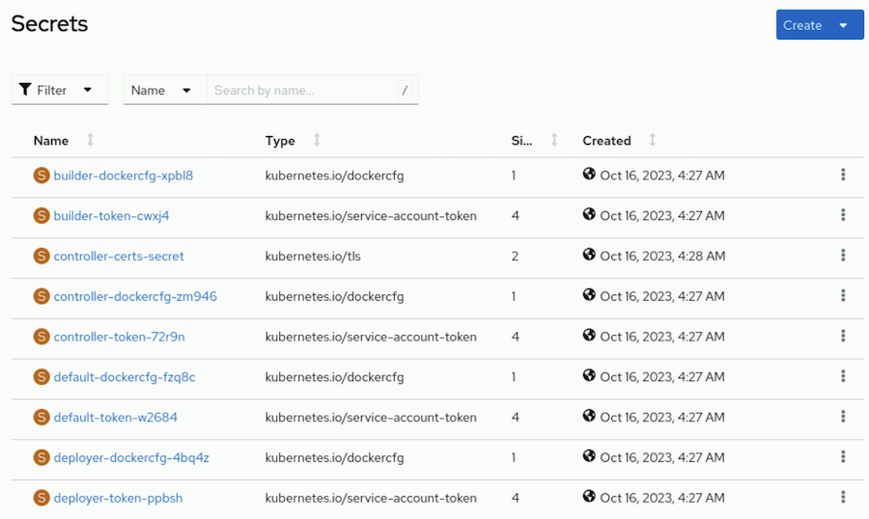
Select a secret and click Add Secret to workload.
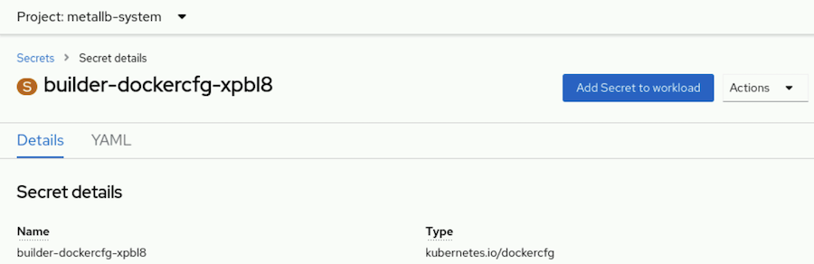
Select the workload, choose the Volume option, and define the mount path for the secret.
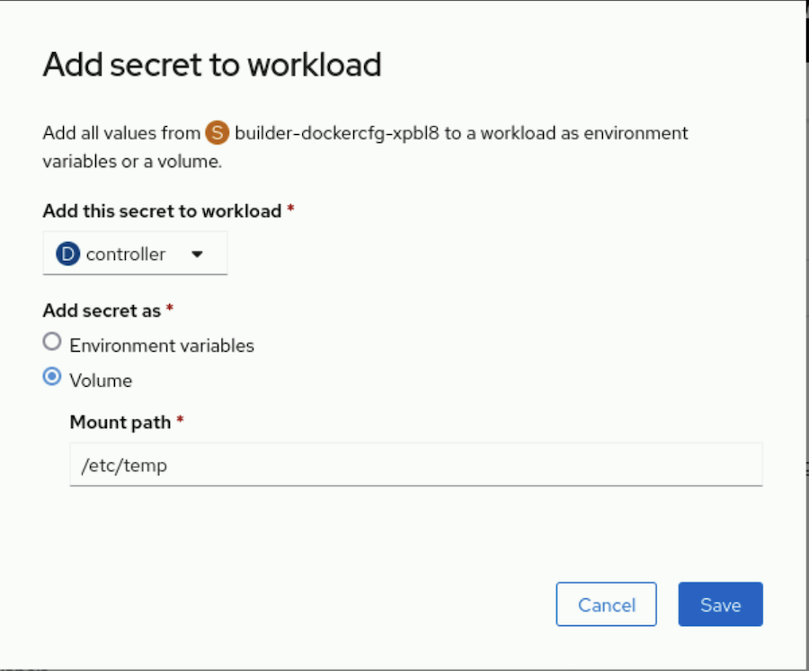
Similar to secrets, you must first create a configuration map before a pod can consume it. The configuration map must exist in the same namespace, or project, as the pod. The following command shows how to create a configuration map from an external configuration file:
[user@host ~]$ oc create configmap demo-map \
--from-file=config-files/httpd.conf
You can similarly add a configuration map as a volume by using the following command:
[user@host ~]$ oc set volume deployment/demo \
--add --type configmap \
--configmap-name demo-map \
--mount-path /app-secrets
To confirm that the volume is attached to the deployment, use the following command:
[user@host ~]$ oc set volume deployment/demo
demo
configMap/demo-map as volume-du9in
mounted at /app-secrets
You can also use the oc set env command to set application environment variables from either secrets or configuration maps. In some cases, you can modify the names of the keys to match the names of environment variables by using the --prefix option. In the following example, the user key from the demo-secret secret sets the MYSQL_USER environment variable, and the root_password key from the demo-secret secret sets the MYSQL_ROOT_PASSWORD environment variable. If the key name from the secret is lowercase, then the corresponding environment variable is converted to uppercase to match the pattern that the --prefix option defines.
[user@host ~]$ oc set env deployment/demo \
--from secret/demo-secret --prefix MYSQL_

Note
You cannot assign configuration maps by using the web console.

Updating Secrets and Configuration Maps
Secrets and configuration maps occasionally require updates. OpenShift provides the oc extract command to ensure that you have the latest data. You can save the data to a specific directory by using the --to option. Each key in the secret or configuration map creates a file with the same name as the key. The content of each file is the value of the associated key. If you run the oc extract command more than one time, then you must use the --confirm option to overwrite the existing files. You can also use the --confirm option to create the target directory for the extracted content.
[user@host ~]$ oc extract secret/demo-secrets -n demo \
--to /tmp/demo --confirm
[user@host ~]$ ls /tmp/demo/
user root_password
[user@host ~]$ cat /tmp/demo/root_password
zT1KTgk
[user@host ~]$ echo k8qhcw3m0 > /tmp/demo/root_password
After updating the locally saved files, use the oc set data command to update the secret or configuration map. For each key that requires an update, specify the name of a key and the associated value. If a file contains the value, then use the --from-file option.
[user@host ~]$ oc set data secret/demo-secrets -n demo \
--from-file /tmp/demo/root_password
You must restart pods that use environment variables for the pods to read the updated secret or configuration map. Pods that use a volume mount to reference secrets or configuration maps receive the updates without a restart by using an eventually consistent approach. By default, the kubelet agent watches for changes to the keys and values that are used in volumes for pods on the node. The kubelet agent detects changes and propagates the changes to the pods to keep volume data consistent. Despite the automatic updates that Kubernetes provides, a restart of the pod is still required if the software reads configuration data only at startup time.

Deleting Secrets and Configuration Maps
Similar to other Kubernetes resources, you can use the delete command to delete secrets and configuration maps that are no longer needed or in use.
[user@host ~]$ kubectl delete secret/demo-secrets -n demo
[user@host ~]$ oc delete configmap/demo-map -n demo

Guided Exercise: Externalize the Configuration of Applications
Deploy a web server that takes configuration files from a configuration map.
Outcomes
- Create a web application deployment.
- Expose the web application deployment to external access.
- Create a configuration map from two files.
- Mount the configuration map in the web application deployment.
As the student user on the workstation machine, use the lab command to prepare your system for this exercise. This command ensures that the cluster is accessible and that all resources are available for this exercise.
[student@workstation ~]$ lab start storage-configs
Instructions
- Log in to the OpenShift web console as the developer user and switch to the Administrator perspective.
  - Open a web browser and go to https://console-openshift-console.apps.ocp4.example.com
  - Click Red Hat Identity Management and log in as the developer user with developer as the password. If the Welcome to the Developer Perspective message is displayed, then click Skip tour.
  - From the perspective switcher, select Administrator.
- Create a web application deployment named webconfig from the web console. Use the registry.ocp4.example.com:8443/ubi9/httpd-24:latest container image.
  - Go to Workloads → Deployments.
  - Set the project to storage-configs and click Create Deployment.
  - Use webconfig for the deployment name and change the image name to registry.ocp4.example.com:8443/ubi9/httpd-24:latest.
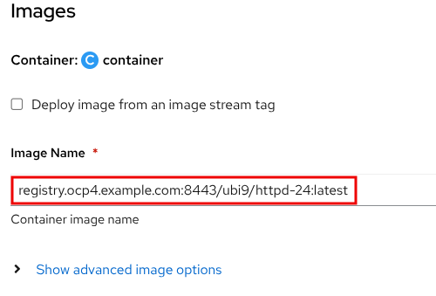
  - Click Create. Wait for the blue circle to indicate that three pods are running.
- Expose the web application to external access from the web console. Create a service and a route for the web application. Use the values from the following tables to create the service and the route.
Service field | Service value
Service name | webconfig-svc
App selector | webconfig
Port number | 8080
Target port | 8080

Route field | Route value
Route name | webconfig-rt
Service name | webconfig-svc
Target port | 8080
  - Go to Networking → Services and click Create Service.
  - Update the service values from the service table.
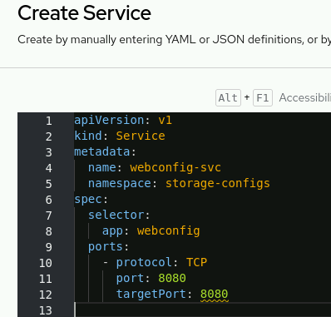
  - Click Create.
Alternatively, you can create the service from the CLI by using the following command:
[student@workstation ~]$ oc expose deploy/webconfig \
--namespace storage-configs --name webconfig-svc \
--selector app=webconfig \
  - --target-port 8080 --port 8080
  - Go to Networking → Routes and click Create Route.
  - Create the route by using the values from the route table:
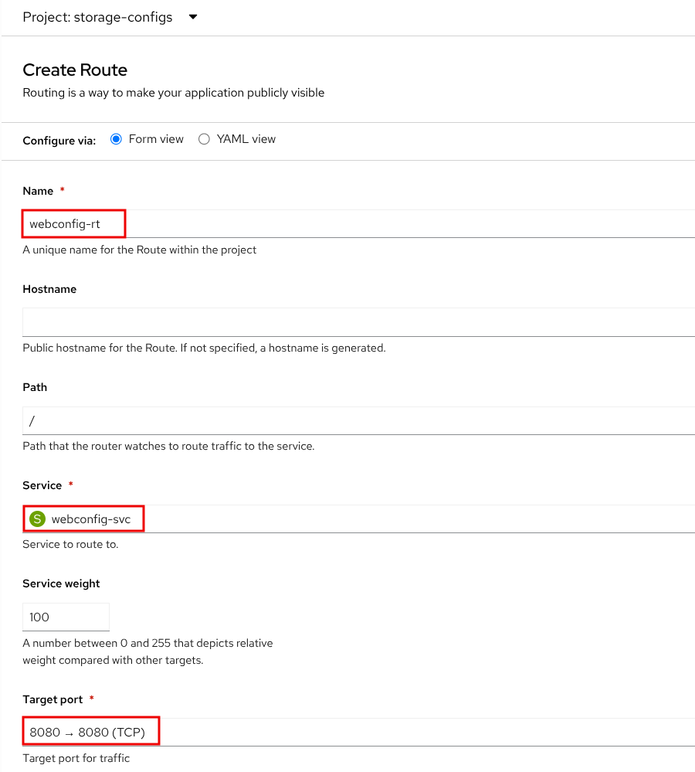
  - Click Create.
Alternatively, you can create the route from the CLI by using the following command:
[student@workstation ~]$ oc expose svc/webconfig-svc \
  - --namespace storage-configs --name webconfig-rt
  - On the Details page of the route, click the Location link.
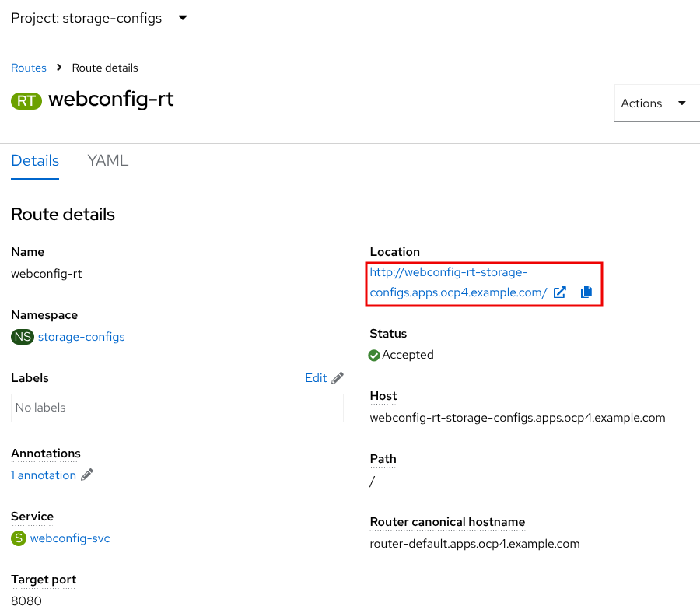
  - The route link opens a browser tab that displays the default test page of the web server. Do not close the browser tab, because you use it in another step.
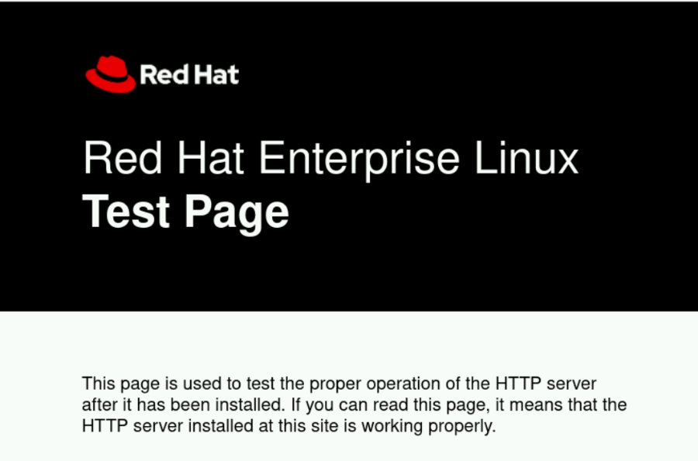
- Create a configuration map that contains the files for the web application by using the web console.
  - Go to Workloads → ConfigMaps and click Create ConfigMap.
  - Set the name of the configuration map to webfiles.
  - Add a data key. In the Data section, define the index.html name as the Key value, and click Browse in the Value field to select the /home/student/DO180/labs/storage-configs/index.html file.
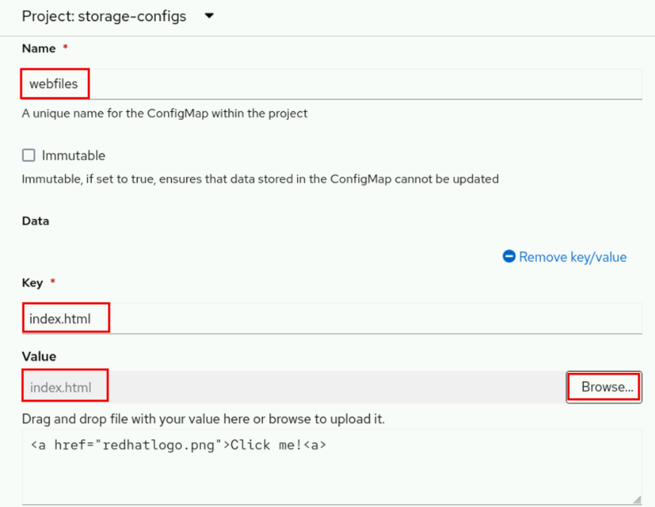
  - Add a binary data key. In the Binary Data section, click Add key/value.
  - Define the redhatlogo.png name as the Key value, and click Browse in the Value field to select the /home/student/DO180/labs/storage-configs/redhatlogo.png file.
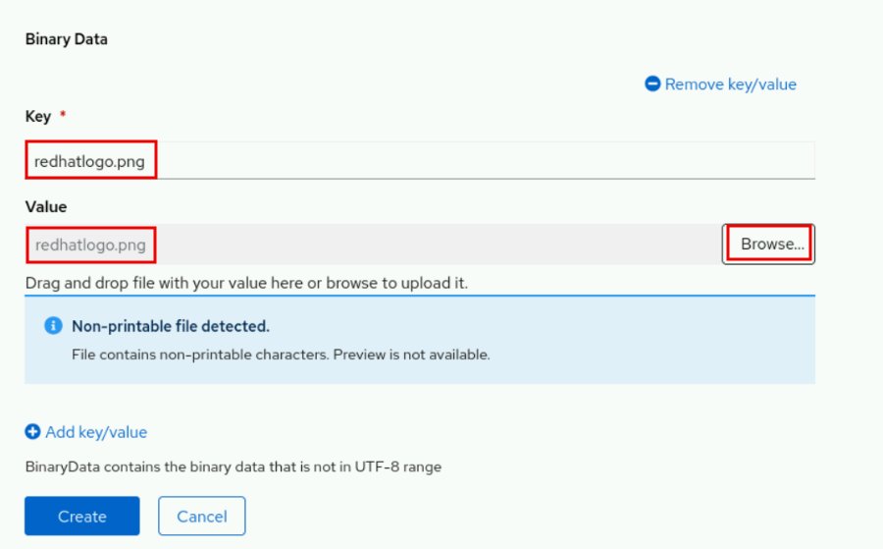
  - Click Create.
- Mount the webfiles configuration map as a volume in the webconfig deployment by using the command line.
  - In a terminal window, log in to the RHOCP cluster as the developer user with developer as the password.
[student@workstation ~]$ oc login -u developer -p developer \
https://api.ocp4.example.com:6443
Login successful.
  - ...output omitted...
  - Select the storage-configs project.
[student@workstation ~]$ oc project storage-configs
  - Now using project "storage-configs" on server "https://api.ocp4.example.com:6443".
  - Mount the webfiles configuration map as a volume.
[student@workstation ~]$ oc set volume deployment/webconfig \
--add --type configmap --configmap-name webfiles \
--name webfiles-vol --mount-path /var/www/html/
  - deployment.apps/webconfig volume updated
  - Verify that the deployment has three available replicas.
[student@workstation ~]$ oc get deployment
NAME READY UP-TO-DATE AVAILABLE AGE
  - webconfig 3/3 3 3 3h20m
- Verify that the web application shows the content from the configuration map.
  - Switch to the web browser, and go to the web server tab. Click the reload icon in the web browser.
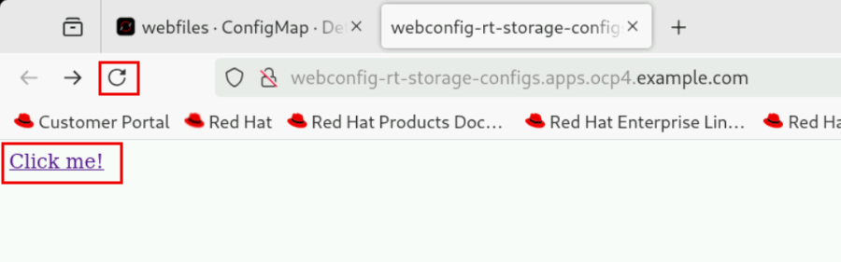
  - Click the Click me! link that the web page displays. The web page shows the Red Hat logo.
Finish
On the workstation machine, use the lab command to complete this exercise. This step is important to ensure that resources from previous exercises do not impact upcoming exercises.
[student@workstation ~]$ lab finish storage-configs

Provision Persistent Data Volumes

Objectives
- Provide applications with persistent storage volumes for block and file-based data.

Kubernetes Persistent Storage
Containers have ephemeral storage by default. The lifetime of this ephemeral storage does not extend beyond the life of the individual pod, and this ephemeral storage cannot be shared across pods. When a container is deleted, all the files and data inside it are also deleted. To preserve the files, containers use persistent storage volumes.
Because OpenShift Container Platform uses the Kubernetes persistent volume (PV) framework, cluster administrators can provision persistent storage for a cluster. Developers can use persistent volume claims (PVCs) to request PV resources without specific knowledge of the underlying storage infrastructure.
Two ways exist to provision storage for the cluster: static and dynamic. Static provisioning requires the cluster administrator to create persistent volumes manually. Dynamic provisioning uses storage classes to create the persistent volumes on demand.
Administrators can use storage classes to provide persistent storage. Storage classes describe types of storage for the cluster. Cluster administrators create storage classes to manage storage services or storage tiers of a service. Rather than specifying provisioned storage, PVCs instead refer to a storage class.
Developers use PVCs to add persistent volumes to their applications. Developers need not know details of the storage infrastructure. With static provisioning, developers use previously created PVs, or ask a cluster administrator to manually create persistent volumes for their applications. With dynamic provisioning, developers declare the storage requirements of the application, and the cluster creates a PV to fill the request.

Persistent Volumes
Not all storage is equal. Storage types vary in cost, performance, and reliability. Multiple storage types are usually available for each Kubernetes cluster.
The following list of commonly used storage volume types and their use cases is not exhaustive.
configMap
The configMap volume externalizes the application configuration data. This use of the configMap resource ensures that the application configuration is portable across environments and can be version-controlled.
emptyDir
An emptyDir volume provides a per-pod directory for scratch data. The directory is usually empty after provisioning. emptyDir volumes are often required for ephemeral storage.
hostPath
A hostPath volume mounts a file or directory from the host node into your pod. To use a hostPath volume, the cluster administrator must configure pods to run as privileged. This configuration grants access to other pods in the same node.
Red Hat does not recommend the use of hostPath volumes in production. Instead, Red Hat supports hostPath mounting for development and testing on a single-node cluster. Although most pods do not need a hostPath volume, it does offer a quick option for testing if an application requires it.
iSCSI
Internet Small Computer System Interface (iSCSI) is an IP-based standard that provides block-level access to storage devices. With iSCSI volumes, Kubernetes workloads can consume persistent storage from iSCSI targets.
local
You can use Local persistent volumes to access local storage devices, such as a disk or partition, by using the standard PVC interface. Local volumes are subject to the availability of the underlying node, and are not suitable for all applications.
NFS
An NFS (Network File System) volume can be accessed from multiple pods at the same time, and thus provides shared data between pods. The NFS volume type is commonly used because of its ability to share data safely. Red Hat recommends to use NFS only for non-production systems.

Volume Access Mode
Persistent volume providers vary in capabilities. A volume uses access modes to specify the modes that it supports. For example, NFS can support multiple read/write clients, but a specific NFS PV might be exported on the server as read-only. OpenShift defines the following access modes, as summarized in the following table:
Table 5.1. Volume Access Modes
Access mode | Abbreviation | Description
ReadWriteOnce | RWO | A single node mounts the volume as read/write. Multiple pods on that single node can access the volume simultaneously.
ReadWriteOncePod | RWOP | A single pod in the cluster mounts the volume as read/write.
ReadOnlyMany | ROX | Many nodes mount the volume as read-only.
ReadWriteMany | RWX | Many nodes mount the volume as read/write.

Developers must select a volume type that supports the required access level by the application. The following table shows some example supported access modes:
Table 5.2. Access Mode Support
Volume type | RWO | RWOP | ROX | RWX
configMap | Yes | Yes | No | No
emptyDir | Yes | Yes | No | No
hostPath | Yes | Yes | No | No
iSCSI | Yes | Yes | Yes | No
local | Yes | Yes | No | No
NFS | Yes | Yes | Yes | Yes

Volume Modes
Kubernetes supports two volume modes for persistent volumes: Filesystem and Block. If the volume mode is not defined for a volume, then Kubernetes assigns the default volume mode, Filesystem, to the volume.
OpenShift Container Platform can provision raw block volumes. These volumes do not have a file system, and can provide performance benefits for applications that either write to the disk directly or that implement their own storage service. Raw block volumes are provisioned by specifying volumeMode: Block in the PV and PVC specification.
The following table provides examples of storage options with block volume support:
Table 5.3. Block Volume Support
Volume plug-in | Manually provisioned | Dynamically provisioned
AWS EBS | Yes | Yes
Azure disk | Yes | Yes
Cinder | Yes | Yes
Fibre channel | Yes | No
GCP | Yes | Yes
iSCSI | Yes | No
local | Yes | No
Red Hat OpenShift Data Foundation | Yes | Yes
VMware vSphere | Yes | Yes

Manually Creating a PV
Administrators use PersistentVolume manifest files to manually create persistent volumes. The following example creates a persistent volume from a fiber channel storage device that uses block mode.
apiVersion: v1
kind: PersistentVolume
metadata:
name: block-pv
spec:
capacity:
storage: 10Gi
accessModes:
- ReadWriteOnce
volumeMode: Block
persistentVolumeReclaimPolicy: Retain
fc:
targetWWNs: ["50060e801049cfd1"]
lun: 0
readOnly: false
PersistentVolume is the resource type for PVs.
Provide a name for the PV, which subsequent claims use to access the PV.
Specify the amount of storage that is allocated to this volume.
The storage device must support the access mode that the PV specifies.
The volumeMode attribute is optional for Filesystem volumes, but is required for Block volumes.
The persistentVolumeReclaimPolicy determines how the cluster handles the PV when the PVC is deleted. Valid options are Retain or Delete.
The remaining attributes are specific to the storage type. In this example, the fc object specifies the Fiber Channel storage type attributes.
If the previous manifest is in a file named my-fc-volume.yaml, then log in as an administrator and run the following command to create the PV resource:
[user@host ~]$ oc create -f my-fc-volume.yaml
To create a persistent volume from the web console, log in as an administrator and go to Storage → PersistentVolumes.

Persistent Volume Claims
A persistent volume claim (PVC) resource represents a request from an application for storage. A PVC specifies the minimal storage characteristics, such as capacity and access mode. A PVC does not specify a storage technology, such as iSCSI or NFS.
The lifecycle of a PVC is not tied to a pod, but to a namespace. Multiple pods from the same namespace but with potentially different workload controllers can connect to the same PVC. You can also sequentially connect storage to and detach storage from different application pods, to initialize, convert, migrate, or back up data.
Kubernetes matches each PVC to a persistent volume (PV) resource that can satisfy the requirements of the claim. It is not an exact match. A PVC might be bound to a PV with a larger disk size than is requested. A PVC that specifies single access might be bound to a PV that is shareable for multiple concurrent accesses. Rather than enforcing policy, PVCs declare what an application needs, which Kubernetes provides on a best-effort basis.

Creating a PVC
A PVC belongs to a specific project. To create a PVC, developers must specify the access mode and size, among other options. A PVC cannot be shared between projects. Developers use a PVC to access a persistent volume (PV). Persistent volumes are not exclusive to projects, and are accessible across the entire OpenShift cluster. When a PV binds to a PVC, the PV cannot be bound to another PVC.
To add a volume to your application deployment, create a PersistentVolumeClaim resource, and add it to the application as a volume. Create the PVC by using either a Kubernetes manifest or the oc set volumes command. In addition to either creating a PVC or using an existing PVC, the oc set volumes command can modify a deployment to mount the PVC as a volume within the pod.
To add a volume to an application deployment, developers can use the oc set volumes command:
[user@host ~]$ oc set volumes deployment/example-application \
--add \
--name example-pv-storage \
--type persistentVolumeClaim \
--claim-mode rwo \
--claim-size 15Gi \
--mount-path /var/lib/example-app \
--claim-name mypvc
Specify the name of the deployment that requires the PVC resource.
Setting the add option to true adds volumes and volume mounts for containers.
The name option specifies a volume name. If not specified, a name is autogenerated.
The supported types, for the add operation, include emptyDir, hostPath, secret, configMap, and persistentVolumeClaim.
The claim-mode option defaults to ReadWriteOnce. The valid values are ReadWriteOnce (RWO), ReadWriteOncePod (RWOP), ReadWriteMany (RWX), and ReadOnlyMany (ROX).
Create a claim with the given size in bytes, if specified along with the persistent volume type. The size must use SI notation, for example, 15, 15 G, or 15 Gi.
The mount-path option specifies the mount path inside the container.
The claim-name option provides the name for the PVC, and is required for the persistentVolumeClaim type.
The command creates a PVC resource and adds it to the application as a volume within the pod.
The command updates the deployment for the application with volumeMounts and volumes specifications.

Verify the volume status
oc get pvc

apiVersion: apps/v1
kind: Deployment
metadata:
...output omitted...
namespace: storage-volumes
...output omitted...
spec:
...output omitted...
template:
...output omitted...
spec:
...output omitted...
volumeMounts:
- mountPath: /var/lib/example-app
name: example-pv-storage
...output omitted...
volumes:
- name: example-pv-storage
persistentVolumeClaim:
claimName: mypvc
...output omitted...
The deployment, which must be in the same namespace as the PVC.
The mount path in the container.
The volume name, which is used to specify the volume that is associated with the mount.
The claim name that is bound to the volume.
The following example specifies a PVC by using a YAML manifest to create a PersistentVolumeClaim API object:
---
apiVersion: v1
kind: PersistentVolumeClaim
metadata:
name: mypvc
labels:
app: example-application
spec:
accessModes:
- ReadWriteOnce
resources:
requests:
storage: 15Gi
PersistentVolumeClaim is the resource type for a PVC.
Use this name in the claimName field of the persistentVolumeClaim element in the volumes section of a deployment manifest.
Specify the access mode that this PVC requests. The storage class provisioner must provide this access mode. If persistent volumes are created statically, then an eligible persistent volume must provide this access mode.
The storage class creates a persistent volume that matches this size request. If persistent volumes are created statically, then an eligible persistent volume must be at least the requested size.
Developers can use the oc create command to create the PVC from the manifest file.
[user@host ~]$ oc create -f pvc_file_name.yaml
Use oc get pvc to view the available PVCs in the current namespace.
[user@host ~]$ oc get pvc
NAME STATUS VOLUME CAPACITY ACCESS MODES STORAGECLASS ...
mypvc Bound pvc-13... 15Gi RWO nfs-storage ...
As a developer, to create a persistent volume claim from the web console, go to Storage → PersistentVolumesClaims.
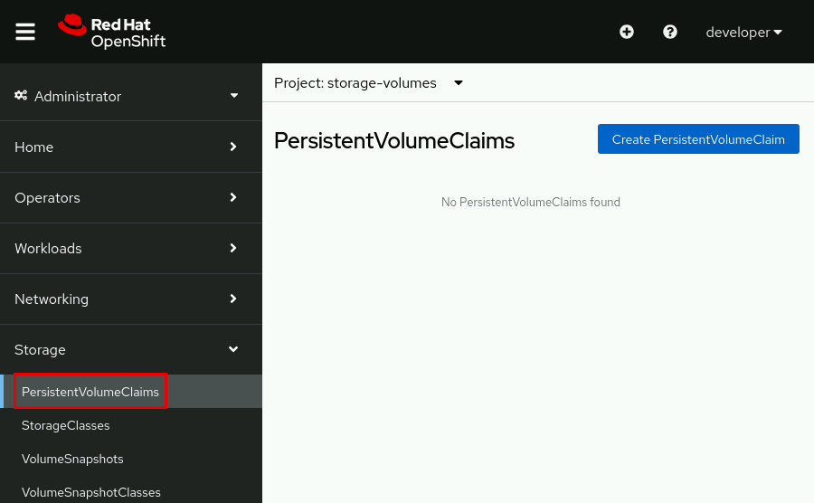
Click Create PersistentVolumeClaim and complete the form by adding the name, the storage class, the size, the access mode, and the volume mode.
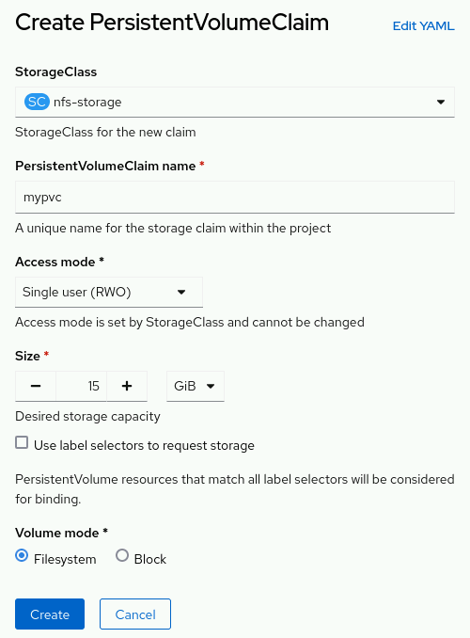

Kubernetes Dynamic Provisioning
PVs are defined by a PersistentVolume API object, which is from existing storage in the cluster. The cluster administrator must statically provision some storage types. Alternatively, the Kubernetes persistent volume framework can use a StorageClass object to dynamically provision PVs.
To create PVCs, developers specify the storage amount, the required access mode, and a storage class to describe and classify the storage. The control loop in the RHOCP control node watches for new PVCs, and binds the new PVC to an appropriate PV. If an appropriate PV does not exist, then a provisioner for the storage class creates one.
Claims remain unbound indefinitely if a matching volume does not exist or if a volume cannot be created with any available provisioner that services a storage class. Claims are bound when matching volumes become available. For example, a cluster with many manually provisioned 50 GiB volumes would not match a PVC that requests 100 GiB. The PVC can be bound when a 100 GiB PV is added to the cluster.
Developers can run the oc get storageclass command to view the storage classes that the cluster provides.
[user@host ~]$ oc get storageclass
NAME PROVISIONER ...
lvms-vg1 topolvm.io ...
nfs-storage (default) k8s-sigs.io/nfs-subdir-external-provisioner
In the example, the nfs-storage storage class is marked as the default storage class. When a default storage class is configured, the PVC must explicitly name any other storage class to use, or can set the storageClassName annotation to "", to be bound to a PV without a storage class.
The following oc set volume command example uses the claim-class option to specify a dynamically provisioned PV.
[user@host ~]$ oc set volumes deployment/example-application \
--add --name example-pv-storage --type pvc \
--claim-class nfs-storage --claim-mode rwo --claim-size 15Gi \
--mount-path /var/lib/example-app --claim-name mypvc

Note
Because a cluster administrator can change the default storage class, Red Hat recommends that you always specify the storage class when you create a PVC.

PV and PVC Lifecycles
When developers create PVCs, they request a specific amount of storage, an access mode, and a storage class. Kubernetes binds each PVC to an appropriate PV. If an appropriate PV does not exist, then a provisioner for the storage class creates one.
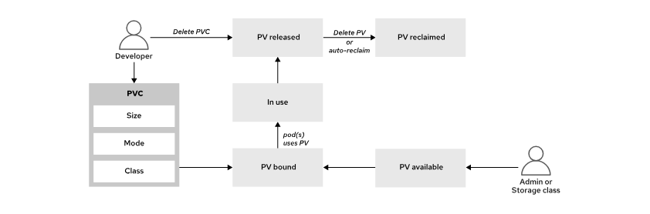
Figure 5.18: PV lifecycle
PVs follow a lifecycle based on their relationship to the PVC.
Available
After a PV is created, it becomes available for any PVC to use in the cluster in any namespace.
Bound
A PV that is bound to a PVC is also bound to the same namespace as the PVC, and no other PVC can use it.
In Use
You can delete a PVC if no pods actively use it. The Storage Object in Use Protection feature prevents the removal of bound PVs and PVCs that pods are actively using. Such removal can result in data loss. Storage Object in Use Protection is enabled by default.
If a user deletes a PVC that a pod actively uses, then the PVC is not removed immediately. PVC removal is postponed until no pods actively use the PVC. Also, if a cluster administrator deletes a PV that is bound to a PVC, then the PV is not removed immediately. PV removal is postponed until the PV is no longer bound to a PVC.
Released
After the developer deletes the PVC that is bound to a PV, the PV is released, and the storage that the PV used can be reclaimed.
Reclaimed
The reclaim policy of a persistent volume tells the cluster what to do with the volume after it is released. A volume's reclaim policy can be Retain or Delete.
Table 5.4. Volume Reclaim Policy
Policy | Description
Retain | Enables manual reclamation of the resource for those volume plug-ins that support it.
Delete | Deletes both the PersistentVolume object from OpenShift Container Platform and the associated storage asset in external infrastructure.

Deleting a Persistent Volume Claim
To delete a volume, developers can use the oc delete command to delete the PVC. The storage class reclaims the volume after removing the PVC.
[user@host ~]$ oc delete pvc/mypvc

Guided Exercise: Provision Persistent Data Volumes
Deploy a MySQL database with persistent storage from a PVC and identify the PV and storage provisioner that back the application.
Outcomes
- Deploy a MySQL database with persistent storage from a PVC.
- Identify the PV that backs the application.
- Identify the storage provisioner that created the PV.
As the student user on the workstation machine, use the lab command to prepare your system for this exercise. This command ensures that the cluster is accessible and that all resources are available for this exercise.
[student@workstation ~]$ lab start storage-volumes
Instructions
- Log in to the OpenShift web console as the developer user and switch to the Administrator perspective.
  - Open a web browser and go to https://console-openshift-console.apps.ocp4.example.com
  - Click Red Hat Identity Management and log in as the developer user with developer as the password. If the Welcome to the Developer Perspective message is displayed, then click Skip tour.
  - From the perspective switcher, select Administrator.
- Identify the default storage class by going to Storage → StorageClasses. The nfs-storage storage class has the Default label and uses the k8s-sigs.io/nfs-subdir-external-provisioner provisioner.
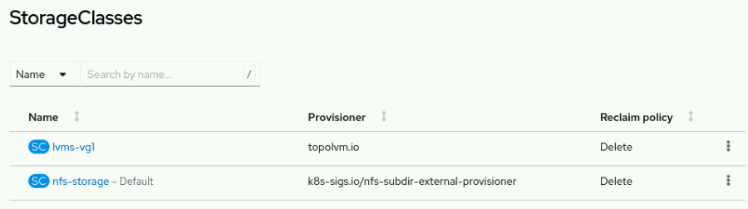
- Use the registry.ocp4.example.com:8443/rhel8/mysql-80 container image to create a MySQL deployment named db-pod. Use the storage-volumes project that the lab command created. Add a service for the database.
  - Go to Workloads → Deployments.
  - Set the project to storage-volumes and click Create Deployment.
  - Use db-pod for the deployment name and change the image name to registry.ocp4.example.com:8443/rhel8/mysql-80.
  - Add the required environment variables for the database.
Table 5.5. MySQL Environment Variables
Name | Value
MYSQL_USER | user1
MYSQL_PASSWORD | redhat123
MYSQL_DATABASE | items

  - In the Advanced options section, click Scaling and set the number of replicas to 1.
  - Click Create. Wait for the blue circle to indicate that a single pod is running.
  - Create a service for the database. Go to Networking → Services and click Create Service.
  - Update the resource file with the following values:
Table 5.6. Service Fields
Field name | Value
Name | db-pod
Selector | app=db-pod
Port | 3306
Target port | 3306

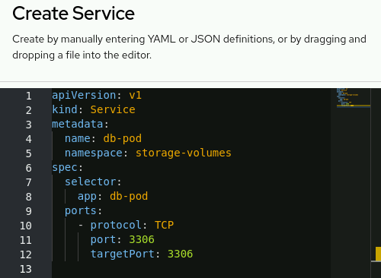
  - Click Create.
- Add to the deployment a 1 GiB, ReadWriteOnce (RWO) PVC named db-pod-pvc. Set the /var/lib/mysql directory as the mount path.
  - Go to Workloads → Deployments.
  - Click the vertical ellipsis icon (⋮) in the row for the db-pod deployment, and select Add storage.
  - In the Add Storage form, click Create new claim.
  - Complete the form with the following values:
Table 5.7. Add PVC Storage Fields
Field name | Value
Persistent volume claim name | db-pod-pvc
Access mode | RWO
Size | 1 GiB
Volume mode | Filesystem
Mount path | /var/lib/mysql

  - Click Save.
  - On the Deployment details page, scroll to the Volumes section, and click the db-pod-pvc link to view the PVC details.
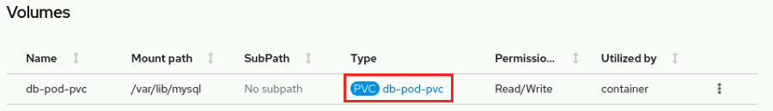
  - To retrieve the name of the PV that is associated with the PVC, go to the YAML tab. The name of the PV is available in the .spec.volumeName parameter. The name starts with pvc- even though the resource is a PV.
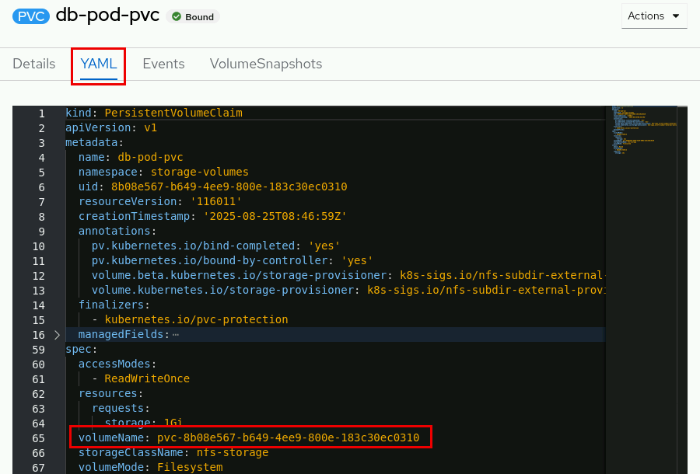
The name of the PV is different on your system.
- Verify that configuring storage changes the deployment resource.
  - Go to Workloads → Deployments, click the db-pod deployment name, and go to the YAML tab.
  - Verify that configuring storage for the deployment results in the volumes and volumeMounts additions.
kind: Deployment
apiVersion: apps/v1

...output omitted...

volumes:
- name: db-pod-pvc
persistentVolumeClaim:
claimName: db-pod-pvc

...output omitted...

volumeMounts:
- name: db-pod-pvc
mountPath: /var/lib/mysql

  - ...output omitted...
- Use a configuration map resource to add initialization data to the database.
  - Review the ~/DO180/labs/storage-volumes/configmap/init-db.sql script that initializes the database. You do not have to change its contents.
DROP TABLE IF EXISTS `Item`;
CREATE TABLE `Item` (`id` BIGINT not null auto_increment primary key, `description` VARCHAR(100), `done` BIT);
INSERT INTO `Item` (`id`,`description`,`done`) VALUES (1,'Pick up newspaper', 0);
  - INSERT INTO `Item` (`id`,`description`,`done`) VALUES (2,'Buy groceries', 1);
  - In a terminal window, log in to the RHOCP cluster as the developer user with developer as the password.
[student@workstation ~]$ oc login -u developer -p developer \
https://api.ocp4.example.com:6443
Login successful.
  - ...output omitted...
  - Set the storage-volumes project as the active project.
[student@workstation ~]$ oc project storage-volumes
  - ...output omitted...
  - Use the contents of the init-db.sql file to create a configuration map named init-db-cm.
[student@workstation ~]$ oc create configmap init-db-cm \
--from-file \
~/DO180/labs/storage-volumes/configmap/init-db.sql
  - configmap/init-db-cm created
  - Add the init-db-cm configuration map as a volume named init-db-volume to the deployment. Specify the volume type as configmap, and set the /var/db/config directory as the mount path.
[student@workstation ~]$ oc set volumes deployment/db-pod \
--add --name init-db-volume --type configmap \
--configmap-name init-db-cm --mount-path /var/db/config
  - deployment.apps/db-pod volume updated
  - Start a remote shell session inside the container.
[student@workstation ~]$ oc rsh deployment/db-pod
  - sh-4.4$
  - Use the mysql client to execute the database script in the /var/db/config/init-db volume.
sh-4.4$ mysql -uuser1 -predhat123 \
items < /var/db/config/init-db.sql
mysql: [Warning] Using a password on the command line interface can be insecure.
  - sh-4.4$
  - Execute a query to verify the database contents.
sh-4.4$ mysql -uuser1 -predhat123 items \
-e 'select * from Item;'
mysql: [Warning] Using a password on the command line interface can be insecure.
+----+-------------------+------------+
| id | description | done |
+----+-------------------+------------+
| 1 | Pick up newspaper | 0x00 |
| 2 | Buy groceries | 0x01 |
+----+-------------------+------------+
  - sh-4.4$
  - Exit the shell session.
sh-4.4$ exit
  - exit
- Delete and then re-create the db-pod deployment to verify that the database data persists.
  - Delete the db-pod deployment.
[student@workstation ~]$ oc delete deployment/db-pod
  - deployment.apps "db-pod" deleted
  - Verify that the PVC still exists without the deployment.
[student@workstation ~]$ oc get pvc
NAME STATUS VOLUME CAPACITY ...
  - db-pod-pvc Bound pvc-8b08...0310 1Gi ...
  - Re-create the db-pod deployment.
[student@workstation ~]$ oc create deployment db-pod \
--port 3306 \
--image registry.ocp4.example.com:8443/rhel8/mysql-80
  - deployment.apps/db-pod created
  - Add the environment variables.
[student@workstation ~]$ oc set env deployment/db-pod \
MYSQL_USER=user1 \
MYSQL_PASSWORD=redhat123 \
MYSQL_DATABASE=items
  - deployment.apps/db-pod updated
  - Use the oc set volumes command to attach the existing PVC to the deployment.
[student@workstation ~]$ oc set volumes deployment/db-pod \
--add --type pvc \
--mount-path /var/lib/mysql \
--name db-pod-vol \
--claim-name db-pod-pvc
  - deployment.apps/db-pod volume updated
  - Create a query-db pod by using the oc run command and the registry.ocp4.example.com:8443/redhattraining/do180-dbinit container image. Use the pod to execute a query against the database service.
It takes up to one minute for the command to display the result.
[student@workstation ~]$ oc run query-db -it --rm --image \
registry.ocp4.example.com:8443/redhattraining/do180-dbinit \
--restart Never \
-- /bin/bash -c "mysql -uuser1 -predhat123 --protocol tcp \
-h db-pod -P3306 items -e 'select * from Item;'"
mysql: [Warning] Using a password on the command line interface can be insecure.
+----+-------------------+------------+
| id | description | done |
+----+-------------------+------------+
| 1 | Pick up newspaper | 0x00 |
| 2 | Buy groceries | 0x01 |
+----+-------------------+------------+
  - pod "query-db" deleted
- Delete the db-pod deployment and the db-pod-pvc PVC.
  - Delete the db-pod deployment.
[student@workstation ~]$ oc delete deployment/db-pod
  - deployment.apps "db-pod" deleted
  - Delete the db-pod-pvc PVC.
[student@workstation ~]$ oc delete pvc/db-pod-pvc
  - persistentvolumeclaim "db-pod-pvc" deleted
Finish
On the workstation machine, use the lab command to complete this exercise. This step is important to ensure that resources from previous exercises do not impact upcoming exercises.
[student@workstation ~]$ lab finish storage-volumes

Selecting a Storage Class for an Application

Objectives
- Match applications with storage classes that provide storage services to satisfy application requirements.

Storage Class Selection
Storage classes describe types of storage for the cluster and provision dynamic storage on demand. The cluster administrator determines the meaning of a storage class, which is also named a profile in other storage systems. For example, an administrator can create one storage class for development use and another for production use.
Kubernetes supports multiple storage back ends. The storage options differ in cost, performance, reliability, and function. An administrator can create different storage classes for these options. As a result, developers can select the storage solution that fits the needs of the application. Developers do not need to know the storage infrastructure details.
An administrator selects the default storage class for dynamic provisioning. A default storage class enables Kubernetes to automatically provision a PVC that does not specify a storage class. Because an administrator can change the default storage class, a developer should explicitly set the storage class for an application.

Reclaim Policy
Outside the application function, the developer must also consider the impact of the reclaim policy on storage requirements.
A reclaim policy determines what happens to the data on a PVC after the PVC is deleted. When you are finished with a volume, you can delete the PVC object from the API, which enables reclamation of the resource. Kubernetes releases the volume when the PVC is deleted, but the volume is not yet available for another claim. The previous claimant's data remains on the volume and must be handled according to the policy. To keep your data, choose a storage class with the retain reclaim policy.
By using the retain reclaim policy, when you delete a PVC, only the PVC object is deleted from the cluster. The PV that backed the PVC, the physical storage device that the PV used, and your data still exist. To reclaim the storage and to use it in your cluster again, the cluster administrator must take manual steps.
To manually reclaim a PV as a cluster administrator, follow these steps:
- Delete the PV.
- [user@host ~]$ oc delete pv pv-name
- The associated asset in the external storage infrastructure, such as an Amazon Web Services (AWS) Elastic Block Store (EBS), Google Compute Engine (GCE) Persistent Disk, Azure Disk, or Cinder volume, still exists after the PV is deleted.
- At this point, the cluster administrator can create another PV by using the same storage and data from the previous PV. A developer could then mount the new PV and access the data from the previous PV.
- Alternatively, the cluster administrator can remove the data on the storage asset and then delete the storage asset.
To automatically delete the PV, the data, and the physical storage for a deleted PVC, you must choose a storage class that uses the delete reclaim policy. This reclaim policy automatically reclaims your storage volume when the PVC is deleted. The delete reclaim policy is the default setting for all storage provisioners that adhere to the Kubernetes Container Storage Interface (CSI) standards. If you use a storage class that does not specify a reclaim policy, then the delete reclaim policy is used.
For more information about the Kubernetes Container Storage Interface standards, refer to the Kubernetes CSI Developer Documentation website at https://kubernetes-csi.github.io/docs/

Kubernetes and Application Responsibilities
Kubernetes does not change how an application relates to storage. The application is responsible for working with its storage devices and for ensuring data integrity and consistency.
Kubernetes storage does not prevent an application from inadvisable actions, such as sharing a data volume between two databases that require exclusive access to data.
Because a PVC is a storage device that your Linux host mounts, an improperly configured application could behave unexpectedly. For example, you could have an iSCSI Logical Unit Number (LUN), which is expressed as a ReadWriteOnce (RWO) PVC that is not supposed to be shared, and then mount that same PVC on two pods of the same host. Whether this situation is problematic depends on the applications.
Usually, it is fine for two processes on the same host to share a disk. After all, many applications on your personal machine share a local disk. However, nothing prevents one text editor from overwriting and losing all edits from another text editor. The use of Kubernetes storage must come with the same caution.
Single-node access (RWO) and shared access (RWX) do not ensure that files can be shared safely and reliably. RWO means that only one cluster node can read and write to the PVC. Alternatively, with RWX, Kubernetes provides a storage volume that any pod can access for reading or writing.

Use Cases for Storage Classes
The administrator creates storage classes that serve the needs of the developers. A StorageClass object defines each storage class, and the object contains information about the storage provider and the capabilities of the storage medium. The provider creates PVs to match the specifications of the storage class. Administrators can create storage classes with various functional levels, based on many factors.
Storage volume modes
A storage class with block volume mode support can increase performance for applications that can use raw block devices. Consider using a storage class with Filesystem volume mode support for applications that share files or that provide file access.
Quality of Service (QoS) levels
A Solid State Drive (SSD) provides high speed and support for frequently accessed files. Use a lower cost and a slower hard drive (HDD) for files that are accessed less often.
Administrative support tier
A production-tier storage class can include volumes that are backed up often. In contrast, a development-tier storage class might include volumes that are not configured with a backup schedule.
Storage classes can use a combination of these factors and others to best fit the needs of the developers.
Kubernetes matches PVCs with the best available PV that is not bound to another PVC. The PV must provide the access mode that is specified in the PVC, and the volume must be at least as large as the requested size in the PVC. The supported access modes depend on the capabilities of the storage provider. A PVC can specify additional criteria, such as the name of a storage class. If a PVC cannot find a PV that matches all criteria, then the PVC enters a pending state and waits until an appropriate PV becomes available.
PVCs can request a specific storage class by specifying the storageClassName attribute. This method of selecting a specific storage class ensures that the storage medium is a good fit for the application requirements. Only PVs of the requested storage class can be bound to the PVC. The cluster administrator can configure dynamic provisioners to service storage classes. The cluster administrator can also create a PV on demand that matches the specifications in the PVC.

Create a Storage Class
The following YAML excerpt describes the definition for a StorageClass object. A cluster administrator or a storage-admin user creates globally scoped StorageClass objects. The following resource shows the parameters for configuring a storage class. This example uses the AWS EBS object definition.
apiVersion: storage.k8s.io/v1
kind: StorageClass
metadata:
name: io1-gold-storage
annotations:
storageclass.kubernetes.io/is-default-class: 'false'
kubernetes.io/description: Provides RWO and RWOP volumes
...output omitted...
parameters:
type: io1
iopsPerGB: "10"
...output omitted...
provisioner: ebs.csi.aws.com
reclaimPolicy: Delete
volumeBindingMode: WaitForFirstConsumer
allowVolumeExpansion: true
A required item that specifies the current API version.
A required item that specifies the API object type.
A required item that specifies the name of the storage class.
An optional item that specifies annotations for the storage class.
An optional item that specifies the required parameters for the specific provisioner; this object differs between plug-ins.
A required item that specifies the type of provisioner that is associated with this storage class.
An optional item that specifies the selected reclaim policy for the storage class.
An optional item that specifies the selected volume binding mode for the storage class.
An optional item that specifies the volume expansion setting.
Several attributes, such as the API version, API object type, and annotations, are common for Kubernetes objects, whereas other attributes are specific to storage class objects.
Parameters
Parameters can configure file types, change storage types, enable encryption, enable replication, and so on. Each provisioner has different parameter options. Accepted parameters depend on the storage provisioner. For example, the io1 value for the type parameter, and the iopsPerGB parameter, are specific to EBS. When a parameter is omitted, the storage provisioner uses the default value.
Provisioners
The provisioner attribute identifies the source of the storage medium plug-in. Provisioners with names that begin with a kubernetes.io value are available by default in a Kubernetes cluster.
ReclaimPolicy
The default reclaim policy, Delete, automatically reclaims the storage volume when the PVC is deleted. Reclaiming storage in this way can reduce the storage costs. The Retain reclaim policy does not delete the storage volume, so that data is not lost if the wrong PVC is deleted. This reclaim policy can result in higher storage costs if space is not manually reclaimed.
VolumeBindingMode
The volumeBindingMode attribute determines how volume attachments are handled for a requesting PVC. Using the default Immediate volume binding mode creates a PV to match the PVC when the PVC is created. This setting does not wait for the pod to use the PVC, and thus can be inefficient. The Immediate binding mode can also cause problems for storage back ends that are topology-constrained or are not globally accessible from nodes in the cluster. PVs are also bound without the knowledge of a pod's scheduling requirements, which might result in unschedulable pods.
By using the WaitForFirstConsumer mode, the volume is created after the pod that uses the PVC is in use. With this mode, Kubernetes creates PVs that conform to the pod's scheduling constraints, such as resource requirements and selectors.
AllowVolumeExpansion
When set to the true value, the storage class specifies that the underlying storage volume can be expanded if more storage is required. Users can resize the volume by editing the corresponding PVC object. This feature can be used only to grow a volume, not to shrink it.
The cluster administrator can use the create command to create a storage class from a YAML manifest file. The resulting storage class is not namespaced, and thus is available to all projects in the cluster.
[user@host ~]$ oc create -f storage-class-filename.yaml
To create a storage class from the web console, log in as an administrator, go to Storage → StorageClasses, and click Create StorageClass. Complete the form or the YAML manifest.

Cluster Storage Classes
Use the oc get storageclass command to view the available storage class options in a cluster.
[user@host ~]$ oc get storageclass
A regular cluster user can view the attributes of a storage class by using the describe command. The following example queries the attributes of the storage class with the lvms-vg1 name.
[user@host ~]$ oc describe storageclass lvms-vg1
IsDefaultClass: No
Annotations: description=Provides RWO and RWOP volumes
Provisioner: topolvm.io
Parameters: csi.storage.k8s.io/fstype=xfs,topolvm.io/device-class=vg1
AllowVolumeExpansion: True
MountOptions: <none>
ReclaimPolicy: Delete
VolumeBindingMode: WaitForFirstConsumer
Events: <none>
The describe command can help a developer to decide whether the storage class is a good fit for an application. If none of the storage classes in the cluster are appropriate for the application, then the developer can request the cluster administrator to create a PV with the required features.

Storage Class Usage
Recall that the oc set volume command can add a PVC and an associated PV to a deployment. A YAML manifest file can declare the parameters of a PVC independently from the deployment. This method is the preferred option to support repeatability, configuration management, and version control. Use the storageClassName attribute to specify the storage class for the PVC.
apiVersion: v1
kind: PersistentVolumeClaim
metadata:
name: my-block-pvc
spec:
accessModes:
- RWO
volumeMode: Block
storageClassName: storage-class-name
resources:
requests:
storage: 10Gi
Use the create command to create the resource from the YAML manifest file.
[user@host ~]$ oc create -f my-pvc-filename.yaml
Use the --claim-name option with the set volume command to add the existing PVC to a deployment.
[user@host ~]$ oc set volume deployment/deployment-name \
--add --name my-volume-name \
--claim-name my-block-pvc \
--mount-path /var/tmp

Guided Exercise: Selecting a Storage Class for an Application
Deploy a MySQL database with persistent storage based on block storage by selecting block storage instead of default file storage.
Outcomes
- Create volumes from a storage class.
- Deploy applications with persistent storage.
As the student user on the workstation machine, use the lab command to prepare your system for this exercise. This command ensures that the cluster is accessible and that all resources are available for this exercise.
[student@workstation ~]$ lab start storage-classes
Instructions
- In a terminal window, log in to the RHOCP cluster as the developer user with developer as the password, and switch to the storage-classes project.
  - Log in to the OpenShift cluster.
[student@workstation ~]$ oc login -u developer -p developer \
https://api.ocp4.example.com:6443
Login successful.
  - ...output omitted...
  - Set the storage-classes project as the active project.
[student@workstation ~]$ oc project storage-classes
  - ...output omitted...
- Examine the available storage classes on the cluster. Identify an appropriate storage class to use for a database application.
  - Use the oc get command to retrieve a list of storage classes in the cluster. You can use the storageclass short name, sc, in the command.
[student@workstation ~]$ oc get sc
NAME PROVISIONER ...
lvms-vg1 topolvm.io ...
  - nfs-storage (default) k8s-sigs.io/nfs-subdir-external-provisioner ...
  - Because an administrator can change the default storage class, applications must specify a storage class that meets the application requirements.
  - Use the oc describe command to view the details of the lvms-vg1 storage class.
[student@workstation ~]$ oc describe sc lvms-vg1
Name: lvms-vg1
IsDefaultClass: No
Annotations: description=Provides RWO and RWOP Filesystem & Block volumes
Provisioner: topolvm.io
Parameters: csi.storage.k8s.io/fstype=xfs,topolvm.io/device-class=vg1
AllowVolumeExpansion: True
MountOptions: <none>
ReclaimPolicy: Delete
VolumeBindingMode: WaitForFirstConsumer
  - Events: <none>
  - The description annotation states that the storage class provides support for block volumes. For some applications, such as databases, block volumes can provide a performance advantage over file system volumes. In the lvms-vg1 storage class, the AllowVolumeExpansion field is set to True. With volume expansion, cluster users can edit their PVC objects and specify a new size for the PVC. Kubernetes then uses the storage back end to automatically expand the volume to the requested size. Kubernetes also expands the file system of pods that use the PVC. Enabling volume expansion can help to protect an application from failing due to the data growing too fast. With these features, the lvms-vg1 storage class is a good choice for the database application.
- Use the registry.ocp4.example.com:8443/rhel8/mysql-80 container image to create a MySQL deployment named db-pod. Add the missing environment variables for the pod to run.
  - Create the db-pod deployment.
[student@workstation ~]$ oc create deployment db-pod \
--port 3306 \
--image registry.ocp4.example.com:8443/rhel8/mysql-80
  - deployment.apps/db-pod created
  - Add the environment variables.
[student@workstation ~]$ oc set env deployment/db-pod \
MYSQL_USER=user1 \
MYSQL_PASSWORD=redhat123 \
MYSQL_DATABASE=items
  - deployment.apps/db-pod updated
  - Verify that the pod is running.
[student@workstation ~]$ oc get pods
NAME READY STATUS RESTARTS AGE
  - db-pod-b4ccfb74-nn4s5 1/1 Running 0 5s
  - Expose the db-pod deployment to create a service.
[student@workstation ~]$ oc expose deployment/db-pod
  - service/db-pod exposed
- Add a 1 Gi, RWO PVC named db-pod-pvc to the deployment. Specify the volume name as lvm-storage, and set the /var/lib/mysql directory as the mount path. Use the lvms-vg1 storage class.
  - Use the oc set volume command to create a PVC for the deployment.
[student@workstation ~]$ oc set volumes deployment/db-pod \
--add --name lvm-storage --type pvc --claim-mode rwo \
--claim-size 1Gi --mount-path /var/lib/mysql \
--claim-class lvms-vg1 --claim-name db-pod-pvc
  - deployment.apps/db-pod volume updated
  - The claim-class option specifies a non-default storage class.
Note
The oc set volumes command does not have an option to set the volume mode property. Thus, the oc set volumes command results in using the default Filesystem volume mode. Use a declarative manifest to set the volume mode to Block. The use of declarative manifests is out of scope for this course.
  - Use the oc get pvc command to view the status of the PVC. Identify the name of the PV, and confirm that the PVC uses the lvms-vg1 non-default storage class.
[student@workstation ~]$ oc get pvc
NAME STATUS VOLUME CAPACITY ACCESS MODES STORAGECLASS
  - db-pod-pvc Bound pvc-72... 1Gi RWO lvms-vg1 ...
  - Use the oc describe pvc command to inspect the details of the db-pod-pvc PVC.
[student@workstation ~]$ oc describe pvc db-pod-pvc
Name: db-pod-pvc
Namespace: storage-classes
StorageClass: lvms-vg1
Status: Bound
Volume: pvc-72084a46-3f32-435e-987b-4ad3b9026021
Labels: <none>
Annotations: pv.kubernetes.io/bind-completed: yes
pv.kubernetes.io/bound-by-controller: yes
volume.beta.kubernetes.io/storage-provisioner: topolvm.io
volume.kubernetes.io/selected-node: master01
volume.kubernetes.io/storage-provisioner: topolvm.io
Finalizers: [kubernetes.io/pvc-protection]
Capacity: 1Gi
Access Modes: RWO
VolumeMode: Filesystem
Used By: db-pod-568888457d-qmxn9
Events:
  - ...output omitted...
  - The Used By attribute confirms that the PVC is bound to a pod.
- Connect to the database to verify that it is working.
[student@workstation ~]$ oc run query-db -it --rm \
--image registry.ocp4.example.com:8443/rhel8/mysql-80 \
--restart Never --command \
-- /bin/bash -c "mysql -uuser1 -predhat123 --protocol tcp \
-h db-pod -P3306 items -e 'show databases;'"
mysql: [Warning] Using a password on the command line interface can be insecure.
+--------------------+
| Database |
+--------------------+
| information_schema |
| items |
| performance_schema |
+--------------------+
- pod "query-db" deleted
- Delete the db-pod deployment and the db-pod-pvc PVC.
  - Delete the db-pod deployment and service.
[student@workstation ~]$ oc delete deployment db-pod
deployment.apps "db-pod" deleted
[student@workstation ~]$ oc delete service db-pod
  - service "db-pod" deleted
  - Verify that the PVC still exists without the deployment.
[student@workstation ~]$ oc get pvc
NAME STATUS VOLUME CAPACITY ACCESS MODES STORAGECLASS
  - db-pod-pvc Bound pvc-72... 1Gi RWO lvms-vg1 ...
  - Delete the db-pod-pvc PVC.
[student@workstation ~]$ oc delete pvc db-pod-pvc
  - persistentvolumeclaim "db-pod-pvc" deleted
- Create a PVC for an application that requires a shared storage volume from the nfs-storage storage class.
  - Create a PVC YAML manifest file named nfs-pvc.yaml with the following contents:
---
apiVersion: v1
kind: PersistentVolumeClaim
metadata:
name: nfs-pvc
spec:
accessModes:
- ReadWriteOnce
resources:
requests:
storage: 1Gi
  - storageClassName: nfs-storage
  - Create the PVC by using the oc create -f command and the YAML manifest file.
[student@workstation ~]$ oc create -f nfs-pvc.yaml
  - persistentvolumeclaim/nfs-pvc created
  - Use the oc describe pvc command to view the details of the PVC resource.
[student@workstation ~]$ oc describe pvc nfs-pvc
Name: nfs-pvc
Namespace: storage-classes
StorageClass: nfs-storage
Status: Bound
Volume: pvc-9f462124-d96e-43e5-96a7-f96dd9375579
Labels: <none>
Annotations: pv.kubernetes.io/bind-completed: yes
pv.kubernetes.io/bound-by-controller: yes
volume.beta.kubernetes.io/storage-provisioner: k8s-sigs.io/nfs-subdir-external-provisioner
volume.kubernetes.io/storage-provisioner: k8s-sigs.io/nfs-subdir-external-provisioner
Finalizers: [kubernetes.io/pvc-protection]
Capacity: 1Gi
Access Modes: RWO
VolumeMode: Filesystem
Used By: <none>
Events:
  - ...output omitted...
  - The Used By: <none> attribute shows that no pod is using the PVC. The Status: Bound value and the Volume attribute assignment confirm that the volume binding mode of the storage class is set to Immediate.
- Use the registry.ocp4.example.com:8443/ubi9/httpd-24:1-321 container image to create a web application deployment named web-pod.
  - Create the web-pod deployment.
[student@workstation ~]$ oc create deployment web-pod \
--port 8080 \
--image registry.ocp4.example.com:8443/ubi9/httpd-24:1-321
  - deployment.apps/web-pod created
  - Create a service for the web-pod application.
[student@workstation ~]$ oc expose deployment web-pod
  - service/web-pod exposed
  - Expose the service to create a route for the wep-pod application. Specify web-pod.apps.ocp4.example.com as the hostname.
[student@workstation ~]$ oc expose svc web-pod \
--hostname web-pod.apps.ocp4.example.com
  - route.route.openshift.io/web-pod exposed
  - View the route that is assigned to the web-pod application.
[student@workstation ~]$ oc get routes
NAME HOST/PORT PATH SERVICES PORT ...
  - web-pod web-pod.apps.ocp4.example.com web-pod 8080 ...
  - Use the curl command to view the index page of the web-pod application.
[student@workstation ~]$ curl -s\
http://web-pod.apps.ocp4.example.com/ | head
<!DOCTYPE html PUBLIC "-//W3C//DTD XHTML 1.1//EN" "http://www.w3.org/TR/xhtml11/DTD/xhtml11.dtd">

<html xmlns="http://www.w3.org/1999/xhtml" xml:lang="en">
<head>
<title>Test Page for the HTTP Server on Red Hat Enterprise Linux</title>
  - ...output omitted...
- Add the nfs-pvc PVC to the web-pod deployment.
  - Use the oc set volume command to add the PVC to the deployment. Specify the volume name as nfs-volume, and set the mount path to the /var/www/html directory.
[student@workstation ~]$ oc set volumes deployment/web-pod \
--add --name nfs-volume \
--claim-name nfs-pvc \
--mount-path /var/www/html
  - deployment.apps/web-pod volume updated
  - The volume mount-path is set to the /var/www/html directory. The server uses this path to serve HTML content.
- Use the registry.ocp4.example.com:8443/redhattraining/do180-roster container image to create a custom web application deployment named app-pod.
  - Create the app-pod deployment and specify port 9090 as the target port.
[student@workstation ~]$ oc create deployment app-pod \
--port 9090 --image \
registry.ocp4.example.com:8443/redhattraining/do180-roster
  - deployment.apps/app-pod created
  - Create a service for the app-pod application.
[student@workstation ~]$ oc expose deployment app-pod
  - service/app-pod exposed
  - Expose the service to create a route for the app-pod application. Use app-pod.apps.ocp4.example.com for the hostname.
[student@workstation ~]$ oc expose svc app-pod \
--hostname app-pod.apps.ocp4.example.com
  - route.route.openshift.io/app-pod exposed
- Add the nfs-pvc PVC to the app-pod application deployment.
  - Use the oc set volume command to add the PVC to the deployment. Set the volume name to nfs-volume and set the mount path to the /var/tmp directory.
[student@workstation ~]$ oc set volumes deployment/app-pod \
--add --name nfs-volume \
--claim-name nfs-pvc \
--mount-path /var/tmp
  - deployment.apps/app-pod volume updated
  - At this point, the web-pod and the app-pod applications are sharing a PVC. Kubernetes cannot prevent data conflicts between the two applications. In this case, the app-pod application is a writer and the web-pod application is a reader, and thus they do not conflict. The application implementation, not Kubernetes, prevents data corruption from the two applications that use the same PVC. The RWO access mode does not protect data integrity; a single node can mount the volume as read/write, and pods that share the volume must exist on the same node.
- Use the app-pod application to add content to the shared volume.
  - Open a web browser and go to http://app-pod.apps.ocp4.example.com
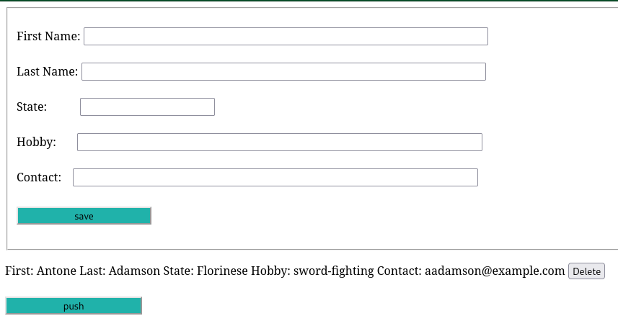
  - In the form, enter your information and click save. The application adds your information to the list after the form.
  - Click push to create the /var/tmp/People.html file on the shared volume.
- Verify that the web-pod application displays the People.html file from the shared PVC. Open a browser tab and go to http://web-pod.apps.ocp4.example.com/People.html
Finish
On the workstation machine, use the lab command to complete this exercise. This step is important to ensure that resources from previous exercises do not impact upcoming exercises.
[student@workstation ~]$ lab finish storage-classes

Manage Non-shared Storage with Stateful Sets

Objectives
- Deploy applications that scale without sharing storage.

Application Clustering
Clustering applications, such as MySQL and Cassandra, typically require persistent storage. This storage maintains the integrity of the data and files that the application uses. When many applications require persistent storage at the same time, multi-disk provisioning might not be possible because of limited resources.
Shared storage solves this problem by allocating resources from a single device to multiple services.

File Storage
File storage solutions provide a familiar directory structure. Using file storage is ideal when applications generate or consume typical volumes of organized data. Applications that use file-based implementations are prevalent, easy to manage, and provide an affordable storage solution.
File-based solutions are a good fit for data backup, archiving, file sharing, and collaboration services because of their reliability. Most data centers provide file storage solutions, such as a network-attached storage (NAS) cluster, for these scenarios.
NAS is a file-based storage architecture that makes stored data accessible to networked devices. NAS gives networks a single access point for storage with built-in security, management, and fault-tolerant capabilities. Networks can run multiple data transfer protocols. Two fundamental protocols are internet protocol (IP) and transmission control protocol (TCP).
The files that are transferred by using these protocols can be formatted with one of the following protocols:
- Network File System (NFS): This protocol enables remote hosts to mount file systems over a network and interact with those file systems as though they are mounted locally.
- Server Message Block (SMB): This protocol implements an application-layer network protocol to access resources on a server, such as file shares and shared printers.
NAS solutions can provide file-based storage to applications within the same data center. This approach applies to the following application architectures:
- Web server content
- File-sharing services
- FTP storage
- Backup archives
These applications take advantage of data reliability and the ease of file sharing that is available by using file storage. Additionally, for file storage data, the OS and file system handle the locking and caching of the files.
Although familiar and prevalent, file storage solutions are not ideal for all application scenarios. One pitfall of file storage is poor handling of large data sets or unstructured data.

Block Storage
Block storage solutions, such as Storage Area Network (SAN) and iSCSI technologies, provide access to raw block devices for application storage. These block devices function as independent storage volumes, such as the physical drives in servers, and typically require formatting and mounting for application access.
Using block storage is ideal when applications require faster access for optimizing computationally heavy data workloads. Applications that use block-level storage implementations gain efficiencies by communicating at the raw device level, instead of relying on operating system layer access.
Block-level approaches enable data distribution on blocks across the storage volume. Blocks also use basic metadata, including a unique identification number for each block of data, for quick retrieval and reassembly of blocks for reading.
SAN and iSCSI technologies provide applications with block-level volumes from network-based storage pools. Using block-level access to storage volumes is common for the following application architectures:
- SQL databases (single-node access)
- Virtual machines (multinode access)
- High-performance data access
- Server-side processing applications
- Multiple block device RAID configurations
Application storage that uses several block devices in a RAID configuration benefits from the data integrity and performance that the various arrays provide.
With Red Hat OpenShift Container Platform, you can create customized storage classes for your applications. With NAS and SAN storage technologies, OpenShift applications can use either the NFS protocol for file-based storage or a block-level protocol for block storage.

Stateful Sets
A stateful application acts according to past states or transactions, which affect the current and future states of the application. Using a stateful application simplifies recovery from failures by starting from a certain point in time.
A stateful set is the representation of a set of pods with consistent identities. These identities are defined as a network with a single stable DNS, hostname, and storage from as many volume claims as the stateful set specifies. A stateful set guarantees that a given network identity maps to the same storage identity.
Deployments represent a set of containers within a pod. Each deployment can have many active replicas, depending on the user specification. These replicas can be scaled up or down, as needed. A replica set is a native Kubernetes API object that ensures that the specified number of pod replicas are running. Deployments are used for stateless applications by default, and they can be used for stateful applications by attaching a persistent volume. All pods in a deployment use the same PVC.
In contrast with deployments, stateful set pods do not share a persistent volume. Instead, each stateful set pod has its own unique persistent volume. Pods are created without a replica set, and each replica records its own transactions. Each replica has its own identifier, which is maintained in any rescheduling. You must configure application-level clustering so that stateful set pods have the same data.
Stateful sets are the best option for applications, such as databases, that require consistent identities and non-shared persistent storage.

Headless Services for Stateful Sets
Stateful sets require a headless service to provide the stable network identity for its pods. Unlike a typical service that gets a single stable IP address (clusterIP) for load balancing, a headless service does not have a clusterIP address.
You create a headless service by explicitly setting its clusterIP field to None. For a DNS lookup on a headless service, the DNS server returns the IP addresses of all the individual pods that the service selects. This feature allows clients to connect directly to a specific pod instead of going through a load balancer.
For a StatefulSet, this behavior is critical. When you associate a stateful set with a headless service, each pod in the set gets a unique and predictable DNS entry. This DNS entry follows the format <pod-name>.<service-name>.<namespace>.svc.cluster.local. For example, a pod named dbserver-0 that is governed by a headless service named mysql-headless can be reached reliably at the dbserver-0.mysql-headless FQDN.
This stable identity enables peer discovery and direct communication between pods in a clustered application. These capabilities are crucial for applications such as distributed databases, where specific pods must be addressed directly for operations such as writing or replication.

Working with Stateful Sets
With Kubernetes, you can use manifest files to specify the intended configuration of a stateful set. You can define the name of the application, labels, the image source, storage, environment variables, and more. The following snippet shows an example of a YAML manifest file for a stateful set named dbserver:
apiVersion: apps/v1
kind: StatefulSet
metadata:
name: dbserver
spec:
selector:
matchLabels:
app: database
replicas: 3
serviceName: mysql
template:
metadata:
labels:
app: database
spec:
containers:
- env:
- name: MYSQL_USER
valueFrom:
secretKeyRef:
key: user
name: sakila-cred
image: registry.ocp4.example.com:8443/redhattraining/mysql-app:v1
name: database
ports:
- containerPort: 3306
name: database
volumeMounts:
- mountPath: /var/lib/mysql
name: data
terminationGracePeriodSeconds: 10
volumeClaimTemplates:
- metadata:
name: data
spec:
accessModes: [ "ReadWriteOncePod" ]
storageClassName: "lvms-vg1"
resources:
requests:
storage: 1Gi
Name of the stateful set.
Application labels.
Number of replicas.
Name of the service that governs the stateful set. This service must exist before the stateful set.
Environment variables, which can be defined explicitly or by using a secret object.
Image source.
Container name.
Container ports.
Mount path information for the persistent volumes for each replica. Each persistent volume has the same configuration.
The access mode of the persistent volume. The valid values are ReadWriteOncePod, ReadWriteOnce, ReadWriteMany, and ReadOnlyMany. The ReadWriteOncePod mode is recommended for production use.
The storage class that the persistent volume uses.
Size of the persistent volume.

Note
Stateful sets can be created only by using manifest files. The oc and kubectl CLIs do not have commands to create stateful sets imperatively.
The following snippet shows an example YAML manifest for a headless service named mysql for the dbserver stateful set:
apiVersion: v1
kind: Service
metadata:
name: mysql
labels:
app: database
spec:
ports:
- port: 3306
name: mysql
clusterIP: None
selector:
app: database
The name of the headless service.
Set the clusterIP field to None to make the service headless.
The service selector must match the labels of the pods that the stateful set created.
You create the mysql headless service by using the oc create command:
[user@host ~]$ oc create -f headless-service.yml
You can verify the creation of the service by running the following command:
[user@host ~]$ oc get svc
NAME TYPE CLUSTER-IP EXTERNAL-IP PORT(S) AGE
service/mysql ClusterIP None <none> 3306/TCP 5s
You can create the dbserver stateful set by using the oc create command:
[user@host ~]$ oc create -f statefulset-dbserver.yml
You can verify the creation of the stateful set by running the following command. In the following example, the stateful set has three replica pods, and all three pods are ready.
[user@host ~]$ oc get statefulset
NAME READY AGE
dbserver 3/3 6s
The stateful set controller assigns each pod a unique and stable name in the <statefulset-name>-<ordinal-index> format. The controller starts pods one at a time, sorted by their ordinal index, and it waits until each pod reports being ready before starting the next one.
[user@host ~]$ oc get pods
NAME READY STATUS RESTARTS AGE
dbserver-0 1/1 Running 0 85s
dbserver-1 1/1 Running 0 82s
dbserver-2 1/1 Running 0 79s
You can get the service endpoints, which are the pods' IP addresses by running the following command:
[user@host ~]$ oc get endpoints
NAME ENDPOINTS AGE
mysql 10.8.0.45:3306,10.8.0.54:3306,10.8.0.61:3306 2m
You resolve the pods' IP addresses by using the headless service; for example, to resolve the IP address for the dbserver-0 pod, you use the dbserver-0.mysql hostname.
[user@host ~]$ oc rsh dbserver-0 curl -v \
telnet://dbserver-0.mysql:3306
Rebuilt URL to: telnet://dbserver-0.mysql:3306/
Trying 10.8.0.45...
TCP_NODELAY set
Connected to dbserver-0.mysql (10.8.0.45) port 3306 (#0)
The stateful set creates three PVCs, one PVC for each replica pod. Each PVC has a unique and stable name in the data-<statefulset-name>-<ordinal-index> format.
[user@host ~]$ oc get pvc
NAME STATUS VOLUME CAPACITY ACCESS MODES ...
data-dbserver-0 Bound pvc-c28... 1Gi RWO ...
data-dbserver-1 Bound pvc-ddb... 1Gi RWO ...
data-dbserver-2 Bound pvc-830... 1Gi RWO ...
Each pod attaches its associated PVC. You can check the PVC that is attached to each replica pod in the stateful set by running the following commands:
[user@host ~]$ oc describe pod dbserver-0
...output omitted...
Volumes:
data:
Type: PersistentVolumeClaim (a reference to a PersistentVolumeClaim in the same namespace)
ClaimName: data-dbserver-0
...output omitted...
[user@host ~]$ oc describe pod dbserver-1
...output omitted...
Volumes:
data:
Type: PersistentVolumeClaim (a reference to a PersistentVolumeClaim in the same namespace)
ClaimName: data-dbserver-1
...output omitted...
[user@host ~]$ oc describe pod dbserver-2
...output omitted...
Volumes:
data:
Type: PersistentVolumeClaim (a reference to a PersistentVolumeClaim in the same namespace)
ClaimName: data-dbserver-2
...output omitted...
The data is replicated between the three pods at the application level. For example, in the dbserver stateful set, you can configure the first pod as the primary, and the other two pods as replicas. The primary pod handles read and write requests, and the replica pods sync with the primary pod for data replication.

Note
Configuring a replicated stateful set application is outside the scope of this course.
You can update the number of replicas of the stateful set by using the oc scale command. The following command adds one more pod to the stateful set. A fourth pod is created if the third pod is up and running.
[user@host ~]$ oc scale statefulset/dbserver --replicas 4
NAME READY STATUS RESTARTS ...
dbserver-0 4/4 Running 0 ...
To delete the stateful set, use the delete statefulset command:
[user@host ~]$ oc delete statefulset dbserver
statefulset.apps "dbserver" deleted
The PVCs are not deleted after the execution of the oc delete statefulset command:
[user@host ~]$ oc get pvc
NAME STATUS VOLUME CAPACITY ACCESS MODES ...
data-dbserver-0 Bound pvc-c28... 1Gi RWO ...
data-dbserver-1 Bound pvc-ddb... 1Gi RWO ...
data-dbserver-2 Bound pvc-830... 1Gi RWO ...
You can create a stateful set from the web console. Go to the Workloads → StatefulSets menu. Click Create StatefulSet and customize the YAML manifest.

Guided Exercise: Manage Non-shared Storage with Stateful Sets
Deploy a replicated web server by using a deployment and verify that all web server pods share a PV; and deploy a replicated MySQL database by using a stateful set and verify that each database instance gets a dedicated PV.
Outcomes
- Deploy a web server with persistent storage.
- Add data to the persistent storage.
- Scale the web server deployment and observe the data that is shared with the replicas.
- Create a database server with a headless service and a stateful set by using YAML manifest files.
- Verify that each instance from the stateful set has a persistent volume claim.
As the student user on the workstation machine, use the lab command to prepare your system for this exercise.the
This command ensures that all resources are available for this exercise.
[student@workstation ~]$ lab start storage-statefulsets
Instructions
- Create a web server deployment named web-server. Use the registry.ocp4.example.com:8443/redhattraining/hello-world-nginx:latest container image.
  - Log in to the OpenShift cluster as the developer user with developer as the password.
[student@workstation]$ oc login -u developer -p developer \
https://api.ocp4.example.com:6443
  - ...output omitted...
  - Change to the storage-statefulsets project.
[student@workstation]$ oc project storage-statefulsets
  - Now using project "storage-statefulsets" on server ...output omitted...
  - Create the web-server deployment.
[student@workstation ~]$ oc create deployment web-server \
--image registry.ocp4.example.com:8443/redhattraining/hello-world-nginx:latest
  - deployment.apps/web-server created
  - Verify the deployment status.
[student@workstation ~]$ oc get deployment
NAME READY UP-TO-DATE AVAILABLE AGE
  - web-server 1/1 1 1 50s
- Add the PVC named web-pv to the web-server deployment. Use the default storage class and the following information to create the persistent volume claim:
Field | Value
Name | web-pv
Type | persistentVolumeClaim
Claim mode | rwo
Claim size | 5Gi
Mount path | /usr/share/nginx/html
Claim name | web-pv-claim
  - Use the oc set volumes command to create and add the web-pv persistent volume to the web-server deployment.
[student@workstation ~]$ oc set volumes deployment/web-server \
--add --name web-pv --type persistentVolumeClaim --claim-mode rwo \
--claim-size 5Gi --mount-path /usr/share/nginx/html --claim-name web-pv-claim
  - deployment.apps/web-server volume updated
  - Because a storage class was not specified with the --claim-class option, the command uses the default storage class to create the persistent volume.
  - Verify the deployment pod status. Notice that a new pod is created and in running status.
[student@workstation ~]$ oc get pods -l app=web-server
NAME READY STATUS RESTARTS AGE
  - web-server-5fb94fd568-48n8t 1/1 Running 0 5s
  - Check that the web-server pod mounts the web-pv PVC. The pod name is different in your cluster.
[student@workstation ~]$ oc get pod web-server-5fb94fd568-48n8t -o json | \
jq .spec.volumes[0].persistentVolumeClaim.claimName
  - "web-pv-claim"
  - Verify that the web-pv PVC shows the bound status.
[student@workstation ~]$ oc get pvc
NAME STATUS VOLUME CAPACITY ACCESS MODES STORAGECLASS ...
  - web-pv-claim Bound pvc-42... 5Gi RWO nfs-storage ...
  - The default storage class, nfs-storage, provisioned the persistent volume.
- Add data to the web-pv PVC by using the exec command.
  - List the pods to retrieve the web-server pod name.
[student@workstation ~]$ oc get pods
NAME READY STATUS RESTARTS AGE
  - web-server-5fb94fd568-48n8t 1/1 Running 0 3m
  - The pod name is different in your cluster.
  - Use the exec command to add the pod name that you retrieved from the previous step to the /usr/share/nginx/html/index.html file on the pod.
[student@workstation ~]$ oc exec -it pod/web-server-5fb94fd568-48n8t \
-- /bin/bash -c \
  - 'echo "Hello, World from ${HOSTNAME}" > /usr/share/nginx/html/index.html'
  - Retrieve the contents of the /var/www/html/index.html file to confirm that the pod name is in the file. (verify the content of the file)
[student@workstation ~]$ oc exec -it pod/web-server-5fb94fd568-48n8t \
-- cat /usr/share/nginx/html/index.html
  - Hello, World from web-server-5fb94fd568-48n8t
- Scale the web-server deployment to two replicas and confirm that an additional pod is created.
  - Scale the web-server deployment to two replicas.
[student@workstation ~]$ oc scale deployment web-server --replicas 2
  - deployment.apps/web-server scaled
  - Verify the replica status and retrieve the pod names.
[student@workstation ~]$ oc get pods
NAME READY STATUS RESTARTS AGE
web-server-5fb94fd568-48n8t 1/1 Running 0 10m
  - web-server-5fb94fd568-rqvpb 1/1 Running 0 6s
  - The pod names are different in your cluster.
- Retrieve the content of the /usr/share/nginx/html/index.html file on the web-server pods by using the oc exec command to verify that the file is the same in both pods.
  - Verify that the /usr/share/nginx/html/index.html file is the same in both pods.
[student@workstation ~]$ oc exec -it pod/web-server-5fb94fd568-48n8t \
-- cat /usr/share/nginx/html/index.html
  - Hello, World from web-server-5fb94fd568-48n8t
[student@workstation ~]$ oc exec -it pod/web-server-5fb94fd568-rqvpb \
-- cat /usr/share/nginx/html/index.html
  - Hello, World from web-server-5fb94fd568-48n8t
  - Notice that both files show the name of the first instance, because they share the persistent volume.
- Create a database server by using a stateful set and a headless service.
  - Edit the /home/student/DO180/labs/storage-statefulsets/statefulset-db.yml file and modify the placeholder text to match the following content:
apiVersion: apps/v1
kind: StatefulSet
metadata:
name: dbserver
spec:
selector:
matchLabels:
app: database
replicas: 2
serviceName: mysql-svc
template:
metadata:
labels:
app: database
spec:
terminationGracePeriodSeconds: 10
containers:
- name: dbserver
image: registry.ocp4.example.com:8443/redhattraining/mysql-app:v1
ports:
- name: database
containerPort: 3306
env:
- name: MYSQL_USER
value: "redhat"
- name: MYSQL_PASSWORD
value: "redhat123"
- name: MYSQL_DATABASE
value: "sakila"
volumeMounts:
- name: data
mountPath: /var/lib/mysql
volumeClaimTemplates:
- metadata:
name: data
spec:
accessModes: [ "ReadWriteOnce" ]
storageClassName: "lvms-vg1"
resources:
requests:
  - storage: 1Gi
  - Edit the /home/student/DO180/labs/storage-statefulsets/service-db.yml file and modify the placeholder text to match the following content:
apiVersion: v1
kind: Service
metadata:
name: mysql-svc
labels:
app: database
spec:
ports:
- port: 3306
name: mysql
clusterIP: None
selector:
  - app: database
  - Create the mysql-svc headless service.
[student@workstation ~]$ oc create -f \
/home/student/DO180/labs/storage-statefulsets/service-db.yml
  - service/mysql-svc created
  - Create the dbserver stateful set.
[student@workstation ~]$ oc create -f \
/home/student/DO180/labs/storage-statefulsets/statefulset-db.yml
  - statefulset.apps/bdserver created
  - Run the watch command and wait until the two stateful set pods are running.
[student@workstation ~]$ watch oc get pod \
-l app=database -o wide
NAME READY STATUS ... AGE IP
dbserver-0 1/1 Running ... 10s 10.8.0.112
  - dbserver-1 1/1 Running ... 5s 10.8.0.113
  - Press Ctrl+C to end the watch command after the pods display Running in the STATUS column.
  - List the mysql-svc service endpoints, which correspond to the pods' IP addresses.
[student@workstation ~]$ oc get endpoints
NAME ENDPOINTS AGE
  - mysql-svc 10.8.0.112:3306,10.8.0.113:3306 10m
  - The endpoint IPs are different on your system.
  - Connect to the dbserver-1 pod by using its unique DNS name.
[student@workstation ~]$ oc rsh dbserver-1 \
curl -v telnet://dbserver-1.mysql-svc:3306
* Rebuilt URL to: telnet://dbserver-1.mysql-svc:3306/
* Trying 10.8.0.113...
* TCP_NODELAY set
* Connected to dbserver-1.mysql-svc (10.8.0.113) port 3306 (#0)
  - ...output omitted...
  - The DNS name resolves IP that corresponds to the dbserver-1 pod that is listed in the previous command.
- Confirm that each instance from the dbserver stateful set has a persistent volume claim. Add data to each stateful set pod.
  - Verify that the two persistent volume claims display Bound in the STATUS column.
[student@workstation ~]$ oc get pvc -l app=database
NAME STATUS ... CAPACITY ACCESS MODE ...
data-dbserver-0 Bound ... 1Gi RWO ...
  - data-dbserver-1 Bound ... 1Gi RWO ...
  - Verify that the dbserver-0 pod mounts the data-dbserver-0 PVC.
[student@workstation ~]$ oc get pod dbserver-0 -o json | \
jq .spec.volumes[0].persistentVolumeClaim.claimName
  - "data-dbserver-0"
  - Verify that the dbserver-1 pod mounts the data-dbserver-1 PVC.
[student@workstation ~]$ oc get pod dbserver-1 -o json | \
jq .spec.volumes[0].persistentVolumeClaim.claimName
  - "data-dbserver-1"
  - Create a table named items within the sakila database in the dbserver-0 pod.
[student@workstation ~]$ oc exec -it pod/dbserver-0 -- /bin/bash -c \
"mysql -uredhat -predhat123 sakila -e 'create table items (count INT);'"
  - mysql: [Warning] Using a password on the command line interface can be insecure.
  - Create a table named inventory within the sakila database in the dbserver-1 pod.
[student@workstation ~]$ oc exec -it pod/dbserver-1 -- /bin/bash -c \
"mysql -uredhat -predhat123 sakila -e 'create table inventory (count INT);'"
  - mysql: [Warning] Using a password on the command line interface can be insecure.
- No data replication is configured at the application level for the dbserver stateful set. Verify that each database pod contains unique data.
  - Confirm that the dbserver-0 pod has a database named sakila with one table named items.
[student@workstation ~]$ oc exec -it pod/dbserver-0 -- /bin/bash -c \
"mysql -uredhat -predhat123 sakila -e 'show tables;'"
mysql: [Warning] Using a password on the command line interface can be insecure.
+------------------+
| Tables_in_sakila |
+------------------+
| items |
  - +------------------+
  - Confirm that the dbserver-1 pod has a database named sakila with one table named inventory.
[student@workstation ~]$ oc exec -it pod/dbserver-1 -- /bin/bash -c \
"mysql -uredhat -predhat123 sakila -e 'show tables;'"
mysql: [Warning] Using a password on the command line interface can be insecure.
+------------------+
| Tables_in_sakila |
+------------------+
| inventory |
  - +------------------+
- Delete a pod in the dbserver stateful set. A new stateful set pod is created with the same ordinal index, and the pod mounts its corresponding PVC. The data remains in the PVC and it is accessible from the pod.
  - Delete the dbserver-0 pod in the dbserver stateful set.
[student@workstation ~]$ oc delete pod dbserver-0
  - pod "dbserver-0" deleted
  - Verify that a new dbserver-0 pod is created.
[student@workstation ~]$ oc get pods -l app=database

NAME READY STATUS RESTARTS AGE
dbserver-0 1/1 Running 0 4s
  - dbserver-1 1/1 Running 0 15m
  - Verify that the dbserver-0 pod mounts the data-dbserver-0 PVC.
[student@workstation ~]$ oc get pod dbserver-0 -o json | \
jq .spec.volumes[0].persistentVolumeClaim.claimName
  - "data-dbserver-0"
  - Verify that the new dbserver-0 pod has the items table within the sakila database.
[student@workstation ~]$ oc exec -it pod/dbserver-0 -- /bin/bash -c \
"mysql -uredhat -predhat123 sakila -e 'show tables;'"
mysql: [Warning] Using a password on the command line interface can be insecure.
+------------------+
| Tables_in_sakila |
+------------------+
| items |
  - +------------------+
Finish
On the workstation machine, use the lab command to complete this exercise. This step is important to ensure that resources from previous exercises do not impact upcoming exercises.
[student@workstation ~]$ lab finish storage-statefulsets

Lab: Manage Storage for Application Configuration and Data
Deploy a web application and its database that share database credentials from a secret. The database should use the default storage for the cluster. Also, you deploy a file-sharing application that runs with multiple replicas and shares its storage volume with a file uploader application. The file sharing and file uploader applications take configuration files from a configuration map and should use NFS file storage for shareability. The database should use local storage for increased performance.
Outcomes
- Deploy a database server.
- Deploy a web application.
- Create a secret that contains the database server credentials.
- Create a configuration map that contains an SQL file.
- Add and remove a volume on the database server and the web application.
- Expose the database server and the web application.
- Scale up the web application.
- Mount the configuration map as a volume.
As the student user on the workstation machine, use the lab command to prepare your system for this exercise. This command ensures that the cluster is accessible and that all resources are available for this exercise.
[student@workstation ~]$ lab start storage-review
Instructions
In this exercise, you work in the storage-review project that the lab command created. The command also created files in the /home/student/DO180/labs/storage-review directory that you use in the exercise.
The API URL of your OpenShift cluster is https://api.ocp4.example.com:6443, and the oc command is already installed on your workstation machine.
- Log in to the OpenShift cluster as the developer user with developer as the password, and change to the storage-review project. You use this project for all your work in this exercise.
- Create a secret named world-cred that contains the following data:
Field | Value
user | redhat
password | redhat123
database | world_x
  - Create a secret that contains the database credentials.
[student@workstation]$ oc create secret generic world-cred \
--from-literal user=redhat \
--from-literal password=redhat123 \
--from-literal database=world_x
  - secret/world-cred created
  - Confirm the creation of the secret.
[student@workstation ~]$ oc get secrets world-cred
NAME TYPE DATA AGE
  - world-cred Opaque 3 2m34s
- Create a configuration map named dbfiles by using the ~/DO180/labs/storage-review/insertdata.sql file.
  - Create a configuration map named dbfiles by using the insertdata.sql file in the ~/DO180/labs/storage-review directory.
[student@workstation ~]$ oc create configmap dbfiles \
--from-file ~/DO180/labs/storage-review/insertdata.sql
  - configmap/dbfiles created
  - Verify the creation of the configuration map.
[student@workstation]$ oc get configmaps
NAME DATA AGE
dbfiles 1 11s
  - ...output omitted...
- Create a database server deployment named dbserver by using the registry.ocp4.example.com:8443/redhattraining/mysql-app:v1 container image. Then, set the missing environment variables by using the world-cred secret. Use the MYSQL_ prefix for the variables.
  - Create the database server deployment.
[student@workstation ~]$ oc create deployment dbserver \
--image \
registry.ocp4.example.com:8443/redhattraining/mysql-app:v1
  - deployment.apps/dbserver created
  - Set the missing environment variables.
[student@workstation ~]$ oc set env deployment/dbserver \
--from secret/world-cred --prefix MYSQL_
  - deployment.apps/dbserver updated
  - Verify that the dbserver pod is in the RUNNING state. The pod name might differ in your output.
[student@workstation ~]$ oc get pods
NAME READY STATUS ...
  - dbserver-6d5bf5d86c-ptrb2 1/1 Running ...
- Add a volume to the dbserver deployment by using the following information:
Field | Value
Name | dbserver-lvm
Type | persistentVolumeClaim
Claim mod | rwo
Claim size | 1Gi
Mount path | /var/lib/mysql
Claim class | lvms-vg1
Claim name | dbserver-lvm-pvc
  - Add a volume to the dbserver deployment.
[student@workstation ~]$ oc set volume deployment/dbserver \
--add --name dbserver-lvm --type persistentVolumeClaim \
--claim-mode rwo --claim-size 1Gi \
--mount-path /var/lib/mysql --claim-class lvms-vg1 \
--claim-name dbserver-lvm-pvc
  - deployment.apps/dbserver volume updated
  - Verify the deployment status.
[student@workstation ~]$ oc get pods
NAME READY STATUS ...
  - dbserver-5bc6bd5d7b-7z7lv 1/1 Running ...
  - Verify the volume status.
[student@workstation ~]$ oc get pvc
NAME STATUS VOLUME CAPACITY ...
  - dbserver-lvm-pvc Bound pvc-2cb8...5025 1Gi ...
- Create a service for the dbserver deployment by using the following information:
Field | Value
Name | mysql-service
Port | 3306
Target port | 3306
  - Expose the dbserver deployment.
[student@workstation ~]$ oc expose deployment dbserver \
--name mysql-service --port 3306 --target-port 3306
  - service/mysql-service exposed
  - Verify the service configuration. The endpoint IP address might differ in your output.
[student@workstation ~]$ oc get services
NAME TYPE CLUSTER-IP EXTERNAL-IP PORT(S)
mysql-service ClusterIP 172.30.240.100 <none> 3306/TCP
[student@workstation ~]$ oc get endpoints
NAME ENDPOINTS AGE
  - mysql-service 10.8.1.36:3306 20s
- Create a web application deployment named file-sharing by using the registry.ocp4.example.com:8443/redhattraining/php-webapp-mysql:v1 container image. Scale the deployment to two replicas. Then, expose the deployment by using the following information:
Field | Value
Name | file-sharing
Port | 8080
Target port | 8080
- Create a route named file-sharing to expose the file-sharing web application to external access. Access the file-sharing route in a web browser to test the connection between the web application and the database server.
  - Create a web application deployment.
[student@workstation ~]$ oc create deployment file-sharing \
--image registry.ocp4.example.com:8443/redhattraining/php-webapp-mysql:v1
  - deployment.apps/file-sharing created
  - Verify the deployment status. Verify that the file-sharing application pod is in the RUNNING state. The pod names might differ on your system.
[student@workstation ~]$ oc get pods
NAME READY STATUS ...
dbserver-5bc6bd5d7b-7z7lv 1/1 Running ...
  - file-sharing-789c5948c8-gdrlz 1/1 Running ...
  - Scale the deployment to two replicas.
[student@workstation ~]$ oc scale deployment file-sharing \
--replicas 2
  - deployment.apps/file-sharing scaled
  - Verify the replica status and retrieve the pod name. The pod names might differ on your system.
[student@workstation ~]$ oc get pods
NAME READY STATUS ...
dbserver-5bc6bd5d7b-7z7lv 1/1 Running ...
file-sharing-789c5948c8-62j9s 1/1 Running ...
  - file-sharing-789c5948c8-gdrlz 1/1 Running ...
  - Expose the file-sharing deployment.
[student@workstation ~]$ oc expose deployment file-sharing \
--name file-sharing --port 8080 --target-port 8080
  - service/file-sharing exposed
  - Verify the service configuration. The endpoint IP address might differ in your output.
[student@workstation ~]$ oc get services
NAME TYPE CLUSTER-IP EXTERNAL-IP PORT(S)
file-sharing ClusterIP 172.30.139.210 <none> 8080/TCP
mysql-service ClusterIP 172.30.240.100 <none> 3306/TCP
[student@workstation ~]$ oc get endpoints
NAME ENDPOINTS AGE
file-sharing 10.8.1.37:8080,10.8.1.38:8080 14s
  - mysql-service 10.8.1.36:3306 5m23s
  - Expose the file-sharing service.
[student@workstation ~]$ oc expose service/file-sharing
route.route.openshift.io/file-sharing exposed
[student@workstation ~]$ oc get routes
NAME HOST/PORT ...
  - file-sharing file-sharing-storage-review.apps.ocp4.example.com
  - Test the connectivity between the web application and the database server. In a web browser, go to http://file-sharing-storage-review.apps.ocp4.example.com, and verify that the Connected successfully message is displayed.
- Mount the dbfiles configuration map to the file-sharing deployment as a volume named config-map-pvc. Set the mount path to the /home/database-files directory. Then, verify the content of the insertdata.sql file.
  - Mount the dbfiles configuration map to the file-sharing deployment.
[student@workstation ~]$ oc set volume deployment/file-sharing \
--add --name config-map-pvc --type configmap \
--configmap-name dbfiles \
--mount-path /home/database-files
  - deployment.apps/file-sharing volume updated
  - Verify the deployment status.
[student@workstation ~]$ oc get pods
NAME READY STATUS ...
dbserver-5bc6bd5d7b-7z7lv 1/1 Running ...
file-sharing-7f77855b7f-949lg 1/1 Running ...
  - file-sharing-7f77855b7f-9zvwq 1/1 Running ...
  - Verify the content of the /home/database-files/insertdata.sql file.
[student@workstation ~]$ oc exec -it \
pod/file-sharing-7f77855b7f-949lg -- \
head /home/database-files/insertdata.sql
-- MySQL dump 10.13 Distrib 8.0.19, for osx10.14 (x86_64)
--
-- Host: 127.0.0.1 Database: world_x
-- ------------------------------------------------------
-- Server version 8.0.19-debug
  - ...output omitted...
- Add a shared volume to the file-sharing deployment. Use the following information to create the volume:
Field | Value
Name | shared-volume
Type | persistentVolumeClaim
Claim mode | rwo
Claim size | 1Gi
Mount path | /home/sharedfiles
Claim class | nfs-storage
Claim name | shared-pvc
- Next, connect to one of the file-sharing deployment pods, and use the cp command to copy the /home/database-files/insertdata.sql file to the /home/sharedfiles directory. Then, remove the config-map-pvc volume from the file-sharing deployment.
  - Add the shared-volume volume to the file-sharing deployment.
[student@workstation ~]$ oc set volume deployment/file-sharing \
--add --name shared-volume --type persistentVolumeClaim \
--claim-mode rwo --claim-size 1Gi \
--mount-path /home/sharedfiles --claim-class nfs-storage \
--claim-name shared-pvc
  - deployment.apps/file-sharing volume updated
  - Verify the deployment status. Your pod names might differ on your system.
[student@workstation ~]$ oc get pods
NAME READY STATUS ...
dbserver-5bc6bd5d7b-7z7lv 1/1 Running ...
file-sharing-65884f75bb-92fxf 1/1 Running ...
  - file-sharing-65884f75bb-gsghk 1/1 Running ...
  - Verify the volume status.
[student@workstation ~]$ oc get pvc
NAME STATUS VOLUME CAPACITY ...
dbserver-lvm-pvc Bound pvc-2cb8...5025 1Gi ...
  - shared-pvc Bound pvc-cf2d...de48 1Gi ...
  - Copy the /home/database-files/insertdata.sql file to the /home/sharedfiles path.
[student@workstation ~]$ oc exec -it \
pod/file-sharing-65884f75bb-92fxf -- \
  - cp /home/database-files/insertdata.sql /home/sharedfiles/
[student@workstation ~]$ oc exec -it \
pod/file-sharing-65884f75bb-92fxf -- \
ls /home/sharedfiles/
  - insertdata.sql
  - Remove the config-map-pvc volume from the file-sharing deployment.
[student@workstation ~]$ oc set volume deployment/file-sharing \
--remove --name=config-map-pvc
  - deployment.apps/file-sharing volume updated
- Add the shared-volume PVC to the dbserver deployment. Then, connect to the dbserver deployment pod and verify the content of the /home/sharedfiles/insertdata.sql file.
  - Add the shared-volume volume to the dbserver deployment.
[student@workstation ~]$ oc set volume deployment/dbserver \
--add --name shared-volume \
--claim-name shared-pvc \
--mount-path /home/sharedfiles
  - deployment.apps/dbserver volume updated
  - Verify the deployment status. The pod names might differ on your system.
[student@workstation ~]$ oc get pods
NAME READY STATUS ...
dbserver-6676fbf5fc-n9hpk 1/1 Running ...
file-sharing-5fdb44cf57-2hhwj 1/1 Running ...
  - file-sharing-5fdb44cf57-z4n7g 1/1 Running ...
  - Verify the content of the /home/sharedfiles/insertdata.sql file.
[student@workstation ~]$ oc exec -it \
pod/dbserver-6676fbf5fc-n9hpk -- \
head /home/sharedfiles/insertdata.sql
-- MySQL dump 10.13 Distrib 8.0.19, for osx10.14 (x86_64)
--
-- Host: 127.0.0.1 Database: world_x
-- ------------------------------------------------------
-- Server version 8.0.19-debug
  - ...output omitted...
- Connect to the database server and execute the /home/sharedfiles/insertdata.sql file to add data to the world_x database. You can execute the file by using the following command:
mysql -u$MYSQL_USER -p$MYSQL_PASSWORD world_x < \
- /home/sharedfiles/insertdata.sql
- Then, confirm connectivity between the web application and the database server by accessing the file-sharing route in a web browser.
  - Connect to the database server and execute the /home/sharedfiles/insertdata.sql file. Then, exit the database server.
  - [student@workstation ~]$ oc rsh dbserver-6676fbf5fc-n9hpk
sh-4.4$ mysql -u$MYSQL_USER -p$MYSQL_PASSWORD world_x < \
/home/sharedfiles/insertdata.sql
mysql: [Warning] Using a password on the command line interface can be insecure.
sh-4.4$ exit
  - exit
  - Test the connectivity between the web application and the database server. In a web browser, go to http://file-sharing-storage-review.apps.ocp4.example.com, and verify that the application retrieves data from the world_x database.
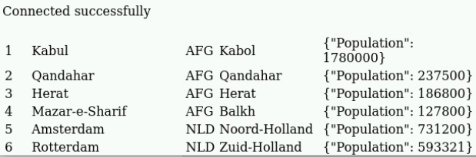
Evaluation
As the student user on the workstation machine, use the lab command to grade your work. Correct any reported failures and rerun the command until successful.
[student@workstation ~]$ lab grade storage-review
Finish
As the student user on the workstation machine, use the lab command to complete this exercise. This step is important to ensure that resources from previous exercises do not impact upcoming exercises.
[student@workstation ~]$ lab finish storage-review

Summary
- Configuration maps are objects that provide mechanisms to inject configuration data into containers.
- The values in secrets are always encoded (not encrypted).
- A PVC resource represents a request from an application for storage, and specifies the essential storage characteristics, such as the capacity and access mode.
- Kubernetes supports two volume modes for persistent volumes: Filesystem and Block.
- Storage classes are a way to describe types of storage for the cluster and to provision dynamic storage on demand.
- A reclaim policy determines what happens to the data on a PV after the PVC is deleted.
- A storage class with block volume mode support can improve performance for applications that can use raw block devices.
- A stateful set is the representation of a set of pods with consistent identities.
- Each stateful set pod has its own unique PV.

Chapter 6. Configure Applications for Reliability
Application High Availability with Kubernetes
Guided Exercise: Application High Availability with Kubernetes
Application Health Probes
Guided Exercise: Application Health Probes
Reserving Compute Capacity for Applications
Guided Exercise: Reserving Compute Capacity for Applications
Limit Compute Capacity for Applications
Guided Exercise: Limit Compute Capacity for Applications
Application Autoscaling
Guided Exercise: Application Autoscaling
Lab: Configure an Application for Reliability
Quiz: Configure an Application for Reliability
Summary
Abstract
Goal | Configure applications to work with Kubernetes for high availability and resilience.
Sections | - Application High Availability with Kubernetes (and Guided Exercise)  - Application Health Probes (and Guided Exercise)  - Reserving Compute Capacity for Applications (and Guided Exercise)  - Limit Compute Capacity for Applications (and Guided Exercise)  - Application Autoscaling (and Guided Exercise)
Lab | - Configure an Application for Reliability

Application High Availability with Kubernetes

Objectives
- Describe how Kubernetes works to keep applications running after failures.

Concepts of Deploying Highly Available Applications
High availability (HA) is a goal of making applications more robust and resistant to runtime failures. Implementing HA techniques decreases the likelihood that an application is completely unavailable to users.
In general, HA can protect an application from failures in the following contexts:
- From itself in the form of application bugs
- From its environment, such as networking issues
- From other applications that exhaust cluster resources
Additionally, HA practices can protect the cluster from applications, such as one with a memory leak.

Writing Reliable Applications
At its core, cluster-level HA tooling mitigates worst-case scenarios. Although HA is not a substitute for fixing application-level issues, it augments developer mitigations. Applications must work with the cluster so that Red Hat OpenShift Container Platform can best handle failure scenarios.
Red Hat OpenShift Container Platform expects the following behaviors from applications:
- Tolerates restarts
- Responds to health probes, such as the startup, readiness, and liveness probes
- Supports multiple simultaneous instances
- Has well-defined and well-behaved resource usage
- Operates with restricted privileges
Although the cluster can run applications that lack the preceding behaviors, applications with these behaviors better use the reliability and HA features that Kubernetes provides.
Most HTTP-based applications provide an endpoint to verify application health. The cluster can be configured to observe this endpoint and mitigate potential issues for the application.
The application is responsible for providing such an endpoint. Developers must decide how the application determines its state.
For example, if an application depends on a database connection, then the application might respond with a healthy status only when the database is reachable. However, not all applications that make database connections need such a check. This decision is at the discretion of the developers.

Kubernetes Application Reliability
If an application pod crashes, then it cannot respond to requests. Depending on the configuration, the cluster can automatically restart the pod. If the application fails without crashing the pod, then the pod continues to run but does not receive requests. The cluster can detect and act on a running but unhealthy pod only with the appropriate health probes.
Kubernetes uses the following HA techniques to improve application reliability:
- Restarting pods: By configuring a restart policy on a pod, the cluster restarts misbehaving instances of an application.
- Probing: By using health probes, the cluster detects when applications cannot respond to requests, and can automatically act to mitigate the issue.
- Horizontal scaling: When the application load changes, the cluster can scale the number of replicas to match the load.
These techniques are explored throughout this chapter.

Restarting Pods
A container in a pod can terminate for various reasons. The restartPolicy field of a pod specification controls whether the kubelet restarts the containers in that pod. The possible values are Always, OnFailure, and Never. The default value is Always.
Policy | Description
Always | The kubelet always restarts a terminated container. This policy is the default.
OnFailure | The kubelet restarts a terminated container only if it exited with a non-zero exit code.
Never | The kubelet never restarts a terminated container.

Guided Exercise: Application High Availability with Kubernetes
Simulate different types of application failures and observe how Kubernetes handles them.
Outcomes
- Explore how the restartPolicy attribute affects crashing pods.
- Observe the behavior of a slow-starting application that has no configured probes.
- Use a deployment to scale the application, and observe the behavior of a broken pod.
As the student user on the workstation machine, use the lab command to prepare your system for this exercise.
This command ensures that the following conditions are true:
- The reliability-ha project exists.
- The resource files are available in the course directory.
- The classroom registry has the long-load container image.
The long-load container image contains an application with utility endpoints. These endpoints perform such tasks as crashing the process and toggling the server's health status.
[student@workstation ~]$ lab start reliability-ha
Instructions
- As the developer user, create a pod from a YAML manifest in the reliability-ha project.
  - Log in to the OpenShift cluster as the developer user with developer as the password.
[student@workstation ~]$ oc login -u developer -p developer \
https://api.ocp4.example.com:6443
Login successful.

  - ...output omitted...
  - Select the reliability-ha project.
[student@workstation ~]$ oc project reliability-ha
  - Now using project "reliability-ha" on server "https://api.ocp4.example.com:6443".
  - Go to the lab materials directory and view the contents of the pod definition. In particular, the manifest sets restartPolicy to Always.
  - [student@workstation ~]$ cd DO180/labs/reliability-ha
[student@workstation reliability-ha]$ cat long-load.yaml
apiVersion: v1
kind: Pod
metadata:
name: long-load
spec:
containers:
- image: registry.ocp4.example.com:8443/redhattraining/long-load:v1
name: long-load
securityContext:
allowPrivilegeEscalation: false
  - restartPolicy: Always
  - Create a pod by using the oc apply command.
[student@workstation reliability-ha]$ oc apply -f long-load.yaml
  - pod/long-load created
  - Send a request to the pod to confirm that it is running and responding.
[student@workstation reliability-ha]$ oc exec long-load -- \
curl -s localhost:3000/health
  - Ok
- Trigger the pod to crash, and observe that the restartPolicy instructs the cluster to re-create the pod.
  - Observe that the pod is running and did not restart.
[student@workstation reliability-ha]$ oc get pods

NAME READY STATUS RESTARTS AGE
  - long-load 1/1 Running 0 1m
  - Send a request to the /destruct endpoint in the application. This request triggers the process to crash.
[student@workstation reliability-ha]$ oc exec long-load -- \
curl -s localhost:3000/destruct
  - command terminated with exit code 52
  - Observe that the pod is running and restarted one time.
[student@workstation reliability-ha]$ oc get pods
NAME READY STATUS RESTARTS AGE
  - long-load 1/1 Running 1 (34s ago) 4m16s
  - Delete the long-load pod.
[student@workstation reliability-ha]$ oc delete pod long-load
  - pod "long-load" deleted
  - The cluster does not re-create the pod, because you manually created the pod outside of a workload resource, such as a deployment.
- Use a restart policy of Never to create the pod, and observe that the cluster does not re-create the pod on crashing.
  - Modify the long-load.yaml file so that the restartPolicy is set to Never.
...output omitted...
  - restartPolicy: Never
  - Create the pod with the updated YAML file.
[student@workstation reliability-ha]$ oc apply -f long-load.yaml
  - pod/long-load created
  - Send a request to the pod to confirm that the pod is running and that the application is responding.
[student@workstation reliability-ha]$ oc exec long-load -- \
curl -s localhost:3000/health
  - Ok
  - Send a request to the /destruct endpoint in the application to crash it.
[student@workstation reliability-ha]$ oc exec long-load -- \
curl -s localhost:3000/destruct
  - command terminated with exit code 52
  - Observe that the cluster does not restart the pod and is in an error state.
[student@workstation reliability-ha]$ oc get pods
NAME READY STATUS RESTARTS AGE
  - long-load 0/1 Error 0 2m36s
  - Delete the long-load pod.
[student@workstation reliability-ha]$ oc delete pod long-load
  - pod "long-load" deleted
- Because the cluster does not know when the application inside the pod is ready to receive requests, you must add a startup delay to the application. A later exercise covers adding this capability by using probes.
  - Update the long-load.yaml file by adding a startup delay and use a restart policy of Always. Set the START_DELAY variable to 60,000 milliseconds (one minute) so that the file exactly matches the following excerpt:
...output omitted...
spec:
containers:
- image: registry.ocp4.example.com:8443/redhattraining/long-load:v1
imagePullPolicy: Always
securityContext:
allowPrivilegeEscalation: false
name: long-load
env:
- name: START_DELAY
value: "60000"
  - restartPolicy: Always
  - Note
Although numbers are a valid YAML type, you must pass environment variables as strings. YAML syntax is also indentation-sensitive.
For these reasons, ensure that your file appears exactly as in the preceding example.
  - Apply the YAML file to create the pod and proceed within one minute to the next step.
[student@workstation reliability-ha]$ oc apply -f long-load.yaml
  - pod/long-load created
  - Within one minute of pod creation, verify the status of the pod. The status shows as Running even though it is not. Try to send a request to the application, and observe that it fails.
[student@workstation reliability-ha]$ oc get pods
NAME READY STATUS RESTARTS AGE
  - long-load 1/1 Running 0 16s
[student@workstation reliability-ha]$ oc exec long-load -- \
curl -s localhost:3000/health
  - app is still starting
  - After waiting one minute for the application to start, send another a request to the pod to confirm that it is running and responding.
[student@workstation reliability-ha]$ oc exec long-load -- \
curl -s localhost:3000/health
  - Ok
- Use a deployment to scale up the number of deployed pods. Observe that deleting the pods causes service outages, even though the deployment handles re-creating the pods.
  - Review the long-load-deploy.yaml file, which defines a deployment, service, and route. The deployment creates three replicas of the application pod.
In each pod, the deployment file sets a START_DELAY environment variable to 15,000 milliseconds (15 seconds). In each pod, the application responds that it is not ready until after the delay.
[student@workstation reliability-ha]$ cat long-load-deploy.yaml
...output omitted...
spec:
containers:
- image: registry.ocp4.example.com:8443/redhattraining/long-load:v1
imagePullPolicy: Always
name: long-load
env:
- name: START_DELAY
value: "15000"
  - ...output omitted...
  - Start the load test script, which sends a request to the /health API endpoint of the application every two seconds. Leave the script running in a visible terminal window.
[student@workstation reliability-ha]$ ./load-test.sh
  - ...output omitted...
  - In a new terminal window, apply the ~/DO180/labs/reliability-ha/long-load-deploy.yaml file.
[student@workstation ~]$ oc apply -f \
~/DO180/labs/reliability-ha/long-load-deploy.yaml
deployment.apps/long-load created
service/long-load created
  - route.route.openshift.io/long-load created
  - Watch the output of the load test script as the pods and the application instances start. After a delay, the requests succeed.
...output omitted...
Ok
Ok
Ok
  - ...output omitted...
  - By using the /togglesick API endpoint of the application, put one of the three pods into a broken state.
[student@workstation ~]$ curl \
long-load-reliability-ha.apps.ocp4.example.com/togglesick
  - no output expected
  - Watch the output of the load test script as some requests start failing. Because of the load balancer, the exact order of the output is random.
...output omitted...
Ok
app is unhealthy
app is unhealthy
Ok
Ok
  - ...output omitted...
  - Press Ctrl+C to end the load test script.
  - Return to the /home/student/ directory.
[student@workstation reliability-ha]$ cd /home/student/
  - [student@workstation ~]$
Finish
On the workstation machine, use the lab command to complete this exercise. This step is important to ensure that resources from previous exercises do not impact upcoming exercises.
[student@workstation ~]$ lab finish reliability-ha

Application Health Probes

Objectives
- Describe how Kubernetes uses health probes during deployment, scaling, and failover of applications.

Kubernetes Probes
Health probes are an important part of maintaining a robust cluster. Health probes enable the cluster to determine the status of an application by repeatedly probing it for a response.
A set of health probes affect a cluster's ability to do the following tasks:
- Mitigate crashes by automatically attempting to restart failing pods.
- Manage failover and load balancing by sending requests only to healthy pods.
- Monitor pods by determining whether and when they are failing.
- Scale applications by determining when a new replica is ready to receive requests.

Authoring Probe Endpoints
Application developers code health probe endpoints during application development. These endpoints determine the health and status of the application. For example, a data-driven application might report a successful health probe only if it can connect to the database.
Health probe endpoints must perform quickly because the cluster calls them often. Endpoints must not perform complicated database queries or many network calls.

Probe Types
Kubernetes provides the following types of probes: startup, readiness, and liveness. Depending on the application, you might configure one or more of these types.

Startup Probes
A startup probe determines when an application's startup process is complete. Unlike a liveness probe, a startup probe is not called after the probe succeeds. If the startup probe does not succeed after a configurable timeout, then the pod restarts based on its restartPolicy value.
Add a startup probe to applications that have a long start time. A startup probe enables the liveness probe to remain short and responsive.

Readiness Probes
A readiness probe determines whether the application is ready to serve requests. If the readiness probe fails, then Kubernetes removes the pod's IP address from the service resource to prevent client traffic from reaching the application.
Readiness probes help to detect temporary issues that might affect your applications. For example, the application might be temporarily unavailable when it starts, because it must establish initial network connections, load files in a cache, or perform initial tasks that take time to complete. The application might occasionally need to run long batch jobs, which make it temporarily unavailable to clients.
Kubernetes continues to run the probe even after the application fails a check. If the probe succeeds again, then Kubernetes adds back the pod's IP address to the service resource, and requests are sent to the pod again.
In such cases, the readiness probe addresses a temporary issue and improves application availability.

Liveness Probes
Like a readiness probe, a liveness probe is called throughout the lifetime of the application. Liveness probes determine whether the application container is in a healthy state. If an application fails its liveness probe enough times, then the cluster restarts the pod according to its restart policy.
Unlike a startup probe, liveness probes run after the application's initial startup process is complete. Usually, this mitigation is by restarting or re-creating the pod.

Types of Tests
When defining a probe, you must specify one of the following types of test to perform:
HTTP GET
Each time that the probe runs, the cluster sends an HTTP GET request to the specified HTTP endpoint. The test is considered a success if the request responds with an HTTP response code between 200 and 399. Other responses cause the test to fail.
Container command
Each time that the probe runs, the cluster runs the specified command in the container. If the command exits with a status code of 0, then the test succeeds. Other status codes cause the test to fail.
TCP socket
Each time that the probe runs, the cluster attempts to open a socket to the container on the specified port. The test succeeds only if the connection is established.

Timings and Thresholds
All the types of probes include timing variables. The period seconds variable defines how often, in seconds, the probe runs. The failure threshold defines how many failed attempts are required before the probe itself fails.
For example, a probe with a failure threshold of 3 and period seconds of 5 can fail up to three times before the overall probe fails. With this configuration, an issue can persist for at least 10 seconds before mitigation begins. Running probes too often wastes cluster resources. Balance these values when you configure probes.

Adding Probes by Using a YAML File
Because probes are defined on a pod template, you can add probes to workload resources such as deployments. To add a probe to an existing deployment, update and apply its YAML file or use the oc edit command.
The following YAML excerpt defines a deployment pod template with a liveness probe:
apiVersion: apps/v1
kind: Deployment
...output omitted...
spec:
...output omitted...
template:
spec:
containers:
- name: web-server
...output omitted...
livenessProbe:
failureThreshold: 6
periodSeconds: 10
httpGet:
path: /health
port: 3000
Defines a liveness probe.
Specifies how many times the probe must fail before mitigating.
Defines how often the probe runs.
Sets the probe as an HTTP request and defines the request port and path.
Specifies the HTTP path to send the request to.
Specifies the port to send the HTTP request over.

Adding Probes via the CLI
Use the oc set probe command to add or modify a probe on a resource. The following command adds a readiness probe to a deployment named front-end:
[user@host ~]$ oc set probe deployment/front-end \
--readiness \
--failure-threshold 6 \
--period-seconds 10 \
--get-url http://:8080/healthz
Defines a readiness probe.
Sets how many times the probe must fail before mitigating.
Sets how often the probe runs.
Sets the probe as an HTTP request, and defines the request port and path.

Note
The set probe command is exclusive to RHOCP and oc.

Adding Probes via the Web Console
To add or modify a probe on a deployment from the web console, go to the Workloads → Deployments menu and select a deployment.
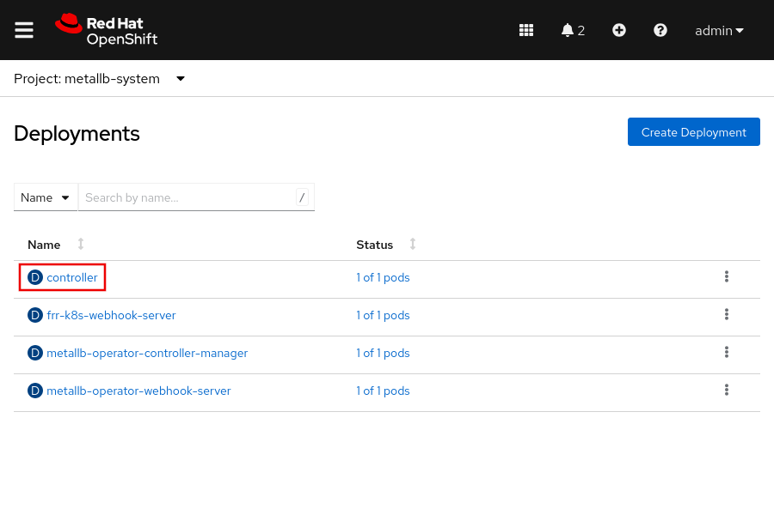
Click Actions and click Add Health Checks.
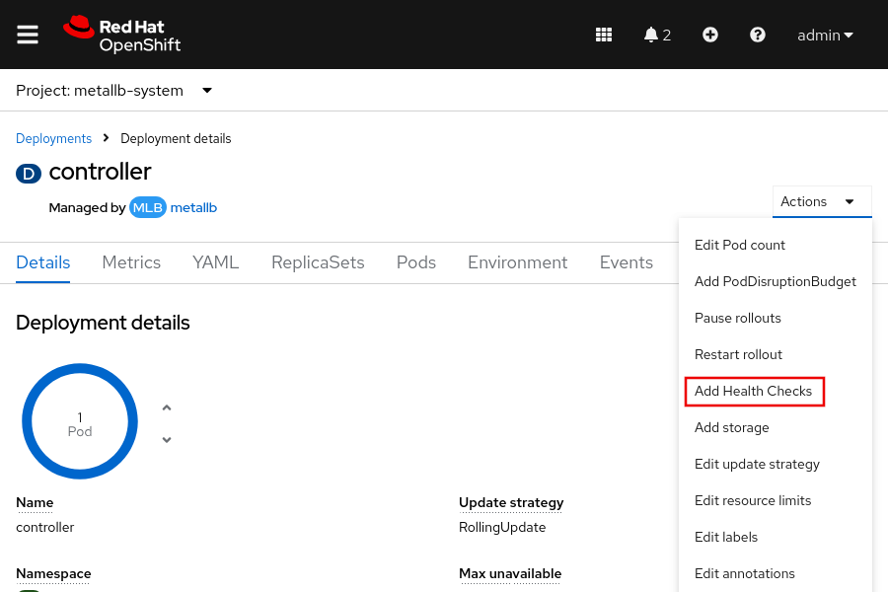
Click Edit probe to specify the readiness type, the HTTP headers, the path, the port, and more.
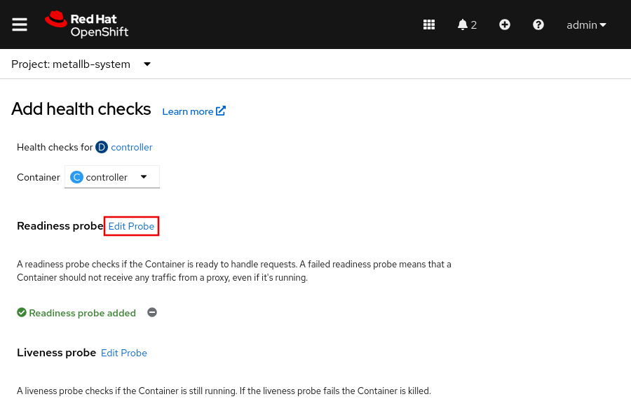

Guided Exercise: Application Health Probes
Configure health probes in a deployment and verify that network clients are insulated from application failures.
Outcomes
- Assess potential issues with an application that is not configured with health probes.
- Configure startup, liveness, and readiness probes for the application.
As the student user on the workstation machine, use the lab command to prepare your system for this exercise.
This command ensures that the following conditions are true:
- The reliability-probes project exists.
- The resource files are available in the course directory.
- The classroom registry has the long-load container image.
The registry.ocp4.example.com:8443/redhattraining/long-load:v1 container image contains an application with utility endpoints. These endpoints perform such tasks as crashing the process and toggling the server's health status.
[student@workstation ~]$ lab start reliability-probes
Instructions
- As the developer user, deploy the long-load application in the reliability-probes project.
  - Log in to the OpenShift cluster as the developer user with developer as the password.
[student@workstation ~]$ oc login -u developer -p developer \
https://api.ocp4.example.com:6443
Login successful.
  - ...output omitted...
  - Set the reliability-probes project as the active project.
[student@workstation ~]$ oc project reliability-probes
  - Now using project reliability-probes on server "https://api.ocp4.example.com:6443".
  - Apply the long-load-deploy.yaml file to create the pod. Move to the next step within one minute.
[student@workstation ~]$ oc apply -f \
~/DO180/labs/reliability-probes/long-load-deploy.yaml
deployment.apps/long-load created
service/long-load created
  - route.route.openshift.io/long-load created
  - Verify that the pods take several minutes to start by sending a request to a pod in the deployment.
[student@workstation ~]$ oc exec deploy/long-load -- \
curl -s localhost:3000/health
  - app is still starting
  - Observe that the pods are ready even though the application is not ready.
[student@workstation ~]$ oc get pods
NAME READY STATUS RESTARTS AGE
long-load-8564d998cc-579nx 1/1 Running 0 30s
long-load-8564d998cc-ttqpg 1/1 Running 0 30s
  - long-load-8564d998cc-wjtfw 1/1 Running 0 30s
- Add a startup probe to the pods so that the cluster knows when the pods are ready.
  - Modify the deployment in the ~/DO180/labs/reliability-probes/long-load-deploy.yaml YAML file by defining a startup probe. The probe runs every three seconds and triggers a pod as failed after 30 failed attempts. The file should match the following excerpt:
...output omitted...
spec:
...output omitted...
template:
...output omitted...
spec:
containers:
- image: registry.ocp4.example.com:8443/redhattraining/long-load:v1
imagePullPolicy: Always
name: long-load
startupProbe:
failureThreshold: 30
periodSeconds: 3
httpGet:
path: /health
port: 3000
env:
  - ...output omitted...
  - Apply the updated long-load-deploy.yaml file.
[student@workstation ~] oc apply -f \
~/DO180/labs/reliability-probes/long-load-deploy.yaml
deployment.apps/long-load configured
service/long-load unchanged
  - route.route.openshift.io/long-load configured
  - Observe that the pods do not show as ready until the application is ready and the startup probe succeeds. Wait for the three pods to reach the ready state. Press Ctrl+c to stop the watch command.
[student@workstation ~]$ watch oc get pods
Every 2.0s: oc get pods

NAME READY STATUS RESTARTS AGE
long-load-785b5b4fc8-7x5ln 1/1 Running 0 90s
long-load-785b5b4fc8-f7pdk 1/1 Running 0 90s
  - long-load-785b5b4fc8-r2nqj 1/1 Running 0 90s
- Add a liveness probe so that the cluster restarts broken instances of the application.
  - Start the load test script.
[student@workstation ~]$ ~/DO180/labs/reliability-probes/load-test.sh
Ok
Ok
Ok
  - ...output omitted...
  - Keep the script running in a visible window.
  - In a new terminal window, use the /togglesick endpoint to make one of the pods unhealthy. Move to the next step within one minute.
[student@workstation ~]$ oc exec \
deploy/long-load -- curl -s localhost:3000/togglesick
  - no output expected
  - The load test window begins to show app is unhealthy. Because only one pod is unhealthy, the remaining pods still respond with Ok.
  - Update the deployment in the ~/DO180/labs/reliability-probes/long-load-deploy.yaml file to add a liveness probe. The probe runs every three seconds and triggers the pod as failed after three failed attempts. Modify the spec.template.spec.containers object in the file to match the following excerpt.
spec:
...output omitted...
template:
...output omitted...
spec:
containers:
- image: registry.ocp4.example.com:8443/redhattraining/long-load:v1
...output omitted...
startupProbe:
failureThreshold: 30
periodSeconds: 3
httpGet:
path: /health
port: 3000
livenessProbe:
failureThreshold: 3
periodSeconds: 3
httpGet:
path: /health
port: 3000
env:
  - ...output omitted...
  - Scale down the deployment to zero replicas.
[student@workstation ~]$ oc scale deploy/long-load --replicas 0
  - deployment.apps/long-load scaled
  - The load test script shows that the application is not available.
Note
Red Hat recommends scaling down an application to zero replicas before making multiple changes to a deployment, such as adding health probes, resource requests, or environment variables. Scaling down to zero replicas prevents creating any pods, and enables pods to terminate gracefully after finishing all current requests.
For multiple deployment updates, scaling down to zero prevents a noisy event log from Kubernetes responding to every change, and conserves cluster resources.
  - Apply the updated long-load-deploy.yaml file to update the deployment, which triggers the deployment to re-create its pods.
[student@workstation ~]$ oc apply -f \
~/DO180/labs/reliability-probes/long-load-deploy.yaml
deployment.apps/long-load configured
service/long-load unchanged
  - route.route.openshift.io/long-load unchanged
  - Wait for the three new pods to reach the ready state. Press Ctrl+c to stop the watch command.
[student@workstation ~]$ watch oc get pods
Every 2.0s: oc get pods

NAME READY STATUS RESTARTS AGE
long-load-785b5b4fc8-8x5ln 1/1 Running 0 70s
long-load-785b5b4fc8-f8pdk 1/1 Running 0 70s
  - long-load-785b5b4fc8-r9nqj 1/1 Running 0 70s
  - Wait for the load test window to show Ok for all responses, and then toggle one of the pods to be unhealthy.
[student@workstation ~]$ oc exec \
deploy/long-load -- curl -s localhost:3000/togglesick
  - no output expected
  - The load test window might show app is unhealthy several times before the cluster restarts the pod.
  - Observe that the cluster restarts the unhealthy pod after the liveness probe fails. After the pod is restarted, the load test window shows only Ok.
[student@workstation ~]$ watch oc get pods
NAME READY STATUS RESTARTS AGE
long-load-fbb7468d9-8xm8j 1/1 Running 0 9m42s
long-load-fbb7468d9-k66dm 1/1 Running 0 8m38s
  - long-load-fbb7468d9-ncxkh 0/1 Running 1 (11s ago) 10m
- Add a readiness probe so that traffic goes only to pods that are ready and healthy.
  - Scale down the deployment to zero replicas.
[student@workstation ~]$ oc scale deploy/long-load --replicas 0
  - deployment.apps/long-load scaled
  - Use the oc set probe command to add the readiness probe.

[student@workstation ~]$ oc set probe deploy/long-load \
--readiness --failure-threshold 1 --period-seconds 3 \
--get-url http://:3000/health
  - deployment.apps/long-load probes updated
  - Scale up the deployment to three replicas.
[student@workstation ~]$ oc scale deploy/long-load --replicas 3
  - deployment.apps/long-load scaled
  - Observe the status of the pods by using the watch command.
[student@workstation ~]$ watch oc get pods
NAME READY STATUS RESTARTS AGE
long-load-d5794d744-8hqlh 0/1 Running 0 48s
long-load-d5794d744-hphgb 0/1 Running 0 48s
  - long-load-d5794d744-lgkns 0/1 Running 0 48s
  - The command does not immediately finish, but continues to show updates to the pods' status. Leave this command running in a visible window.
  - Wait for the pods to show as ready. Then, in a new terminal window, make one of the pods unhealthy for five seconds by using the /hiccup endpoint.
[student@workstation ~]$ oc exec \
deploy/long-load -- curl -s localhost:3000/hiccup?time=5
  - no output expected
  - The pod status window shows that one of the pods is no longer ready.
[student@workstation ~]$ watch oc get pods
NAME READY STATUS RESTARTS AGE
long-load-d5794d744-8hqlh 1/1 Running 0 83s
long-load-d5794d744-hphgb 0/1 Running 0 83s
  - long-load-d5794d744-lgkns 1/1 Running 0 83s
  - After five seconds, the pod is healthy again and shows as ready.
The load test window might show app is unhealthy one time before the pod is set as not ready. After the cluster determines that the pod is no longer ready, it stops sending traffic to the pod until either the pod recovers or the liveness probe fails. Because the pod is sick for only five seconds, it is enough time for the readiness probe to fail, but not the liveness probe.
Note
Optionally, repeat this step and observe as the temporarily sick pod's status changes.
  - Stop the load test and status commands by pressing Ctrl+c in their respective windows.
Finish
On the workstation machine, use the lab command to complete this exercise. This step is important to ensure that resources from previous exercises do not impact upcoming exercises.
[student@workstation ~]$ lab finish reliability-probes

Reserving Compute Capacity for Applications

Objectives
- Configure an application with resource requests so Kubernetes can make scheduling decisions.

Kubernetes Pod Scheduling
The Red Hat OpenShift Container Platform pod scheduler determines the placement of new pods onto nodes in the cluster. Appropriate scheduling prevents resource contention and places workloads on nodes that meet their specific requirements. The pod scheduler algorithm follows a three-step process:
Filtering nodes
A pod can define a node selector that matches the labels in the cluster nodes. The scheduler considers only nodes with matching labels as eligible.
Additionally, the scheduler filters the list of running nodes by evaluating each node against a set of predicates. A pod can define resource requests for compute resources such as CPU, memory, and storage. Only nodes with enough available computer resources are eligible.
The filtering step reduces the list of eligible nodes. In some cases, the pod could run on any of the nodes. In other cases, all the nodes are filtered out. The pod cannot be scheduled until a node with the appropriate prerequisites becomes available.
If all nodes are filtered out, then a FailedScheduling event is generated for the pod.
Prioritizing nodes
By using multiple priority criteria, the scheduler determines a weighted score for each node. Nodes with higher scores are better candidates to run the pod.
Selecting a node
The scheduler sorts the candidate list according to these scores, and selects the node with the highest score. If multiple nodes have the same high score, then one node is selected in a round-robin fashion. After a host is selected, the cluster generates a Scheduled event for the pod.

Note
The scheduler is flexible and can be customized for advanced scheduling situations. Customizing the scheduler is outside the scope of this course.

Configuring Compute Resource Requests
For applications that require a specific amount of compute resources, you can define a resource request in the pod definition. The resource requests assign hardware resources for the application deployment.
Resource requests specify the minimum required compute resources to schedule a pod. The scheduler tries to find a node with enough available compute resources to satisfy the pod requests.
In Kubernetes, memory resources are measured in bytes, and CPU resources are measured in CPU units. CPU units are allocated by using millicore units. A millicore is a CPU core, either virtual or physical, that is split into 1000 units. A request value of "1000 m" allocates an entire CPU core to a pod. You can also use fractional values to allocate CPU resources. For example, you can set the CPU resource request to the 0.1 value, which represents 100 millicores (100 m). Likewise, a CPU resource request with the 1.0 value represents an entire CPU or 1000 millicores (1000 m).
You can define resource requests for each container in a deployment resource. If you do not define resources, then the container specification shows a resources: {} line.
To specify requests, modify the resources: {} section in the deployment manifest. The following example defines a resource request of 100 millicores (100m) of CPU and one gibibyte (1Gi) of memory.
...output omitted...
spec:
containers:
- image: quay.io/redhattraining/hello-world-nginx:v1.0
name: hello-world-nginx
resources:
requests:
cpu: "100m"
memory: "1Gi"
If you use the oc edit command to modify a deployment, then ensure that you use the correct indentation. Indentation mistakes can result in the editor not saving changes. Alternatively, use the oc set resources command to specify resource requests. The following command sets the same requests as the preceding example:
[user@host ~]$ oc set resources deployment hello-world-nginx \
--requests cpu=100m,memory=1gi
The oc set resources command works with any resource that includes a pod template, such as Deployment and Job resources.

Inspecting Cluster Compute Resources
Cluster administrators can view the available and used compute resources of a node. As a cluster administrator, you can use the oc describe node command to determine the compute resource capacity of a node. The command shows the capacity of the node and how much of that capacity is allocatable. It also displays the amount of allocated and requested resources on the node.
[user@host ~]$ oc describe node master01
Name: master01
Roles: control-plane,master,worker
...output omitted...
Capacity:
cpu: 8
ephemeral-storage: 125293548Ki
hugepages-1Gi: 0
hugepages-2Mi: 0
memory: 20531668Ki
pods: 250
Allocatable:
cpu: 7500m
ephemeral-storage: 114396791822
hugepages-1Gi: 0
hugepages-2Mi: 0
memory: 19389692Ki
pods: 250
...output omitted...
Non-terminated Pods: (88 in total)
... Name CPU Requests CPU Limits Memory Requests Memory Limits ...
... ---- ------------ ---------- --------------- -------------
... controller-... 10m (0%) 0 (0%) 20Mi (0%) 0 (0%) ...
... metallb-... 50m (0%) 0 (0%) 20Mi (0%) 0 (0%) ...
... metallb-... 0 (0%) 0 (0%) 0 (0%) 0 (0%) ...
Allocated resources:
(Total limits may be over 100 percent, i.e., overcommitted.)
Resource Requests Limits
-------- -------- ------
cpu 3183m (42%) 1202m (16%)
memory 12717Mi (67%) 1350Mi (7%)
...output omitted...
RHOCP cluster administrators can also use the oc adm top pods command. This command shows the compute resource usage for each pod in a project. You must include the --namespace or -n options to specify a project. If you do not specify a project, then the command returns the resource usage for pods in the current project.
The following command displays the resource usage for pods in the openshift-dns project:
[user@host ~]$ oc adm top pods -n openshift-dns
NAME CPU(cores) MEMORY(bytes)
dns-default-5kpn5 1m 33Mi
node-resolver-6kdxp 0m 2Mi
Additionally, cluster administrators can use the oc adm top nodes command to view the resource usage of cluster nodes. You can include the node name to view the resource usage of a particular node.
[user@host ~]$ oc adm top node master01
NAME CPU(cores) CPU% MEMORY(bytes) MEMORY%
master01 1250m 16% 10268Mi 54%

Guided Exercise: Reserving Compute Capacity for Applications
Configure an application with compute resource requests that allow and prevent successful scheduling and scaling of its pods.
Outcomes
- Inspect how memory resource requests allocate cluster node memory.
- Explore how adjusting resource requests impacts the number of replicas that the cluster can schedule on a node.
As the student user on the workstation machine, use the lab command to prepare your system for this exercise.
This command ensures that the following conditions are true:
- The reliability-requests project exists.
- The resource files are available in the course directory.
- The classroom registry has the registry.ocp4.example.com:8443/redhattraining/long-load:v1 container image.
The registry.ocp4.example.com:8443/redhattraining/long-load:v1 container image contains an application with utility endpoints. These endpoints perform such tasks as crashing the process and toggling the server's health status.
[student@workstation ~]$ lab start reliability-requests
Instructions
- As the admin user, deploy the long-load application by applying the long-load-deploy.yaml file in the reliability-requests project.
  - Log in to the OpenShift cluster as the admin user with redhatocp as the password.
[student@workstation ~]$ oc login -u admin -p redhatocp \
https://api.ocp4.example.com:6443
Login successful.
  - ...output omitted...
  - Note
In general, use accounts with the least required privileges to perform a task. In the classroom environment, this account is the developer user. However, you need cluster administrator privileges to view the cluster node metrics in this exercise.
  - View the total memory request allocation for the node.
[student@workstation ~]$ oc describe node master01
...output omitted...
Allocated resources:
(Total limits may be over 100 percent, i.e., overcommitted.)
Resource Requests Limits
-------- -------- ------
cpu 3158m (42%) 980m (13%)
memory 12667Mi (66%) 1250Mi (6%)
  - ...output omitted...
  - The command output shows that the pods that are currently running on the node requested a total of 12667 MiB of memory. That value might be slightly different on your system.
Important
Projects and objects from previous exercises can cause the memory usage from this exercise to mismatch the intended results. Delete any unrelated projects before continuing.
If you still experience issues, then re-create your classroom environment and try this exercise again.
  - Select the reliability-requests project.
[student@workstation ~]$ oc project reliability-requests
  - Now using project "reliability-requests" on server "https://api.ocp4.example.com:6443".
  - Go to the ~/DO180/labs/reliability-requests directory. Create a deployment, a service, and a route by using the oc apply command and the long-load-deploy.yaml file.
[student@workstation ~]$ cd DO180/labs/reliability-requests
[student@workstation reliability-requests]$ oc apply -f long-load-deploy.yaml
deployment.apps/long-load created
service/long-load created
  - route.route.openshift.io/long-load created
- Add a resource request to the pod definition and scale the deployment beyond the cluster's capacity.
  - Modify the long-load-deploy.yaml file by adding a resource request. The request allocates one gibibyte (1 GiB) to each of the application pods.
spec:
...output omitted...
template:
...output omitted...
spec:
containers:
- image: registry.ocp4.example.com:8443/redhattraining/long-load:v1
resources:
requests:
memory: 1Gi
  - ...output omitted...
  - Apply the YAML file to modify the deployment with the resource request.
[student@workstation reliability-requests]$ oc apply -f long-load-deploy.yaml
deployment.apps/long-load configured
service/long-load unchanged
  - route.route.openshift.io/long-load unchanged
  - Scale the deployment to have 10 replicas.
[student@workstation reliability-requests]$ oc scale deploy/long-load \
--replicas 10
  - deployment.apps/long-load scaled
  - Observe that the cluster cannot schedule all pods on the single node. The cluster cannot schedule pods with the Pending status.
[student@workstation reliability-requests]$ oc get pods
NAME READY STATUS RESTARTS AGE
...output omitted...
long-load-86bb4b79f8-44zwd 0/1 Pending 0 58s
  - ...output omitted...
  - Retrieve the cluster event log, and observe that insufficient memory is the cause of the failed scheduling.
[student@workstation reliability-requests]$ oc get events \
--field-selector reason="FailedScheduling"
  - ... pod/long-load-... 0/1 nodes are available: 1 Insufficient memory. ...
  - Alternatively, view the events for a pending pod to see the reason. In the following command, replace the pod name with one of the pending pods in your classroom.
[student@workstation reliability-requests]$ oc describe \
pod/long-load-86bb4b79f8-44zwd
...output omitted...
Events:
  - ...output omitted... 0/1 nodes are available: 1 Insufficient memory. ...
  - Observe that the node's requested memory usage is high.
[student@workstation reliability-requests]$ oc describe node master01
...output omitted...
Allocated resources:
(Total limits may be over 100 percent, i.e., overcommitted.)
Resource Requests Limits
-------- -------- ------
cpu 3158m (42%) 980m (13%)
memory 18811Mi (99%) 1250Mi (6%)
  - ...output omitted...
  - The command output shows that the pods from the long-load deployment requested most of the remaining memory from the node. However, not enough memory is available to accommodate the 10 replicas.
- Reduce the requested memory per pod so that the replicas can run on the node.
  - Manually set the resource request to 250Mi.
[student@workstation reliability-requests]$ oc set resources deploy/long-load \
--requests memory=150Mi
  - deployment.apps/long-load resource requirements updated
  - Delete the pods so that the deployment controller re-creates the pods with the new resource request.
[student@workstation reliability-requests]$ oc delete pod -l app=long-load
pod "long-load-557b4d94f5-29brx" deleted
  - ...output omitted...
  - Observe that all pods can start with the lowered memory request. Within one minute, the cluster marks the pods as Ready and places them in the Running state, with no pods in the Pending status.
[student@workstation reliability-requests]$ oc get pods
NAME READY STATUS RESTARTS AGE
long-load-557b4d94f5-68hbb 1/1 Running 0 3m14s
long-load-557b4d94f5-bfk7c 1/1 Running 0 3m21s
long-load-557b4d94f5-bnpzh 1/1 Running 0 3m21s
long-load-557b4d94f5-chtv9 1/1 Running 0 3m21s
long-load-557b4d94f5-drg2p 1/1 Running 0 3m14s
long-load-557b4d94f5-hwsz6 1/1 Running 0 3m12s
long-load-557b4d94f5-k5vqj 1/1 Running 0 3m21s
long-load-557b4d94f5-lgstq 1/1 Running 0 3m21s
long-load-557b4d94f5-r8hq4 1/1 Running 0 3m21s
  - long-load-557b4d94f5-xrg7c 1/1 Running 0 3m21s
  - Observe that the memory usage of the node is lower.
[student@workstation reliability-requests]$ oc describe node master01
...output omitted...
Allocated resources:
(Total limits may be over 100 percent, i.e., overcommitted.)
Resource Requests Limits
-------- -------- ------
cpu 3158m (42%) 980m (13%)
memory 15167Mi (80%) 1250Mi (6%)
  - ...output omitted...
  - Return to the /home/student/ directory.
[student@workstation reliability-requests]$ cd /home/student/
  - [student@workstation ~]$
Finish
On the workstation machine, use the lab command to complete this exercise. This step is important to ensure that resources from previous exercises do not impact upcoming exercises.
[student@workstation ~]$ lab finish reliability-requests

Limit Compute Capacity for Applications

Objectives
- Configure an application with resource limits so Kubernetes can protect other applications from it.
Memory and CPU requests that you define for containers help Red Hat OpenShift Container Platform (RHOCP) to select a compute node to run your pods. However, these resource requests do not restrict the memory and CPU that the containers can use. For example, setting a memory request at 1 GiB does not prevent the container from consuming more memory.
Red Hat recommends that you set the memory and CPU requests to the peak usage of your application. In contrast, by setting lower values, you overcommit the node resources. If all the applications that are running on the node start to use resources above the values that they request, then the compute nodes might run out of memory and CPU.
In addition to requests, you can set memory and CPU limits to prevent your applications from consuming too many resources.

Setting Memory Limits
A memory limit specifies the amount of memory that a container can use across all its processes.
As soon as the container reaches the limit, the compute node selects and then kills a process in the container. When that event occurs, RHOCP detects that the application is not working any more, because the main container process is missing, or because the health probes report an error. RHOCP then restarts the container according to the pod restartPolicy attribute, which defaults to Always.
RHOCP relies on Linux kernel features to implement resource limits, and to kill processes in containers that reach their memory limits:
Control groups (cgroups)
RHOCP uses control groups to implement resource limits. Control groups are a Linux kernel mechanism for controlling and monitoring system resources, such as CPU and memory.
Out-of-Memory killer (OOM killer)
When a container reaches its memory limit, the Linux kernel triggers the OOM killer subsystem to select and then kill a process.
You must set a memory limit when the application has a memory usage pattern that you must mitigate, such as when the application has a memory leak. A memory leak is a bug in the application, which occurs when the application uses some memory but does not free it after use. If the leak appears in an infinite service loop, then the application uses more and more memory over time, and can end up consuming all the available memory on the system. For these applications, setting a memory limit prevents them from consuming all the node's memory. The memory limit also enables OpenShift to regularly restart applications to free up their memory when they reach the limit.
To set a memory limit for the container in a pod, use the oc set resources command:
[user@host ~]$ oc set resources deployment/hello --limits memory=1Gi
In addition to the oc set resources command, you can define resource limits from a file in the YAML format:
apiVersion: apps/v1
kind: Deployment
...output omitted...
spec:
containers:
- image: registry.access.redhat.com/ubi9/nginx-120:1-86
name: hello
resources:
requests:
cpu: 100m
memory: 500Mi
limits:
cpu: 200m
memory: 1Gi
When RHOCP restarts a pod because of an OOM event, it updates the pod's lastState attribute, and sets the reason to OOMKilled:
[user@host ~]$ oc get pod hello-67645f4865-vvr42 -o yaml
...output omitted...
status:
...output omitted...
containerStatuses:
- containerID: cri-o://806b...9fe7
image: registry.access.redhat.com/ubi9/nginx-120:1-86
imageID: registry.access.redhat.com/ubi9/nginx-120:1-86@sha256:1403...fd34
lastState:
terminated:
containerID: cri-o://bbc4...9eb2
exitCode: 137
finishedAt: "2023-03-08T07:56:06Z"
reason: OOMKilled
startedAt: "2023-03-08T07:51:43Z"
name: hello
ready: true
restartCount: 1
...output omitted...
To set a memory limit for the container in a pod from the web console, select a deployment, and click Actions → Edit resource limits.
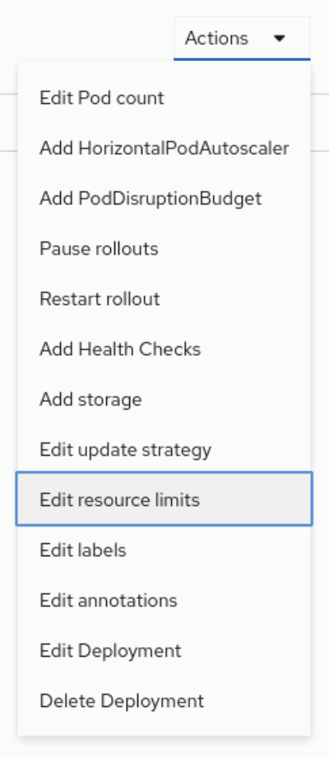
Set memory limits by increasing or decreasing the memory on the Limit section.
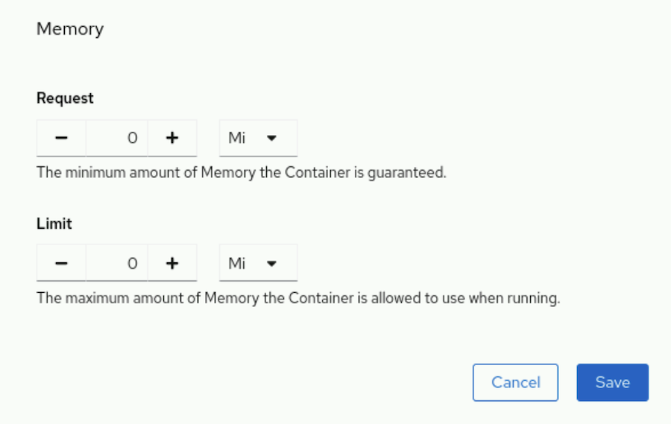

Setting CPU Limits
CPU limits work differently from memory limits. When the container reaches the CPU limit, RHOCP inhibits the container's processes, even if the node has available CPU cycles. The application continues to work, but at a slower pace.
In contrast, if you do not set a CPU limit, then the container can consume as much CPU as is available on the node. If the node's CPU is under pressure, for example because several containers are running CPU-intensive tasks, then the Linux kernel shares the CPU resource between all these containers, according to the CPU requests value for the containers.
You must set a CPU limit when you require a consistent application behavior across clusters and nodes. For example, if the application runs on a node where the CPU is available, then the application can execute at full speed. On the other hand, if the application runs on a node with CPU pressure, then the application executes at a slower pace.
The same behavior can occur between your development and production clusters. Because the two environments might have different node configurations, the application might run differently when you move it from development to production.

Note
Clusters can have differences in hardware configuration beyond what limits observe. For example, two clusters' nodes might have CPUs with equal core count and unequal clock speeds.
Requests and limits do not account for these hardware differences. If your clusters differ in such a way, take care that requests and limits are appropriate for both configurations.
By setting a CPU limit, you mitigate the differences between the configuration of the nodes, and you experience a more consistent behavior.
To set a CPU limit for the container in a pod, use the oc set resources command:
[user@host ~]$ oc set resources deployment/hello --limits cpu=200m
You can also define CPU limits from a file in the YAML format:
apiVersion: apps/v1
kind: Deployment
...output omitted...
spec:
containers:
- image: registry.access.redhat.com/ubi9/nginx-120:1-86
name: hello
resources:
requests:
cpu: 100m
memory: 500Mi
limits:
cpu: 200m
memory: 1Gi
To set a CPU limit for the container in a pod from the web console, select a deployment, and click Actions → Edit resource limits.
Set CPU limits by increasing or decreasing the CPU on the Limit section.
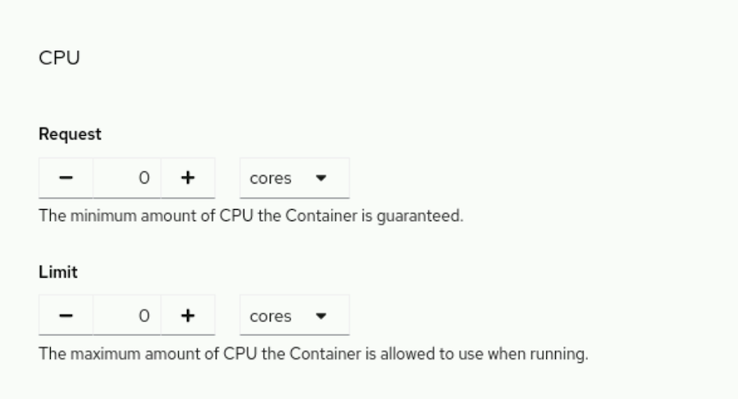

Viewing Requests, Limits, and Actual Usage
By using the RHOCP command-line interface, cluster administrators can view compute usage information on individual nodes. The oc describe node command displays detailed information about a node, including information about the pods that are running on the node. For each pod, it shows CPU requests and limits, as well as memory requests and limits. If you do not specify a request or limit, then the pod shows a zero for that column. The command also displays a summary of all the resource requests and limits.
[user@host ~]$ oc describe node master01
Name: master01
Roles: control-plane,master,worker
...output omitted...
Non-terminated Pods: (88 in total)
... Name CPU Requests CPU Limits Memory Requests Memory Limits ...
... ---- ------------ ---------- --------------- -------------
... controller-... 10m (0%) 0 (0%) 20Mi (0%) 0 (0%) ...
... metallb-... 50m (0%) 0 (0%) 20Mi (0%) 0 (0%) ...
... metallb-... 0 (0%) 0 (0%) 0 (0%) 0 (0%) ...
...output omitted...
Allocated resources:
(Total limits may be over 100 percent, i.e., overcommitted.)
Resource Requests Limits
-------- -------- ------
cpu 3183m (42%) 1202m (16%)
memory 12717Mi (67%) 1350Mi (7%)
...output omitted...
The oc describe node command displays requests and limits. The oc adm top command shows resource usage. The oc adm top nodes command shows the resource usage for nodes in the cluster. You must run these commands as a cluster administrator.
The oc adm top pods command shows the resource usage for each pod in a project.
The following command displays the resource usage for the pods in the openshift-console project:
[user@host ~]$ oc adm top pods -n openshift-console
NAME CPU(cores) MEMORY(bytes)
console-6689c8589c-bcpb7 1m 48Mi
downloads-79658645bd-hx649 1m 31Mi
To visualize the consumption of resources from the web console, select a deployment, and click the Metrics tab. From this tab, you can view the usage for memory, CPU, the file system, and incoming and outgoing traffic.
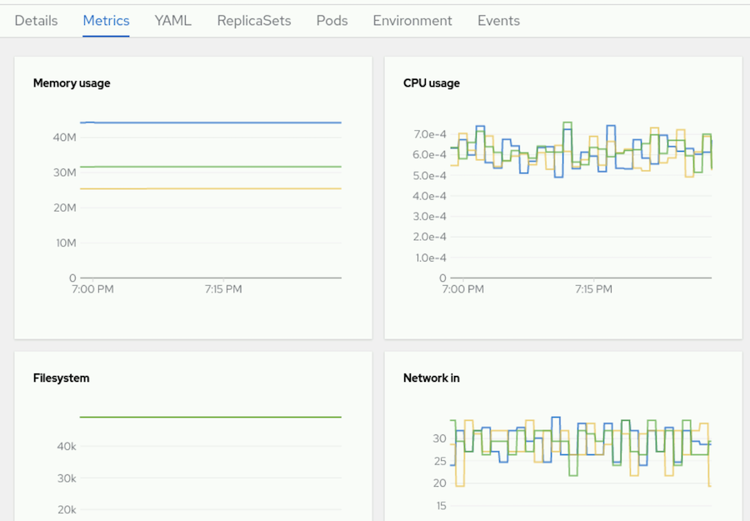

Guided Exercise: Limit Compute Capacity for Applications
Configure an application with compute resource limits that allow and prevent successful execution of its pods.
Outcomes
You should be able to monitor the memory usage of an application, and set a memory limit for a pod.
As the student user on the workstation machine, use the lab command to prepare your system for this exercise.
This command ensures that all resources are available for this exercise. It also creates the reliability-limits project and the /home/student/DO180/labs/reliability-limits/resources.txt file. The resources.txt file contains some commands that you use during the exercise. You can use the file to copy and paste these commands.
[student@workstation ~]$ lab start reliability-limits
Instructions
- Log in to the OpenShift cluster as the developer user with the developer password. Use the reliability-limits project.
  - Log in to the OpenShift cluster.
[student@workstation ~]$ oc login -u developer -p developer \
https://api.ocp4.example.com:6443
Login successful.
  - ...output omitted...
  - Set the reliability-limits project as the active project.
[student@workstation ~]$ oc project reliability-limits
  - ...output omitted...
- Create the leakapp deployment from the ~/DO180/labs/reliability-limits/leakapp.yml file that the lab command prepared. The application has a bug, and leaks 1 MiB of memory every second.
  - Review the ~/DO180/labs/reliability-limits/leakapp.yml resource file. The memory limit is set to 35 MiB. Do not change the file.
...output omitted...
resources:
requests:
memory: 20Mi
limits:
  - memory: 35Mi
  - Use the oc apply command to create the application. Ignore the warning message.
[student@workstation ~]$ oc apply -f \
~/DO180/labs/reliability-limits/leakapp.yml
  - deployment.apps/leakapp created
  - Wait for the pod to start. You might have to rerun the command several times for the pod to report a Running status. The name of the pod on your system probably differs.
[student@workstation ~]$ oc get pods
NAME READY STATUS RESTARTS AGE
  - leakapp-99bb64c8d-hk26k 1/1 Running 0 12s
- Watch the pod. OpenShift restarts the pod after 30 seconds.
  - Use the watch command to monitor the oc get pods command. Wait for OpenShift to restart the pod, and then press Ctrl+C to quit the watch command.
[student@workstation ~]$ watch oc get pods
Every 2.0s: oc get pods workstation: Thur Sep 4 09:04:47 2025

NAME READY STATUS RESTARTS AGE
  - leakapp-99bb64c8d-hk26k 1/1 Running 1 (15s ago) 48s
  - Retrieve the container status to verify that OpenShift restarted the pod due to an Out-Of-Memory (OOM) event.
[student@workstation ~]$ oc get pods leakapp-99bb64c8d-hk26k \
-o jsonpath='{.status.containerStatuses[0].lastState}' | jq .
{
"terminated": {
"containerID": "cri-o://5800...1d04",
"exitCode": 137,
"finishedAt": "2025-09-04T09:04:47Z",
"reason": "OOMKilled",
"startedAt": "2025-09-04T09:04:17Z"
}
  - }
- Observe the pod status for a few minutes, until the CrashLoopBackOff status is displayed. During this period, OpenShift restarts the pod several times because of the memory leak.
Between each restart, OpenShift sets the pod status to CrashLoopBackOff, waits an increasing amount of time between retries, and then restarts the pod. The delay between restarts gives the operator the opportunity to fix the issue.
After various retries, OpenShift finally sets the CrashLoopBackOff wait timer to five minutes. During this wait time, the application is not available to your customers.
[student@workstation ~]$ watch oc get pods
Every 2.0s: oc get pods workstation: Thur Sep 4 09:04:47 2025

NAME READY STATUS RESTARTS AGE
- leakapp-99bb64c8d-hk26k 0/1 CrashLoopBackOff 4 (82s ago) 5m25s
- Press Ctrl+C to quit the watch command.
- Fixing the memory leak would resolve the issue. However, it might take some time for the developers to fix the bug. In the meantime, set the memory limit to 600 MiB. With this setting, the pod can run for ten minutes before the application reaches the limit.
  - Use the oc set resources command to set the new limit. Ignore the warning message.
[student@workstation ~]$ oc set resources deployment/leakapp \
--limits memory=600Mi
  - deployment.apps/leakapp resource requirements updated
  - Wait for the pod to start. You might have to rerun the command several times for the pod to report a Running status. The name of the pod on your system probably differs.
[student@workstation ~]$ oc get pods
NAME READY STATUS RESTARTS AGE
  - leakapp-6bc64dfcd-86fpc 1/1 Running 0 12s
  - Wait two minutes to verify that OpenShift no longer restarts the pod every 30 seconds.
[student@workstation ~]$ watch oc get pods
Every 2.0s: oc get pods workstation: Thur Sep 4 09:04:47 2025

NAME READY STATUS RESTARTS AGE
  - leakapp-6bc64dfcd-86fpc 1/1 Running 0 3m12s
  - Press Ctrl+C to quit the watch command.
- Review the memory that the pod consumes. The metrics for the pod are available a few minutes after the pod starts. You might have to rerun the command after the metrics are available, or if the command displays an error message that the metrics are not available. The memory usage on your system can differ.
[student@workstation ~]$ oc adm top pods
NAME CPU(cores) MEMORY(bytes)
- leakapp-6bc64dfcd-86fpc 1m 133Mi
- Optional. Wait about 10 minutes from the creation time until the application reaches the out of memory error. After this period, OpenShift restarts the pod, because it reached the 600 MiB memory limit.
  - Open a new terminal window, and then run the watch command to monitor the oc adm top pods command.
[student@workstation ~]$ watch oc adm top pods
Every 2.0s: oc adm top pods workstation: Thur Sep 4 09:04:47 2025

NAME CPU(cores) MEMORY(bytes)
  - leakapp-6bc64dfcd-86fpc 0m 176Mi
  - Leave the command running and do not interrupt it.
Note
You might see a message that metrics are not yet available. If so, wait some time and try again.
  - In the first terminal, run the watch command to monitor the oc get pods command. Watch the output of the oc adm top pods command in the second terminal. When the memory usage reaches 600 MiB, the OOM subsystem kills the process inside the container, and OpenShift restarts the pod.
[student@workstation ~]$ watch oc get pods
Every 2.0s: oc get pods workstation: Thur Sep 4 09:04:47 2025

NAME READY STATUS RESTARTS AGE
  - leakapp-6bc64dfcd-86fpc 1/1 Running 1 (3s ago) 9m58s
  - Press Ctrl+C to quit the watch command.
  - Press Ctrl+C to quit the watch command in the second terminal. Close this second terminal when done.
Finish
On the workstation machine, use the lab command to complete this exercise. This step is important to ensure that resources from previous exercises do not impact upcoming exercises.
[student@workstation ~]$ lab finish reliability-limits

Application Autoscaling

Objectives
- Configure a horizontal pod autoscaler for an application.
Kubernetes can autoscale a deployment based on current load on the application pods, by means of the HorizontalPodAutoscaler resource type.

Horizontal Pod Autoscaling
In a production environment, the load on an application can fluctuate significantly. Manually scaling the number of application pods to match demand is inefficient and prone to error. Red Hat OpenShift Container Platform (RHOCP) provides an automated solution for this challenge by using the Horizontal Pod Autoscaler (HPA). The HPA automatically scales the number of pods in a replication controller, deployment, replica set, or stateful set based on observed metrics such as CPU utilization.
For an enterprise, effective autoscaling is critical for several reasons:
- High Availability and Performance: By automatically adding pods during traffic spikes, the HPA ensures that the application remains responsive and meets its service-level objectives.
- Cost Optimization: During periods of low traffic, the HPA scales down the number of pods. Removing the extra pods releases unused resources back to the cluster, to enable other workloads to use them and to optimize overall resource usage.
- Operational Efficiency: Automating the scaling process removes the need for manual intervention by operations teams. The automation reduces the risk of human error and enables engineers to focus on other tasks.

The Autoscaling Process in Kubernetes
The HPA is implemented as a control loop that runs inside the Kubernetes controller manager. A HorizontalPodAutoscaler resource uses performance metrics that the RHOCP monitoring stack collects. The monitoring stack comes preinstalled in RHOCP. The autoscaler works in a continuous loop. By default, the controller manager checks HPA resources every 15 seconds. During each check, it performs the following steps:
- The autoscaler retrieves the target metric for scaling from the HPA resource definition.
- For each pod that the HPA resource targets, the autoscaler collects the current value of the metric from the metrics server.
- For each targeted pod, the autoscaler computes the usage percentage, based on the collected metric and the resource requests that are defined in the pod specification.
- The autoscaler computes the average usage across all the targeted pods.
- It establishes a ratio between the target metric value and the current average metric value.
- The autoscaler uses this ratio to make a scaling decision, either to increase or to decrease the number of replicas for the target resource.

Prerequisites for Autoscaling
To autoscale a deployment, you must specify resource requests for the containers in your pods. The HPA uses the requested resource values to calculate the utilization percentage. The autoscaler requires resource requests to calculate utilization and to perform scaling actions.

Important
Pods that are created by using the oc create deployment command do not define resource requests by default. Using the RHOCP autoscaler might therefore require editing the deployment resources to add requests. Alternatively, you can create custom YAML resource files for your application. You can also add to your project a LimitRange resource, which defines default resource requests for pods.

Creating a Horizontal Pod Autoscaler
You can create an HPA resource by using the command line, a YAML manifest, or the web console.

Using the oc autoscale Command
To create a HorizontalPodAutoscaler resource from the command line, use the oc autoscale command:
[user@host ~]$ oc autoscale deployment/hello \
--min 1 --max 10 --cpu-percent 80
This command creates an HPA that targets the hello deployment. The HPA maintains the pod count between 1 and 10 replicas. It scales the deployment to keep the average CPU utilization of its pods at or below 80% of their requested CPU.
The maximum and minimum values for the horizontal pod autoscaler resource accommodate bursts of load and avoid overloading the RHOCP cluster. If the load on the application changes too quickly, then it might help to keep several spare pods to cope with sudden bursts of user requests. Conversely, too many pods can use up all cluster capacity and impact other applications that use the same RHOCP cluster.

Using a YAML Manifest
For more advanced configurations and for managing infrastructure as code, you can define an HPA resource in a YAML file.
apiVersion: autoscaling/v2
kind: HorizontalPodAutoscaler
metadata:
name: hello
spec:
minReplicas: 1
maxReplicas: 10
metrics:
- resource:
name: cpu
target:
averageUtilization: 80
type: Utilization
type: Resource
scaleTargetRef:
apiVersion: apps/v1
kind: Deployment
name: hello
The minReplicas field specifies the minimum number of pods.
The maxReplicas field specifies the maximum number of pods.
The metrics array defines the metrics to use for scaling decisions.
The averageUtilization field specifies the target average CPU utilization for each pod, and is represented as a percentage. If the global average CPU usage is above that value, then the horizontal pod autoscaler starts new pods. If the global average CPU usage is below that value, then the horizontal pod autoscaler deletes pods.
The scaleTargetRef field points to the resource that the HPA manages.
Use the oc apply command to create the resource from the file.
[user@host ~]$ oc apply -f hello-hpa.yaml
The preceding example creates an HPA resource that scales based on CPU usage. Alternatively, it can scale based on memory usage by setting the resource name to memory.
apiVersion: autoscaling/v2
kind: HorizontalPodAutoscaler
metadata:
name: hello
spec:
minReplicas: 1
maxReplicas: 10
metrics:
- resource:
name: memory
target:
averageUtilization: 80
...output omitted...
The resource name is set to memory to trigger scaling based on memory utilization.

Note
Memory-based autoscaling is not suitable for all applications. For example, applications that are based on the Java Virtual Machine (JVM) often claim large memory at startup and do not release it. If an application's memory usage does not correlate with its load, then memory-based autoscaling might not be effective.

Using the Web Console
To create an HPA resource from the web console, in the Developer perspective, select the project and click the Topology menu. Click the Deployment for the application to display the details for the deployment. Select Action → Add HorizontalPodAutoscaler from the menu.
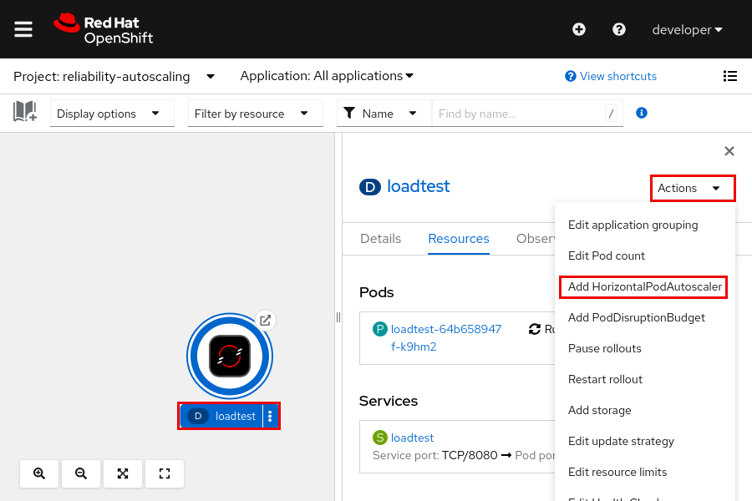
Use the Add Horizontal Pod Autoscaler form or YAML view to set the HPA parameters.

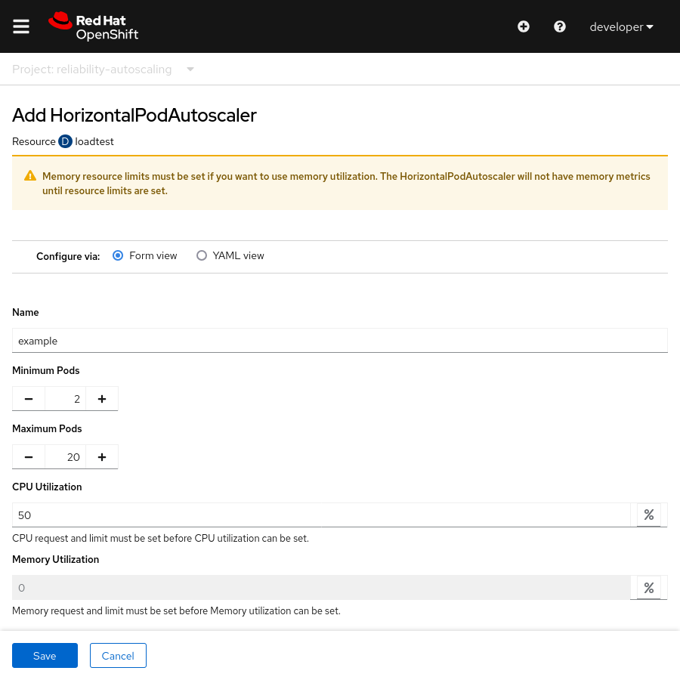

Verifying Horizontal Pod Autoscaler Status
After creating an HPA object, you can monitor its status and activity.

Viewing HPA Objects
To get information about HPA resources in the current project, use the oc get hpa command:
[user@host ~]$ oc get hpa
NAME REFERENCE TARGETS MINPODS MAXPODS REPLICAS AGE
hello Deployment/hello <unknown>/80% 1 10 1 30s
The horizontal pod autoscaler initially has the value of <unknown> in the TARGETS column. It might take up to five minutes for <unknown> to change and display a percentage for current usage. A persistent value of <unknown> in the TARGETS column might indicate that the target deployment does not define resource requests for the specified metric. The horizontal pod autoscaler scales only pods with resource requests.

Inspecting HPA Details and Events
For detailed information, use the oc describe hpa command. This command shows the HPA's configuration, current metrics, and a log of recent scaling events.
[user@host ~]$ oc describe hpa hello
...output omitted...
Events:
Type Reason Age From Message
---- ------ ---- ---- -------
Normal SuccessfulRescale 16m horizontal-pod-autoscaler New size: 2; ...
Normal SuccessfulRescale 14m horizontal-pod-autoscaler New size: 4; ...
Normal SuccessfulRescale 14m horizontal-pod-autoscaler New size: 8; ...
...output omitted...
The Events section is useful for troubleshooting, by providing a chronological record of when and why the HPA scaled up or scaled down the target resource.

Guided Exercise: Application Autoscaling
Configure an autoscaler for an application and then load test that application to observe scaling up.
Outcomes
- Deploy an application.
- Manually scale the application.
- Configure application resource requests.
- Deploy the application with a Horizontal Pod Autoscaler.
As the student user on the workstation machine, use the lab command to prepare your system for this exercise.
This command ensures that the cluster is accessible and that all resources are available for this exercise. It also creates the reliability-autoscaling project.
[student@workstation ~]$ lab start reliability-autoscaling
Instructions
- Log in to the OpenShift cluster as the developer user with developer as the password. Use the reliability-autoscaling project.
  - Log in to the OpenShift cluster.
[student@workstation ~]$ oc login -u developer -p developer \
https://api.ocp4.example.com:6443
Login successful.
  - ...output omitted...
  - Set the reliability-autoscaling project as the active project.
[student@workstation ~]$ oc project reliability-autoscaling
  - ...output omitted...
- Create the loadtest deployment, service, and route. The deployment uses the registry.ocp4.example.com:8443/redhattraining/loadtest:v1.0 container image, which provides a web application. The web application exposes an API endpoint that creates a CPU-intensive task when queried.
  - Review the ~/DO180/labs/reliability-autoscaling/loadtest.yml resource file that the lab command prepared. The container specification does not include the resources section that you use to specify CPU requests and limits. You configure that section in another step. Do not change the file for now.
apiVersion: v1
kind: List
metadata: {}
items:
- apiVersion: apps/v1
kind: Deployment
...output omitted...
spec:
containers:
- image: registry.ocp4.example.com:8443/redhattraining/loadtest:v1.0
name: loadtest
readinessProbe:
failureThreshold: 3
httpGet:
path: /api/loadtest/v1/healthz
port: 8080
scheme: HTTP
periodSeconds: 10
successThreshold: 1
timeoutSeconds: 1

- apiVersion: v1
kind: Service
...output omitted...

- apiVersion: route.openshift.io/v1
kind: Route
  - ...output omitted...
  - Use the oc apply command to create the application.
[student@workstation ~]$ oc apply -f \
~/DO180/labs/reliability-autoscaling/loadtest.yml
deployment.apps/loadtest created
service/loadtest created
  - route.route.openshift.io/loadtest created
  - Run the watch command and wait for the pod to report the Running status. The name of the pod is different in your cluster.
[student@workstation ~]$ watch oc get pods
Every 2.0s: oc get pods

NAME READY STATUS RESTARTS AGE
  - loadtest-86d987b9bf-w66x9 1/1 Running 0 40s
  - Press Ctrl+C to end the watch command.
- Configure a horizontal pod autoscaler resource for the loadtest deployment. Set the minimum number of replicas to 2 and the maximum to 20. Set the average CPU usage to 50% of the CPU requests attribute.
The horizontal pod autoscaler does not work, because the loadtest deployment does not specify requests for CPU usage.
  - Use the oc autoscale command to create the horizontal pod autoscaler resource.
[student@workstation ~]$ oc autoscale deployment/loadtest --min 2 --max 20 \
--cpu-percent 50
  - horizontalpodautoscaler.autoscaling/loadtest autoscaled
  - Retrieve the status of the loadtest horizontal pod autoscaler resource. The unknown value in the TARGETS column indicates that OpenShift cannot compute the current CPU usage of the loadtest deployment. The deployment must include the CPU requests attribute for OpenShift to be able to compute the CPU usage.
[student@workstation ~]$ oc get hpa loadtest
NAME REFERENCE TARGETS MINPODS MAXPODS REPLICAS AGE
  - loadtest Deployment/loadtest <unknown>/50% 2 20 2 74s
  - Get more details about the resource status. You might have to rerun the command several times. Wait up to three minutes for the command to report the warning message.
[student@workstation ~]$ oc describe hpa loadtest
Name: loadtest
Namespace: reliability-autoscaling
...output omitted...
Conditions:
Type Status Reason Message
---- ------ ------ -------
AbleToScale True SucceededGetScale the HPA controller was able to get the target's current scale
ScalingActive False FailedGetResourceMetric the HPA was unable to compute the replica count: failed to get cpu utilization: missing request for cpu
Events:
Type ... Message
---- ... -------
...output omitted...
Warning ... failed to get cpu utilization: missing request for cpu
  - ...output omitted...
  - Delete the horizontal pod autoscaler resource. You re-create the resource in another step, after you fix the loadtest deployment.
[student@workstation ~]$ oc delete hpa loadtest
  - horizontalpodautoscaler.autoscaling "loadtest" deleted
  - Delete the loadtest application.
[student@workstation ~]$ oc delete -f \
~/DO180/labs/reliability-autoscaling/loadtest.yml
deployment.apps "loadtest" deleted
service "loadtest" deleted
  - route.route.openshift.io "loadtest" deleted
- Add a CPU resource section to the ~/DO180/labs/reliability-autoscaling/loadtest.yml file. Redeploy the application from the file.
  - Edit the ~/DO180/labs/reliability-autoscaling/loadtest.yml file, and configure the CPU limits and requests for the loadtest deployment. The pod needs 25 millicores to operate, and must not consume more that 100 millicores.
You can compare your work with the completed ~/DO180/solutions/reliability-autoscaling/loadtest.yml file that the lab command prepared.
...output omitted...
spec:
containers:
- image: registry.ocp4.example.com:8443/redhattraining/loadtest:v1.0
name: loadtest
readinessProbe:
failureThreshold: 3
httpGet:
path: /api/loadtest/v1/healthz
port: 8080
scheme: HTTP
periodSeconds: 10
successThreshold: 1
timeoutSeconds: 1
resources:
requests:
cpu: 25m
limits:
cpu: 100m
  - ...output omitted...
  - Use the oc apply command to deploy the application from the file.
[student@workstation ~]$ oc apply -f \
~/DO180/labs/reliability-autoscaling/loadtest.yml
deployment.apps/loadtest created
service/loadtest created
  - route.route.openshift.io/loadtest created
  - Run the watch command and wait until the pod is running. The name of the pod is different in your cluster.
[student@workstation ~]$ watch oc get pods
NAME READY STATUS RESTARTS AGE
  - loadtest-667bdcdc99-vhc9x 1/1 Running 0 36s
  - Press Ctrl+C to end the watch command after the pod displays Running in the STATUS column.
- Manually scale the loadtest deployment by first increasing and then decreasing the number of running pods.
  - Scale up the loadtest deployment to five pods.
[student@workstation ~]$ oc scale deployment/loadtest --replicas 5
  - deployment.apps/loadtest scaled
  - Run the watch command and wait until the five pods are running. The names of the pods are different in your cluster.
[student@workstation ~]$ watch oc get pods
NAME READY STATUS RESTARTS AGE
loadtest-667bdcdc99-5fcvh 1/1 Running 0 43s
loadtest-667bdcdc99-dpspr 1/1 Running 0 42s
loadtest-667bdcdc99-hkssk 1/1 Running 0 43s
loadtest-667bdcdc99-vhc9x 1/1 Running 0 8m11s
  - loadtest-667bdcdc99-z5n9q 1/1 Running 0 43s
  - Press Ctrl+C to end the watch command after the pods display Running in the STATUS column.
  - Scale down the loadtest deployment back to one pod.
[student@workstation ~]$ oc scale deployment/loadtest --replicas 1
  - deployment.apps/loadtest scaled
  - Run the watch command and wait until the pod is running. The name of the pod is different in your cluster.
[student@workstation ~]$ watch oc get pods
NAME READY STATUS RESTARTS AGE
  - loadtest-667bdcdc99-vhc9x 1/1 Running 0 11m
  - Press Ctrl+C to end the watch command after the pod displays Running in the STATUS column.
- Configure a horizontal pod autoscaler resource for the loadtest deployment. Set the minimum number of replicas to 2 and the maximum to 20. Set the average CPU usage to 50% of the CPU request attribute.
  - Use the oc autoscale command to create the horizontal pod autoscaler resource.
[student@workstation ~]$ oc autoscale deployment/loadtest --min 2 --max 20 \
--cpu-percent 50
  - horizontalpodautoscaler.autoscaling/loadtest autoscaled
  - Open a new terminal window and run the watch command to monitor the oc get hpa loadtest command. Wait up to five minutes for the loadtest horizontal pod autoscaler to report usage in the TARGETS column.
Notice that the horizontal pod autoscaler scales up the deployment to two replicas, to conform with the minimum number of pods that you configured.
[student@workstation ~]$ watch oc get hpa loadtest
Every 2.0s: oc get hpa loadtest workstation: Fri Mar 3 06:26:24 2023

NAME REFERENCE TARGETS MINPODS MAXPODS REPLICAS AGE
  - loadtest Deployment/loadtest 0%/50% 2 20 2 52s
  - Leave the command running, and do not interrupt it.
- Increase the CPU usage by sending requests to the loadtest application API.
  - Use the oc get route command to retrieve the URL of the application.
[student@workstation ~]$ oc get route loadtest
NAME HOST/PORT ...
  - loadtest loadtest-reliability-autoscaling.apps.ocp4.example.com ...
  - Send a request to the application API to simulate additional CPU pressure on the container. Do not wait for the curl command to complete, and continue with the exercise. After one minute, the command reports a timeout error that you can ignore.
[student@workstation ~]$ curl \
loadtest-reliability-autoscaling.apps.ocp4.example.com/api/loadtest/v1/cpu/1
<html><body><h1>504 Gateway Time-out</h1>
The server didn't respond in time.
  - </body></html>
  - Watch the output of the oc get hpa loadtest command in the second terminal. After a minute, the horizontal pod autoscaler detects an increase in the CPU usage and deploys additional pods.
Note
The increased activity of the application does not immediately trigger the autoscaler. Wait a few moments if you do not see any changes to the number of replicas.
You might need to run the curl command multiple times before the application uses enough CPU to trigger the autoscaler.
The CPU usage and the number of replicas on your system probably differ.
Every 2.0s: oc get hpa loadtest workstation: Fri Mar 3 07:20:19 2023

NAME REFERENCE TARGETS MINPODS MAXPODS REPLICAS AGE
  - loadtest Deployment/loadtest 220%/50% 2 20 9 16m
  - Wait five minutes after the curl command completes. The oc get hpa loadtest command shows that the CPU load decreases.
Note
Although the horizontal pod autoscaler resource can be quick to scale up, it is slower to scale down.
Every 2.0s: oc get hpa loadtest workstation: Fri Mar 3 07:23:11 2023

NAME REFERENCE TARGETS MINPODS MAXPODS REPLICAS AGE
  - loadtest Deployment/loadtest 0%/50% 2 20 9 18m
  - Optional: Wait for the loadtest application to scale down. It takes five additional minutes for the horizontal pod autoscaler to scale down to two replicas.
Every 2.0s: oc get hpa loadtest workstation: Fri Mar 3 07:29:12 2023

NAME REFERENCE TARGETS MINPODS MAXPODS REPLICAS AGE
  - loadtest Deployment/loadtest 0%/50% 2 20 2 24m
  - Press Ctrl+C to quit the watch command. Close that second terminal when done.
Finish
On the workstation machine, use the lab command to complete this exercise. This step is important to ensure that resources from previous exercises do not impact upcoming exercises.
[student@workstation ~]$ lab finish reliability-autoscaling

Lab: Configure an Application for Reliability
Deploy and troubleshoot a reliable application that defines health probes, compute resource requests, and compute resource limits so it can run N instances per node; and configure a horizontal pod autoscaler that scales to a maximum of N instances.
Outcomes
- Set the resource requests for a deployment.
- Configure a readiness probe.
- Create a horizontal pod autoscaler.
As the student user on the workstation machine, use the lab command to prepare your system for this exercise. This command ensures that the cluster is accessible and that all resources are available for this exercise.
[student@workstation ~]$ lab start reliability-review
Instructions
In this exercise, you work in the reliability-review project that the lab command created. The command also deployed the longload application in the reliability-review project.
The API URL of your OpenShift cluster is https://api.ocp4.example.com:6443, and the oc command is already installed on your workstation machine.
- Log in to the OpenShift cluster as the developer user with developer as the password, and change to the reliability-review project. You use this project for all your work in this exercise.
  - Log in to the OpenShift cluster.
[student@workstation ~]$ oc login -u developer -p developer \
https://api.ocp4.example.com:6443
  - ...output omitted...
  - Change to the reliability-review project.
[student@workstation ~]$ oc project reliability-review
  - ...output omitted...
- The longload application in the reliability-review project fails to start. Diagnose and then fix the issue. The application needs 512 MiB of memory to work.
After you fix the issue, you can confirm that the application works by running the ~/DO180/labs/reliability-review/curl_loop.sh script that the lab command prepared. The script sends requests to the application in a loop. For each request, the script displays the pod name and the application status. Press Ctrl+C to end the script.
  - List the pods in the project. The pod is in the Pending status. The name of the pod is different in your cluster.
[student@workstation ~]$ oc get pods
NAME READY STATUS RESTARTS AGE
  - longload-64bf8dd776-b6rkz 0/1 Pending 0 8m1s
  - Retrieve the events for the pod. No compute node has enough memory to accommodate the pod.
[student@workstation ~]$ oc describe pod longload-64bf8dd776-b6rkz
Name: longload-64bf8dd776-b6rkz
Namespace: reliability-review
...output omitted...
Events:
Type Reason Age From Message
---- ------ ---- ---- -------
  - Warning FailedScheduling 8m default-scheduler 0/1 nodes are available: 1 Insufficient memory. preemption: 0/1 nodes are available: 1 No preemption victims found for incoming pod.
  - Verify that the longload deployment requests 8 GiB of memory by running the following command:
[student@workstation ~]$ oc get deployment longload -o jsonpath='{.spec.template.spec.containers[0].resources.requests.memory}{"\n"}'
  - 8Gi
  - Set the memory requests for the longload deployment to 512 MiB.
[student@workstation ~]$ oc set resources deployment/longload \
--requests memory=512Mi
  - deployment.apps/longload resource requirements updated
  - Run the watch command and wait until the longload pod is running. The name of the pod is different in your cluster.
[student@workstation ~]$ oc get pods
NAME READY STATUS RESTARTS AGE
  - longload-5897c9558f-cx4gt 1/1 Running 0 86s
  - Press Ctrl+C to end the watch command after the pod displays Running in the STATUS column.
  - Run the ~/DO180/labs/reliability-review/curl_loop.sh script to confirm that the application works. You might get the curl: (7) Failed to connect …​ message until the application is ready.
[student@workstation ~]$ ~/DO180/labs/reliability-review/curl_loop.sh
1 curl: (7) Failed to connect to master01.ocp4.example.com port 30372: Connection refused
2 longload-5897c9558f-cx4gt: app is still starting
3 longload-5897c9558f-cx4gt: app is still starting
4 longload-5897c9558f-cx4gt: app is still starting
5 longload-5897c9558f-cx4gt: Ok
6 longload-5897c9558f-cx4gt: Ok
7 longload-5897c9558f-cx4gt: Ok
8 longload-5897c9558f-cx4gt: Ok
  - ...output omitted...
  - Press Ctrl+C to end the script after the application displays the Ok message.
- When the longload application scales up, your customers complain that some requests fail. To replicate the issue, manually scale up the longload application to three replicas, and run the ~/DO180/labs/reliability-review/curl_loop.sh script at the same time.
The application takes seven seconds to initialize. The application exposes the /health API endpoint on HTTP port 3000. Configure the longload deployment to use this endpoint, to ensure that the application is ready before serving client requests.
  - Open a second terminal window and run the ~/DO180/labs/reliability-review/curl_loop.sh script.
[student@workstation ~]$ ~/DO180/labs/reliability-review/curl_loop.sh
1 longload-5897c9558f-cx4gt: Ok
2 longload-5897c9558f-cx4gt: Ok
3 longload-5897c9558f-cx4gt: Ok
4 longload-5897c9558f-cx4gt: Ok
  - ...output omitted...
  - Leave the script running and do not interrupt it.
  - In the first terminal window, scale up the longload application to three replicas.
[student@workstation ~]$ oc scale deployment/longload --replicas 3
  - deployment.apps/longload scaled
  - Switch back to the second terminal, and watch the output of the curl_loop.sh script. Some requests fail because OpenShift sends requests to the new pods before the application is ready.
...output omitted...
22 longload-5897c9558f-cx4gt: Ok
23 longload-5897c9558f-cx4gt: Ok
24 longload-5897c9558f-cx4gt: Ok
25 curl: (7) Failed to connect to master01.ocp4.example.com port 30372: Connection refused
26 curl: (7) Failed to connect to master01.ocp4.example.com port 30372: Connection refused
27 longload-5897c9558f-cx4gt: Ok
28 curl: (7) Failed to connect to master01.ocp4.example.com port 30372: Connection refused
29 longload-5897c9558f-cx4gt: Ok
30 curl: (7) Failed to connect to master01.ocp4.example.com port 30372: Connection refused
31 longload-5897c9558f-tpssf: app is still starting
32 longload-5897c9558f-kkvm5: app is still starting
33 longload-5897c9558f-cx4gt: Ok
34 longload-5897c9558f-tpssf: app is still starting
35 longload-5897c9558f-tpssf: app is still starting
36 longload-5897c9558f-tpssf: app is still starting
37 longload-5897c9558f-cx4gt: Ok
38 longload-5897c9558f-tpssf: app is still starting
39 longload-5897c9558f-cx4gt: Ok
40 longload-5897c9558f-cx4gt: Ok
  - ...output omitted...
  - Leave the script running and do not interrupt it.
  - Add a readiness probe to the longload deployment.
[student@workstation ~]$ oc set probe deployment/longload --readiness \
--initial-delay-seconds 7 \
--get-url http://:3000/health
  - deployment.apps/longload probes updated
  - Scale down the longload application back to one pod.
[student@workstation ~]$ oc scale deployment/longload --replicas 1
  - deployment.apps/longload scaled
  - If scaling down breaks the curl_loop.sh script, then press Ctrl+c to stop the script in the second terminal. Then, restart the script.
  - To test your work, scale up the application to three replicas again.
[student@workstation ~]$ oc scale deployment/longload --replicas 3
  - deployment.apps/longload scaled
  - Watch the output of the curl_loop.sh script in the second terminal, and observe that no requests fail.
...output omitted...
92 longload-7ddcc9b7fd-72dtm: Ok
93 longload-7ddcc9b7fd-72dtm: Ok
94 longload-7ddcc9b7fd-72dtm: Ok
95 longload-7ddcc9b7fd-qln95: Ok
96 longload-7ddcc9b7fd-wrxrb: Ok
97 longload-7ddcc9b7fd-qln95: Ok
98 longload-7ddcc9b7fd-wrxrb: Ok
99 longload-7ddcc9b7fd-72dtm: Ok
  - ...output omitted...
  - Press Ctrl+C to end the script. Do not close the second terminal window.
- Configure the longload application so that it automatically scales up when the average memory usage is above 60% of the memory requests value, and scales down when the usage is below this percentage. The minimum number of replicas must be one, and the maximum must be three. The resource that you create for scaling the application must be named longload.
The lab command provides the ~/DO180/labs/reliability-review/hpa.yml resource file as an example. Use the oc explain command to learn the valid parameters for the hpa.spec.metrics.resource.target attribute. Because the file is incomplete, you must update it first if you choose to use it.
To test your work, use the oc exec deploy/longload -- curl localhost:3000/leak command to send an HTTP request to the application /﻿leak API endpoint. Each request consumes an additional 480 MiB of memory. To free this memory, you can use the ~/DO180/labs/reliability-review/free.sh script.
  - Before you create the horizontal pod autoscaler resource, scale down the application to one pod.
[student@workstation ~]$ oc scale deployment/longload --replicas 1
  - deployment.apps/longload scaled
  - Edit the ~/DO180/labs/reliability-review/hpa.yml resource file. You can retrieve the parameters for the resource attribute by using the oc explain hpa.spec.metrics.resource and oc explain hpa.spec.metrics.resource.target commands.
apiVersion: autoscaling/v2
kind: HorizontalPodAutoscaler
metadata:
name: longload
labels:
app: longload
spec:
maxReplicas: 3
minReplicas: 1
scaleTargetRef:
apiVersion: apps/v1
kind: Deployment
name: longload
metrics:
- type: Resource
resource:
name: memory
target:
type: Utilization
  - averageUtilization: 60
  - Use the oc apply command to deploy the horizontal pod autoscaler.
[student@workstation ~]$ oc apply -f ~/DO180/labs/reliability-review/hpa.yml
  - horizontalpodautoscaler.autoscaling/longload created
  - In the second terminal, run the watch command to monitor the oc get hpa longload command. Wait for the longload horizontal pod autoscaler to report usage in the TARGETS column. The percentages might be different in your cluster.
[student@workstation ~]$ watch oc get hpa longload
NAME REFERENCE TARGETS MINPODS MAXPODS REPLICAS AGE
  - longload Deployment/longload 13%/60% 1 3 1 75s
  - Leave the command running and do not interrupt it.
  - To test your work, run the oc exec deploy/longload — curl localhost:3000/leak command in the first terminal for the application to allocate 480 MiB of memory.
[student@workstation ~]$ oc exec deploy/longload -- curl -s localhost:3000/leak
  - longload-7ddcc9b7fd-72dtm: consuming memory!
  - In the second terminal, after a few seconds, observe that the oc get hpa longload command shows the memory increase. The horizontal pod autoscaler scales up the application to more than one replica. The percentages might be different in your cluster.
NAME REFERENCE TARGETS MINPODS MAXPODS REPLICAS AGE
  - longload Deployment/longload 145%/60% 1 3 3 5m18s
  - To test your work, run the ~/DO180/labs/reliability-review/free.sh script in the first terminal for the application to release the memory. Ensure that the pod that was consuming memory now frees the memory. Execute the free.sh script several times if necessary.
[student@workstation ~]$ ~/DO180/labs/reliability-review/free.sh
  - longload-7ddcc9b7fd-72dtm: releasing memory!
  - In the second terminal, after ten minutes, observe that the oc get hpa longload command shows the memory decrease. The horizontal pod autoscaler scales down the application to one replica. The percentages might be different in your cluster.
NAME REFERENCE TARGETS MINPODS MAXPODS REPLICAS AGE
  - longload Deployment/longload 12%/60% 1 3 1 15m28s
  - Press Ctrl+C to end the watch command. Close the second terminal window.
Evaluation
As the student user on the workstation machine, use the lab command to grade your work. Correct any reported failures and rerun the command until successful.
[student@workstation ~]$ lab grade reliability-review
Finish
As the student user on the workstation machine, use the lab command to complete this exercise. This step is important to ensure that resources from previous exercises do not impact upcoming exercises.
[student@workstation ~]$ lab finish reliability-review

Summary
- A highly available application is resistant to scenarios that might otherwise make it unavailable.
- Kubernetes and RHOCP provide HA features, such as health probes, that help the cluster to route traffic only to working pods.
- Resource requests and limits help to keep cluster node resource usage balanced.
- Horizontal pod autoscalers automatically add or remove replicas based on current resource usage and specified parameters.

Chapter 7. Manage Application Updates
Container Image Identity and Tags
Guided Exercise: Container Image Identity and Tags
Update Application Image and Settings
Guided Exercise: Update Application Image and Settings
Reproducible Deployments with OpenShift Image Streams
Guided Exercise: Reproducible Deployments with OpenShift Image Streams
Automatic Image Updates with OpenShift Image Change Triggers
Guided Exercise: Automatic Image Updates with OpenShift Image Change Triggers
Lab: Manage Application Updates
Summary
Abstract
Goal | Manage reproducible application updates and rollbacks of code and configurations.
Sections | - Container Image Identity and Tags (and Guided Exercise)  - Update Application Image and Settings (and Guided Exercise)  - Reproducible Deployments with OpenShift Image Streams (and Guided Exercise)  - Automatic Image Updates with OpenShift Image Change Triggers (and Guided Exercise)
Lab | - Manage Application Updates

Container Image Identity and Tags

Objectives
- Relate container image tags to their identifier hashes, and identify container images from pods and containers on Kubernetes nodes.

Kubernetes Image Tags
The full name of a container image is composed of several parts. For example, the registry.redhat.io/rhel9/nginx-124:9.6 image name is composed of the following elements:
- The registry server is registry.redhat.io.
- The namespace is rhel9.
- The name is nginx-124. In this example, the name of the image includes the version of the software, which is Nginx version 1.20.
- The tag, which points to a specific version of the image, is 9.6. If you omit the tag, then most container tools use the latest tag by default.
Multiple tags can refer to the same image version. The following screenshot of the Red Hat Ecosystem Catalog at https://catalog.redhat.com/software/containers/explore lists the tags for the rhel9/nginx-124 image:
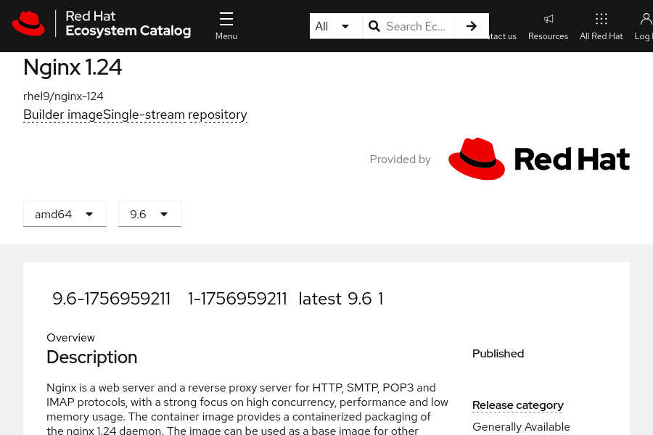
In this case, the 9.6, latest, and 1 tags point to the same image version. You can use any of these tags to refer to that version.
The latest and 1 tags are floating tags, because they can point to different image versions over time. For example, when developers publish a new version of the image, they change the latest tag to point to that new version. They also update the 1 tag to point to the latest release of that version, such as 1-1756959211.
As a user of the image, by specifying a floating tag, you ensure that you always consume the up-to-date image version that corresponds to the tag.

Floating Tag Issues
Vendors, organizations, and developers who publish images manage their tags and establish their own lifecycle for floating tags. They can reassign a floating tag to a new image version without notice.
As a user of the image, you might not notice that the tag that you were using now points to a different image version.
Suppose that you deploy an application on OpenShift and use the latest tag for the image. The following series of events might occur:
- When OpenShift deploys the container, it pulls the image with the latest tag from the container registry.
- Later, the image developer pushes a new version of the image, and reassigns the latest tag to that new version.
- OpenShift relocates the pod to a different cluster node, for example because the original node fails.
- On that new node, OpenShift pulls the image with the latest tag, and thereby retrieves the new image version.
- Now the OpenShift deployment runs with a new version of the application, without your awareness of that version update.
A similar issue is that when you scale up your deployment, OpenShift starts new pods. On the nodes, OpenShift pulls the latest image version for these new pods. As a result, if a new version is available, then your deployment runs with containers that use different versions of the image. Application inconsistencies and unexpected behavior might occur.
To prevent these issues, select an image that is guaranteed not to change over time. You thus gain control over the lifecycle of your application; you can choose when and how OpenShift deploys a new image version.
You can select a static image version in several ways:
- Use a tag that does not change, instead of relying on floating tags.
- Use OpenShift image streams for tight control over the image versions. Another section in this course discusses image streams further.
- Use the Secure Hash Algorithm (SHA) image ID instead of a tag when referencing an image version.
The distinction between a floating and non-floating tag is not a technical one, but a convention. A developer is discouraged, although not prevented, from pushing a different image to an existing tag. Thus, you must specify the SHA image ID to guarantee that the referenced container image does not change.

Using an SHA Image ID
Developers assign tags to images. In contrast, an SHA image ID, or digest, is a unique identifier that the container registry computes and assigns to images. The SHA ID is an immutable string that refers to a specific image version. Using the SHA ID for identifying an image is the most secure approach.
To refer to an image by its SHA ID, replace name:tag with name@SHA-ID in the image name. The following example uses the SHA image ID instead of a tag:
registry.redhat.io/rhel9/nginx-124@sha256:126903359331eb9f2c87950f952442...
To retrieve the SHA image ID from the tag, use the oc image info command.

Note
A multi-architecture image references images for several CPU architectures. Multi-architecture images include an index that points to the images for different platforms and CPU architectures.
For these images, the oc image info command requires you to select an architecture by using the --filter-by-os option:
[user@host ~]$ oc image info registry.redhat.io/rhel9/nginx-124:9.6
error: the image is a manifest list and contains multiple images - use --filter-by-os to select from:

OS DIGEST
linux/amd64 sha256:c83789b0c7765e172bee5d36948e63e5db43248d8a3d69a3bb1...
linux/arm64/v8 sha256:dd239a25567a7b3887848b927bf9376fc76c4c4a57290afee55...
linux/ppc64le sha256:0e9df5ef304708e1244697dc127816f07ece420bc47ea388cf1...
linux/s390x sha256:0dd7ddd965e11c8a70fbcc66499b72de4e508afb0e4dfca48e8...
The following example displays the SHA ID for the image that the 9.6 tag currently points to:
[user@host ~]$ oc image info --filter-by-os linux/amd64 \
registry.redhat.io/rhel9/nginx-124:9.6
Name: registry.redhat.io/rhel9/nginx-124:9.6
Digest: sha256:c83789b0c7765e172bee5d36948e63e5db43248d8a3d69a3bb1...
Manifest List: sha256:126903359331eb9f2c87950f952442db456750190956b9301d0...
Media Type: application/vnd.oci.image.manifest.v1+json
...output omitted...
The SHA image ID, or digest, for the specified image tag and architecture.
You can also use the skopeo inspect command. The output format differs from the oc image info command, although both commands report similar data.
If you use the oc debug node/node-name command to connect to a compute node, then you can list the locally available images by running the crictl images --digests --no-trunc command. The --digests option instructs the command to display the SHA image IDs, and the --no-trunc option instructs the command to display the full SHA string. Otherwise, the command displays only the first characters.
[user@host ~]$ oc debug node/node-name
Temporary namespace openshift-debug-csn2p is created for debugging node...
Starting pod/node-name-debug ...
To use host binaries, run `chroot /host`
Pod IP: 192.168.50.10
If you don't see a command prompt, try pressing enter.
sh-4.4# chroot /host
sh-4.4# crictl images --digests --no-trunc \
registry.redhat.io/rhel9/nginx-124:9.6
IMAGE TAG DIGEST IMAGE ID ...
registry.redhat.io/rhel9/nginx-124: 9.6 sha256:c837...71de 2e68...949e ...
The IMAGE ID column displays the local image identifier that the container engine assigns to the image. This identifier is not related to the SHA ID.
The container image format relies on SHA-256 hashes to identify several image components, such as the image layers or the image metadata. Because some commands also report these SHA-256 strings, ensure that you use the SHA-256 hash that corresponds to the SHA image ID. Commands often refer to the SHA image ID as the image digest.

Selecting a Pull Policy
When you deploy an application, OpenShift selects a compute node to run the pod. On that node, OpenShift pulls the image and then starts the container.
By setting the imagePullPolicy attribute in the deployment resource, you can control how OpenShift pulls the image.
The following example shows the myapp deployment resource:
[user@host ~]$ oc get deployment myapp -o yaml
apiVersion: apps/v1
kind: Deployment
...output omitted...
template:
metadata:
creationTimestamp: null
labels:
app: myapp
spec:
containers:
- image: registry.redhat.io/rhel9/nginx-124:9.6
imagePullPolicy: IfNotPresent
name: nginx-124
...output omitted...
The image pull policy is set to IfNotPresent.
The imagePullPolicy attribute can take the following values:
IfNotPresent
If the image is already on the compute node, because another container is using it or because OpenShift pulled the image during a preceding pod run, then OpenShift uses that local image. Otherwise, OpenShift pulls the image from the container registry.
If you use a floating tag in your deployment, and the image with that tag is already on the node, then OpenShift does not pull the image again, even if the floating tag might point to a newer image in the source container registry.
OpenShift sets the imagePullPolicy attribute to IfNotPresent by default when you use a tag or the SHA ID to identify the image.
Always
OpenShift always verifies whether an updated version of the image is available on the source container registry. To do so, OpenShift retrieves the SHA ID of the image from the registry. If a local image with that same SHA ID is already on the compute node, then OpenShift uses that image. Otherwise, OpenShift pulls the image.
If you use a floating tag in your deployment, and an image with that tag is already on the node, then OpenShift queries the registry anyway to ensure that the tag still points to the same image version. However, if the developer pushed a new version of the image and updated the floating tag, then OpenShift retrieves that new image version.
OpenShift sets the imagePullPolicy attribute to Always by default when you use the latest tag, or when you do not specify a tag.
Never
OpenShift does not pull the image, and expects the image to be already available on the node. Otherwise, the deployment fails.
To use this option, you must prepopulate your compute nodes with the images that you plan to use. You use this mechanism to improve speed or to avoid relying on a container registry for these images.

Pruning Images from Cluster Nodes
When OpenShift deletes a pod from a compute node, it does not remove the associated image. OpenShift can reuse the images without having to pull them again from the remote registry.
Because the images consume disk space on the compute nodes, OpenShift needs to remove, or prune, the unused images when disk space becomes sparse. The kubelet process, which runs on the compute nodes, includes a garbage collector that runs every five minutes. If the usage of the file system that stores the images is above 85%, then the garbage collector removes the oldest unused images. Garbage collection stops when the file-system usage drops below 80%.
The references section includes instructions to adjust these default thresholds.
From a compute node, you can run the crictl imagefsinfo command to retrieve the name of the file system that stores the images:
[user@host ~]$ oc debug node/node-name
Temporary namespace openshift-debug-csn2p is created for debugging node...
Starting pod/node-name-debug ...
To use host binaries, run `chroot /host`
Pod IP: 192.168.50.10
If you don't see a command prompt, try pressing enter.
sh-4.4# chroot /host
sh-4.4# crictl imagefsinfo
{
"status": {
"timestamp": "1674465624446958511",
"fsId": {
"mountpoint": "/var/lib/containers/storage/overlay-images"
},
"usedBytes": {
"value": "1318560"
},
"inodesUsed": {
"value": "446"
}
}
}

Note
The oc debug node and crictl commands require cluster administrator privileges.
From the preceding command output, the file system that stores the images is /var/lib/containers/storage/overlay-images. The images consume 1318560 bytes of disk space.
From the compute node, you can use the crictl rmi command to remove an unused image. However, pruning objects by using the crictl command might interfere with the garbage collector and the kubelet process.
It is recommended that you rely on the garbage collector to prune unused objects, images, and containers from the compute nodes. The garbage collector is configurable to better fulfill any custom needs. The garbage collector thresholds are configurable via the KubeletConfig Custom Resource (CR).

Guided Exercise: Container Image Identity and Tags
Update an application by changing its deployment to reference a newer image tag, and find the hashes of the old and new application images.
Outcomes
Inspect container images, list images of containers that run on compute nodes, and deploy applications by using image tags or SHA IDs.
As the student user on the workstation machine, use the lab command to prepare your system for this exercise.
This command ensures that all resources are available for this exercise. It also creates the updates-ids project and the /home/student/DO180/labs/updates-ids/resources.txt file. The resources.txt file contains the name of the images and some commands that you use during the exercise. You can use the file to copy and paste these image names and commands.
[student@workstation ~]$ lab start updates-ids
Instructions
- Log in to the OpenShift cluster as the developer user with developer as the password. Use the updates-ids project.
  - Log in to the OpenShift cluster.
[student@workstation ~]$ oc login -u developer -p developer \
https://api.ocp4.example.com:6443
Login successful.
  - ...output omitted...
  - Set the updates-ids project as the active project.
[student@workstation ~]$ oc project updates-ids
  - ...output omitted...
- Inspect the two versions of the registry.ocp4.example.com:8443/ubi8/httpd-24 image from the classroom container registry. The classroom setup copied that image from the Red Hat Ecosystem Catalog. The original image is registry.access.redhat.com/ubi8/httpd-24.
  - Use the oc image info command to inspect the image version that the 1-209 tag references. Notice the unique SHA ID that identifies the image version.
Note
To improve readability, the instructions truncate the SHA-256 strings.
On your system, the commands return the full SHA-256 strings. Also, you must type the full SHA-256 string, to provide such a parameter to a command.
[student@workstation ~]$ oc image info \
registry.ocp4.example.com:8443/ubi8/httpd-24:1-209 | head
Name: registry.ocp4.example.com:8443/ubi8/httpd-24:1-209
Digest: sha256:b1e3...f876
  - ...output omitted...
  - Inspect the image version that the 1-215 tag references. Notice that the SHA ID, or digest, differs from the preceding image version.
[student@workstation ~]$ oc image info \
registry.ocp4.example.com:8443/ubi8/httpd-24:1-215 | head
Name: registry.ocp4.example.com:8443/ubi8/httpd-24:1-215
Digest: sha256:91ad...fd83
  - ...output omitted...
  - Use the skopeo inspect command to inspect images. The output format differs from the oc image info command, although both commands report similar data.
Use the skopeo login command to log in to the registry as the developer user with developer as the password.
[student@workstation ~]$ skopeo login registry.ocp4.example.com:8443 -u developer
Password: developer
  - Login Succeeded!
  - Use the skopeo inspect command to inspect the 1-215 image tag.
[student@workstation ~]$ skopeo inspect \
docker://registry.ocp4.example.com:8443/ubi8/httpd-24:1-215 | head
{
"Name": "registry.ocp4.example.com:8443/ubi8/httpd-24",
"Digest": "sha256:91ad...fd83",
"RepoTags": [
"1-209",
"1-215",
"latest"
],
...output omitted...
  - }
  - The skopeo inspect command also shows other existing image tags.
- Deploy an application from the image version that the 1-209 tag references.
  - Use the oc create deployment command to deploy the application. Set the name of the deployment to httpd1.
[student@workstation ~]$ oc create deployment httpd1 \
--image registry.ocp4.example.com:8443/ubi8/httpd-24:1-209
  - deployment.apps/httpd1 created
  - Wait for the pod to start, and then retrieve the name of the cluster node that runs it. You might have to rerun the command several times for the pod to report the Running status. The name of the pod on your system probably differs.
[student@workstation ~]$ oc get pods -o wide
NAME READY STATUS RESTARTS AGE IP NODE ...
  - httpd1-6dff796d99-pm2x6 1/1 Running 0 19s 10.8.0.104 master01 ...
  - Retrieve the name of the container that is running inside the pod. The crictl ps command that you run in a following step takes the container name as an argument.
[student@workstation ~]$ oc get deployment httpd1 -o wide
NAME READY UP-TO-DATE AVAILABLE AGE CONTAINERS ...
  - httpd1 1/1 1 1 1m10s httpd-24 ...
- Access the cluster node and retrieve the image that the container is using.
  - Log in to the OpenShift cluster as the admin user with redhatocp as the password.
[student@workstation ~]$ oc login -u admin -p redhatocp
Login successful.
  - ...output omitted...
  - Use the oc debug node command to access the cluster node.
[student@workstation ~]$ oc debug node/master01
Temporary namespace openshift-debug-flz4d is created for debugging node...
Starting pod/master01-debug-w9cqk ...
To use host binaries, run `chroot /host`
Pod IP: 192.168.50.10
If you don't see a command prompt, try pressing enter.
  - sh-5.1#
  - In the remote shell, run the chroot /﻿host command to use host binaries.
sh-5.1# chroot /host
  - sh-5.1#
  - Use the crictl ps command to confirm that the httpd-24 container is running. Add the -o yaml option to display the container details in YAML format.
sh-4.4# crictl ps --name httpd-24 -o yaml
containers:
- annotations:
...output omitted...
image:
annotations: {}
image: registry.ocp4.example.com:8443/ubi8/httpd-24@sha256:b1e3...f876
...output omitted...
imageRef: registry.ocp4.example.com:8443/ubi8/httpd-24@sha256:b1e3...f876
labels:
...output omitted...
  - state: CONTAINER_RUNNING
  - Notice that the command refers to the image by its SHA ID, and not by the tag that you specified when you created the deployment resource.
  - Use the crictl images command to list the locally available images on the node. The registry.ocp4.example.com:8443/ubi8/httpd-24:1-209 image is in that list, because the local container engine pulled it when you deployed the httpd1 application.
Note
The IMAGE ID column displays the local image identifier that the container engine assigns to the image. This identifier is not related to the SHA image ID that the container registry assigned to the image.
Most crictl commands, such as crictl images or crictl rmi, accept a local image identifier instead of the full image name. For example, you can run the crictl images 8ee59251acc93 command as a short version of the crictl images registry.ocp4.example.com:8443/ubi8/httpd-24:1-209 command.
sh-5.1# crictl images
IMAGE TAG IMAGE ID SIZE
...output omitted...
quay.io/openshift-release-dev/ocp-release <none> d29424caa281a 517MB
quay.io/openshift-release-dev/ocp-v4.0-art-dev <none> 42a50bb73e2fb 588MB
quay.io/openshift-release-dev/ocp-v4.0-art-dev <none> df18dddad77e7 510MB
quay.io/openshift-release-dev/ocp-v4.0-art-dev <none> 388587ea693e1 447MB
...output omitted...
registry.ocp4.example.com:8443/ubi8/httpd-24 1-209 8ee59251acc93 461MB
  - ...output omitted...
  - The crictl images command does not display the SHA image IDs by default. Rerun the command and add the --digests option to display the SHA IDs. Also, add the local image ID to the command to limit the output to the registry.ocp4.example.com:8443/ubi8/httpd-24:1-209 image.
The command reports only the first characters of the SHA image ID. These characters match the SHA ID of the image that the httpd-24 container is using. Therefore, the httpd-24 container is using the expected image.
sh-5.1# crictl images --digests 8ee59251acc93
IMAGE TAG DIGEST IMAGE ID ...
  - registry.ocp4.example.com:8443/ubi8/httpd-24 1-209 b1e3c572516d1 8ee59251acc93 ...
  - Disconnect from the cluster node.
sh-5.1# exit
exit
sh-5.1# exit
exit

Removing debug pod ...
Temporary namespace openshift-debug-flz4d was removed.
  - [student@workstation ~]$
- Log in as the developer user and deploy another application by using the SHA ID of the image as the digest.
  - Log in to the OpenShift cluster as the developer user with developer as the password.
[student@workstation ~]$ oc login -u developer -p developer
Login successful.
  - ...output omitted...
  - Use the oc image info command to retrieve the SHA ID of the image version that the 1-209 tag references. Specify the JSON format for the command output. Parse the JSON output with the jq -r command to retrieve the value of the .digest object.
[student@workstation ~]$ oc image info \
registry.ocp4.example.com:8443/ubi8/httpd-24:1-209 -o json | \
jq -r .digest
  - sha256:b1e3...f876
  - Export the SHA ID as the $IMAGE environment variable.
  - [student@workstation ~]$ IMAGE=sha256:b1e3...f876
  - Use the oc create deployment command to deploy the application. Set the name of the deployment to httpd2.
[student@workstation ~]$ oc create deployment httpd2 \
--image registry.ocp4.example.com:8443/ubi8/httpd-24@$IMAGE
  - deployment.apps/httpd2 created
  - Confirm that the new deployment refers to the image version by its SHA ID.
[student@workstation ~]$ oc get deployment httpd2 -o wide
NAME READY ... CONTAINERS IMAGES ...
  - httpd2 1/1 ... httpd-24 registry.../ubi8/httpd-24@sha256:b1e3...f876 ...
- Update the httpd2 application by using a more recent image version.
  - In the httpd2 deployment, update the httpd-24 container to use the image version that the 1-215 tag references.
[student@workstation ~]$ oc set image deployment/httpd2 \
httpd-24=registry.ocp4.example.com:8443/ubi8/httpd-24:1-215
  - deployment.apps/httpd2 image updated
  - Confirm that the deployment refers to the new image version.
[student@workstation ~]$ oc get deployment httpd2 -o wide
NAME READY ... IMAGES ...
  - httpd2 1/1 ... registry.ocp4.example.com:8443/ubi8/httpd-24:1-215 ...
  - Confirm that the deployment finished redeploying the pod. You might have to rerun the command several times for the pod to report a Running status. The pod names probably differ on your system.
[student@workstation ~]$ oc get pods
NAME READY STATUS RESTARTS AGE
httpd1-6dff796d99-pm2x6 1/1 Running 0 118m
  - httpd2-998d9b9b9-5859j 1/1 Running 0 21s
  - Inspect the pod to confirm that the container is using the new image. Replace the pod name with your own pod from the previous step.
[student@workstation ~]$ oc get pod httpd2-998d9b9b9-5859j \
-o jsonpath='{.spec.containers[0].image}{"\n"}'
  - registry.ocp4.example.com:8443/ubi8/httpd-24:1-215
- Add the latest tag to the image version that the 1-209 tag already references. Deploy an application from the image with the latest tag.
  - Use the skopeo login command to log in to the classroom container registry as the developer user with developer as the password.
[student@workstation ~]$ skopeo login -u developer -p developer \
registry.ocp4.example.com:8443
  - Login Succeeded!
  - Use the skopeo copy command to add the latest tag to the image.
[student@workstation ~]$ skopeo copy \
docker://registry.ocp4.example.com:8443/ubi8/httpd-24:1-209 \
docker://registry.ocp4.example.com:8443/ubi8/httpd-24:latest
Getting image source signatures
...output omitted...
  - Writing manifest to image destination
  - Use the oc image info command to confirm that both tags refer to the same image. The two commands report the same SHA image ID, which indicates that the tags point to the same image version.
[student@workstation ~]$ oc image info \
registry.ocp4.example.com:8443/ubi8/httpd-24:1-209 | head
Name: registry.ocp4.example.com:8443/ubi8/httpd-24:1-209
Digest: sha256:b1e3...f876
  - ...output omitted...
[student@workstation ~]$ oc image info \
registry.ocp4.example.com:8443/ubi8/httpd-24:latest | head
Name: registry.ocp4.example.com:8443/ubi8/httpd-24:latest
Digest: sha256:b1e3...f876
  - ...output omitted...
  - Use the oc create deployment command to deploy another application. Set the name of the deployment to httpd3. To confirm that by default the command selects the latest tag, do not provide the tag part in the image name.
[student@workstation ~]$ oc create deployment httpd3 \
--image registry.ocp4.example.com:8443/ubi8/httpd-24
  - deployment.apps/httpd3 created
  - Confirm that the pod is running. You might have to rerun the command several times for the pod to report the Running status. The pod names probably differ on your system.
[student@workstation ~]$ oc get pods
NAME READY STATUS RESTARTS AGE
httpd1-6dff796d99-pm2x6 1/1 Running 0 150m
httpd2-998d9b9b9-5859j 1/1 Running 0 32m
  - httpd3-85b978d758-fvqdr 1/1 Running 0 42s
  - Confirm that the pod is using the expected image. Notice that the SHA image ID corresponds to the image that the 1-209 tag references. You retrieved that SHA image ID in a preceding step when you ran the oc image info command.
[student@workstation ~]$ oc describe pod httpd3-85b978d758-fvqdr | \
grep ID
Container ID: cri-o://baa3...7c90
  - Image ID: registry.ocp4.example.com:8443/ubi8/httpd-24@sha256:b1e3...f876
- Assign the latest tag to a different image version. This operation simulates a developer who pushes a new version of an image and assigns the latest tag to that new image version.
  - Use the skopeo copy command to add the latest tag to the image version that the 1-215 tag already references. The command automatically removes the latest tag from the earlier image.
[student@workstation ~]$ skopeo copy \
docker://registry.ocp4.example.com:8443/ubi8/httpd-24:1-215 \
docker://registry.ocp4.example.com:8443/ubi8/httpd-24:latest
Getting image source signatures
...output omitted...
Writing manifest to image destination
  - Storing signatures
  - Log out of the classroom container registry.
[student@workstation ~]$ skopeo logout registry.ocp4.example.com:8443
  - Removed login credentials for registry.ocp4.example.com:8443
  - Note
The skopeo logout command logs out of a specified registry server by deleting the cached credentials in the ${XDG_RUNTIME_DIR}/containers/auth.json file.
Red Hat recommends removing cached credentials that are no longer required.
  - Even though the latest tag is now referencing a different image version, OpenShift does not redeploy the pods that are running with the previous image version.
Rerun the oc describe pod command to confirm that the pod still uses the preceding image.
[student@workstation ~]$ oc describe pod httpd3-85b978d758-fvqdr | \
grep ID
Container ID: cri-o://2cee...3a68
  - Image ID: registry.ocp4.example.com:8443/ubi8/httpd-24@sha256:b1e3...f876
- Scale the httpd3 deployment to two pods.
  - Use the oc scale command to add a new pod to the deployment.
[student@workstation ~]$ oc scale deployment/httpd3 --replicas 2
  - deployment.apps/httpd3 scaled
  - List the pods to confirm that two pods are running for the httpd3 deployment. The pod names probably differ on your system.
[student@workstation ~]$ oc get pods
httpd1-6dff796d99-pm2x6 1/1 Running 0 75m
httpd2-998d9b9b9-5859j 1/1 Running 0 30m
httpd3-85b978d758-f98jh 1/1 Running 0 54s
  - httpd3-85b978d758-fvqdr 1/1 Running 0 11m
  - Retrieve the SHA image ID for the pod that the deployment initially created. The ID did not change. The container is still using the original image version.
[student@workstation ~]$ oc describe pod httpd3-85b978d758-fvqdr | \
grep ID
Container ID: cri-o://2cee...3a68
  - Image ID: registry.ocp4.example.com:8443/ubi8/httpd-24@sha256:b1e3...f876
  - Retrieve the SHA image ID for the additional pod. Notice that the ID is different. The additional pod is using the image that the latest tag is currently referencing.
[student@workstation ~]$ oc describe pod httpd3-85b978d758-f98jh | \
grep ID
Container ID: cri-o://d254...c893
  - Image ID: registry.ocp4.example.com:8443/ubi8/httpd-24@sha256:91ad...fd83
  - The state of the deployment is inconsistent. The two replicated pods use a different image version. Consequently, the scaled application might not behave correctly. Red Hat recommends that you use a less volatile tag than latest in production environments, or that you tightly control the tag assignments in your container registry.
Finish
On the workstation machine, use the lab command to complete this exercise. This step is important to ensure that resources from previous exercises do not impact upcoming exercises.
[student@workstation ~]$ lab finish updates-ids

Update Application Image and Settings

Objectives
- Update applications with minimal downtime by using deployment strategies.

Application Code, Configuration, and Data
Modern applications loosely couple code, configuration, and data. Configuration files and data are not hardcoded as part of the software. Instead, the software loads the configuration and data from an external source. Externalizing configuration and data enables deploying an application to different environments without requiring a change to the application source code.
OpenShift provides configuration map, secret, and volume resources to store the application configuration and data. The application code is available through container images.
Because OpenShift deploys applications from container images, developers must build a new version of the image when they update the code of their application. Organizations usually use a continuous integration and continuous delivery (CI/CD) pipeline to automatically build the image from the application source code, and then push the resulting image to a container registry.
You use OpenShift resources, such as configuration maps and secrets, to update the application configuration. To control the deployment process of a new image version, use a Deployment object.

Deployment Strategies
Deploying functional application changes or new versions to users is a significant phase of the CI/CD pipelines, where you add value to the development process.
Introducing application changes carries risks, such as downtime during the deployment, bugs, or reduced application performance. You can reduce or mitigate some risks with testing and validation stages in the pipelines.
Application or service downtime can result in lost business, disruption to other services that depend on yours, and violations of the service-level agreements, among others. To reduce downtime and minimize risks in deployments, use a deployment strategy. A deployment strategy changes or upgrades an application to minimize the impact of those changes.
In OpenShift, you use Deployment objects to define deployments and deployment strategies. The RollingUpdate and Recreate strategies are the main OpenShift deployment strategies.
To select the RollingUpdate or Recreate strategies, you set the .spec.strategy.type property of the Deployment object. The following snippet shows a Deployment object that uses the Recreate strategy:
apiVersion: apps/v1
kind: Deployment
metadata:
...output omitted...
spec:
progressDeadlineSeconds: 600
replicas: 10
revisionHistoryLimit: 10
selector:
matchLabels:
app: myapp2
strategy:
type: Recreate
template:
...output omitted...

Rolling Update Strategy
The RollingUpdate strategy replaces one instance after another until all instances are replaced. In this strategy, both versions of the application run simultaneously, and the RollingUpdate strategy scales down instances of the previous version only when the new version is ready. The main drawback is that this strategy requires compatibility between the versions in the deployment.
The following graphic shows the deployment of a new version of an application by using the RollingUpdate strategy:
- Some application instances run a code version that needs updating (v1). OpenShift scales up a new instance with the updated application version (v2). Because the new instance with version v2 is not ready, only the version v1 instances fulfill customer requests.
- The instance with v2 is ready and accepts customer requests. OpenShift scales down an instance with version v1, and scales up a new instance with version v2. Both versions of the application fulfill customer requests.
- The new instance with v2 is ready and accepts customer requests. OpenShift scales down the remaining instance with version v1.
- No instances remain to replace. The application update was successful and without downtime.
The RollingUpdate strategy supports continuous deployment, and eliminates application downtime during deployments. You can use this strategy if the different versions of your application can run at the same time.

Note
The RollingUpdate strategy is the default strategy if you do not specify a strategy on the Deployment objects.
The following snippet shows a Deployment object that uses the RollingUpdate strategy:
apiVersion: apps/v1
kind: Deployment
metadata:
...output omitted...
spec:
progressDeadlineSeconds: 600
replicas: 10
revisionHistoryLimit: 10
selector:
matchLabels:
app: myapp2
strategy:
rollingUpdate:
maxSurge: 25%
maxUnavailable: 50%
type: RollingUpdate
template:
...output omitted...
Out of the many parameters to configure the RollingUpdate strategy, the preceding snippet shows the maxSurge and maxUnavailable parameters.
During a rolling update, the number of pods for the application varies, because OpenShift starts new pods for the new revision and removes pods from the previous revision. The maxSurge parameter indicates how many pods OpenShift can create above the normal number of replicas. The maxUnavailable parameter indicates how many pods OpenShift can remove below the normal number of replicas. You can express these parameters as percentages or as the number of pods.
If you do not configure a readiness probe for your deployment, then during a rolling update, OpenShift starts sending client traffic to new pods as soon as they are running. However, the application inside a container might not be immediately ready to accept client requests, which might need to load files to cache, to establish a network connection to a database, or to perform initial tasks that might take time to complete. Consequently, OpenShift redirects client requests to a container that is not yet ready, and these requests fail.
Adding a readiness probe to the deployment prevents OpenShift from sending traffic to new pods that are not ready.

Recreate Strategy
In this strategy, all the instances of an application are stopped first, and are then replaced with new ones. The major drawback of this strategy is that it causes downtime in your services. For a period, no application instances are available to fulfill requests.
The following graphic shows the deployment of a new version of an application that uses the Recreate strategy:
- The application has some instances that run a code version to update (v1).
- OpenShift scales down the running instances to zero. Scaling down to zero causes application downtime, because no instances are available to fulfill requests.
- OpenShift scales up new instances with a new version of the application (v2). When the new instances are booting, the downtime continues.
- Starting the new instances resolves the application outage and completes the Recreate strategy.
The Recreate strategy is not recommended for applications that need high availability, for example, medical systems. You can use this strategy when your application cannot have different simultaneously running code versions. You might also use this strategy to execute data migrations or data transformations before the new code starts.

Rolling out Applications
When you update a Deployment object, OpenShift automatically rolls out the application. If you apply several modifications in a row, such as modifying the image version, updating the environment variables, and configuring the readiness probe, then OpenShift rolls out the application for each modification.
To prevent these multiple deployments, pause the rollout, apply all your modifications to the Deployment object, and then resume the rollout. OpenShift then performs a single rollout to apply all your modifications to the Deployment object.
- Use the oc rollout pause command for the myapp deployment:
- [user@host ~]$ oc rollout pause deployment/myapp
- The following commands modify the image, an environment variable, and the readiness probe:
[user@host ~]$ oc set image deployment/myapp \
nginx-120=registry.access.redhat.com/ubi9/nginx-120:1-86
[user@host ~]$ oc set env deployment/myapp NGINX_LOG_TO_VOLUME=1
- [user@host ~]$ oc set probe deployment/myapp --readiness --get-url http://:8080
- Resume the rollout of the myapp deployment:
- [user@host ~]$ oc rollout resume deployment/myapp
- OpenShift rolls out the application to apply all your modifications to the Deployment object.
You can follow a similar process when you create and configure a new deployment:
- Create the deployment, and set the number of replicas to zero. By setting the replicas to zero, OpenShift does not roll out your application, and no pods are running:
[user@host ~]$ oc create deployment myapp2 \
- --image registry.access.redhat.com/ubi9/nginx-120:1-86 --replicas 0
- Confirm that the deployment has no running pods:
[user@host ~]$ oc get deployment/myapp2
NAME READY UP-TO-DATE AVAILABLE AGE
- myapp2 0/0 0 0 9s
- Apply the configuration to the Deployment object. The following command adds a readiness probe:
- [user@host ~]$ oc set probe deployment/myapp2 --readiness --get-url http://:8080
- Scale up the deployment and OpenShift rolls out the application:
- [user@host ~]$ oc scale deployment/myapp2 --replicas 10
[user@host ~]$ oc get deployment/myapp2
NAME READY UP-TO-DATE AVAILABLE AGE
- myapp2 10/10 10 10 18s

Monitoring Replica Sets
When OpenShift rolls out an application from the Deployment object, it creates a ReplicaSet object. Replica sets are responsible for creating and monitoring the pods. If a pod fails, then the ReplicaSet object deploys a new one.
To deploy pods, replica sets use the pod template definition from the Deployment object. OpenShift copies the template definition from the Deployment object when it creates the ReplicaSet object.
When you update the Deployment object, OpenShift does not update the existing ReplicaSet object. Instead, it creates another ReplicaSet object with the new pod template definition. Then, OpenShift rolls out the application according to the update strategy.
Therefore, several ReplicaSet objects for a deployment can exist at the same time on your system. During a rolling update, the earlier and the new ReplicaSet objects coexist and coordinate the rollout of the new application version. After the rollout completes, OpenShift keeps the earlier ReplicaSet object so that you can roll back if the new application version does not operate correctly.
The following graphic shows a Deployment object and two ReplicaSet objects. The earlier ReplicaSet object for version 1 of the application does not run any pods. The current ReplicaSet object for version 2 of the application manages three replicated pods.
Do not directly change or delete ReplicaSet objects, because OpenShift manages them through the associated Deployment objects. The .spec.revisionHistoryLimit attribute in Deployment objects specifies how many ReplicaSet objects OpenShift keeps. OpenShift automatically deletes the extra ReplicaSet objects. Also, when you delete a Deployment object, OpenShift deletes all the associated ReplicaSet objects.
Run the oc get replicaset command to list the ReplicaSet objects. OpenShift uses the Deployment object name as a prefix for the ReplicaSet objects.
[user@host ~]$ oc get replicaset
NAME DESIRED CURRENT READY AGE
myapp2-574968dd59 0 0 0 3m27s
myapp2-76679885b9 10 10 10 22s
myapp2-786cbf9bc8 0 0 0 114s
The preceding output shows three ReplicaSet objects for the myapp2 deployment. Whenever you modified the myapp2 deployment, OpenShift created a ReplicaSet object. The second object in the list is active and monitors 10 pods. The other ReplicaSet objects do not manage any pods.
During a rolling update, two ReplicaSet objects are active. The earlier ReplicaSet object is scaling down, and at the same time the new ReplicaSet object is scaling up:
[user@host ~]$ oc get replicaset
NAME DESIRED CURRENT READY AGE
myapp2-574968dd59 0 0 0 13m
myapp2-5fb5766df5 4 4 2 21s
myapp2-76679885b9 8 8 8 10m
myapp2-786cbf9bc8 0 0 0 11m
The new ReplicaSet object already started four pods, but the READY column shows that the readiness probe succeeded for only two pods so far. These two pods are likely to receive client traffic.
The ReplicaSet object already scaled down from 10 to 8 pods.

Managing Rollout
Because OpenShift preserves ReplicaSet objects from earlier deployment versions, you can roll back if you notice that the new version of the application does not work.
Use the oc rollout undo command to roll back to the preceding deployment version. The command uses the existing ReplicaSet object for that version to roll back the pods. The command also reverts the Deployment object to the preceding version.
[user@host ~]$ oc rollout undo deployment/myapp2
Use the oc rollout status command to control the rollout process:
[user@host ~]$ oc rollout status deployment/myapp2
deployment "myapp2" successfully rolled out
If the rollout operation fails, because you specify a wrong container image name or the readiness probe fails, then OpenShift does not automatically roll back your deployment. In this case, run the oc rollout undo command to revert to the preceding working configuration.
By default, the oc rollout undo command rolls back to the preceding deployment version. If you need to roll back to an earlier revision, then list the available revisions and add the --to-revision option to the oc rollout undo command.
- Use the oc rollout history command to list the available revisions:
[user@host ~]$ oc rollout history deployment/myapp2
deployment.apps/myapp2
REVISION CHANGE-CAUSE
1 <none>
3 <none>
4 <none>
- 5 <none>
- Note
The CHANGE-CAUSE column provides a user-defined message that describes the revision. You can store the message in the kubernetes.io/change-cause deployment annotation after every rollout:
[user@host ~]$ oc annotate deployment/myapp2 \
kubernetes.io/change-cause="Image updated to 1-86"
deployment.apps/myapp2 annotated
[user@host ~]$ oc rollout history deployment/myapp2
deployment.apps/myapp2
REVISION CHANGE-CAUSE
1 <none>
3 <none>
4 <none>
- 5 Image updated to 1-86
- Add the --revision option to the oc rollout history command for more details about a specific revision:
[user@host ~]$ oc rollout history deployment/myapp2 --revision 1
deployment.apps/myapp2 with revision #1
Pod Template:
Labels: app=myapp2
pod-template-hash=574968dd59
Containers:
nginx-120:
Image: registry.access.redhat.com/ubi9/nginx-120:1-86
Port: <none>
Host Port: <none>
Environment: <none>
Mounts: <none>
- Volumes: <none>
- The pod-template-hash attribute is the suffix of the associated ReplicaSet object. For example, you can inspect the ReplicaSet object for more details by using the oc describe replicaset myapp2-574968dd59 command.
- Roll back to a specific revision by adding the --to-revision option to the oc rollout undo command:
- [user@host ~]$ oc rollout undo deployment/myapp2 --to-revision 1
If you use floating tags to refer to container image versions in deployments, then the resulting image when you roll back a deployment might have changed in the container registry. As a result, the image that you run after the rollback might not be the original one that you used.
To prevent this issue, use the OpenShift image streams for referencing images instead of floating tags. A later section in this course discusses the OpenShift image streams in more detail.

Guided Exercise: Update Application Image and Settings
Update the manifests of a database and a web application while minimizing interruption of service to their users.
Outcomes
You should be able to pause, update, and resume a deployment, and roll back a failing application.
As the student user on the workstation machine, use the lab command to prepare your system for this exercise.
This command ensures that all resources are available for this exercise. It also creates the updates-rollout-db project and deploys a MySQL database in that project. It creates the updates-rollout-web project and then deploys a web application with 10 replicas.
The command creates the /home/student/DO180/labs/updates-rollout/resources.txt file. The resources.txt file contains the name of the images and some commands that you use during the exercise. You can use the file to copy and paste these image names and commands.
[student@workstation ~]$ lab start updates-rollout
Instructions
- Log in to the OpenShift cluster as the developer user with the developer password. Use the updates-rollout-db project.
  - Log in to the OpenShift cluster.
[student@workstation ~]$ oc login -u developer -p developer \
https://api.ocp4.example.com:6443
Login successful.
  - ...output omitted...
  - Set the updates-rollout-db project as the active project.
[student@workstation ~]$ oc project updates-rollout-db
  - ...output omitted...
- Review the resources that the lab command created. Confirm that you can connect to the database. The MySQL database uses ephemeral storage.
  - List the Deployment object and confirm that the pod is available. Retrieve the name of the container. You use that information when you update the container image in another step.
[student@workstation ~]$ oc get deployment -o wide
NAME READY UP-TO-DATE AVAILABLE AGE CONTAINERS ...
  - mydb 1/1 0 1 17m mysql-80 ...
  - List the pods and confirm that the pod is running. The name of the pod on your system probably differs.
[student@workstation ~]$ oc get pod
NAME READY STATUS RESTARTS AGE
  - mydb-5c79866d48-5xzkk 1/1 Running 0 18m
  - Retrieve the name of the image that the pod is using. The pod is using the rhel9/mysql-80 image version 1-224. Replace the pod name with your own from the previous step.
[student@workstation ~]$ oc get pod mydb-5c79866d48-5xzkk \
-o jsonpath='{.spec.containers[0].image}{"\n"}'
  - registry.ocp4.example.com:8443/rhel9/mysql-80:1-224
  - The classroom setup copied that image from the Red Hat Ecosystem Catalog. The original image is registry.redhat.io/rhel9/mysql-80.
  - Confirm that you can connect to the database system by listing the available databases. Run the mysql command from inside the pod and connect as the operator1 user by using test as the password.
[student@workstation ~]$ oc rsh mydb-5c79866d48-5xzkk \
mysql --user=operator1 --password=test -e "SHOW DATABASES"
mysql: [Warning] Using a password on the command line interface can be insecure.
+--------------------+
| Database |
+--------------------+
| information_schema |
| performance_schema |
| quotes |
  - +--------------------+
- You must implement several updates to the Deployment object. Pause the deployment to prevent OpenShift from rolling out the application for each modification that you make. After you pause the deployment, change the password for the operator1 database user, update the container image, and then resume the deployment.
  - Pause the mydb deployment.
[student@workstation ~]$ oc rollout pause deployment/mydb
  - deployment.apps/mydb paused
  - Change the password of the operator1 database user to redhat123. To change the password, update the MYSQL_PASSWORD environment variable in the pod template of the Deployment object.
[student@workstation ~]$ oc set env deployment/mydb MYSQL_PASSWORD=redhat123
  - deployment.apps/mydb updated
  - Because the Deployment object is paused, confirm that the new password is not yet active. To do so, rerun the mysql command by using the current password. The database connection succeeds.
[student@workstation ~]$ oc rsh mydb-5c79866d48-5xzkk \
mysql --user=operator1 --password=test -e "SHOW DATABASES"
mysql: [Warning] Using a password on the command line interface can be insecure.
+--------------------+
| Database |
+--------------------+
| information_schema |
| performance_schema |
| quotes |
  - +--------------------+
  - Update the MySQL container image to the 1-228 version.
[student@workstation ~]$ oc set image deployment/mydb \
mysql-80=registry.ocp4.example.com:8443/rhel9/mysql-80:1-228
  - deployment.apps/mydb image updated
  - Because the Deployment object is paused, confirm that the pod still uses the 1-224 image version.
[student@workstation ~]$ oc get pod mydb-5c79866d48-5xzkk \
-o jsonpath='{.spec.containers[0].image}{"\n"}'
  - registry.ocp4.example.com:8443/rhel9/mysql-80:1-224
  - Resume the mydb deployment.
[student@workstation ~]$ oc rollout resume deployment/mydb
  - deployment.apps/mydb resumed
  - Confirm that the new rollout completes by waiting for the new pod to be running. The name of the pod on your system probably differs.
[student@workstation ~]$ oc get pods
NAME READY STATUS RESTARTS AGE
  - mydb-dd5dcbddb-rmf85 1/1 Running 0 2m2s
- Verify that OpenShift applied all your modifications to the Deployment object.
  - Retrieve the name of the image that the new pod is using. In the following command, use the name of the new pod as a parameter to the oc get pod command. The pod is now using the 1-228 image version.
[student@workstation ~]$ oc get pod mydb-dd5dcbddb-rmf85 \
-o jsonpath='{.spec.containers[0].image}{"\n"}'
  - registry.ocp4.example.com:8443/rhel9/mysql-80:1-228
  - Confirm that you can connect to the database system by using the new password, redhat123, for the operator1 database user.
[student@workstation ~]$ oc rsh mydb-dd5dcbddb-rmf85 \
mysql --user=operator1 --password=redhat123 -e "SHOW DATABASES"
mysql: [Warning] Using a password on the command line interface can be insecure.
+--------------------+
| Database |
+--------------------+
| information_schema |
| performance_schema |
| quotes |
  - +--------------------+
- In the second part of the exercise, you perform a rolling update of a replicated web application. Use the updates-rollout-web project and review the resources that the lab command created.
  - Set the updates-rollout-web project as the active project.
[student@workstation ~]$ oc project updates-rollout-web
  - ...output omitted...
  - List the Deployment object and confirm that the pods are available. Retrieve the name of the containers. You use that information when you update the container image in another step.
[student@workstation ~]$ oc get deployment -o wide
NAME READY UP-TO-DATE AVAILABLE AGE CONTAINERS ...
  - version 10/10 10 10 32m versioned-hello ...
  - List the ReplicaSet objects. Because OpenShift did not yet perform rolling updates, only one ReplicaSet object exists. The name of the ReplicaSet object on your system probably differs.
[student@workstation ~]$ oc get replicaset
NAME DESIRED CURRENT READY AGE
  - version-7bfff6b5b4 10 10 10 11m
  - Retrieve the name and version of the image that the ReplicaSet object uses to deploy the pods. The pods are using the redhattraining/versioned-hello image version v1.0.
[student@workstation ~]$ oc get replicaset version-7bfff6b5b4 \
-o jsonpath='{.spec.template.spec.containers[0].image}{"\n"}'
  - registry.ocp4.example.com:8443/redhattraining/versioned-hello:v1.0
  - Confirm that the version deployment includes a readiness probe. The probe performs an HTTP GET request on port 8080.
[student@workstation ~]$ oc get deployment version \
-o jsonpath='{.spec.template.spec.containers[0].readinessProbe}' | jq .
{
"failureThreshold": 3,
"httpGet": {
"path": "/",
"port": 8080,
"scheme": "HTTP"
},
"initialDelaySeconds": 3,
"periodSeconds": 10,
"successThreshold": 1,
"timeoutSeconds": 1
  - }
- To watch the rolling update that you cause in a following step, open a new terminal window and then run the ~/DO180/labs/updates-rollout/curl_loop.sh script that the lab command prepared. The script sends web requests to the application in a loop.
  - Open a new terminal.
  - Run the /home/student/DO180/labs/updates-rollout/curl_loop.sh script. Leave the script running and do not interrupt it.
[student@workstation ~]$ /home/student/DO180/labs/updates-rollout/curl_loop.sh
Hi!
Hi!
Hi!
Hi!
  - ...output omitted...
- Change the container image of the version deployment. The new application version creates a web page with a different message.
  - Switch back to the first terminal window, and then use the oc set image command to update the deployment.
[student@workstation ~]$ oc set image deployment/version \
versioned-hello=registry.ocp4.example.com:8443/redhattraining/versioned-hello:v1.1
  - deployment.apps/version image updated
  - Changing the image caused a rolling update. Watch the output of the curl_loop.sh script in the second terminal. If the output of the curl_loop.sh is not updating, then press Ctrl+c to stop the script in the second terminal. Then, restart the script.
Before the update, only pods that run the v1.0 version of the application reply. During the rolling updates, both old and new pods are responding. After the update, only pods that run the v1.1 version of the application reply. The following output probably differs on your system.
...output omitted...
Hi!
Hi!
Hi!
Hi!
Hi! v1.1
Hi! v1.1
Hi!
Hi! v1.1
Hi!
Hi! v1.1
Hi! v1.1
Hi! v1.1
Hi! v1.1
  - ...output omitted...
  - Do not stop the script.
- Confirm that the rollout process is successful. List the ReplicaSet objects and verify that the new object uses the new image version.
  - Use the oc rollout status command to confirm that the rollout process is successful.
[student@workstation ~]$ oc rollout status deployment/version
  - deployment "version" successfully rolled out
  - List the ReplicaSet objects. The initial object scaled down to zero pods. The new ReplicaSet object scaled up to 10 pods. The names of the ReplicaSet objects on your system probably differ.
[student@workstation ~]$ oc get replicaset
NAME DESIRED CURRENT READY AGE
version-7bfff6b5b4 0 0 0 28m
  - version-b7fddfc8c 10 10 10 3m40s
  - Retrieve the name and version of the image that the new ReplicaSet object uses. This image provides the new version of the application.
[student@workstation ~]$ oc get replicaset version-b7fddfc8c \
-o jsonpath='{.spec.template.spec.containers[0].image}{"\n"}'
  - registry.ocp4.example.com:8443/redhattraining/versioned-hello:v1.1
- Roll back the version deployment.
  - Use the oc rollout undo command to roll back to the initial application version. Ignore the warning message.
[student@workstation ~]$ oc rollout undo deployment/version
  - deployment.apps/version rolled back
  - Watch the output of the curl_loop.sh script in the second terminal. The pods that run the v1.0 version of the application are responding again. The following output probably differs on your system.
...output omitted...
Hi! v1.1
Hi! v1.1
Hi! v1.1
Hi! v1.1
Hi!
Hi! v1.1
Hi!
Hi! v1.1
Hi! v1.1
Hi!
Hi!
Hi!
  - ...output omitted...
  - Press Ctrl+C to quit the script. Close that second terminal when done.
  - List the ReplicaSet objects. The initial object scaled up to 10 pods. The object for the new application version scaled down to zero pods.
[student@workstation ~]$ oc get replicaset
NAME DESIRED CURRENT READY AGE
version-7bfff6b5b4 10 10 10 52m
  - version-b7fddfc8c 0 0 0 27m
Finish
On the workstation machine, use the lab command to complete this exercise. This step is important to ensure that resources from previous exercises do not impact upcoming exercises.
[student@workstation ~]$ lab finish updates-rollout

Reproducible Deployments with OpenShift Image Streams

Objectives
- Ensure reproducibility of application deployments by using image streams and short image names.

Image Streams
Image streams provide a crucial abstraction layer for managing container images within a Red Hat OpenShift Container Platform (RHOCP) environment. For enterprises, this abstraction is key to establishing secure, consistent, and efficient software supply chains. By decoupling application definitions from the specific location and version of an image, image streams enable robust CI/CD pipelines, simplify image promotion across environments, and enhance security by controlling which images are available for deployment.
The distinction between a floating and a non-floating tag is a convention rather than technical. A developer is discouraged, although not prevented, from pushing a different image to an existing tag. Therefore, a pod that references an image tag is not guaranteed to retrieve the same image when the pod is restarted. Image streams resolve this problem and also provide essential rollback capabilities.
Image streams are one of the main differentiators between OpenShift and upstream Kubernetes. Whereas Kubernetes resources reference container images directly, OpenShift resources, such as build configurations, reference image streams. OpenShift also extends Kubernetes resources, such as Kubernetes Deployments, with annotations that enable them to use image streams.
With image streams, OpenShift can ensure reproducible, stable deployments of containerized applications and also rollbacks of deployments to their latest known-good state.
Image streams provide a stable, short name to reference a container image that is independent of any registry server and container runtime configuration.

Image Stream Tags
An image stream represents one or more sets of container images. Each set, or stream, is identified by an image stream tag. Unlike container images in a registry server, which have multiple tags from the same image repository, an image stream can have multiple image stream tags that reference container images from different registry servers and image repositories.
An image stream provides default configurations for a set of image stream tags. Each image stream tag references one stream of container images, and can override most configurations from its associated image stream.
In the following illustration, a deployment that uses the Image-4 image can be rolled back to using the Image-3 image, because the ISTAG-B image stream tag keeps a history of used images:
An image stream tag stores a copy of the metadata about its current container image, including the SHA image ID. The SHA image ID is a unique identifier that the container registry computes and assigns to images. Storing metadata supports faster search and inspection of container images, because you do not need to reach its source registry server.
You can also configure an image stream tag to store the source image layers in the OpenShift internal container registry, which acts as a local image cache. Storing image layers locally avoids the need to fetch these layers from their source registry server. Consumers of the cached image, such as pods and deployments, reference the internal registry as the source registry of the image.
To better visualize the relationship between image streams and image stream tags, you can explore the openshift project that is pre-created in all OpenShift clusters. You can see many image streams in that project, including the php image stream:
[user@host ~]$ oc get is -n openshift -o name
...output omitted...
imagestream.image.openshift.io/nodejs
imagestream.image.openshift.io/perl
imagestream.image.openshift.io/php
imagestream.image.openshift.io/postgresql
imagestream.image.openshift.io/python
...output omitted...
Several tags exist for the php image stream, and an image stream tag resource exists for each tag:
[user@host ~]$ oc get istag -n openshift | grep php
8.0-ubi9 image-registry ... 6 days ago
8.0-ubi8 image-registry ... 6 days ago
7.4-ubi8 image-registry ... 6 days ago
7.3-ubi7 image-registry ... 6 days ago
The oc describe command on an image stream shows information from both the image stream and its image stream tags:
[user@host ~]$ oc describe is php -n openshift
Name: php
Namespace: openshift
...output omitted...
Tags: 5

8.0-ubi9
tagged from registry.access.redhat.com/ubi9/php-80:latest
...output omitted...

8.0-ubi8 (latest)
tagged from registry.access.redhat.com/ubi8/php-80:latest
...output omitted...

7.4-ubi8
tagged from registry.access.redhat.com/ubi8/php-74:latest
...output omitted...

7.3-ubi7
tagged from registry.access.redhat.com/ubi7/php-73:latest
...output omitted...
In the previous example, each of the php image stream tags refers to a different image name.

Image Names, Tags, and IDs
The textual name of a container image is a string. Although the image name is sometimes interpreted as consisting of multiple components, such as registry-host-name/repository-or-organization-or-user-name/image-name:tag-name, splitting the image name into its components is a matter of convention, not of structure.
An SHA image ID is an SHA-256 hash that uniquely identifies an immutable container image. You cannot modify a container image. Instead, you create a container image with a new ID. When you push a new container image to a registry server, the server associates the existing textual name with the new image ID.
When you start a container from an image name, you download the image that is currently associated with that image name. The image ID behind that name might change at any moment, and the next container that you start might have a different image ID. If the image that is associated with an image name has any issues, and you know only the image name, then you cannot roll back to an earlier image.
OpenShift image stream tags keep a history of the latest image IDs that they fetched from a registry server. The history of image IDs is the stream of images from an image stream tag. You can use the history inside an image stream tag to roll back to a previous image, if for example a new container image causes a deployment error.
Updating a container image in an external registry does not automatically update an image stream tag. The image stream tag keeps the reference to the last image ID that it fetched. The image stream tag behavior is crucial to scaling applications, because it isolates OpenShift from changes that happen on a registry server.
Suppose that you deploy an application from an external registry, and after a few days of testing with some users, you decide to scale its deployment to enable a larger user population. In the meantime, your vendor updates the container image on the external registry. If OpenShift had no image stream tags, then the new pods would get the new container image, which is different from the image on the original pod. Depending on the changes, this new image could cause your application to fail. Because OpenShift stores the image ID of the original image in an image stream tag, it can create pods by using the same image ID and avoid any incompatibility between the original and the updated image.
OpenShift keeps the image ID of the first pod, and ensures that new pods use the same image ID. OpenShift ensures that all pods use the same image.
To better visualize the relationship between an image stream, an image stream tag, an image name, and an image ID, refer to the following oc describe is command, which shows the source image and current image ID for each image stream tag:
[user@host ~]$ oc describe is php -n openshift
Name: php
Namespace: openshift
...output omitted...

8.0-ubi9
tagged from registry.access.redhat.com/ubi9/php-80:latest
...output omitted...
* registry.access.redhat.com/ubi9/php-80@sha256:2b82...f544
2 days ago

8.0-ubi8 (latest)
tagged from registry.access.redhat.com/ubi8/php-80:latest
* registry.access.redhat.com/ubi8/php-80@sha256:2c74...5ef4
2 days ago
...output omitted...
If your OpenShift cluster administrator already updated the php:8.0-ubi9 image stream tag, the oc describe is command shows multiple image IDs for that tag:
[user@host ~]$ oc describe is php -n openshift
Name: php
Namespace: openshift
...output omitted...

8.0-ubi9
tagged from registry.access.redhat.com/ubi9/php-80:latest
...output omitted...
* registry.access.redhat.com/ubi9/php-80@sha256:2b82...f544
2 days ago
registry.access.redhat.com/ubi9/php-80@sha256:8840...94f0
5 days ago
registry.access.redhat.com/ubi9/php-80@sha256:506c...5d90
9 days ago
In the previous example, the asterisk (*) shows which image ID is the current one for each image stream tag. It is usually the latest one to be imported, and the first one that is listed.
When an OpenShift image stream tag references a container image from an external registry, you must explicitly update the image stream tag to get new image IDs from the external registry. By default, OpenShift does not monitor external registries for changes to the image ID that is associated with an image name.
You can configure an image stream tag to check the external registry for updates on a defined schedule. By default, new image stream tags do not check for updated images.

Image Stream Use Cases
Image streams provide an evolution approach for the container workflows of an organization, and can improve deployment reliability and resilience.
As an example, an organization could start by downloading container images directly from the Red Hat public registry and later set up an enterprise registry as a mirror of those images to reduce bandwidth. OpenShift users would not notice any change, because they still refer to these images by using the same image stream name. Users of the RHEL container tools would notice the change, because those users would need either to change the registry names in their commands, or to change their container engine configurations to search for the local mirror first.
A common enterprise use case for image streams is to manage the promotion of application images across different environments, such as for development, testing, and production. A CI/CD pipeline can build an image and push it to an image stream tag such as myapp:latest-dev. After automated tests pass, the same immutable image digest can be tagged into the testing environment's image stream, for example, as myapp:qa-stable. This use of the image stream tags ensures that the same artifact is tested. Finally, after successful QA, the image digest is tagged as myapp:prod-v1.2, triggering a production deployment. This process provides traceability and consistency throughout the application lifecycle.
In other scenarios, the registry-agnostic flexibility that an image stream provides can be helpful. Suppose that you start with a database container image with security issues, and the vendor takes too long to update the image with fixes. Later, you find another vendor who provides an alternative container image for the same database, where those security issues are already fixed, and even better, with a history of providing timely updates to them. If those container images have a compatible configuration of environment variables and volumes, then you could change your image stream to point to the image from the alternative vendor.
Red Hat provides hardened, supported container images, such as the MariaDB database, that work mostly as drop-in replacements of container images from popular open source projects. Replacing unreliable image sources with supported Red Hat alternatives, when available, is a preferred use of image streams.

Creating Image Streams and Tags
In addition to the image streams in the openshift project, you can create image streams in your project so that the resources in that project, such as Deployment objects, can use them.
Use the oc create is command to create an image stream in the current project. The following example creates an image stream named keycloak:
[user@host ~]$ oc create is keycloak
After you create the image stream, you can add image stream tags. A common method is to import an image from a remote registry, which creates the image stream if it does not exist and adds the tag. Use the oc import-image command for this purpose. The following example adds the 25.0 tag to the keycloak image stream. In this example, the image stream tag refers to the quay.io/keycloak/keycloak:25.0.2 image from the Quay.io public repository.
[user@host \~]$ oc import-image keycloak:25.0 \
--from=quay.io/keycloak/keycloak:25.0.2 --confirm
Alternatively, use the oc tag SOURCE-IMAGE IMAGE-STREAM-TAG command to add image stream tags to an existing image stream.
[user@host ~]$ oc tag quay.io/keycloak/keycloak:25.0.2 keycloak:25.0
Repeat the preceding command if you need more image stream tags:
[user@host ~]$ oc tag quay.io/keycloak/keycloak:19.0 keycloak:19.0
Use the oc tag command to update an image stream tag with a new source image reference. The following example changes the keycloak:25.0 image stream tag to point to the quay.io/keycloak/keycloak:25.0.3 image:
[user@host ~]$ oc tag quay.io/keycloak/keycloak:25.0.3 keycloak:25.0
Use the oc describe is command to verify that the image stream tag points to the SHA ID of the source image:
[user@host ~]$ oc describe is keycloak
Name: keycloak
Namespace: myproject
Created: 5 minutes ago
Labels: <none>
Annotations: openshift.io/image.dockerRepositoryCheck=2023-01-31T11:12:44Z
Image Repository: image-registry.openshift-image-registry.svc:5000/.../keycloak
Image Lookup: local=false
Unique Images: 3
Tags: 2

25.0
tagged from quay.io/keycloak/keycloak:25.0.3

* quay.io/keycloak/keycloak@sha256:c167...62e9
47 seconds ago
quay.io/keycloak/keycloak@sha256:5569...b311
5 minutes ago

19.0
tagged from quay.io/keycloak/keycloak:19.0

* quay.io/keycloak/keycloak@sha256:40cc...ffde
5 minutes ago

Inspecting an Image Stream Definition
To learn the structure of an image stream, you can inspect its YAML definition.
[user@host \~]$ oc get is/php -o yaml -n openshift
apiVersion: image.openshift.io/v1
kind: ImageStream
metadata:
...output omitted...
name: php
namespace: openshift
...output omitted...
spec:
lookupPolicy:
local: false
tags:
- annotations:
description: Build and run PHP 7.4 applications on UBI 8. For more information
about using this builder image, including OpenShift considerations, see https://github.com/sclorg/s2i-php-container/blob/master/7.4/README.md.
...output omitted...
version: "7.4"
from:
kind: DockerImage
name: registry.ocp4.example.com:8443/ubi8/php-74:latest
generation: 2
importPolicy:
importMode: Legacy
name: 7.4-ubi8
referencePolicy:
type: Local
...output omitted...
status:
dockerImageRepository: image-registry.openshift-image-registry.svc:5000/openshift/php
tags:
- items:
- created: "2025-09-12T09:34:46Z"
dockerImageReference: registry.ocp4.example.com:8443/ubi8/php-74@sha256:32cb...f691
generation: 2
image: sha256:32cb...f691
tag: 7.4-ubi8
- items:
- created: "2025-09-12T09:34:46Z"
dockerImageReference: registry.ocp4.example.com:8443/ubi8/php-80@sha256:0194...aff6
generation: 2
image: sha256:0194...aff6
tag: 8.0-ubi8
...output omitted...
The name of the ImageStream object.
The project where the image stream resides.
The lookupPolicy controls whether this image stream can be used to satisfy short image names in pod specifications within the same project.
The spec.tags section defines the intended state, and lists each tag and its source image.
The status.dockerImageRepository field shows the path to this image stream in the internal RHOCP registry.
The status.tags section shows the current state, including the history of image digests for each tag.
The dockerImageReference in the status section records the immutable digest (SHA ID) of the image that was imported for the tag.

Importing Image Stream Tags Periodically
When you create an image stream tag, OpenShift configures it with the SHA ID of the source image that you specify. After creation, the image stream tag does not change, even if the developer pushes a new version of the source image.
By using image stream tags, you are in control of the images that your applications are using. If you want to use a new image version, then you must manually update the image stream tag to point to that new version.
However, for some container registries that you trust, or for some specific images, you might prefer the image stream tags to refresh automatically.
For example, Red Hat regularly updates the images from the Red Hat Ecosystem Catalog with bug and security fixes. To benefit from these updates as soon as Red Hat releases them, you can configure your image stream tags to refresh regularly.
OpenShift can periodically verify whether a new image version is available. When OpenShift detects a new version, it automatically updates the image stream tag. To activate that periodic refresh, add the --scheduled option to the oc tag command.
[user@host ~]$ oc tag quay.io/keycloak/keycloak:25.0.3 keycloak:25.0 --scheduled
By default, OpenShift verifies the image every 15 minutes. The refresh period is a setting that your cluster administrators can adapt.

Configuring Image Pull-through
When OpenShift starts a pod that uses an image stream tag, it pulls the corresponding image from the source container registry.
When the image comes from a registry on the internet, pulling the image can take time, or even fail in the event of a network outage. Some public registries have bandwidth throttling rules that can slow down your downloads further.
To mitigate these issues, you can configure your image stream tags to cache the images in the OpenShift internal container registry. The first time that OpenShift pulls the image, it downloads the image from the source repository and then stores the image in its internal registry. After that initial pull, OpenShift retrieves the image from the internal registry.
To activate image pull-through, add the --reference-policy local option to the oc tag command.
[user@host ~]$ oc tag quay.io/keycloak/keycloak:25.0.3 keycloak:25.0 \
--reference-policy local

Using Image Streams in Deployments
When you create a Deployment object, you can specify an image stream instead of a container image from a registry. Using an image stream in Kubernetes workload resources, such as deployments, requires preparation:
- Create the image stream object in the same project as the Deployment object.
- Enable the local lookup policy in the image stream object.
- In the Deployment object, reference the image stream tag by its name, such as keycloak:25.0, and not by the full image name from the source registry.

Enabling the Local Lookup Policy
When you use an image stream in a Deployment object, OpenShift looks for that image stream in the current project. However, OpenShift considers only the image streams with an enabled local lookup policy.
Use the oc set image-lookup command to enable the local lookup policy for an image stream:
[user@host ~]$ oc set image-lookup keycloak
Use the oc describe is command to verify that the policy is active:
[user@host ~]$ oc describe is keycloak
Name: keycloak
Namespace: myproject
Created: 3 hours ago
Labels: <none>
Annotations: openshift.io/image.dockerRepositoryCheck=2023-01-31T11:12:44Z
Image Repository: image-registry.openshift-image-registry.svc:5000/.../keycloak
Image Lookup: local=true
Unique Images: 3
Tags: 2
...output omitted...
You can also retrieve the local lookup policy status for all the image streams in the current project by running the oc set image-lookup command without parameters:
[user@host ~]$ oc set image-lookup
NAME LOCAL
keycloak true
zabbix-agent false
nagios false
To disable the local lookup policy, add the --enabled=false option to the oc set image-lookup command:
[user@host ~]$ oc set image-lookup keycloak --enabled=false

Configuring Image Streams in Deployments
When you create a Deployment object by using the oc create deployment command, use the --image option to specify the image stream tag:
[user@host ~]$ oc create deployment mykeycloak --image keycloak:25.0
When you use a short name, OpenShift looks for a matching image stream in the current project. OpenShift considers only the image streams with an enabled local lookup policy. If it does not find an image stream, then OpenShift looks for a regular container image in the allowed container registries. The reference documentation at the end of this lecture describes how to configure these allowed registries.
You can also use image streams with other Kubernetes workload resources:
- Job objects, which you can create by using the following command:
- [user@host ~]$ oc create job NAME --image IMAGE-STREAM-TAG -- COMMAND
- CronJob objects, which you can create by using the following command:
[user@host ~]$ oc create cronjob NAME --image IMAGE-STREAM-TAG \
- --schedule CRON-SYNTAX -- COMMAND
- Pod objects, which you can create by using the following command:
- [user@host ~]$ oc run NAME --image IMAGE-STREAM-TAG
Another section in this course discusses how changing an image stream tag can automatically roll out the associated deployments. The Automatic Image Updates with OpenShift Image Change Triggers chapter in this course discusses how updating an image stream tag triggers automatic rollouts of associated deployments.

Guided Exercise: Reproducible Deployments with OpenShift Image Streams
Deploy an application that references container images indirectly by using image streams.
Outcomes
You should be able to create image streams and image stream tags, and deploy applications that use image stream tags.
As the student user on the workstation machine, use the lab command to prepare your system for this exercise.
This command ensures that all resources are available for this exercise. It also creates the updates-imagestreams project and the /home/student/DO180/labs/updates-imagestreams/resources.txt file. The resources.txt file contains the name of the images and some commands that you use during the exercise. You can use the file to copy and paste these image names and commands.
[student@workstation ~]$ lab start updates-imagestreams
Instructions
- Log in to the OpenShift cluster as the developer user with the developer password. Use the updates-imagestreams project.
  - Log in to the OpenShift cluster.
[student@workstation ~]$ oc login -u developer -p developer \
https://api.ocp4.example.com:6443
Login successful.
  - ...output omitted...
  - Set the updates-imagestreams project as the active project.
[student@workstation ~]$ oc project updates-imagestreams
  - ...output omitted...
- Create the versioned-hello image stream and the v1.0 image stream tag from the registry.ocp4.example.com:8443/redhattraining/versioned-hello:v1.0 image.
  - Use the oc create is command to create the image stream.
[student@workstation ~]$ oc create is versioned-hello
  - imagestream.image.openshift.io/versioned-hello created
  - Use the oc tag command to create the image stream tag.
[student@workstation ~]$ oc tag \
registry.ocp4.example.com:8443/redhattraining/versioned-hello:v1.0 \
versioned-hello:v1.0
  - Tag versioned-hello:v1.0 set to registry.ocp4.example.com:8443/redhattraining/versioned-hello:v1.0.
- Enable image stream resolution for the versioned-hello image stream so that Kubernetes resources in the current project can use it.
  - Use the oc set image-lookup command to enable image lookup resolution.
[student@workstation ~]$ oc set image-lookup versioned-hello
  - imagestream.image.openshift.io/versioned-hello image lookup updated
  - Run the oc set image-lookup command without any arguments to verify your work.
[student@workstation ~]$ oc set image-lookup
NAME LOCAL
  - versioned-hello true
- Review the image stream and confirm that the image stream tag refers to the source image by its SHA ID. Verify that the source image in the registry.ocp4.example.com:8443 registry has the same SHA ID.
  - Retrieve the details of the versioned-hello image stream.
Note
To improve readability, the instructions truncate the SHA-256 strings.
[student@workstation ~]$ oc describe is versioned-hello
Name: versioned-hello
Namespace: updates-imagestreams
Created: 7 minutes ago
...output omitted...

v1.0
tagged from registry.ocp4.example.com:8443/redhattraining/versioned-hello:v1.0

* registry.ocp4.example.com:8443/.../versioned-hello@sha256:66e0...105e
  - 7 minutes ago
  - Use the oc image info command to query the image from the classroom container registry. The SHA image ID is the same as the one from the image stream tag.
[student@workstation ~]$ oc image info \
registry.ocp4.example.com:8443/redhattraining/versioned-hello:v1.0 | head
Name: registry.ocp4.example.com:8443/redhattraining/versioned-hello:v1.0
Digest: sha256:66e0...105e
Media Type: application/vnd.docker.distribution.manifest.v2+json
  - ...output omitted...
- Create a deployment named version that uses the versioned-hello:v1.0 image stream tag.
  - Use the oc create deployment command to create the object.
[student@workstation ~]$ oc create deployment version --image versioned-hello:v1.0
  - deployment.apps/version created
  - Wait for the pod to start. You might have to rerun the command several times for the pod to report a Running status. The name of the pod on your system probably differs.
[student@workstation ~]$ oc get pods
NAME READY STATUS RESTARTS AGE
  - version-744bf7694b-bzhd2 1/1 Running 0 2m11s
- Confirm that both the deployment and the pod refer to the image by its SHA ID.
  - Retrieve the image that the deployment uses. The deployment refers to the image from the source registry by its SHA ID. The v1.0 image stream tag also points to that SHA image ID.
[student@workstation ~]$ oc get deployment -o wide
... IMAGES ...
  - ... registry.ocp4.example.com:8443/.../versioned-hello@sha256:66e0...105e ...
  - Retrieve the image that the pod is using. The pod is also referring to the image by its SHA ID.
[student@workstation ~]$ oc get pod version-744bf7694b-bzhd2 \
-o jsonpath='{.spec.containers[0].image}{"\n"}'
  - registry.ocp4.example.com:8443/redhattraining/versioned-hello@sha256:66e0...105e
Finish
On the workstation machine, use the lab command to complete this exercise. This step is important to ensure that resources from previous exercises do not impact upcoming exercises.
[student@workstation ~]$ lab finish updates-imagestreams

Automatic Image Updates with OpenShift Image Change Triggers

Objectives
- Ensure automatic update of application pods by using image streams with Kubernetes workload resources.

Using Triggers to Manage Images
Image stream tags record the SHA ID of the source container image. Thus, an image stream tag always points to an immutable image.
If a new version of the source image becomes available, then you can change the image stream tag to point to that new image. However, a Deployment object that uses the image stream tag does not roll out automatically. For an automatic rollout, you must configure the Deployment object with an image trigger.
If you update an image stream tag to point to a new image version, and you notice that this version does not work as expected, then you can revert the image stream tag. Deployment objects for which you configured a trigger automatically roll back to that previous image.
Other Kubernetes workloads also support image triggers, such as Pod, CronJob, and Job objects.

Configuring Image Triggers for Deployments
Before you can configure image triggers for a Deployment object, ensure that the Deployment object is using image stream tags for its containers:
- Create the image stream object in the same project as the Deployment object.
- Enable the local lookup policy in the image stream object by using the oc set image-lookup command.
- In the Deployment object, reference the image stream tags by their names, such as keycloak:20, and not by the full image names from the source registry.
Image triggers apply at the container level. If your Deployment object includes several containers, then you can specify a trigger for each one. Before you can set triggers, retrieve the container names:
[user@host ~]$ oc get deployment mykeycloak -o wide
NAME READY UP-TO-DATE AVAILABLE AGE CONTAINERS ...
mykeycloak 0/1 1 0 6s keycloak ...
Use the oc set triggers command to configure an image trigger for the container inside the Deployment object. Use the --from-image option to specify the image stream tag to watch.
[user@host ~]$ oc set triggers deployment/mykeycloak --from-image keycloak:20 \
--containers keycloak
To provide automatic image rollout for Deployment objects, OpenShift adds the image.openshift.io/triggers annotation to store the configuration in JSON format.
The following example retrieves the content of the image.openshift.io/triggers annotation, and then uses the jq command to display the configuration in a more readable format:
[user@host ~]$ oc get deployment mykeycloak \
-o jsonpath='{.metadata.annotations.image\.openshift\.io/triggers}' | jq .
[
{
"from": {
"kind": "ImageStreamTag",
"name": "keycloak:20"
},
"fieldPath": "spec.template.spec.containers[?(@.name==\"keycloak\")].image"
}
]
The fieldPath attribute is a JSONPath expression that OpenShift uses to locate the attribute that stores the container image name. OpenShift updates that attribute with the new image name and SHA ID whenever the image stream tag changes.
For a more concise view, use the oc set triggers command with the name of the Deployment object as an argument:
[user@host ~]$ oc set triggers deployment/mykeycloak
NAME TYPE VALUE AUTO
deployments/mykeycloak config true
deployments/mykeycloak image keycloak:20 (keycloak) true
OpenShift uses the configuration trigger to roll out the deployment whenever you change its configuration, such as to update environment variables or to configure the readiness probe.
OpenShift watches the keycloak:20 image stream tag that the keycloak container uses.
The true value under the AUTO column indicates that the trigger is enabled.
You can disable the configuration trigger by using the oc rollout pause command, and you can re-enable it by using the oc rollout resume command.
You can disable the image trigger by adding the --manual option to the oc set triggers command:
[user@host ~]$ oc set triggers deployment/mykeycloak --manual \
--from-image keycloak:20 --containers keycloak
You re-enable the trigger by using the --auto option:
[user@host ~]$ oc set triggers deployment/mykeycloak --auto \
--from-image keycloak:20 --containers keycloak
You can remove the triggers from all the containers in the Deployment object by adding the --remove-all option to the command:
[user@host ~]$ oc set triggers deployment/mykeycloak --remove-all

Rolling out Deployments
A Deployment object with an image trigger automatically rolls out when the image stream tag changes.
The image stream tag might change because you manually update it to point to a new version of the source image. The image stream tag might also change automatically if you configure it for periodic refresh, by adding the --scheduled option to the oc tag command. When the image stream tag automatically changes, all the Deployment objects with a trigger that refers to that image stream tag also roll out.

Rolling Back Deployments
To roll back the Deployment objects, you revert the image stream tag. By reverting the image stream tag, OpenShift rolls out the Deployment object to use the previous image that the image stream tag is pointing to again.

Managing Image Stream Tags
You can create image streams and image stream tags in several ways. The following three commands perform the same operation. They all create the keycloak image stream if it does not exist, and then create the keycloak:20.0.2 image stream tag:
[user@host ~]$ oc create istag keycloak:20.0.2 \
--from-image quay.io/keycloak/keycloak:20.0.2

[user@host ~]$ oc import-image keycloak:20.0.2 \
--from quay.io/keycloak/keycloak:20.0.2 --confirm

[user@host ~]$ oc tag quay.io/keycloak/keycloak:20.0.2 keycloak:20.0.2
You can rerun the oc import-image and oc tag commands to update the image stream tag from the source image. If the source image changes, then the commands update the image stream tag to point to that new version. However, you can use the oc create istag command only for the initial creation of the image stream tag. You cannot update tags by using the oc create istag command.
The --help option shows more details about these commands.
You can create several image stream tags that point to the same image. The following command creates the keycloak:20 image stream tag, which points to the same image as the keycloak:20.0.2 image stream tag. In this example, the keycloak:20 image stream tag is an alias for the keycloak:20.0.2 image stream tag.
[user@host ~]$ oc tag --alias keycloak:20.0.2 keycloak:20
The oc describe is command reports that both tags point to the same image:
[user@host ~]$ oc describe is keycloak
Name: keycloak
Namespace: myproject
...output omitted...

20.0.2 (20)
tagged from quay.io/keycloak/keycloak:20.0.2

* quay.io/keycloak/keycloak@sha256:5569...b311
3 minutes ago
Using aliases for image tags is a similar concept to the use of floating tags for container images. Suppose that a new image version is available in the Quay.io repository. You can create an image stream tag for that new image:
[user@host ~]$ oc create istag keycloak:20.0.3 \
--from-image quay.io/keycloak/keycloak:20.0.3
imagestreamtag.image.openshift.io/keycloak:20.0.3 created
[user@host ~]$ oc describe is keycloak
Name: keycloak
Namespace: myproject
...output omitted...

20.0.3
tagged from quay.io/keycloak/keycloak:20.0.3

* quay.io/keycloak/keycloak@sha256:c167...62e9
36 seconds ago

20.0.2 (20)
tagged from quay.io/keycloak/keycloak:20.0.2

* quay.io/keycloak/keycloak@sha256:5569...b311
About an hour ago
The keycloak:20 image stream tag does not change. Therefore, the Deployment objects that use that tag do not roll out.
After testing the new image, you can move the keycloak:20 tag to point to the new image stream tag:
[user@host ~]$ oc tag --alias keycloak:20.0.3 keycloak:20
Tag keycloak:20 set up to track keycloak:20.0.3.
[user@host ~]$ oc describe is keycloak
Name: keycloak
Namespace: myproject
...output omitted...

20.0.3 (20)
tagged from quay.io/keycloak/keycloak:20.0.3

* quay.io/keycloak/keycloak@sha256:c167...62e9
10 minutes ago

20.0.2
tagged from quay.io/keycloak/keycloak:20.0.2

* quay.io/keycloak/keycloak@sha256:5569...b311
About an hour ago
Because the keycloak:20 image stream tag points to a new image, OpenShift rolls out all the Deployment objects that use that tag. These new deployments that use the new image should be tested to ensure that they perform as expected. If the new application does not work as expected, you can roll back the deployments by resetting the keycloak:20 tag to the previous image stream tag, as shown here:
[user@host ~]$ oc tag --alias keycloak:20.0.2 keycloak:20
By providing a level of abstraction, image streams give you control over managing the container images that you use in your OpenShift cluster.

Guided Exercise: Automatic Image Updates with OpenShift Image Change Triggers
Update an application that references container images indirectly though image streams.
Outcomes
- Add an image trigger to a deployment.
- Modify an image stream tag to point to a new image.
- Watch the rollout of the application.
- Roll back a deployment to the previous image.
As the student user on the workstation machine, use the lab command to prepare your system for this exercise.
This command ensures that all resources are available for this exercise. It also creates the updates-triggers project and deploys a web application with 10 replicas.
The command creates the /home/student/DO180/labs/updates-triggers/resources.txt file. The resources.txt file contains the name of the images and some commands that you use during the exercise. You can use the file to copy and paste these image names and commands.
[student@workstation ~]$ lab start updates-triggers
Instructions
- Log in to the OpenShift cluster as the developer user with the developer password. Use the updates-triggers project.
  - Log in to the OpenShift cluster.
[student@workstation ~]$ oc login -u developer -p developer \
https://api.ocp4.example.com:6443
Login successful.
  - ...output omitted...
  - Set the updates-triggers project as the active project.
[student@workstation ~]$ oc project updates-triggers
  - ...output omitted...
- Inspect the versioned-hello image stream that the lab command created.
  - Verify that the lab command enabled the local lookup policy for the versioned-hello image stream.
[student@workstation ~]$ oc set image-lookup
NAME LOCAL
  - versioned-hello true
  - Verify that the lab command created the versioned-hello:1 image stream tag. The image stream tag refers to the image in the classroom registry by its SHA ID.
Note
To improve readability, the instructions truncate the SHA-256 strings.
On your system, the commands return the full SHA-256 strings. Also, you must type the full SHA-256 string, to provide such a parameter to a command.
[student@workstation ~]$ oc get istag
NAME IMAGE REFERENCE ...
  - versioned-hello:1 ...:8443/redhattraining/versioned-hello@sha256:66e0...105e ...
  - Verify that the lab command created the versioned-hello:1 image stream tag from the registry.ocp4.example.com:8443/redhattraining/versioned-hello:1-123 image.
[student@workstation ~]$ oc get istag versioned-hello:1 \
-o jsonpath='{.tag.from.name}{"\n"}'
  - registry.ocp4.example.com:8443/redhattraining/versioned-hello:1-123
- Inspect the Deployment object that the lab command created. Verify that the application is available from outside the cluster.
  - List the Deployment objects. The version deployment retrieved the SHA image ID from the versioned-hello:1 image stream tag. The Deployment object includes a container named versioned-hello. You use that information in a later step, when you configure the trigger.
[student@workstation ~]$ oc get deployment -o wide
NAME READY ... CONTAINERS IMAGES ...
  - version 10/10 ... versioned-hello .../versioned-hello:1 ...
  - Open a new terminal.
  - Run the /home/student/DO180/labs/updates-triggers/curl_loop.sh script that the lab command prepared. The script sends web requests to the application in a loop. Leave the script running and do not interrupt it.
[student@workstation ~]$ /home/student/DO180/labs/updates-triggers/curl_loop.sh
Hi!
Hi!
Hi!
Hi!
  - ...output omitted...
- Add an image trigger to the Deployment object.
  - Return to the first terminal window, and then use the oc set triggers command to add the trigger for the versioned-hello:1 image stream tag to the versioned-hello container.
[student@workstation ~]$ oc set triggers deployment/version \
--from-image versioned-hello:1 --containers versioned-hello
  - deployment.apps/version triggers updated
  - Review the definition of the trigger from the image.openshift.io/triggers annotation.
[student@workstation ~]$ oc get deployment version \
-o jsonpath='{.metadata.annotations.image\.openshift\.io/triggers}' | jq .
[
{
"from": {
"kind": "ImageStreamTag",
"name": "versioned-hello:1"
},
"fieldPath": "spec.template.spec.containers[?(@.name==\"versioned-hello\")].image"
}
  - ]
- Update the versioned-hello:1 image stream tag to point to the 1-125 tag of the registry.ocp4.example.com:8443/redhattraining/versioned-hello image. Watch the output of the curl_loop.sh script to verify that the Deployment object automatically rolls out.
  - Use the oc tag command to update the versioned-hello:1 tag.
[student@workstation ~]$ oc tag \
registry.ocp4.example.com:8443/redhattraining/versioned-hello:1-125 \
versioned-hello:1
  - Tag versioned-hello:1 set to registry.ocp4.example.com:8443/redhattraining/versioned-hello:1-125.
  - Changing the image stream tag triggered a rolling update. Watch the output of the curl_loop.sh script in the second terminal.
Before the update, only pods that use the earlier version of the image reply. During the rolling updates, both old and new pods respond. After the update, only pods that run the latest version of the image reply. The following output probably differs on your system, and after the rollout completes, shows only the v1.1 version.
...output omitted...
Hi!
Hi!
Hi!
Hi!
Hi! v1.1
Hi! v1.1
Hi!
Hi! v1.1
Hi!
Hi! v1.1
Hi! v1.1
Hi! v1.1
Hi! v1.1
  - ...output omitted...
  - Do not stop the script.
- Inspect the Deployment object and the image stream.
  - List the version deployment and notice that the image changed.
[student@workstation ~]$ oc get deployment version -o wide
NAME READY ... CONTAINERS IMAGES ...
  - version 10/10 ... versioned-hello .../versioned-hello@sha256:834d...fcb4 ...
  - Display the details of the versioned-hello image stream. The versioned-hello:1 image stream tag points to the image with the same SHA ID as in the Deployment object.
Notice that the preceding image is still available. In the following step, you roll back to that image by specifying its SHA ID.
[student@workstation ~]$ oc describe is versioned-hello
Name: versioned-hello
Namespace: updates-triggers
...output omitted...

1
tagged from registry.ocp4.example.com:8443/redhattraining/versioned-hello:1-125

* registry.ocp4.example.com:8443/.../versioned-hello@sha256:834d...fcb4
6 minutes ago
registry.ocp4.example.com:8443/.../versioned-hello@sha256:66e0...105e
  - 37 minutes ago
- Roll back the Deployment object by reverting the versioned-hello:1 image stream tag.
  - Use the oc tag command. For the source image, copy and paste the old image name and the SHA ID from the output of the preceding command.
[student@workstation ~]$ oc tag \
registry.ocp4.example.com:8443/redhattraining/versioned-hello@sha256:66e0...105e \
versioned-hello:1
  - Tag versioned-hello:1 set to registry.ocp4.example.com:8443/redhattraining/versioned-hello@sha256:66e0...105e.
  - Watch the output of the curl_loop.sh script in the second terminal. The pods that run the v1.0 version of the application are responding again. The following output probably differs on your system, and after the rollout completes, shows only the v1.0 version.
...output omitted...
Hi! v1.1
Hi! v1.1
Hi! v1.1
Hi! v1.1
Hi!
Hi! v1.1
Hi! v1.1
Hi! v1.1
Hi!
Hi! v1.1
Hi! v1.1
Hi!
Hi!
Hi!
  - ...output omitted...
  - Press Ctrl+C to end the script execution. Close the second terminal.
Finish
On the workstation machine, use the lab command to complete this exercise. This step is important to ensure that resources from previous exercises do not impact upcoming exercises.
[student@workstation ~]$ lab finish updates-triggers

Lab: Manage Application Updates

Update two live applications to their latest releases as identified by non-floating tags.

Outcomes

You should be able to configure Deployment objects with images and triggers, and configure image stream tags and aliases.

As the student user on the workstation machine, use the lab command to prepare your system for this exercise.

This command ensures that all resources are available for this exercise. It also creates the updates-review project and deploys two applications, app1 and app2, in that project.

The command creates the /home/student/DO180/labs/updates-review/resources.txt file. The resources.txt file contains the name of the images that you use during the exercise. You can use the file to copy and paste these image names.

[student@workstation ~]$ lab start updates-review

Instructions

The API URL of your OpenShift cluster is https://api.ocp4.example.com:6443, and the oc command is already installed on your workstation machine.

Log in to the OpenShift cluster as the developer user with the developer password. Use the updates-review project for your work.

Your team created the app1 deployment in the updates-review project from the registry.ocp4.example.com:8443/redhattraining/php-ssl:latest container image. Recently, a developer in your organization pushed a new version of the image and then reassigned the latest tag to that version.
Reconfigure the app1 deployment to use the 1-222 static tag instead of the latest floating tag, to prevent accidental redeployment of your application with untested image versions that your developers can publish at any time.

Log in to the OpenShift cluster.

[student@workstation ~]$ oc login -u developer -p developer \

https://api.ocp4.example.com:6443

Login successful.

...output omitted...

Set the updates-review project as the active project.

[student@workstation ~]$ oc project updates-review

...output omitted...

Verify that the app1 deployment uses the latest tag. Retrieve the container name.

[student@workstation ~]$ oc get deployment/app1 -o wide

NAME READY ... CONTAINERS IMAGES ...

app1 1/1 ... php-ssl registry...:8443/redhattraining/php-ssl:latest ...

In the Deployment object, change the image to registry.ocp4.example.com:8443/redhattraining/php-ssl:1-222.

[student@workstation ~]$ oc set image deployment/app1 \

php-ssl=registry.ocp4.example.com:8443/redhattraining/php-ssl:1-222

deployment.apps/app1 image updated

Verify your work.

[student@workstation ~]$ oc get deployment/app1 -o wide

NAME READY ... CONTAINERS IMAGES ...

app1 1/1 ... php-ssl registry...:8443/redhattraining/php-ssl:1-222 ...

The app2 deployment is using the php-ssl:1 image stream tag, which is an alias for the php-ssl:1-222 image stream tag.
Enable image triggering for the app2 deployment, so that whenever the php-ssl:1 image stream tag changes, OpenShift rolls out the application. You test your configuration in a later step, when you reassign the php-ssl:1 alias to a new image stream tag.

Retrieve the container name from the Deployment object.

[student@workstation ~]$ oc get deployment/app2 -o wide

NAME READY UP-TO-DATE AVAILABLE AGE CONTAINERS ...

app2 1/1 1 1 21m php-ssl ...

Add the image trigger to the Deployment object.

[student@workstation ~]$ oc set triggers deployment/app2 \

--from-image php-ssl:1 --containers php-ssl

deployment.apps/app2 triggers updated

Verify your work.

[student@workstation ~]$ oc set triggers deployment/app2

NAME TYPE VALUE AUTO

deployments/app2 config true

deployments/app2 image php-ssl:1 (php-ssl) true

A new image version, registry.ocp4.example.com:8443/redhattraining/php-ssl:1-234, is available in the container registry. Your QA team tested and approved that version. It is ready for production.
Create the php-ssl:1-234 image stream tag that points to the new image. Move the php-ssl:1 image stream tag alias to the new php-ssl:1-234 image stream tag. Verify that the app2 application redeploys.

Create the php-ssl:1-234 image stream tag.

[student@workstation ~]$ oc create istag php-ssl:1-234 \

--from-image registry.ocp4.example.com:8443/redhattraining/php-ssl:1-234

imagestreamtag.image.openshift.io/php-ssl:1-234 created

Move the php-ssl:1 alias to the new php-ssl:1-234 image stream tag.

[student@workstation ~]$ oc tag --alias php-ssl:1-234 php-ssl:1

Tag php-ssl:1 set up to track php-ssl:1-234.

Verify that the app2 application rolls out. The names of the replica sets on your system probably differ.

[student@workstation ~]$ oc describe deployment/app2

Name: app2

Namespace: updates-review

...output omitted...

Events:

Type ... Age Message

---- ---- -------

Normal ... 33m ... Scaled up replica set app2-7dd589f6d5 to 1

Normal ... 3m30s ... Scaled up replica set app2-7bf5b7787 to 1

Normal ... 3m28s ... Scaled down replica set app2-7dd589f6d5 to 0 from 1

Evaluation

As the student user on the workstation machine, use the lab command to grade your work. Correct any reported failures and rerun the command until successful.

[student@workstation ~]$ lab grade updates-review

Finish

As the student user on the workstation machine, use the lab command to complete this exercise. This step is important to ensure that resources from previous exercises do not impact upcoming exercises.

[student@workstation ~]$ lab finish updates-review

Abbreviations and definitions
etcd is the database that stores the entire state of a Kubernetes cluster — it's Kubernetes' memory.
It's a key-value store, meaning it saves data as simple pairs (a key and its value) rather than tables. Everything Kubernetes knows lives here: which pods exist, which nodes are available, deployments, services, secrets, configmaps — the complete picture of what your cluster should look like and what it currently looks like.

Runtime is the environment your app needs to actually run — the language interpreter or VM plus its system libraries. For example, a Python app needs the Python runtime; a Java app needs the JVM. Without the right runtime, your code is just text that can't execute.
Dependencies are the external pieces of code your app relies on but didn't write itself — libraries and packages like Flask, requests, or a MySQL driver. Your app imports them and calls their functions. They're declared in files like requirements.txt (Python) or package.json (Node), so the system knows exactly what to install and which versions.
Artifacts are the packaged, ready-to-use outputs of your build process — the deliverable you actually deploy. A compiled binary, a .jar file, a Python wheel, or most relevant to you, a container image. The artifact bundles your code together with its dependencies (and sometimes the runtime) into one fixed, versioned unit.
How they fit together in DevOps: you write code that has dependencies, those run on a runtime, and your CI/CD pipeline packages all of it into an artifact that gets pushed to a registry and deployed.
A YAML manifest is a text file where you describe what you want Kubernetes to create — and Kubernetes reads it and makes it happen.
The key idea is that it's declarative: you don't write step-by-step commands telling Kubernetes how to do something. You just describe the end result you want ("I want 3 copies of this app running"), and Kubernetes figures out how to get there and keeps it that way.
YAML itself is just a human-readable format for structured data. It uses indentation (spaces, never tabs) to show how things nest, and key: value pairs to hold information — similar in spirit to the key-value idea behind etcd, just written for humans to read and edit.
Almost every Kubernetes manifest has the same four top-level fields:
yaml
apiVersion: apps/v1 # which API version to use
kind: Deployment # what type of object you want
metadata: # name, labels, identifying info
name: tempconverter
spec: # the actual desired state
replicas: 3
…

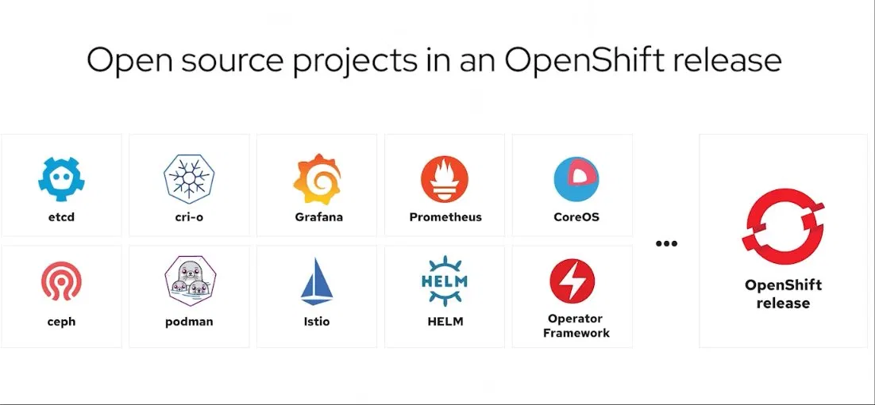
etcd — the key-value store that holds the entire cluster's state (its memory).
cri-o — the lightweight container runtime that actually starts and stops your containers.
Grafana — dashboards that turn metrics into visual graphs and charts.
Prometheus — collects and stores metrics (CPU, memory, traffic) by scraping your apps over time.
CoreOS — the minimal, container-optimized operating system the cluster nodes run on (RHCOS).
ceph — distributed storage that gives your containers reliable, persistent data across many machines.
podman — builds and runs container images without a background daemon (what you use on your VM).
Istio — a service mesh that manages, secures, and routes traffic between your services.
HELM — a package manager for Kubernetes that bundles manifests into reusable, installable charts.
Operator Framework — lets you build "operators" that automate running complex apps the way a human admin would.
OpenShift release — Red Hat's enterprise product that bundles all these open-source pieces into one tested, supported platform.
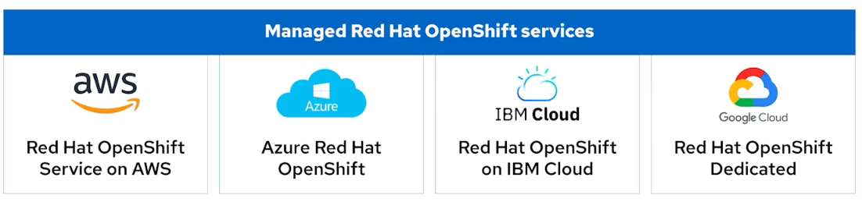
These are all managed OpenShift services — meaning Red Hat (and the cloud provider) run and maintain the OpenShift platform for you, so you don't have to install, patch, or babysit the cluster yourself. The difference between them is just which cloud it runs on and who you pay.
Red Hat OpenShift Service on AWS (ROSA) — OpenShift running on Amazon's cloud, jointly managed by Red Hat and AWS, billed through your AWS account.
Azure Red Hat OpenShift (ARO) — OpenShift running on Microsoft Azure, jointly managed by Red Hat and Microsoft, billed through Azure.
Red Hat OpenShift on IBM Cloud — OpenShift running on IBM's cloud, managed by IBM and Red Hat, billed through IBM Cloud.
Red Hat OpenShift Dedicated — a single-tenant OpenShift cluster managed by Red Hat, which can run on AWS or Google Cloud, billed directly through Red Hat.
The simple takeaway: same OpenShift, four different homes — pick whichever cloud you already use, and Red Hat keeps the platform running for you.
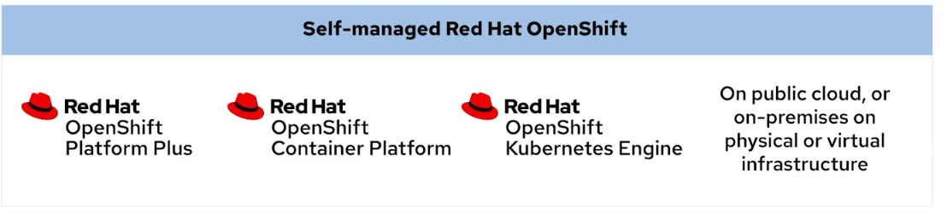
These are the self-managed OpenShift options — meaning you install, run, and maintain the cluster yourself (Red Hat provides the software and support, but no one runs it for you). They're tiered by how much is included.
Red Hat OpenShift Kubernetes Engine — the entry tier: core OpenShift with the essential Kubernetes platform and container tools, but without the extra developer and management add-ons.
Red Hat OpenShift Container Platform — the middle, most common tier: everything in the Engine plus the full developer experience, build tools, monitoring, and the web console.
Red Hat OpenShift Platform Plus — the top tier: everything in Container Platform plus advanced tools for managing many clusters, security, and a private image registry.
On public cloud, or on-premises on physical or virtual infrastructure — not a product, just a note that you can install any of these wherever you want: a public cloud, your own data center, on bare-metal servers, or on VMs.
The simple takeaway: same three tiers, more features as you go up — and because they're self-managed, you can run them anywhere you control the infrastructure.

USEFUL COMMANDS
–help
Double tab - auto completion
Use a JSONPath filter to determine the number of allocatable pods for the master01 node.
[student@workstation ~]$ oc get node master01 -o jsonpath='{.status.allocatable.pods}{"\n"}'

Select the two valid condition types for a control plane node.
kubectl get node master01 -o jsonpath='{.status.conditions[*].type}'

Same as vim — since oc edit opens in vim by default:
- Save and exit: Esc then :wq + Enter
- Exit without saving: Esc then :q! + Enter

That shows all available fields in the output, and you pick the one you need
skopeo inspect docker://REGISTRY/IMAGE:TAG | jq 'keys'

Quiz: Run Applications as Containers and Pods — Cheat Sheet

LOGIN FIRST (always do this before any skopeo command)
bash
skopeo login registry.ocp4.example.com:8443
# Username: developer / Password: developer

Q1: Which command is executed in a container image?
Answer: D — /bin/sh -c $STI_SCRIPTS_PATH/usage
Command:
bash
oc image info registry.ocp4.example.com:8443/ubi8/php-74:latest
Look for the Command: line in the output.
Tip: If Command is empty, check Labels for io.openshift.s2i.scripts-url. For S2I images the command is usually /bin/sh -c $STI_SCRIPTS_PATH/usage.

Q2: Deployment scenarios based on UID (php-74 = UID 1001)
Answer: C and E
Command:
bash
oc image info registry.ocp4.example.com:8443/ubi8/php-74:latest | grep User
Rules to remember:
- Regular user deploys → OpenShift ignores the image USER, assigns a random UID from the namespace range → non-privileged, NOT 1001
- Admin user deploys → OpenShift honors the image USER → UID = 1001 (what the image defines)
- UID > 0 = non-privileged in both cases
So:
- C ✅ — non-privileged user (always true, UID 1001 is not root)
- E ✅ — UID is 1001 when admin deploys (admin honors the image USER)

Q3: What is the hash (Digest) for an image?
Answer: D — sha256:d282…f38f
Command:
bash
skopeo inspect docker://registry.ocp4.example.com:8443/rhel9/mysql-80:1-237 | jq '.Digest'
Or:
bash
oc image info registry.ocp4.example.com:8443/rhel9/mysql-80:1-237
Look for the Digest: line at the top of the output.

Q4: Which environment variables are in an image?
Answer: C and E — HOME=/var/lib/pgsql and PGUSER=postgres
Command:
bash
skopeo inspect docker://registry.ocp4.example.com:8443/rhel8/postgresql-13:latest | jq '.Env'
Or:
bash
oc image info registry.ocp4.example.com:8443/rhel8/postgresql-13:latest
Look for the Environment: section in the output.

Q5: Which tags are available for an image?
Answer: B, C, E — 1, latest, 8.4
Command:
bash
skopeo list-tags docker://registry.ocp4.example.com:8443/ubi8/ubi
Lists all available tags for the image repository.

Q6: Which images run as privileged when admin deploys?
Answer: A and D — postgresql-13 (UID 26) and mysql-80 (UID 27)
Command:
bash
for image in \
registry.ocp4.example.com:8443/rhel8/postgresql-13:latest \
registry.ocp4.example.com:8443/ubi8/php-74:latest \
registry.ocp4.example.com:8443/ubi8/nodejs-16:latest \
registry.ocp4.example.com:8443/rhel8/mysql-80:latest \
registry.ocp4.example.com:8443/ubi8/python-39; do
echo -n "$image → "
oc image info $image | grep User
done
Rule:
- UID 0 or no User = root = privileged ✅
- Low system UIDs like 26 (postgres) and 27 (mysql) = system accounts = treated as privileged in this context ✅
- UID 1001 etc. = non-privileged ❌

Q7: Which port is exposed in an image?
Answer: D — 3306/tcp
Command:
bash
oc image info registry.ocp4.example.com:8443/rhel8/mysql-80
Look for the Exposes Ports: line in the output.
Or:
bash
skopeo inspect --config docker://registry.ocp4.example.com:8443/rhel8/mysql-80 | jq '.config.ExposedPorts'

SUMMARY OF KEY COMMANDS
What you need | Command
Executed command in image | oc image info IMAGE → look for Command:
User/UID of image | oc image info IMAGE | grep User
Image hash/digest | skopeo inspect docker://IMAGE | jq '.Digest'
Environment variables | skopeo inspect docker://IMAGE | jq '.Env'
Available tags | skopeo list-tags docker://REGISTRY/REPO
Exposed ports | oc image info IMAGE → look for Exposes Ports:
All image info at once | oc image info IMAGE

what are replicas?
Replicas are simply copies of the same pod running at the same time.
Replicas are simply copies of the same pod running at the same time.
For example, if you have a web app and set replicas: 3, Kubernetes runs 3 identical copies of that pod simultaneously. This gives you:
- High availability — if one pod crashes, the other two keep serving requests
- Load balancing — traffic is spread across all copies
- Scalability — more copies = more capacity to handle requests

